Supplementary Table 1. Search strategies for each database included in the systematic search.
Database | Search formula | Number of records identified
Pubmed | ("whole-brain radiotherapy" OR "WBRT" OR "whole-brain radiation therapy" OR "Whole-brain irradiation" OR "Whole-brain external beam radiotherapy" OR "intensity-modulated radiotherapy" OR "IMRT" OR "stereotactic radiosurgery" OR "SRS") AND ("SIB" OR "boost") AND ("brain" OR "central nervous system" OR "CNS" OR "intracranial" OR "cerebral") | 544
Embase | ('whole-brain radiotherapy'/exp OR 'whole-brain radiotherapy' OR 'wbrt' OR 'whole-brain radiation therapy'/exp OR 'whole-brain radiation therapy' OR 'whole-brain irradiation' OR 'whole-brain external beam radiotherapy' OR 'intensity-modulated radiotherapy'/exp OR 'intensity-modulated radiotherapy' OR 'imrt'/exp OR 'imrt' OR 'stereotactic radiosurgery'/exp OR 'stereotactic radiosurgery' OR 'srs') AND ('sib'/exp OR 'sib' OR 'boost'/exp OR 'boost') AND ('brain'/exp OR 'brain' OR 'central nervous system'/exp OR 'central nervous system' OR 'cns'/exp OR 'cns' OR 'intracranial' OR 'cerebral') | 1489
Web of Science | ("whole-brain radiotherapy" OR "WBRT" OR "whole-brain radiation therapy" OR "Whole-brain irradiation" OR "Whole-brain external beam radiotherapy" OR "intensity-modulated radiotherapy" OR "IMRT" OR "stereotactic radiosurgery" OR "SRS") AND ("SIB" OR "boost") AND ("brain" OR "central nervous system" OR "CNS" OR "intracranial" OR "cerebral") | 824

Supplementary Figure 1. Risk of bias assessment.
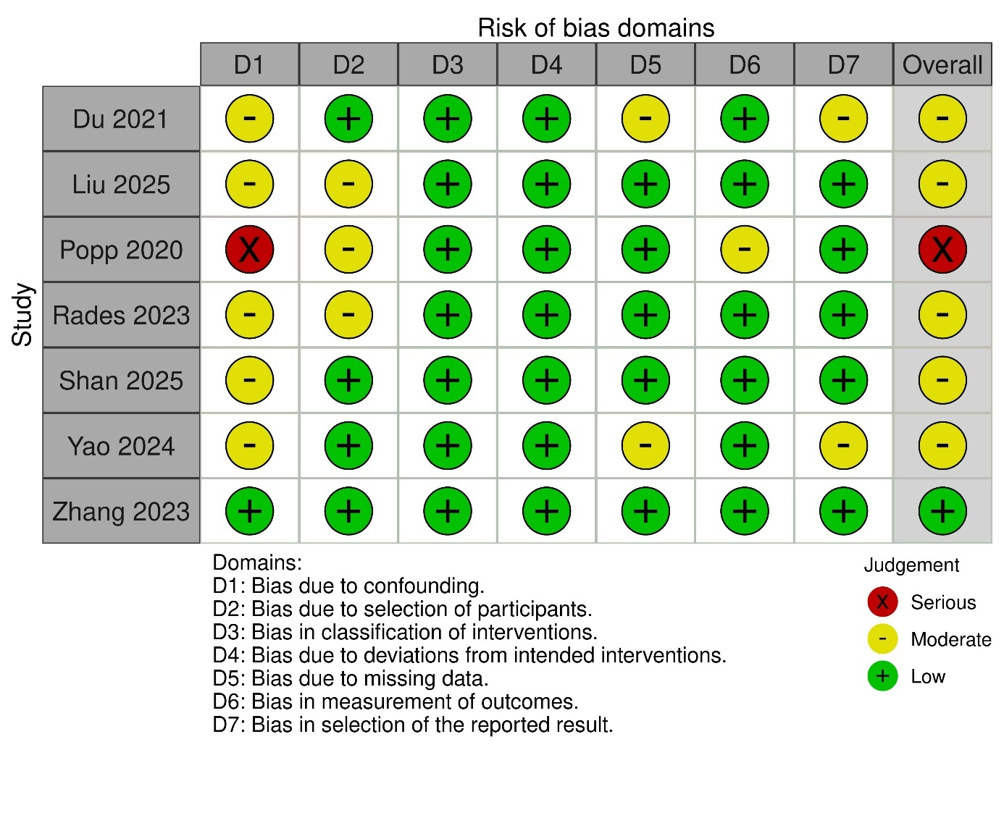

Supplementary Figure 2. Analysis of publication bias for overall survival.
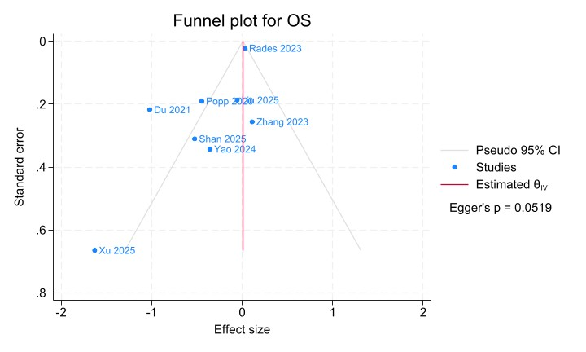
Supplementary Figure 3. Subgroup analysis for the overall survival.
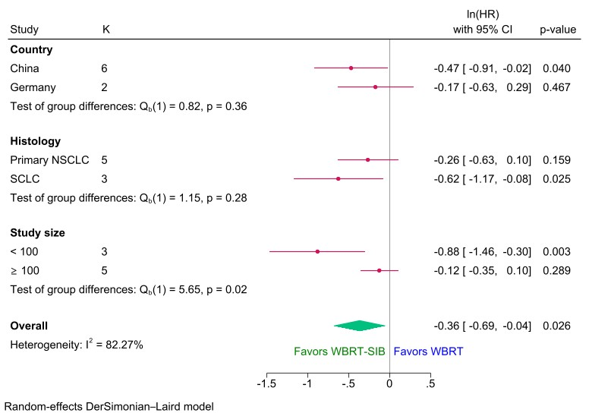
NSCLC – non-small cell lung cancer; SCLC – small cell lung cancer

Supplementary Figure 4. Pooled analysis of the best response to the treatment.
