Supplementary information
for
NMR characterisation of the antibiotic resistance-mediating 32mer RNA from the 23S ribosomal RNA
Christina Muhs¹, Lena Kemper¹, Christian Richter¹, Francesca Lavore², Markus Weingarth², Anna Wacker¹, Harald Schwalbe¹
^{1.} Center for Biomolecular Magnetic Resonance (BMRZ), Institute for Organic Chemistry and Chemical Biology, Frankfurt am Main, Goethe University, Max-von-Laue-Straße 7, 60438 Frankfurt am Main, Germany
^{2.} NMR Spectroscopy, Department of Chemistry, Utrecht University, Padualaan 8, 3584 CH Utrecht, the Netherlands
Keywords: m6A, DMA, erythromycin methyl transferase, antibiotic resistance, solution NMR-spectroscopy, 23S ribosomal RNA
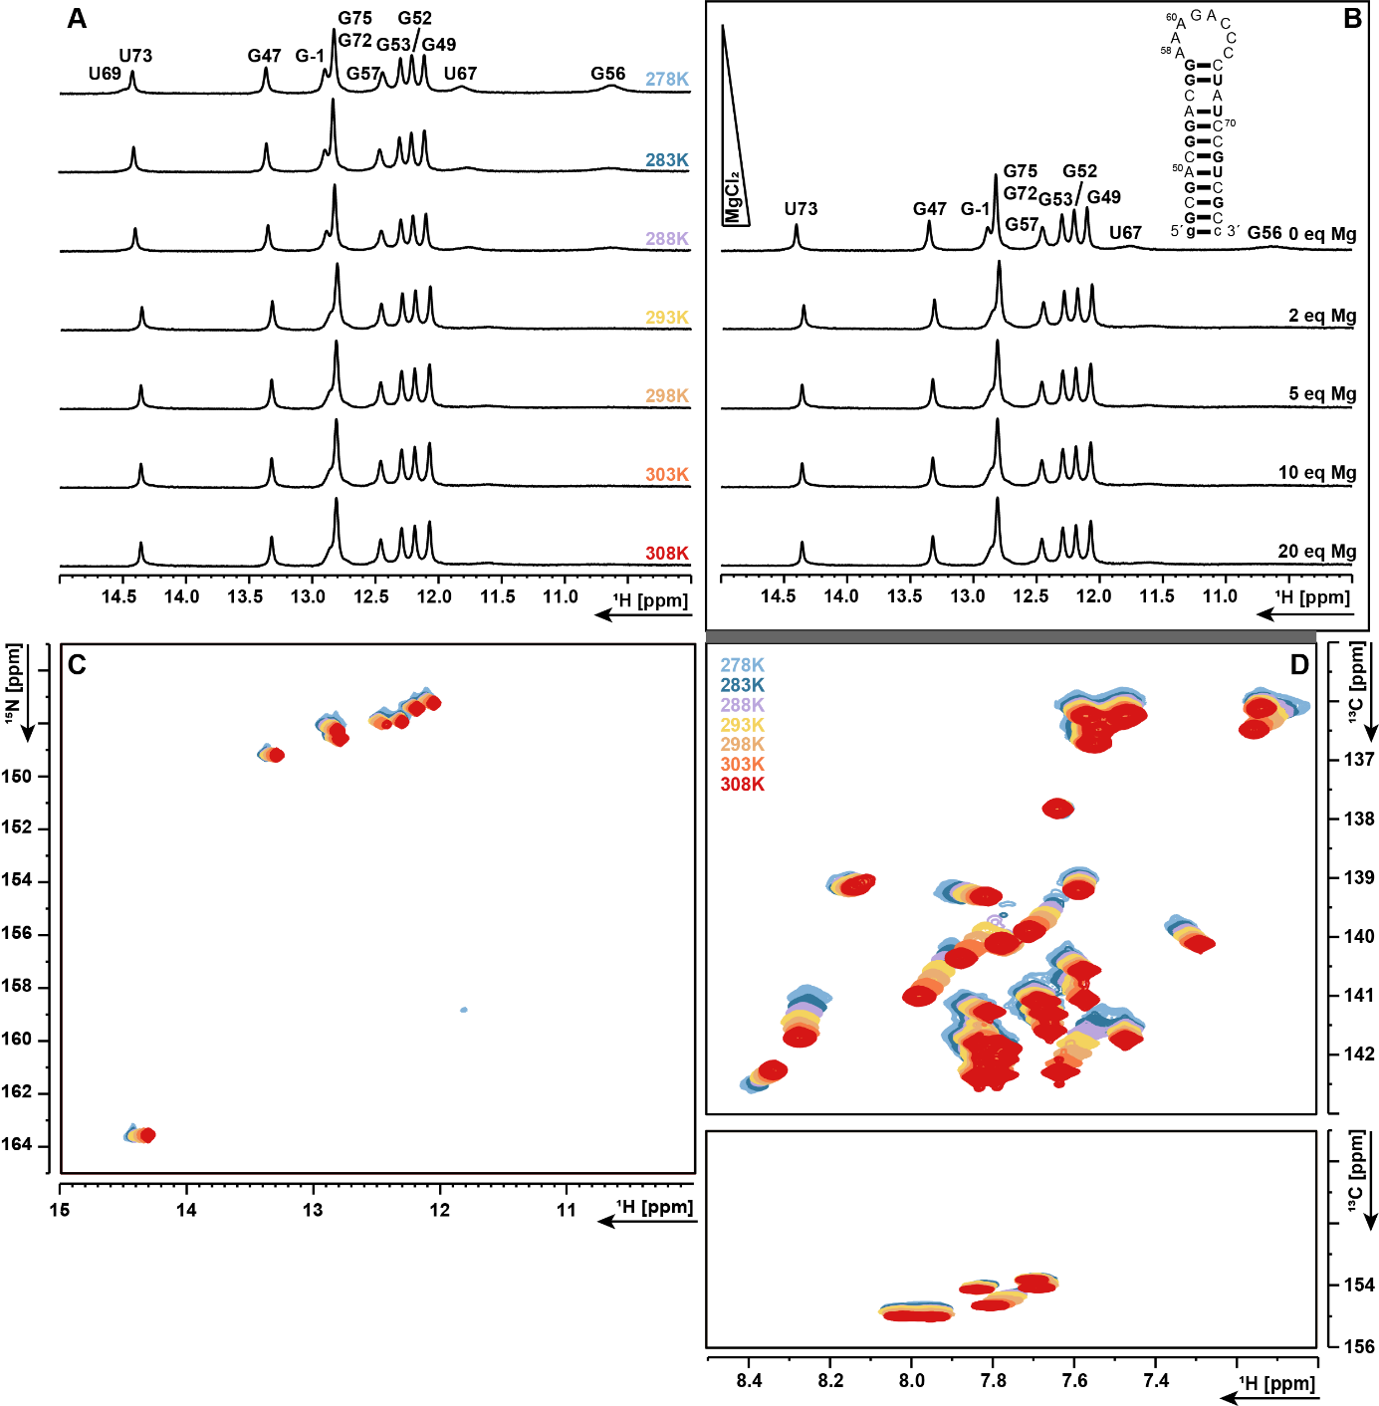
Figure SI 1: A) ¹H-1D spectra of the unmethylated RNA construct measured within a temperature range of 278 K to 308 K. B) ¹H-1D spectra were measured at 278 K with varying MgCl₂ concentrations (0 eq – 20 eq) to an RNA concentration of 185 µM. Temperature series were measured for C) ¹H,¹⁵N-best-TROSY D) ¹H,¹³C-HSQC.

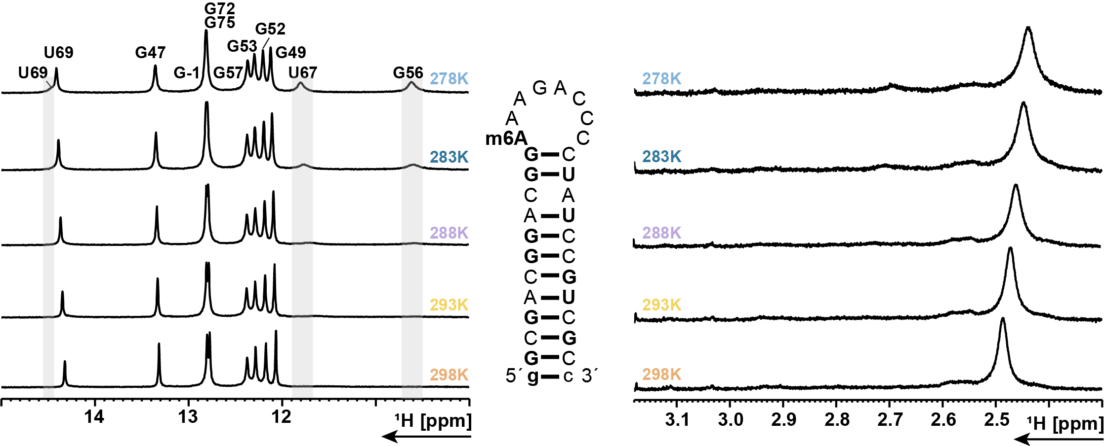
Figure SI 2: ¹H-1D spectra of the m⁶A-construct measured in a temperature range of 278 K to 298 K. The left side of the figure displays the imino-proton signal region, while the methyl group signal is shown on the right.

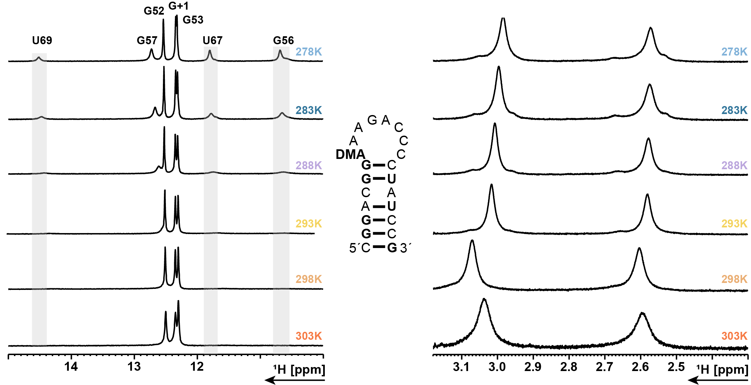
Figure SI 3: ¹H-1D spectra of the DMA-construct measured within a temperature range of 278 K to 298 K. The left side of the figure displays the imino-proton signal region, while the methyl group signals are shown on the right.
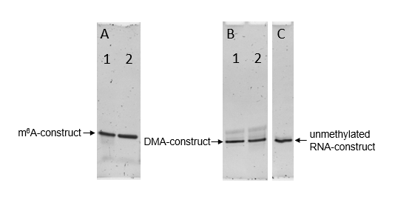
Figure SI 4: Purity of the RNA samples: A) Di-methylated (DMA) – construct before (1) and after (2) HPLC purification. B) Mono-methylated (m⁶A) – construct after (1) and before (2) HPLC. C) unmethylated RNA - construct after HPLC. Conditions for denaturing PAGE: A) 12% PAGE, 30 min @ 240 V; B) 15% PAGE, 35 min @ 260 V; C) 15% PAGE, 35 min @ 260 V.

