APPENDIX
This appendix presents data related to the Indian economy. It also outlines the policy and institutional changes that govern sectors over time. We also discuss economic data, policy changes and national and sectoral interventions initiated by the Modi government from 2014-2024.
Mapping of India’s Growth Patterns Across Sectors
India’s “growth story” is founded on an aggregation of diverse sectoral growth rates. Figure 1 presents data supporting the conventional wisdom that the service sector has led Indian growth. Each category within the service sector has exceeded the 5.7 percent average annual value added for the economy as a whole, while manufacturing, agriculture, and mining are below the average at 5.7 percent, 3.9 percent, and 1.9 percent respectively. However, the conventional wisdom obscures substantial variation within the service sector, with real estate and professional services growing at 8.3 percent annually, while financial services and transport, storage and communications have annual growth rates at 5.9 and 5.7 percent. Furthermore, as Bhandari and Kale (2019) point out, since the reforms in the early 1990s, different service subsectors have been growth leaders at different points in time in response to sectorally-specific reforms and/or the utilization of new technologies that vary across sectors and subsectors.
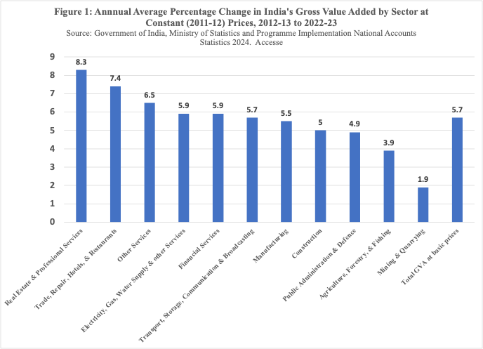

More importantly, the conventional wisdom obscures the contribution of the most dynamic sectors within industry to India’s economic growth. Disaggregating manufacturing, as shown in Figure 2, reveals that from 2011-12 to 2023-24, there were substantial differences between fast-growing industrial sectors like pharmaceuticals, medicinal chemical and botanical products (134 percent), furniture (119 percent), basic metals (91 percent), on the one hand, and sluggish sectors such as ‘other manufacturing’ (-15 percent), fabricated metals, excluding machinery (-8 percent), and leather (-6 percent). Important sectors have undergone sluggish growth – e.g. electrical machinery and textiles, each at 7 percent (Figure 2). Rather than claim that India’s growth is based on services, a more accurate description would be that particular service sub-sectors and some manufacturing sectors’ revival have fueled India’s aggregate growth rate.
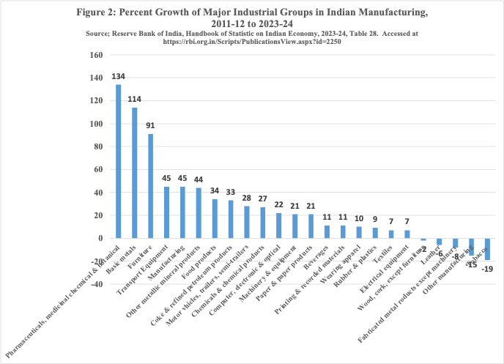

Decentering of Regulatory Institutions after 1991
Policy reforms augmented the variation across sectors, decentering the economy and polity. After the 1991 economic crisis, domestic policymakers accelerated the reform of India’s license-quota-permit-raj, opened the economy to some extent, and curtailed domestic regulations regarding monopoly practices. India’s economic reforms diversified and decentered India’s economic governance in two ways. First, by rolling back central government planning and controls, India has created greater horizontal competition (Sinha 2004) and a “federal market economy” (Rudolph and Rudolph 2001) that enhances the importance of state and local government policies in promoting economic development. Macroeconomic reforms – trade liberalization, delicensing, etc. – interact with variations in state-level business environments and geographic factors to produce divergent outcomes. States compete for investment and fashion policies to attract investment to particular sectors. Karnataka has specialized in securing investment in informatics, Gujarat has attracted capital to petroleum refining, and Tamil Nadu has promoted its ship-building and automobile industry. The relative success of states in attracting investment to different sectors has promoted divergent developmental pathways and led to disparate growth rates across the states.
The transition from dirigiste regulation to the “new regulatory state” (Echeverri-Gent 2024; Kapur and Khosla 2019; Dubash and Morgan 2013) is the second way India’s economic governance has been diversified and decentralized. India’s economic reforms have replaced the central government’s dirigiste regulation through the Planning Commission and government departments with independent regulatory agencies for different economic sectors. The old dirigiste regulation dictated investment patterns, prices, and trade. The new regime uses regulations to shape how markets coordinate economic behavior. Under the old dirigisme, generalists implemented regulation. The new regulation requires implementation by officials with specialized expertise. Under the old system, economic regulation was coordinated by the Planning Commission. India’s new regulatory state coordinates regulators through sectoral policy instruments. In sum, India’s new economic policies have diversified its economy and economic regulation. Distinct varieties of policies and sectoral “marketcraft” have interacted with factors at regional, national, and international levels as well as with the legacies of dirigiste institutions to forge divergent developmental trajectories across sectors.
Modi’s Governance Model: Centrally Directed with Sectoral Interventions
Modi’s campaign slogan, “Minimum government, maximum governance,” led many to expect that he would be a liberalizer and reduce the role of the government in the economy. Conventional approaches to economic reforms conceptualize liberalization as decentralizing authority over the economy from state to market institutions. However, the truth is more complex, and our sector-centered analytical framework illuminates these complexities. The Modi government’s uneven efforts to expand the role of the market were accompanied by measures to centralize authority over key state institutions of economic governance, including investment levers of the state. Especially during its second term, the Modi government has accelerated a push for massive infrastructure investment in roads, airports and rail corridors. In one year alone, 2022-23, capital expenditure in infrastructure increased by 33% with a special focus on infrastructure and energy. Such investments will create broad conditions for all sectors and allow the central government to shape and control levers of sectoral development. Yet, simultaneously, in 2020, the government unveiled production-linked schemes for 14 key sectors to create, “national champions and to create jobs.” The sectoral focus of such schemes ranged from pharmaceuticals and electronics to telecom, and solar panels. In 2023, they also included sectors such as drones, man-made fibre, and a greater push for the food-processing sector, with a special focus on millet-based products. Our multi-level framework allows us to explore the connections between the infrastructure push that should benefit all sectors with the specific sectorally-specific subsidies that highlight the strategic value that Modi places on green energy and the government’s push to revive employment intensive sectors such as electronics.

References
Acharya, Shivangi, and Sarita Chaaganti Singh, 2023. "India Weighs Changes to Improve Uptake of Production Incentive Scheme,” Reuters, November 9 2023, https://www.reuters.com/world/india/india-weighs-changes-improve-uptake-production-incentive-scheme-sources-2023-11-09/
Reserve Bank of India. 2024. Handbook of Statistics on Indian Economy, 2023-2024. Mumbai: Reserve Bank of India

Examples of such independent regulatory agencies are the Telecom Regulatory Authority of India, the Securities and Exchange Board of India, the Insurance Regulatory and Development Authority, the Food Safety and Standards Authority of India, the Petroleum and Natural Gas Regulatory Board, and the Central Electricity Regulatory Commission.
https://www.investindia.gov.in/production-linked-incentives-schemes-india ; Also, see Acharya and Singh (2023).

