The Social Impact of COVID-19 on Migrants in Urban Africa
Supplementary Appendix

Table of Contents

Appendix A: Survey Coding and Demographic Statistics (p. 2)

Appendix B: Survey Analysis (p. 8)

Appendix C: Neighborhood Vignettes (p. 9)

Appendix D: Police Brutality and Protests in Johannesburg (p. 12)
Appendix E: Migrant Employment Status by City (p. 13)

Appendix A: Survey Coding and Demographic Statistics
The following section details how we coded survey respondents into demographic categories for comparative analysis. Across the demographic questions, a total of 10 respondents were recorded as “unknown/no response”; we dropped these observations from the analysis.

Table A1. Migrant Type of Survey Respondents

Respondent Type | Frequency | Percentage (%)
Native/Long-Term | 538 | 32.73
Domestic | 603 | 54.52
International | 503 | 45.48
Total | 1644 | 100.00

Questions #3: “Were you born in this country? Note to fieldworker: Record to retain a 70:30 quota with 25% domestic migrants?”
Questions #103: “What country were you born in?”

To ascertain respond type we used survey questions 3 and 103. We generated a variable, RespondentType, and coded all responses as native / long-term residents. Respondent type was changed to international migrant if they answered “No” to question 3. This produced 575 international migrants, however we expected 603. Using question 103, We found that international migrants from other survey city countries (for example, a migrant from South Africa in Nairobi), were originally counted as native / long-term residents. These 28 responses were then recoded as international migrants. Respondents were coded as domestic migrants if they responded “yes” to question 3. The remaining respondents (n = 538) were coded as native / long-term residents. This classification was further confirmed by triangulating answers from with Q236 (see Table A5).

Table A2. Migrant Survey Location

Migrants by Survey City
City | Frequency | Percentage (%)
Accra | 388 | 35.08
Johannesburg | 313 | 28.30
Nairobi | 405 | 36.62
Total | 1106 | 100.00

Question #8: “Question to the Fieldworker: Which city is the interview conducted in?”

Fieldworkers were asked the record where the interview was conducted. For the purpose of analysis, we generated three distinct city variables: Accra, Johannesburg, and Nairobi. Each city variable includes all migrants interviewed in that city.

Table A3. Migrant Gender

Migrant Gender
Gender | Frequency | Percentage (%)
Female | 559 | 50.59
Male | 546 | 49.41
Total | 1105 | 100.00

Question #4: “Respondent’s sex. If unclear, ask the respondent how they identify Note to fieldworker: Record to retain 50:50 Quota”

Table A4. Migrant Education

Migrant Education Level
Education Level | Frequency | Percentage (%)
None | 72 | 6.52
Some or all of primary | 335 | 30.34
Some or all of secondary | 539 | 48.82
More than secondary | 158 | 14.31
Total | 1104 | 100.00

Question #111: “What is the highest level of formal education you have completed?”

While the survey had X options to this question, we categorized the education variable as 4 categories. Primary education includes both respondents who completed primary school and those who did not. Secondary education also represents those who completed secondary school and those who did not, however, it also includes the “Other” category. The original survey responses included an “Other, please specify” category. We determined that the majority of those responses were those who partially completed secondary school. Therefore, for the purposes of the analysis, we include those responses with secondary education. We also merged “Finished tertiary education” and “Post-grad degree” into one distinct category, labeled “Beyond secondary.”

Table A5. Migrant Residence Time in Survey City

Residence Time | Frequency | Percentage (%)
New (<2 yrs.) | 283 | 25.61
Medium-Term (2-8 yrs.) | 737 | 66.70
Long-Term (>8 yrs.) | 85 | 7.69
Total | 1105 | 100.00

Question #236: “How long have you been at your current residence?”

Fieldworkers were asked to record how long a respondent has been at their current residence. The responses were recorded as one of the following: less than 1 month, 1-3 months, 3-6 months, less than a year, one year, more than 2 years, more than 8 years. For the purposes of this analysis, we merged these responses to form three categories: new resident, medium-term resident, and long-term resident. New residents have lived in their current residence for less than 2 years, medium-term residents for 2-8 years, long-term residents for over 8 years.

Table A6. Migrant Refugee Status

Refugee Status | Frequency | Percentage (%)
Non-Refugee | 1066 | 96.47
Refugee | 39 | 3.53
Total | 1105 | 100.00

Question #214: “Have you ever stayed in a camp or settlement specially designated for refugees or displaced persons?”

Respondents who answered “yes” to question 214 were recorded as a refugee. Respondents who answered “no” were recorded as a “non-refugee.”

Table A7. Migrant Age

Migrant Age
Age Range | Frequency | Percentage (%)
Young Adult (<24 yrs.) | 221 | 19.38
Adult (25-64 yrs.) | 872 | 78.84
Senior (>65 yrs.) | 13 | 1.18
Total | 1106 | 100.00

Question #104: “Year of Birth : What year were you born?”

Respondent age was originally recorded as birth year. To better interpret these results, we divided the sample into three age categories: young adult (<24 yrs.), adult (25-64 yrs.), and senior (> 65 yrs.). we then calculated the birth years which fit within each age group, for the year 2021. Young adults were born after 1997, adults were born between 1956 – 1996, and seniors were born before 1955.

Table A8. Migrant Mobility During COVID-19

Migrants with Change of Residence Since March 2020
Residence Change (y/n) | Frequency | Percentage (%)
Yes | 988 | 89.41
No | 117 | 10.59
Total | 1105 | 100.00

Question #226: “Since March 2020, have you changed your place of residence? ”

Using question 226, we determined how many migrants changed their place of residence since March of 2020.”

Table A9. Migrant Social Engagements Inside of Survey City

Migrant Social Engagements Inside Survey City Since March 2020
Change in Engagement Frequency | Frequency | Percentage (%)
Increased | 80 | 7.24
Decreased | 675 | 59.46
Remained the Same | 368 | 33.30
Total | 1105 | 100.00

Question #228: “Have your social engagements with other people inside the city increased or decreased since March 2020? ”

Respondents were asked about their social engagements inside the survey city in question 228. Their responses were recorded as “increased,” “decreased,” or “remained the same.”
Table A10. Migrant Employment Status

Migrant Employment Status
Employment Status | Frequency | Percentage (%)
Full-Time | 167 | 15.14
Part-Time | 54 | 4.90
Self-Employed | 418 | 37.90
Casual Employment | 153 | 13.87
Voluntary Worker | 6 | 0.54
Student | 38 | 3.45
Homemaker | 19 | 1.72
Unemployed | 189 | 17.14
Other | 59 | 5.35
Total | 1103 | 100.00

Question #303: “How would you define your current employment status?”

Respondents were asked about their employment status in question 303. Their responses were categorized into pre-determined list of employment types: casual employment/temporary worker, doing casual jobs, housewife/homemaker, self-employed (run small business/income generation project), university/technikon/correspondence student/ voluntary worker, working full-time (formal/informal sector), working part-time (formal/informal sector), unemployed, and other. From our analysis, we combined “causal employment/temporary worker” and “doing causal jobs” categories.

Appendix B: Survey Analysis
Figure B1. Migrant Social Engagements During COVID-19
Survey question: Have your social engagements with other people inside the city increased or decreased since March 2020?
Values: Decreased, Stayed the same, Increased
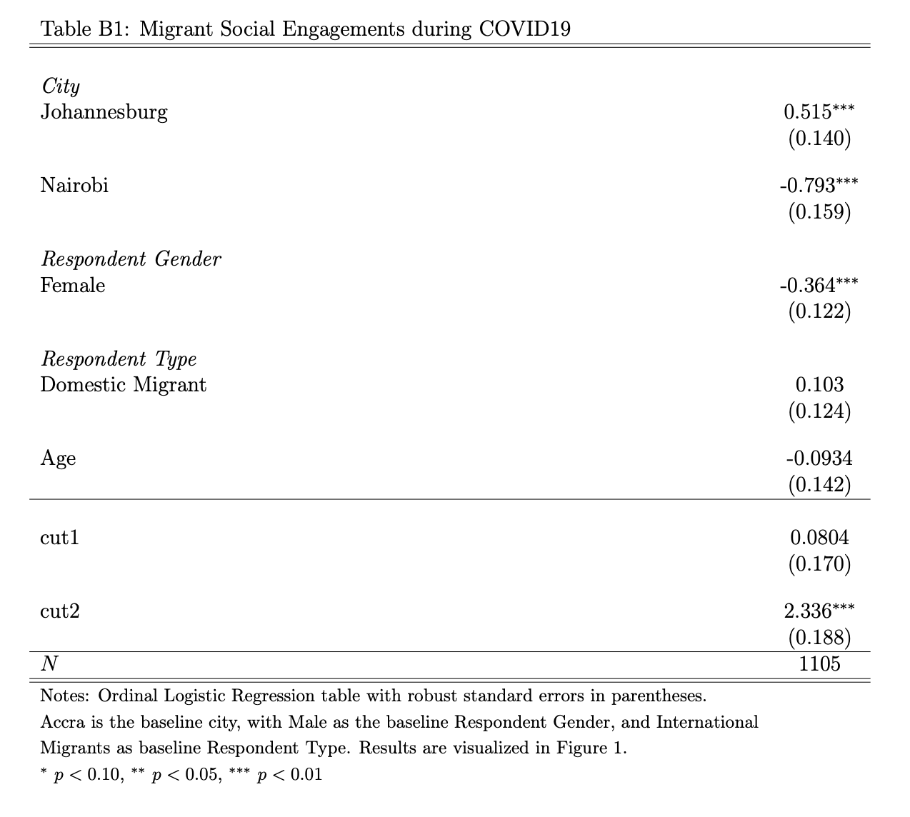

Appendix C: Survey Neighborhoods
The MTAFP surveyed three neighborhoods with large migrant populations in each of the cities. Below are brief vignettes about each neighborhood.
Accra
The survey enumerators visited three Accra neighborhoods: Jamestown, Old Fadama, and Madina. These neighborhoods are characterized by rapid urbanization and large migrant populations (Landau et al., 2021).
Jamestown is one of Accra’s oldest areas and is located close to the Central Business District. Despite its central location, Jamestown has high poverty rates and a high percentage of low-income housing (Tutu et al., 2017). Jamestown’s proximity to the economic district and low housing costs makes it a popular destination for migrants (Landau et al., 2021). In particular, the neighborhood’s composition has also noticeably changed in recent years due to domestic rural-urban migration (Codjoe et al., 2014).
Old Fadama is one of the largest informal settlements in Accra. Like Jamestown, Old Fadama is also a popular destination for domestic migrants, especially from Northern Ghana (Landau et al., 2021). Located in the heart of Accra, the neighborhood features informal housing and access to adequate sanitation (Landau et al., 2021; Tutu et al., 2017).
The final Accra neighborhood is Madina. Like Jamestown and Old Fadama, Madina attracts large numbers of domestic and international migrants (Landau et al., 2021). However, unlike the other two neighborhoods, Madina is better known for its international migrants. Madina is a Zongo settlement, which refers to an urban African area mostly populated by migrants from northern savannah regions (Ghana Property Centre, 2023).

Johannesburg
The survey teams visited three Johannesburg neighborhoods: Berea, Diepsloot, and Katlehong South. These neighborhoods are commonly known as townships. Like Accra, urbanization has also shaped these areas; however, apartheid-era policies of racial exclusion from cities significantly altered their development. Following the dismantling of apartheid policies in the 1990s, large number of South Africans migrated from rural to urban areas. Berea is one such example. Berea is a densely populated inner-city neighborhood of Johannesburg. After apartheid, the neighborhood transitioned from a middle-class white area to a primarily black area, with a large percentage of international migrants (Landau et al., 2021).
Situated north of Johannesburg, Diepsloot is another densely populated area, home to nearly 200,000 people (Mahajan & Sandeep, 2014). Like Berea, the apartheid also shaped Diepsloot, which was initially a transit camp for people forcibly removed from other informal settlements (Ibid.). Diepsloot has rapidly expanded since its establishment and is now home to many international migrants (Landau et al., 2021). Given the MTFAP’s interest in migrant behavior, the survey team focused on Extension One, one of the most transient areas of Diepsloot and a frequent site of violence against international migrants (Ibid.).
Katlehong is the third largest township in South Africa. Like its counterparts, it emerged in response to apartheid-era race-based urban management policies (Mokoena et al., 2019). Katlehong was initially established as several illegal squatter camps. The township has dramatically expanded since that time and is now one of the most migrant-heavy areas in the country (Landau et al., 2021).

Nairobi
The neighborhoods surveyed in Nairobi were Ongata Rongai, Kawangware, and Kayole. Ongata Rongai, also knowns as Rongai, is a fast-developing residential urban area (Kazungu et al., 2011). The town continues to absorb an influx of migrants struggling to find housing in Nairobi (Landau et al., 2021).
Kawangware has also experienced rapid population growth driven by urbanization (Landau et al., 2021). As one of Nairobi’s largest informal settlements, Kawangware residents face poor living conditions. Despite these conditions, the settlement is home to a diverse group of domestic migrants, mainly from Luhya, Kissii, Luo, and Kikuyu-dominant regions, and international migrants from East African countries such as Burundi, Uganda, and Ethiopia (Ibid.).
Like Kawangware, Kayole is predominantly composed of informal settlements (Landau et al., 2021). Located in the Embakasi Division of Nairobi’s Eastland area, Kayole developed through the forced relocation of people from Nairobi’s city center to the outskirts (Njambi, 2013). The settlement is also home to many asylum seekers and urban migrants from Africa’s Great Lakes Region (Landau et al., 2021).

Appendix D: Police Brutality and Protests in Johannesburg
Fig D1 Location of Johannesburg Protests
Fig 1D. Google Earth image of Johannesburg, South Africa, and its surrounding townships. The townships where the survey was conducted (Diepsloot, Berea, and Katlehong) are marked with a star. The townships were Collins Khosa and Sibusiso Amos are marked with a circle (Alexandra and Vosloorus respectively). Protests that occurred in Johannesburg between March 2020 and April 2021 are marked with a square. Protests at the Constitutional Court and U.S. Consulate General were against police brutality and occurred in June of 2020 (The Zimbabwe Mail 2020; Harrisberg 2020 ). The protest at the University of Witwatersrand was against the human trial of the COVID-19 vaccine and occurred in July of 2020 (Civicus Monitor 2020)

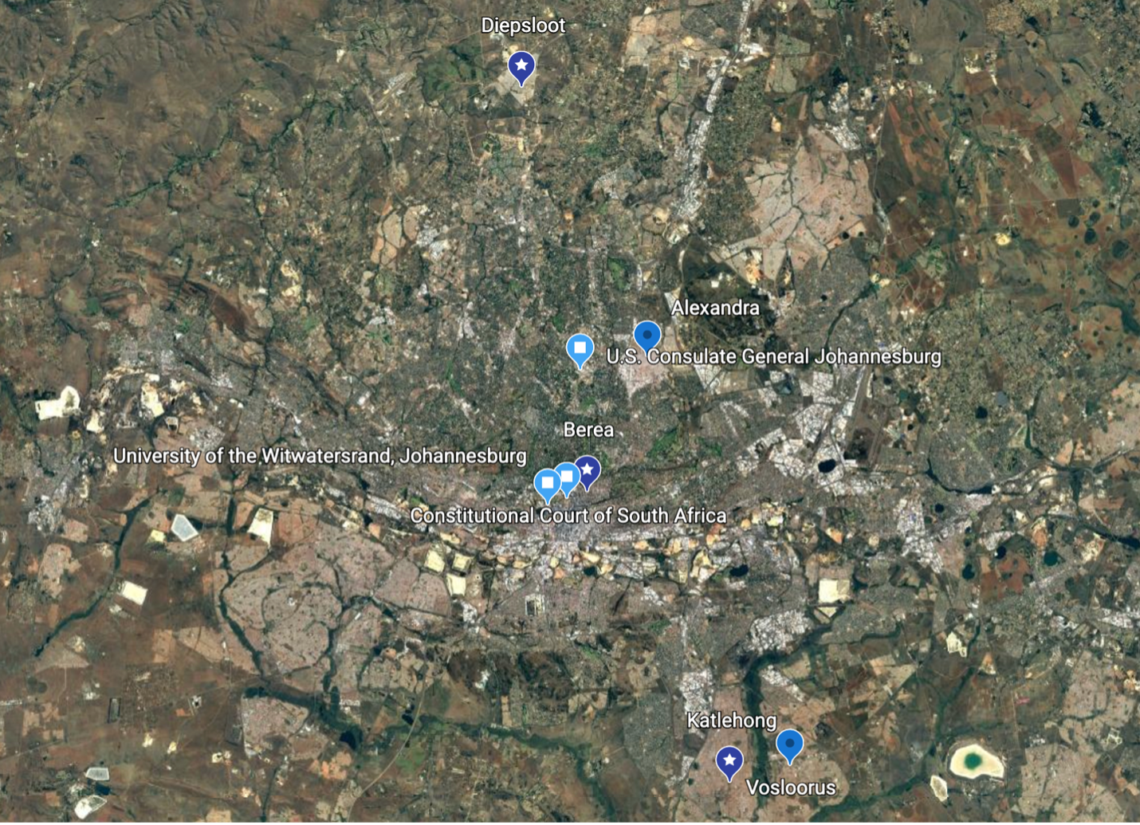

Appendix E: Migrant Employment Status by City
Table E1. Migrant Employment Type by City
Percent of Migrant Employment Type by City
Employment Status | City
 | Accra (n = 388) | Johannesburg (n = 313) | Nairobi (n = 402)
Full-Time | 15.46 | 20.44 | 10.70
Part-Time | 2.84 | 7.03 | 5.22
Self-Employed | 46.65 | 31.95 | 34.08
Casual Employment | 14.95 | 6.71 | 18.41
Voluntary Worker | 1.03 | 0.64 | 0.00
Student | 1.55 | 3.51 | 5.22
Homemaker | 1.03 | 0.96 | 2.99
Unemployed | 6.70 | 26.52 | 19.90
Other | 9.79 | 2.24 | 3.48

Table E3. Percent of each migrant employment type in each survey city.

References
Civicus Monitor (2020). “Protests documented amid COVID19 Restrictions.” https://monitor.civicus.org/updates/2020/10/26/protests-documented-amid-covid-19-restrictions/

Codjoe, S. N. A., Owusu, G., & Burkett, V. (2014). Perception, experience, and indigenous knowledge of climate change and variability: The case of Accra, a sub-Saharan African city. Regional environmental change, 14(1), 369-383.

Ghana Property Centre. (2023). “Madina Area Guide.” https://ghanapropertycentre.com/area-guides/greater-accra/la-nkwantanang-madina-municipal/madina

Kazungu, R., Gitau, J., & Gichuru, P. (2011). Planning challenge of Karen and Ongata-Ronga peripheral locations. International Society of City and Regional Planners.

Landau, L. B., Blue, K., Setrana, M., & Majidi, N. (2021). Mobility, Temporality, and Africa’s Future Politics Project.

Mahajan, S. (2014). Economics of South African Townships: Special Focus on Diepsloot. World Bank Study. Washington, DC: World Bank Group. https://openknowledge.worldbank.org/handle/10986/19282

Mokoena, B., Moyo, T., Makoni, E., & Musakwa, W. (2019). Spatio-Temporal Modelling & the New Urban Agenda in Post-Apartheid South Africa. The International Archives of Photogrammetry, Remote Sensing and Spatial Information Sciences, 42, 1327-1332.

Njambi, L. (2013). Kayole Soweto Project. Nairobi City Water and Sewerage Company.

The Zimbabwe Mail (2020). “South Africa, Kenya protest against US fascist regime.” https://www.thezimbabwemail.com/world-news/south-africa-kenya-protest-against-us-fascist-regime/

Tutu, R. A., Boateng, J. K., Busingye, J. D., & Ameyaw, E. (2017). Asymmetry in an uneven place: migrants’ lifestyles, social capital, and self-rated health status in James Town, Accra. GeoJournal, 82(5), 907-921.

