PSYCHOMETRIC EVALUATION OF THE HSPS 39
Supplementary Material

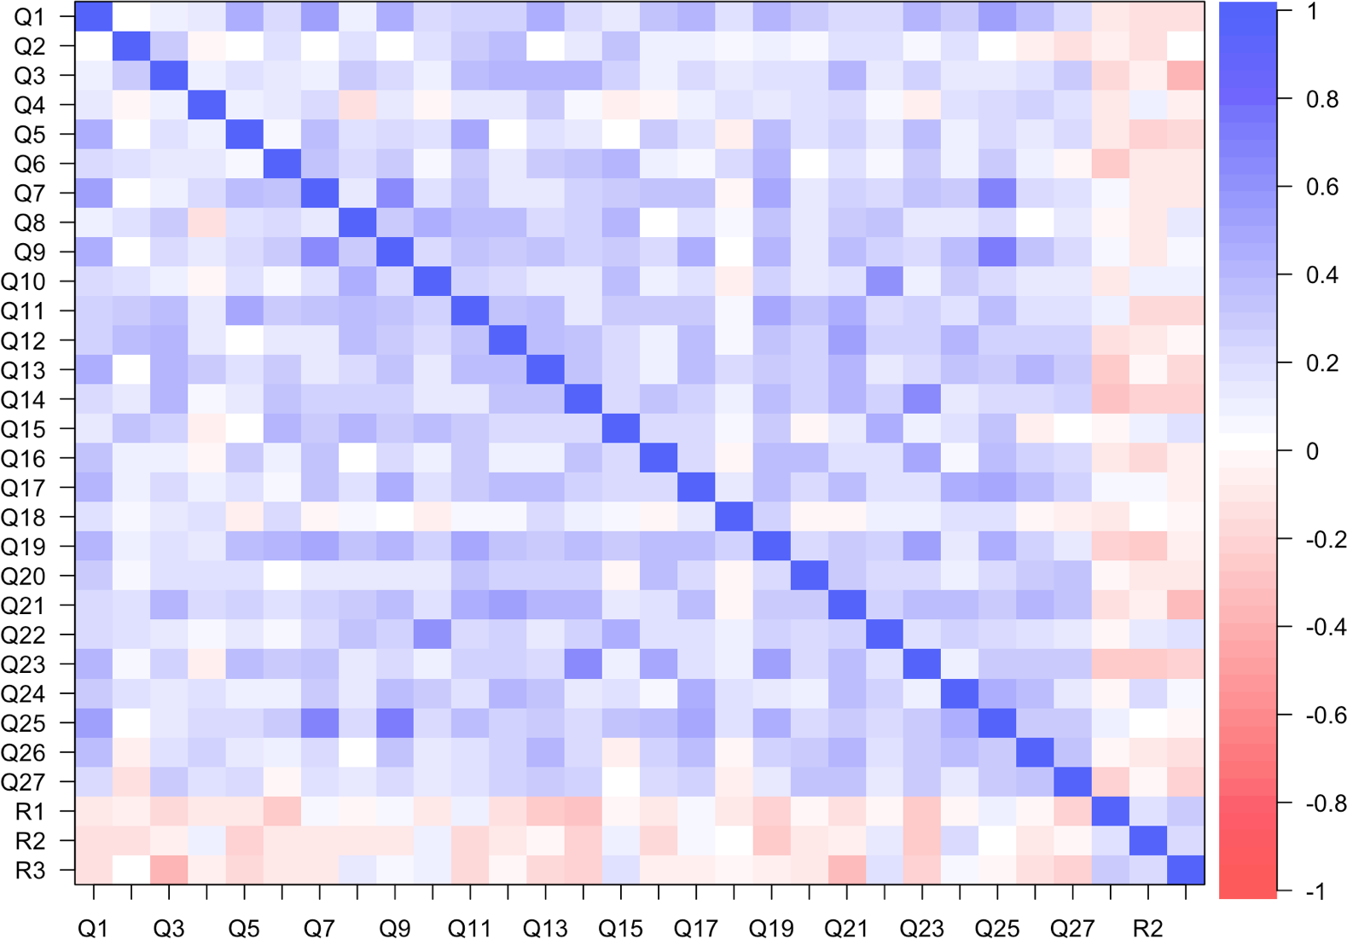

Figure Supp-1: A correlation heat map of HSP scale items and researcher-generated reverse-scored items. On balance, HSPS items correlated positively with each other, but neg- atively with the researcher-generated reverse-scored items. Discrepant correlations suggest a degree of social desirability bias, especially for items 8, 10, 15 and 22. Q = HSPS question number; R = reverse-scored item number.

PSYCHOMETRIC EVALUATION OF THE HSPS
40

Table Supp-1: Factor composition per sample
Item | 2016 | 2017 | 2018 | Combined *
1. Are you easily overwhelmed by strong sensory input? | NS/PO | NS/PO | PO | NS/PO
2. Do you seem to be aware of subtleties in your environment? | NS | PO | AS | -
3. Do other people’s moods affect you? | NS | NS | - | NS
4. Do you tend to be more sensitive to pain? | NS | NS | NS | NS
5. Do you find yourself needing to withdraw during busy days, into bed or into a darkened room or any place where you can have some privacy and relief from stimulation? | NS | NA | NA | NS
6. Are you particularly sensitive to the effects of caffeine? | - | NS | - | -
7. Are you easily overwhelmed by things like bright lights, strong smells, coarse fabrics, or sirens close by? | PO | PO | PO | PO
8. Do you have a rich, complex inner life? | - | NS | - | -
9. Are you made uncomfortable by loud noises? | PO | PO | PO | PO
10. Are you deeply moved by the arts or music? | AS | AS | AS | AS
11. Does your nervous system sometimes feel so frazzled that you just have to go off by yourself? | NS | NA | NA | NS
12. Are you conscientious? | CP | CP | CP | CP
13. Do you startle easily? | NS | NA/NS | NS | NS
14. Do you get rattled when you have a lot to do in a short amount of time? | NA | NA | NA | NA
15. When people are uncomfortable in a physical environment do you tend to know what needs to be done to make it more comfortable (like changing the lighting or the seating)? | - | -NS | CP | -
16. Are you annoyed when people try to get you to do too many things at once? | NA | NA | NA | NA
17. Do you try hard to avoid making mistakes or forgetting things? | CP | CP | CP | CP
18. Do you make a point to avoid violent movies and TV shows? | - | NS/CP | NS | -
19. Do you become unpleasantly aroused when a lot is going on around you? | NA | NA | - | PO
20. Does being very hungry create a strong reaction in you, disrupting your concentration or mood? | NA | NS | - | NA
21. Do changes in your life shake you up? | NA | NA | - | NA
22. Do you notice and enjoy delicate or fine scents, tastes, sounds, works of art? | AS | AS | AS | AS
23. Do you find it unpleasant to have a lot going on at once? | NA | NA | NA | NA
24. Do you make it a high priority to arrange your life to avoid upsetting or overwhelming situations? | CP | CP | CP | CP
25. Are you bothered by intense stimuli, like loud noises or chaotic scenes? | PO | PO | PO | PO
26. When you must compete or be observed while performing a task, do you become so nervous or shaky that you do much worse than you would otherwise? | NA | NA | NA | NA
27. When you were a child, did your parents or teachers seem to see you as sensitive or shy? | - | NA | - | -
* NA = Negative Affectivity; NS = Neural Sensitivity; PO = Propensity to Overwhelm; AS = Aesthetic Sensitivity; CP = Careful Processing

PSYCHOMETRIC EVALUATION OF THE HSPS
41

Table Supp-2: HSPS and reverse-scored items: factor loadings based on the pattern matrix
Item NA NS PO AS CP * h²
23. Do you find it unpleasant to have a lot going on at once? | .80 |  |  |  |  | .69
16. Are you annoyed when people try to get you to do too many things at once? | .64 |  |  |  |  | .45
14. Do you get rattled when you have a lot to do in a short amount of time? | .59 |  |  |  |  | .49
26. When you must compete or be observed while performing a task, do you become so nervous or shaky that you do much worse than you would otherwise? | .39 |  |  |  |  | .22
R2. Do you prefer your life to be very fast-paced (filled with activity)? | -.37 |  |  |  |  | .19
21. Do changes in your life shake you up? | .33 |  |  |  |  | .32
20. Does being very hungry create a strong reaction in you, disrupting your concentration or mood? | .31 |  |  |  |  | .14
R1. Do you often feel less emotional than other people (e.g. you cry less; you don’t fall in love as easily etc.)? |  | -.54 |  |  |  | .24
13. Do you startle easily? |  | .48 |  |  |  | .37
4. Do you tend to be more sensitive to pain? |  | .46 |  |  |  | .28
3. Do other people’s moods affect you? |  | .46 |  |  |  | .28
R3. Do you find personal criticism easy to deal with? |  | -.39 |  |  |  | .20
9. Are you made uncomfortable by loud noises? |  |  | .76 |  |  | .53
25. Are you bothered by intense stimuli, like loud noises or chaotic scenes? |  |  | .73 |  |  | .62
7. Are you easily overwhelmed by things like bright lights, strong smells, coarse fabrics, or sirens close by? |  |  | .60 |  |  | .42
19. Do you become unpleasantly aroused when a lot is going on around you? |  |  | .34 |  |  | .38
22. Do you notice and enjoy delicate or fine scents, tastes, sounds, works of art? |  |  |  | .76 |  | .59
10. Are you deeply moved by the arts or music? |  |  |  | .75 |  | .56
17. Do you try hard to avoid making mistakes or forgetting things? |  |  |  |  | .62 | .44
24. Do you make it a high priority to arrange your life to avoid upsetting or overwhelming situations? |  |  |  |  | .58 | .37
12. Are you conscientious? |  |  |  |  | .58 | .33
Rotated sum of squared loadings | 2.66 | 2.12 | 2.48 | 1.54 | 1.47
Explained variance (%) | 9 | 7 | 8 | 5 | 5
Cronbach’s α | .74 | .61 | .76 | .74 | .62
* NA = Negative Affectivity; NS = Neural Sensitivity; PO = Propensity to Overwhelm; AS = Aesthetic Sensitivity; CP = Careful Processing

PSYCHOMETRIC EVALUATION OF THE HSPS 42

Table Supp-3: Multi-group confirmatory factor analysis
Model χ² df χ² /df p value SRMR RMSEA TLI AIC BIC *
English home language (n = 407)
One factor | 1333.43 | 324 | 4.12 | < .001 | .077 | .087 | .622 | 40264 | 40589
Two factor | 1033.96 | 274 | 3.77 | < .001 | .083 | .083 | .696 | 37085 | 37390
Three factor | 773.13 | 227 | 3.41 | < .001 | .085 | .077 | .705 | 34455 | 34744
Four factor | 921.62 | 293 | 3.15 | < .001 | .087 | .073 | .753 | 38335 | 38672
Bifactor | 780.61 | 301 | 2.59 | < .001 | .058 | .063 | .807 | 39758 | 40174
Five factor | 399.09 | 160 | 2.49 | < .001 | .056 | .061 | .876 | 29104 | 29385
One factor 1024.05 324 3.16 < .001 .076 .079 .638 |  |  |  |  |  |  |  | 34363 | 34674
Two factor | 770.04 | 274 | 2.81 | < .001 | .084 | .073 | .724 | 31668 | 31959
Three factor | 663.70 | 227 | 2.92 | < .001 | .092 | .075 | .670 | 29607 | 29883
Four factor | 759.99 | 293 | 2.59 | < .001 | .092 | .068 | .748 | 32779 | 33101
Bifactor | 684.11 | 301 | 2.27 | < .001 | .064 | .061 | .787 | 34069 | 34468
Five factor | 265.74 | 160 | 1.66 | < .001 | .055 | .044 | .925 | 24764 | 25032

Non-English home language (n = 342)

* SRMR = Standardised Root Mean square Residual; RMSEA = Root Mean Square Error of Approximation; TLI = Tucker-Lewis Index; AIC
= Akaike Information Criterion; BIC = Bayesian Information Criterion

