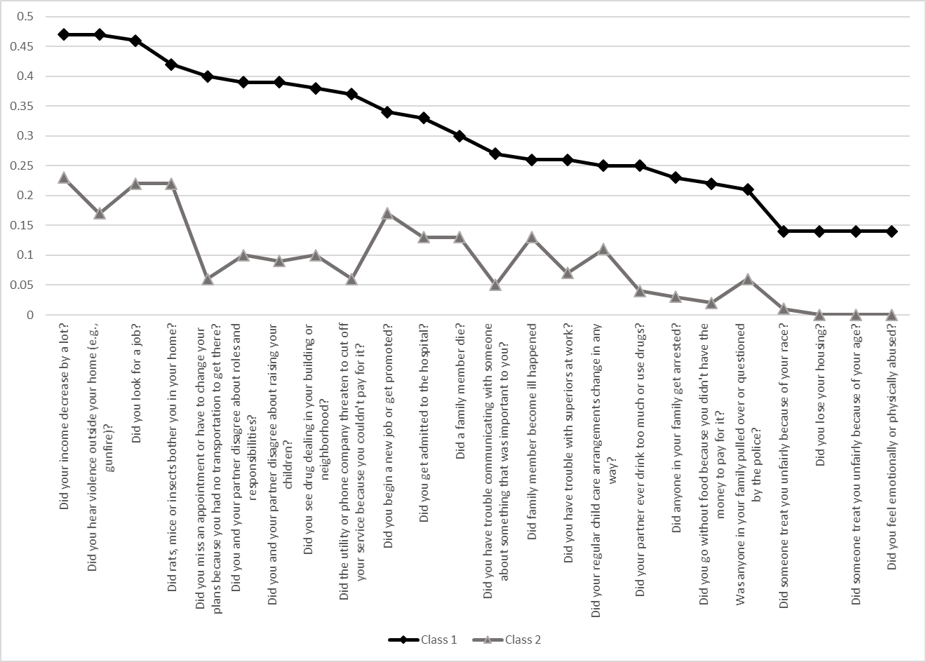
S1 Fig. Expected endorsement probabilities for the CRISYS-RS items chosen from the final latent class model.

