Supplemental Material

Manuscript CUPS-D-21-02775R1
"The Spanish Adaptation of the Relationship Power Inventory"

This file includes:
1. Relationship Power Inventory [Spanish Adaptation of the Relationship Power Inventory (SARPI)]. 2
2. The correlation matrix between items 4
3. Factor Structure of the proposed Models 7
3.1. Fig. 1. Factor Structure of the M1: Original model of four factors (self-process power, self-outcome power, partner-process power, and partner-outcome power) nested into two second-order correlated factors (self-power and partner-power) 7
3.2. Fig. 2. Factor Structure of the M2: Four-factor correlated model (self-process power, self-outcome power, partner-process power, and partner-outcome power) 8
3.3. Fig. 3. Factor Structure of the M3: Two-factor correlated model (self-power and partner-power). 9
4. Factor Structure of the re-specified proposed Models 10
4.1. Fig. 4. Factor Structure of the respecified M1 10
4.2. Fig. 5. Factor Structure of the respecified M2 11
5. Comparation between Model 1 and Model 2 13
5.1. M1 vs M2 13
5.2. M1 vs. respecified M1 13
5.3. M2 vs. respecified M2 13
5.4. Respecified M1 vs. respecified M2 13

Relationship Power Inventory [Spanish Adaptation of the Relationship Power Inventory (SARPI)].

For each statement, rate how true it is of you and your partner generally in your relationship. [Valora con qué frecuencia se ajusta cada afirmación a la relación que mantenéis tu pareja y tu].
Never  Nunca |  |  | Sometimes  A veces |  |  | Always  Siempre
1 | 2 | 3 | 4 | 5 | 6 | 7

1. I am more likely than my partner to start discussions about issues in our relationship. [Es más probable que sea yo quien inicie conversaciones sobre problemas que surgen en nuestra relación de pareja].
2. I have more say than my partner does when we make decisions in our relationship. [Cuando tomamos decisiones en nuestra relación, finalmente mi opinión tiene más peso que la de mi pareja].
3. My partner is more likely to get his/her way than me when we disagree about issues in our relationship. [Es más probable que se decida lo que mi pareja quiere cuando estamos en desacuerdo sobre algunos asuntos de nuestra relación].
4. My partner has more power than me when deciding about issues in our relationship. [Mi pareja tiene más poder que yo cuando decidimos sobre ciertos asuntos de nuestra relación].
5. I have more control over decision making than my partner does in our relationship. [Tengo más control que mi pareja sobre las decisiones en nuestra relación].
6. My partner tends to bring up issues in our relationship more often than I do. [Mi pareja suele exponer los problemas de nuestra relación más a menudo que yo].
7. When my partner and I make decisions in our relationship, I tend to structure and lead the discussion. [Cuando mi pareja y yo estamos tomando decisiones en nuestra relación, yo tiendo a estructurar y liderar la conversación].
8. When we make decisions in our relationship, my partner gets the final say. [Cuando tomamos decisiones en nuestra relación, es mi pareja quien suele tener la última palabra].
9. I have more influence than my partner does on decisions in our relationship. [Tengo más influencia que mi pareja sobre las decisiones en nuestra relación].
10. I tend to bring up issues in our relationship more often than my partner does. [Suelo exponer los problemas de nuestra relación más a menudo que mi pareja].
11. I am more likely than my partner to get my way when we disagree about issues in our relationship. [Es más probable que sea yo quien me salga con la mía cuando mi pareja y yo estamos en desacuerdo sobre ciertos asuntos de nuestra relación].
12. My partner is more likely than me to start discussions about issues in our relationship. [Es más probable que sea mi pareja quien inicie conversaciones sobre ciertos problemas en nuestra relación].
13. I lay out the options more than my partner does when we discuss decisions in our relationship. [Cuando estamos debatiendo decisiones en nuestra relación de pareja, suelo ser yo, más que mi pareja, quien exponga diferentes opciones].
14. When we make decisions in our relationship, I get the final say. [Cuando tomamos decisiones en nuestra relación, yo suelo tener la última palabra].
15. My partner lays out the options more than I do when we discuss decisions in our relationship. [Cuando estamos debatiendo decisiones en nuestra relación, suele ser mi pareja, más que yo, quien exponga posibles opciones].
16. My partner has more say tan I do when we make decisions in our relationship. [Cuando tomamos decisiones en nuestra relación, la opinión de mi pareja tiene más peso que la mía].
17. My partner has more control over decision making than I do in our relationship. [Mi pareja tiene más control sobre las decisiones finales que tomamos en nuestra relación].
18. When my partner and I make decisions in our relationship, my partner tends to structure and lead the discussion. [Cuando mi pareja y yo estamos tomando decisiones en nuestra relación, suele ser mi pareja quien estructure y lidere la conversación].
19. I have more power than my partner when deciding about issues in our relationship. [Cuando decidimos sobre ciertos asuntos de nuestra relación, finalmente tengo más poder que mi pareja].
20. My partner has more influence than I do on decisions in our relationship. [Mi pareja tiene más influencia que yo en las decisiones que se toman en nuestra relación].

The correlation matrix between items

Table 1.
The correlation matrix between items
 | Item 1 | Item 2 | Item 3 | Item 4 | Item 5 | Item 6 | Item 7 | Item 8 | Item 9 | Item 10 | Item 11 | Item 12 | Item 13 | Item 14 | Item 15 | Item 16 | Item 17 | Item 18 | Item 19 | Item 20
Item 1 | _ | .30*** | -.07 | -.11** | .30*** | -.43*** | .45*** | -.08* | .33*** | .62*** | .26*** | -.50*** | .42*** | .27*** | -.22*** | -.12*** | -.14*** | -.32*** | .27*** | -.14***
Item 2 | .29*** | _ | -.02 | -.02 | .56*** | -.10** | .41*** | -.08* | .51*** | .33*** | .57*** | -.13*** | -.34*** | .57*** | -.09* | .07 | -.11** | -.13*** | .50*** | -.08*
Item 3 | -.18*** | -.32*** | _ | .68*** | -.03 | .24*** | -.02 | .50*** | -.06 | -.05 | .16*** | .26*** | .05 | -.11** | .26*** | .52*** | .64*** | .39*** | -.07* | .51***
Item 4 | -.18*** | -.36*** | .63*** | _ | .10** | .29*** | -.01 | .65*** | .02 | -.04 | -.12*** | .27*** | .05 | -.07 | .25*** | .51*** | .51*** | .43*** | .01 | .51***
Item 5 | .32*** | .50*** | -.30*** | -.31*** | _ | -.08* | .45*** | -.05 | .58*** | .39*** | .56*** | -.10** | .38*** | .59*** | -.07 | .04 | -.01 | -.09** | .78*** | .03
Item 6 | .15** | -.14** | .36*** | .38*** | -.12* | _ | -.21*** | .25*** | -.10* | -.43*** | -.15*** | .68*** | -.18*** | -.09* | .41*** | .25*** | .25*** | .51*** | -.09* | .25***
Item 7 | .50*** | .48*** | -.22*** | -.26*** | .53*** | -.08 | _ | -.05 | .49*** | .50*** | .45*** | -.28*** | .55*** | .43*** | -.19*** | -.05 | -.09* | -.25*** | .47*** | -.04
Item 8 | -.24*** | -.28*** | .54*** | .53*** | -.24*** | .41*** | -.24*** | _ | -.05 | -.05 | -.15*** | .30*** | -.01 | -.13*** | .29*** | .55*** | .55*** | .43*** | -.08* | .53***
Item 9 | .32*** | .50*** | -.25*** | -.28*** | .54*** | -.14** | .49*** | -.23*** | _ | .42*** | .50*** | -.14*** | .40*** | .53*** | -.09* | -.02 | -.08* | -.13*** | .59*** | -.03
Item 10 | .28*** | .31*** | -.16*** | -.18*** | .35*** | -.14** | .49*** | -.18*** | .29*** | _ | .42*** | .42*** | .47*** | .35*** | -.21*** | -.08* | -.08* | -.27*** | .37*** | -.07
Item 11 | .35*** | .52*** | -.31*** | -.29*** | .62*** | -.11* | .53*** | -.28*** | .59*** | .38*** | _ | -.13*** | .38*** | .65*** | -.08* | -.14*** | -.16*** | -.13*** | .53*** | -.13***
Item 12 | -.07 | -.24*** | .54*** | .55*** | -.19*** | .60*** | -.05 | .56*** | -.21*** | -.01 | -.17*** | _ | -.21*** | -.09* | .46*** | .29*** | .29*** | .58*** | -.11** | .29***
Item 13 | .52*** | .27*** | -.21*** | -.24*** | .30*** | .05 | .44*** | -.22*** | .29*** | .47*** | .30*** | -.12* | _ | .34*** | -.28*** | .01 | .02 | -.20*** | .38*** | .04
Item 14 | .36*** | .52*** | -.39*** | -.37*** | .57*** | -.13** | .52*** | -.33*** | .53*** | .29*** | .57*** | -.23*** | .35*** | _ | -.06 | -.06 | -.10** | -.10** | .57*** | -.06
Item 15 | -.11* | -.20*** | .33*** | .33*** | -.11*** | .35** | -.04 | .35*** | -.17*** | .14** | -.07 | .58*** | -.04 | -.15** | _ | .32*** | .33*** | .56*** | -.04 | .31***
Item 16 | -.17*** | -.34*** | .59*** | .54*** | -.26*** | .40*** | -.24*** | .58*** | -.28*** | -.17*** | -.28*** | .57*** | -.26*** | -.37*** | .34*** | _ | .57*** | .45*** | .02 | .58***
Item 17 | -.12* | -.31*** | .57*** | .60*** | -.27*** | .43*** | -.23*** | .57*** | -.29*** | -.18*** | -.29*** | .60*** | -.20*** | -.38*** | .35*** | .66*** | _ | .48*** | -.04 | .56***
Item 18 | .08 | -.25*** | .41*** | .41*** | -.18*** | .60*** | -.09 | .44*** | -.24*** | -.01 | -.17*** | .59*** | .15** | -.19*** | .58*** | .44*** | .46*** | _ | -.09* | .50***
Item 19 | .31*** | .51*** | -.35*** | -.35*** | .51*** | -.16*** | .52*** | -.28*** | .53*** | .29*** | .54*** | -.22*** | .32*** | .59*** | -.15** | -.37*** | -.34*** | -.23*** | _ | .02
Item 20 | -.14** | -.31*** | .56*** | .57*** | -.26*** | .44*** | -.19*** | .53*** | -.28*** | -.23*** | -.27*** | .56*** | -.19*** | -.33*** | .35*** | .78*** | .60*** | .47*** | -.32*** | _
Note. Sample 1 (N = 400) correlation matrix items appears under the diagonal; Sample 2 (N = 755) correlation matrix items appears upper the diagonal.
*p < .05; **p < .01***p < .001

3. Factor Structure of the proposed Models

3.1. Fig. 1. Factor Structure of the M1: Original model of four factors (self-process power, self-outcome power, partner-process power, and partner-outcome power) nested into two second-order correlated factors (self-power and partner-power)
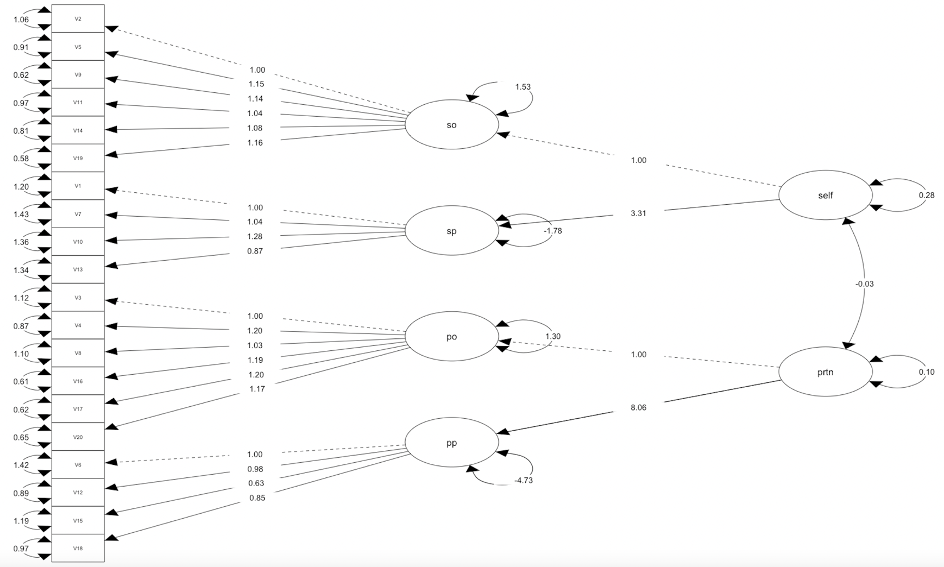

Note. so = self-outcome power; sp = self-process power; po = partner-outcome power; pp = partner-process power; Self = self-power; prtn = partner-power

3.2. Fig. 2. Factor Structure of the M2: Four-factor correlated model (self-process power, self-outcome power, partner-process power, and partner-outcome power)
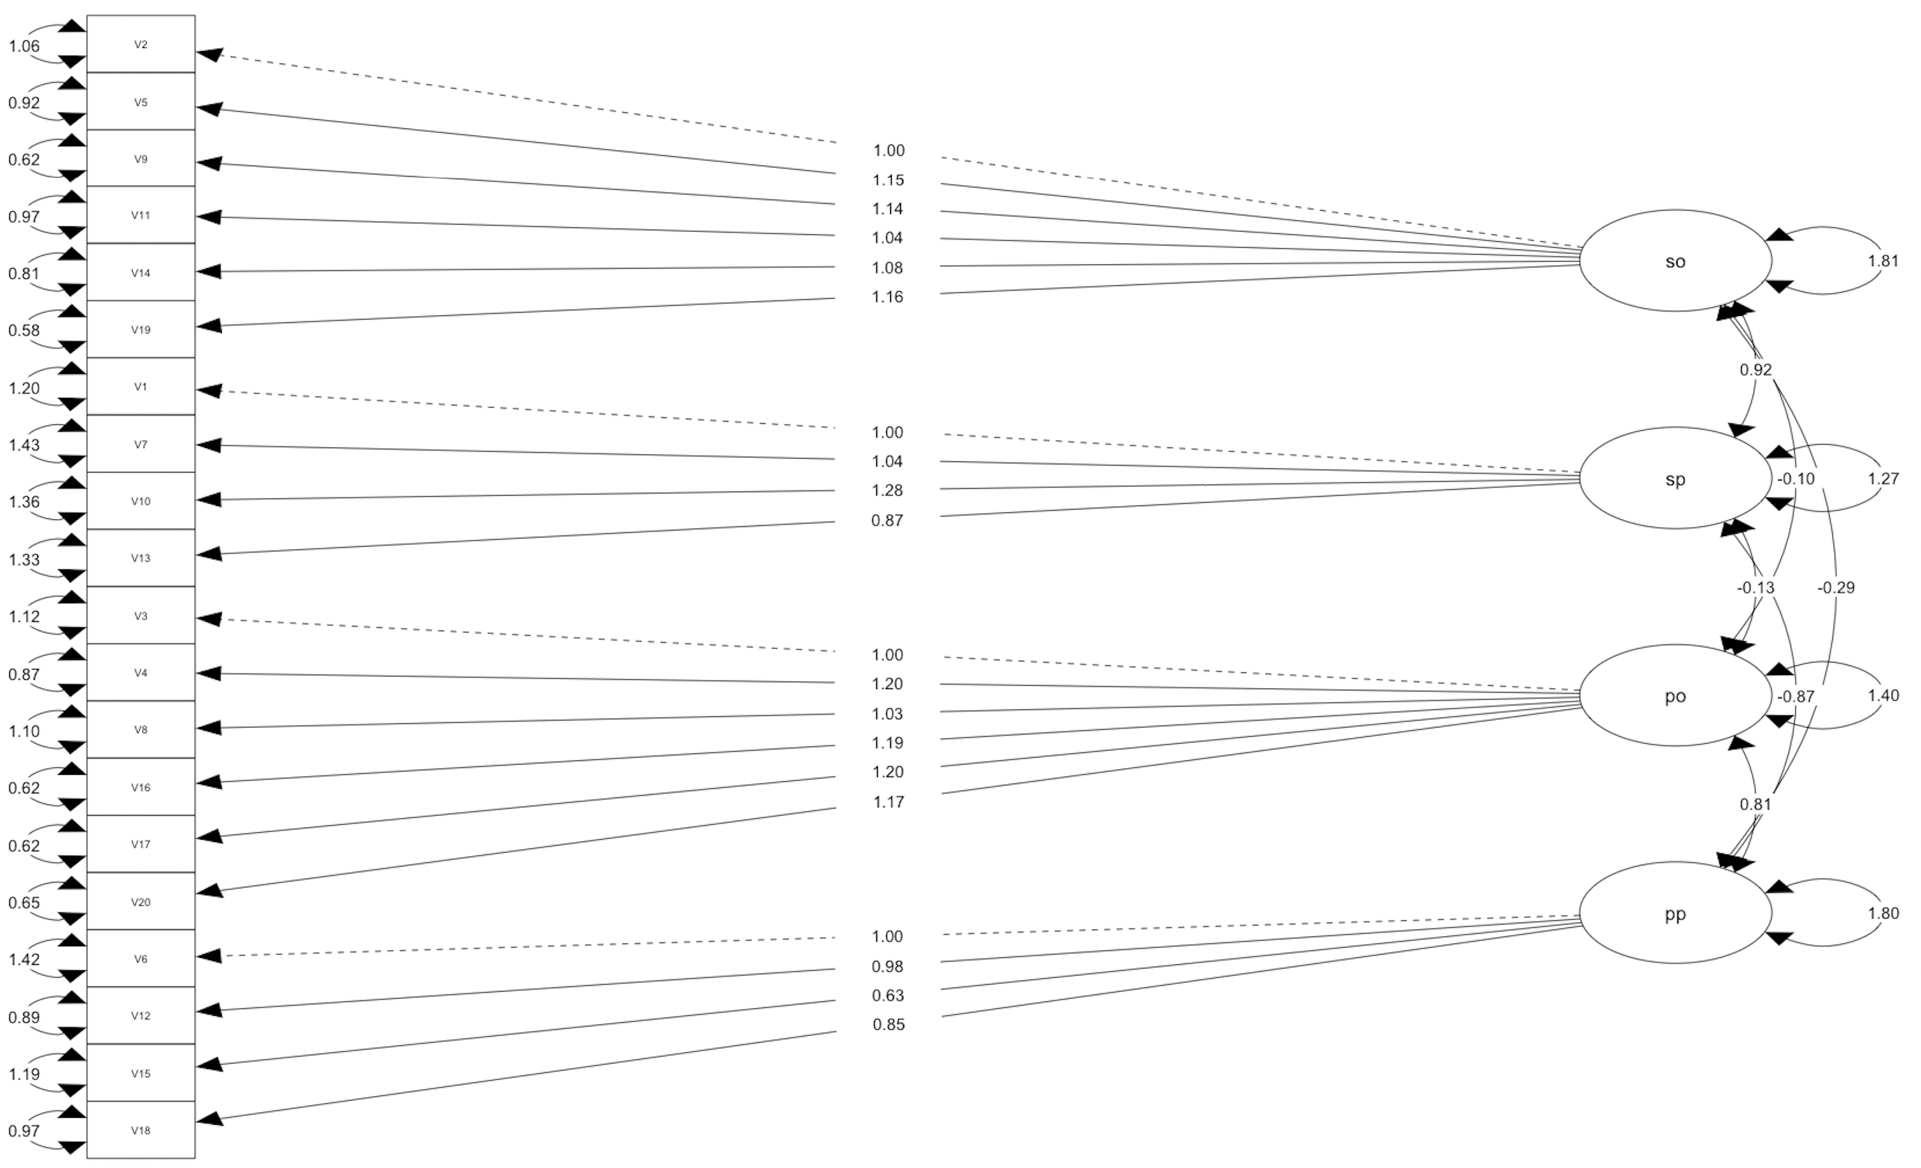

Note. so = self-outcome power; sp = self-process power; po = partner-outcome power; pp = partner-process power

3.3. Fig. 3. Factor Structure of the M3: Two-factor correlated model (self-power and partner-power).
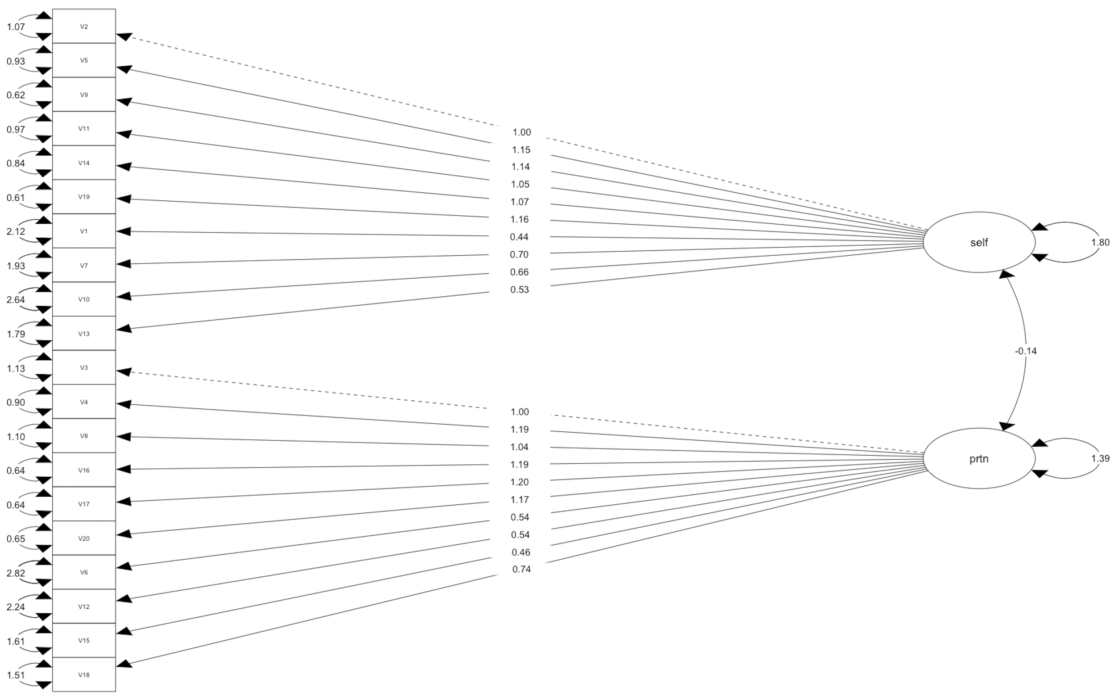

Note. Self = self-power; prtn = partner-power

4. Factor Structure of the re-specified proposed Models

4.1. Fig. 4. Factor Structure of the respecified M1
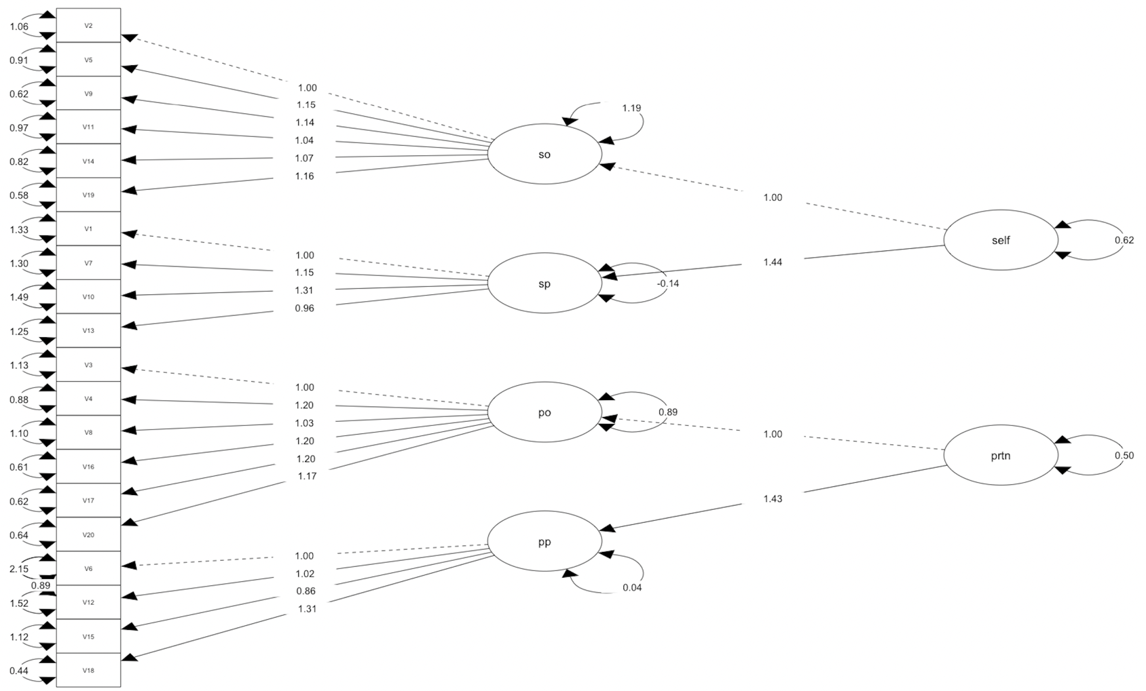

Note: M1 was recalculated by removing nonsignificant correlations between self and partner first order factor that were not related (r = -.03, p = .19) and introducing correlations between the measurement error of items 6 and 12 (because they have redundant context and high MI= 61.43). so = self-outcome power; sp = self-process power; po = partner-outcome power; pp = partner-process power; self = self-power; prtn = partner-power. The final fit was: χ2(165) = 705.550, p < .001, CFI = .93, TLI = .92, RMSEA = .066, 90% CI [.06, .07], SRMR = .10.

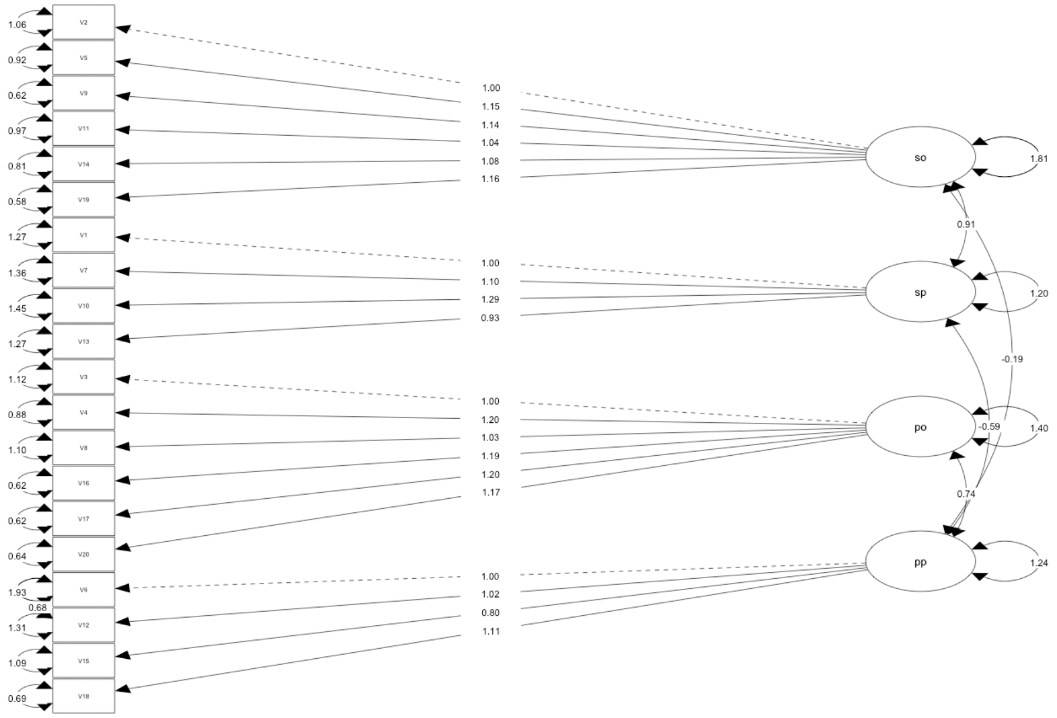
4.2. Fig. 5. Factor Structure of the respecified M2

Note: M2 was recalculated by removing nonsignificant correlations between self and partner first order factor that were not related: self-outcome and partner-outcome (r = -.10, p = .18), self-process and partner-outcome r = -.13, p = .06), and introducing correlations between the measurement error of items 6 and 12 (because they have redundant context and high MI= 61.43). so = self-outcome power; sp = self-process power; po = partner-outcome power; pp = partner-process power. The final fit was: χ2(165) = 586.34, p < .001, CFI = .95, TLI = .94, RMSEA = .058, 90% CI [.05, .06], SRMR = .06.
.

5. Comparation between Model 1 and Model 2

Model 1 as well as model 2 showed an acceptable fit. Moreover, the differences in the goodness-of-fit indices between them are very small. Therefore, likelihood ratio tests were performed to compare the models’ fit.

5.1. M1 vs M2
We found a significantly better fit of Model 2 in comparison to Model 1 (χ2 = 14.90, df = 46, p = .001).

5.2. M1 vs. respecified M1
We found a significantly better fit of respecified M1 in comparison to M1 (χ2 = 98.99, df = 45, p < .001).

5.3. M2 vs. respecified M2
We found a significantly better fit of respecified M2 in comparison to M2 (χ2 = 77.89, df = 45, p < .001).

5.4. Respecified M1 vs. respecified M2
We found a significantly better fit of respecified M2 in comparison to respecified M1 (χ2 = 169.31, df = 45, p < .001).

Based on the aforementioned results, respecified M2 was supported as the latent factorial structure of the SARPI.

