Supplement
This is the supplementary information for the article:
Wessels, M., Zähme, C., & Oberfeld, D. Auditory information improves time-to-collision estimation for accelerating vehicles. Curr Psychol. https://doi.org/10.1007/s12144-022-03375-6

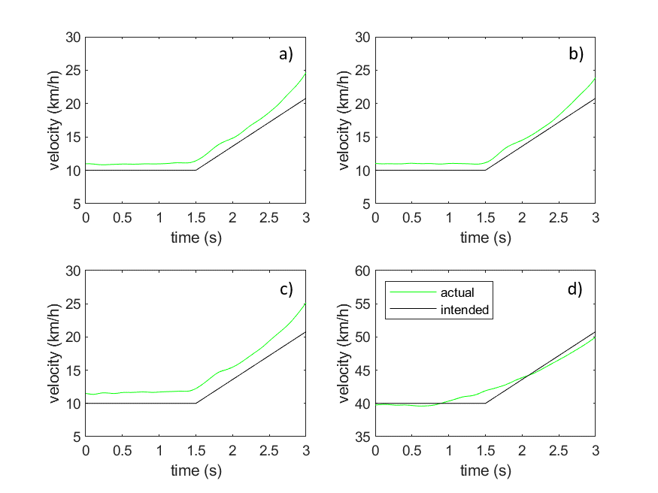
Fig. S1
Velocity profiles of the presented accelerating vehicle approaches. The actual (green line) and the intended velocity (black line) are shown over the time course of a trial. Each panel a)-d) corresponds to one of the four acoustic recordings of the accelerating vehicle.

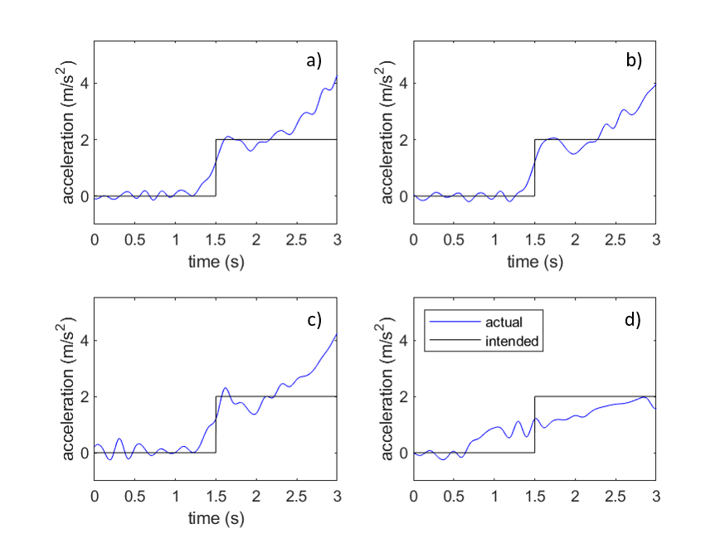
Fig. S2
Acceleration profiles of the presented accelerating vehicle approaches. The actual (blue line) and the intended acceleration (black line) are shown over the time course of a trial. Each panel a)-d) corresponds to one of the four acoustic recordings of the accelerating vehicle.

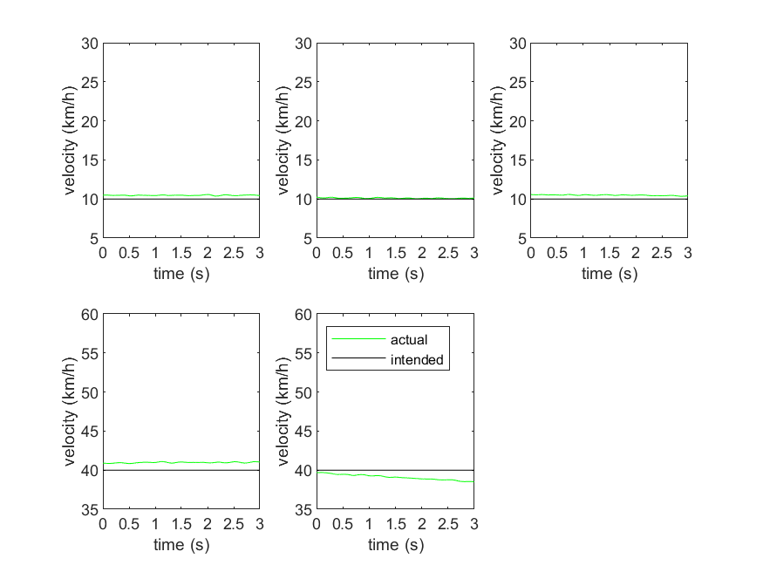
Fig. S3
Velocity profiles of the presented constant velocity vehicle approaches. The actual (green line) and the intended velocity (black line) are shown over the time course of a trial. Each panel corresponds to one of the five acoustic recordings of the vehicle at a constant velocity.

