Supplementary Information
ANOVA Results of Mental Health and Emotion Regulation Outcomes across Self-Compassion Profiles for Female and Male Adolescents (95% confidence intervals).
 | Females | Males
Anxiety Symptoms (SCAS) | 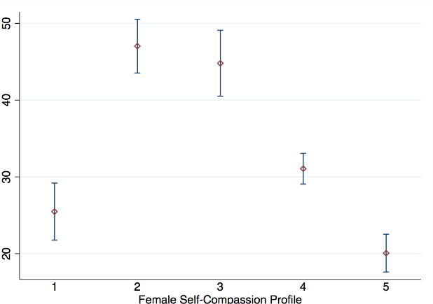 | 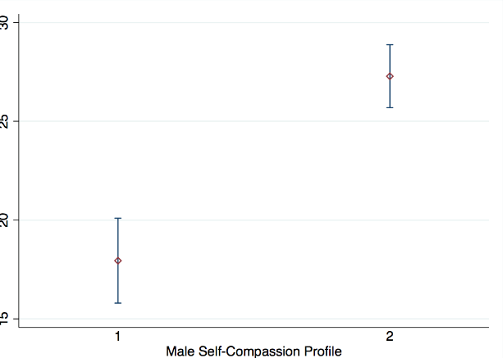
Depression symptoms (SMFQ) | 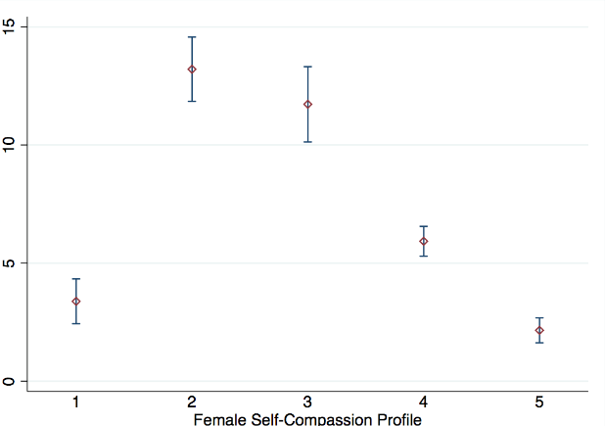 | 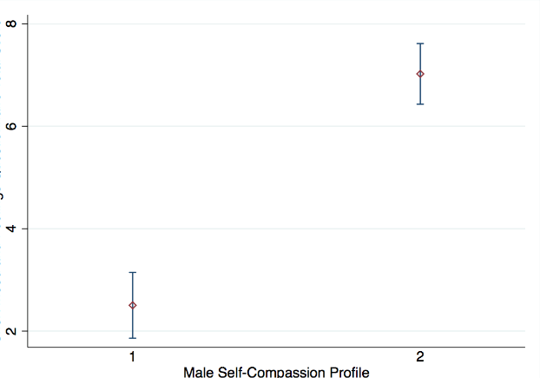
Social Perfectionism (CATS) | 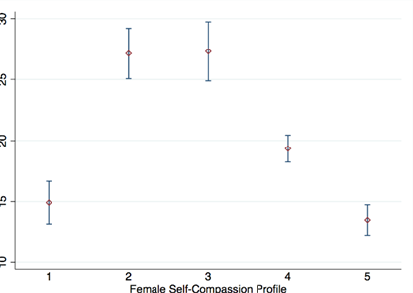 | 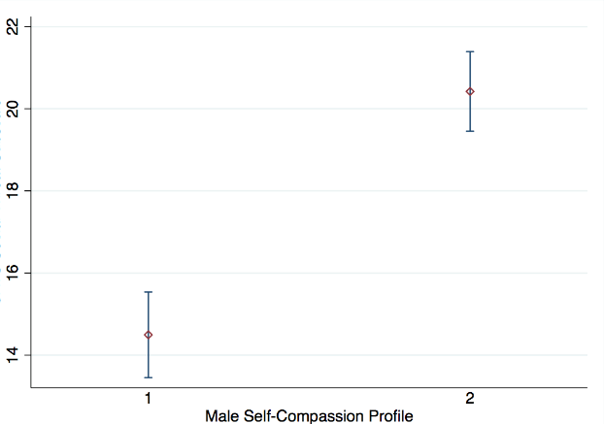
Personal Perfectionism (CATS) | 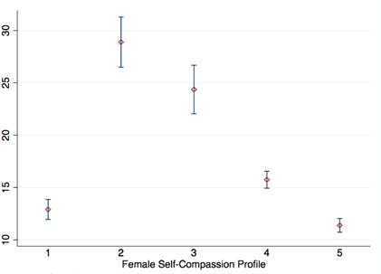 | 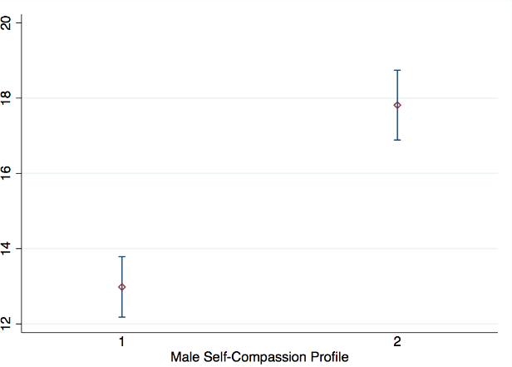
Distress Disclosure (DDI) | 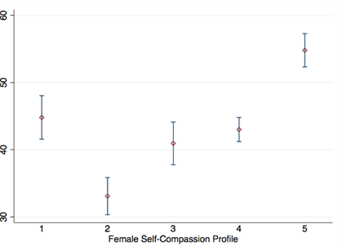 | 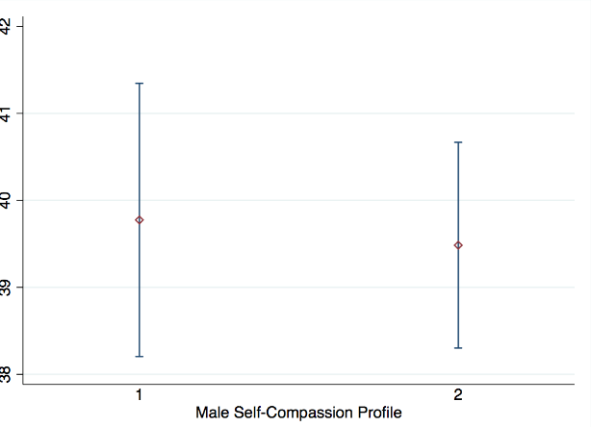
Intolerance of Uncertainty (IUS) | 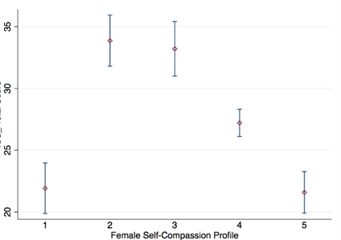 | 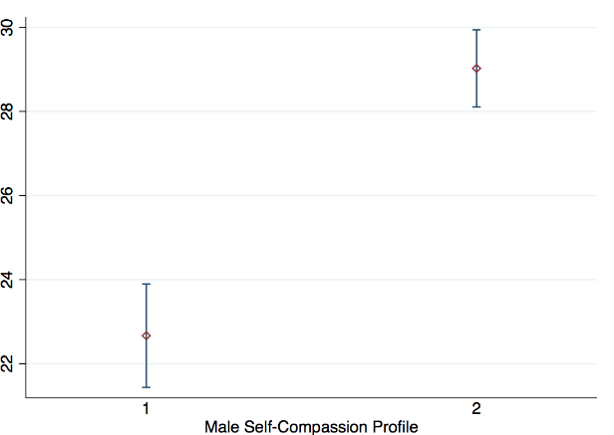
Repetitive Thinking (RTQ) | 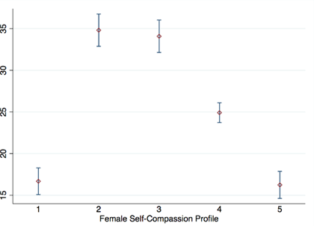 | 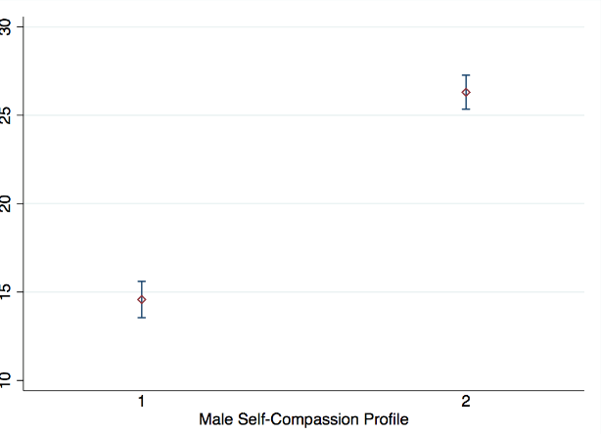
Avoidance & Fusion (AFQ) | 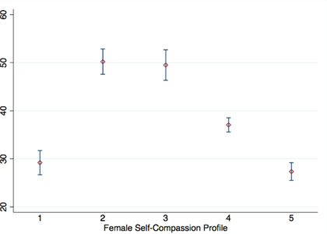 | 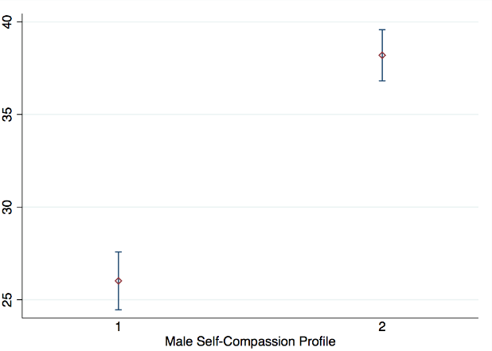

Note. Females. F1 = Low Self-Relating profile; F2 = Uncompassionate profile; F3 = High Self-Relating profile; F4 = Moderately Compassionate profile; F5 = Highly Compassionate profile.
Males. M1 = Low Self-Relating profile; M2 = Moderate Self-Relating profile.

