Supplemental Material

Figure 1
Line Plot of Trimmed Means Split by Joke for Straight Condition

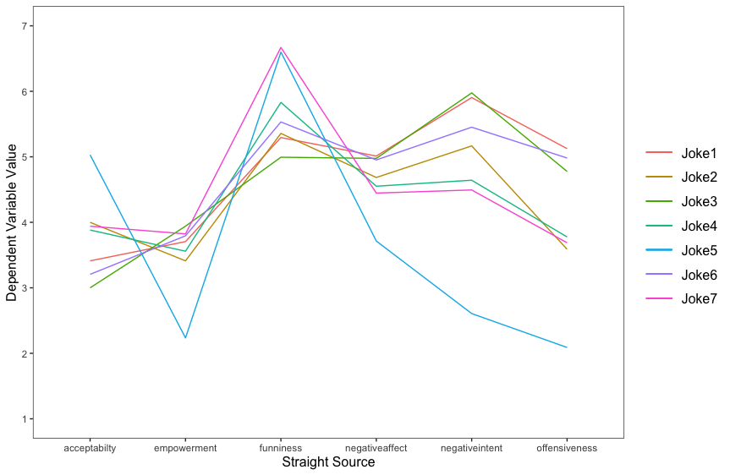

Figure 2
Line Plot of Trimmed Means Split by Joke for Gay Condition

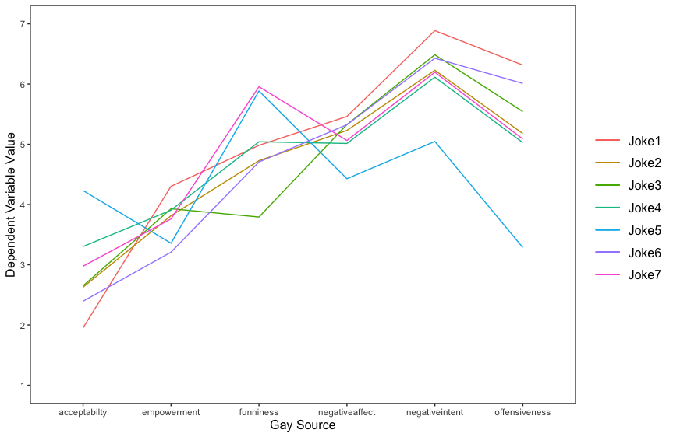

Table 1
Robust Independent Samples (Yuen’s) T-Tests for all Dependent Variables in Study 1 by Joke

Joke | Dependent Variable | t | df | p | ξ
1 | Negative Intent | 3.72 | 28.9 | .001 | .60
 | Negative Affect | 2.10 | 45.3 | .042 | .37
 | Offensiveness | 2.99 | 44 | .005 | .50
 | Funniness | .670 | 59.6 | .506 | .11
 | Empowerment | 1.33 | 57.9 | .188 | .21
 | Acceptability | 3.42 | 38.4 | .001 | .57
2 | Negative Intent | 2.81 | 40.4 | .008 | .46
 | Negative Affect | 2.01 | 42.1 | .051 | .35
 | Offensiveness | 3.45 | 54.6 | .001 | .49
 | Funniness | 1.53 | 60.3 | .131 | .23
 | Empowerment | 1.00 | 47.2 | .321 | .16
 | Acceptability | 3.25 | 51.4 | .002 | .48
3 | Negative Intent | 1.46 | 47.5 | .151 | .25
 | Negative Affect | 1.38 | 51.1 | .173 | .22
 | Offensiveness | 1.37 | 51.3 | .177 | .23
 | Funniness | 2.63 | 52.4 | .011 | .41
 | Empowerment | .08 | 53.8 | .939 | .04
 | Acceptability | .53 | 49.6 | .601 | .09
4 | Negative Intent | 3.40 | 41.3 | .002 | .53
 | Negative Affect | 1.867 | 44.6 | .068 | .28
 | Offensiveness | 2.230 | 50.7 | .030 | .37
 | Funniness | 1.901 | 60.2 | .062 | .30
 | Empowerment | .671 | 58.9 | .505 | .12
 | Acceptability | 1.07 | 52.1 | .289 | .18
5 | Negative Intent | 5.54 | 59.1 | .001 | .71
 | Negative Affect | 2.30 | 55.1 | .025 | .35
 | Offensiveness | 2.40 | .61 | .020 | .38
 | Funniness | 2.00 | 58.2 | .050 | .30
 | Empowerment | 2.63 | 60.0 | .011 | .44
 | Acceptability | 1.60 | 58.6 | .116 | .26
6 | Negative Intent | 2.82 | 37.9 | .008 | .46
 | Negative Affect | 1.54 | 42.6 | .131 | .30
 | Offensiveness | 2.18 | 46.7 | .034 | .34
 | Funniness | 1.59 | 54.5 | .119 | .26
 | Empowerment | 1.25 | 51.1 | .217 | .20
 | Acceptability | 1.68 | 48.8 | .099 | .30
7 | Negative Intent | 4.45 | 42.3 | .001 | .64
 | Negative Affect | 2.357 | 52.4 | .022 | .37
 | Offensiveness | 2.46 | 56.3 | .017 | .38
 | Funniness | 2.198 | 53.8 | .032 | .34
 | Empowerment | .146 | 55.6 | .884 | .04
 | Acceptability | 2.527 | 53.6 | .014 | .37
Note. Tests were conducted using .1 as the trim proportion.

Table 2
Correlational Matrix of Dependent Variables in Study 2
 | offense | funny | naffect | nintent | empower | morality | acceptable | Social emotions
funny | -0.438*** | —
naffect | 0.714*** | -0.562*** | —
nintent | 0.631*** | -0.276*** | 0.612*** | —
empower | 0.135* | 0.139* | 0.130* | 0.065 | —
morality | -0.534*** | 0.426*** | -0.541*** | -0.450*** | 0.048 | —
acceptable | -0.691*** | 0.514*** | -0.639*** | -0.582*** | 0.073 | 0.631*** | —
social emotions | 0.483*** | -0.118* | 0.416*** | 0.629*** | 0.018 | -0.246*** | -0.373*** | —
CAD | 0.733*** | -0.351*** | 0.663*** | 0.729*** | 0.100 | -0.495*** | -0.648*** | 0.611***
Note. p < .05. **p < .01. ***p < .001.
Table 3
Correlational Matrix Study 3
 | offense | funny | naffect | nintent | morality | acceptable | Social emotions
funny | -0.443*** | —
naffect | 0.691*** | -0.477*** | —
nintent | 0.304*** | -0.204** | 0.313*** | —
morality | -0.601*** | 0.363*** | -0.454*** | -0.155* | —
acceptable | -0.701*** | 0.516*** | -0.515*** | -0.233*** | 0.641*** | —
social emotions | 0.152* | -0.028 | 0.063 | 0.120 | -0.162* | -0.058 | —
CAD | 0.705*** | -0.435*** | 0.629*** | 0.629*** | 0.523*** | -0.563*** | 0.159*
Note. *p < .05. **p < .01. ***p < .001.

