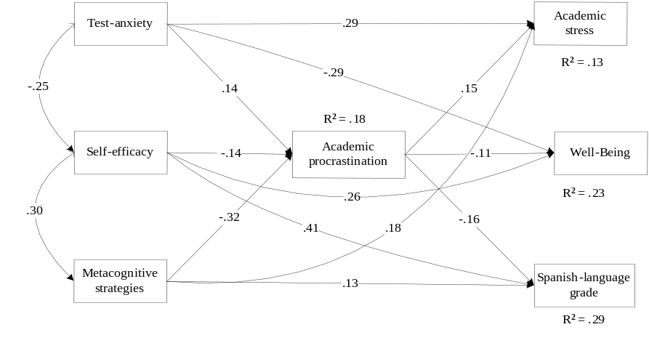
Fig 4.a. Standardized parameter estimates for Spanish language

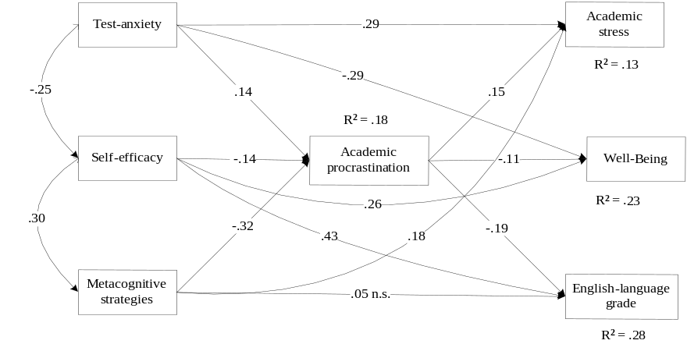
Figure 4.b. Standardized parameter estimates for English language

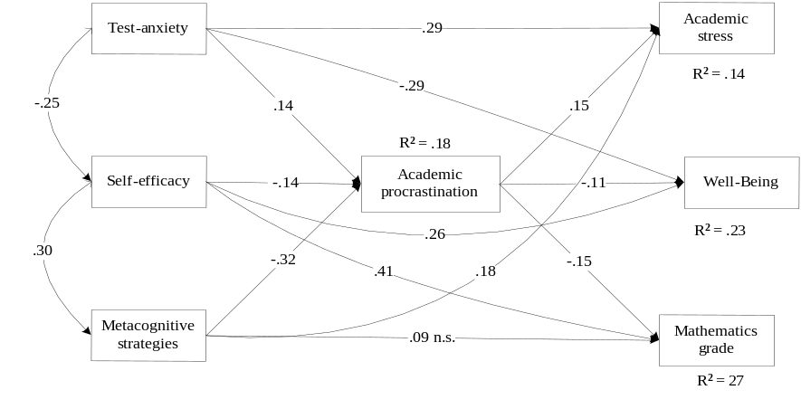
Figure 4.c. Standardized parameter estimates for Mathematics

Fig 4. Standardized parameter estimates in the model for CSE subjects: Spanish language, English language, and Mathematics (Note: all parameters are statistically significant -p <.05-, except where otherwise noted -not significant, n.s.-)

