Supplemental information

Supplemental Methods. The procedures of the 2-AFC tests before Experiments 1 and 2
Fig. S1 (related to Fig. 2). Results of Horizontal- and Vertical-real Objects
Fig. S2 (related to Fig. 3). Results of Horizontal- and Vertical-illusory Objects

Supplemental Methods
Before each experiment, we checked the effectiveness of the awareness manipulation by a 2-AFC test. The stimuli and procedure in the 2-AFC test were the same as those in Experiments 1 and 2, except that, participants were asked to judge the opening orientation of the present UOs: leftward or rightward for the horizontal-UOs block; upward or downward for the vertical-UOs block (Fig. 1A). For each participant, the average luminance of masks in the visible condition (0.005 cd/m²) was constant, while the luminance of masks rendering UO invisible to each participant was determined in a criterion-free way, with correction according to each participant’s individual behavioral performance and oral report. Specifically, we set the average luminance of masks in invisible condition for each participant as 5.328 cd/m² (a low value to ensure every participant can see the UO) at the beginning and instructed participants to report to the experimenter if they could clearly see the orientation of UOs with 3 consecutive trials. Then, we gradually increased the luminance of masks until participants were unable to report the direction of UOs verbally and participants’ behavioral performances reached an accuracy rate of ~ 60% at that time. At last, the luminance of masks was increased on a smaller scale until participants’ behavioral performances reach ~50%. In this way, the customized luminance of masks for each participant was determined and the luminance of masks in the invisible condition (mean± standard error of the mean [SEM]) were as follows: horizontal-UOs in Experiment 1: 13.225±0.205 cd/m²; vertical-UOs in Experiment 1: 12.298±0.240 cd/m²; horizontal-UOs in Experiment 2: 9.637±0.260 cd/m²; vertical-UOs in Experiment 2:9.885±0.222 cd/m² .
For each participant and each experiment, after determining the customized luminance of masks, they needed perform other 3 blocks of each condition (visible-horizontal UOs, invisible-horizontal UOs, visible-vertical UOs, and the invisible-vertical UOs) to further check the effectiveness of the awareness manipulation. Results showed that, in the invisible condition, participants’ performances were not statistically different from chance (mean percent correct ± standard error of the mean [SEM], Experiment 1: 49.232 ± 0.597%, t(19) = -1.286, p = 0.214, Cohen’s d = 0.288; Experiment 2：50.195 ± 0.326%, t(19) = 0.600, p = 0.556, Cohen’s d = 0.134), confirming that the UOs were invisible; in the visible condition, by contrast, their performances were more accurate (Experiment 1: 98.151 ± 0.384%; Experiment 2: 95.178 ± 0.676%), indicating that our awareness manipulation was effective for both visible and invisible conditions.

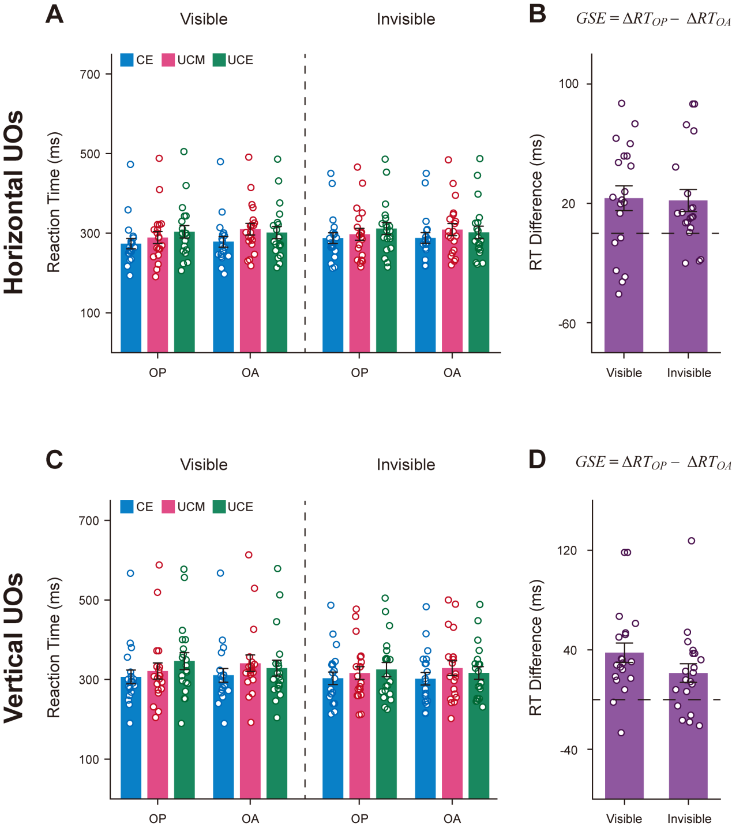
Fig. S1 Results of Horizontal- and Vertical-real Objects. Mean RTs in horizontal (A) and vertical (C) sessions are shown for CE, UCM, and UCE in the OP and OA trials for visible (left) and invisible (right) conditions. The gradual spread effect (GSE) for visible and invisible conditions in horizontal (B) and vertical (D) sessions. Results showed that the GSEs were significantly greater than zero in both the visible (the horizontal session: t(19) = 2.823, p = 0.011, Cohen’s d = 0.631; the vertical session: t(19) = 4.788, p < 0.001, Cohen’s d = 1.071) and invisible (the horizontal session: t(19) = 2.994, p = 0.007, Cohen’s d = 0.669; the vertical session: t(19) = 2.858, p = 0.010, Cohen’s d = 0.639) conditions. These results indicated the same qualitative conclusion between the horizontal and vertical UOs, suggesting that our awareness-independent gradual spread of object-based attention in Experiment 1 couldn’t be derived by the hemifield difference between the uncued-middle and uncued-end targets, relative to the cue. Error bars denote 1 SEM calculated across participants.

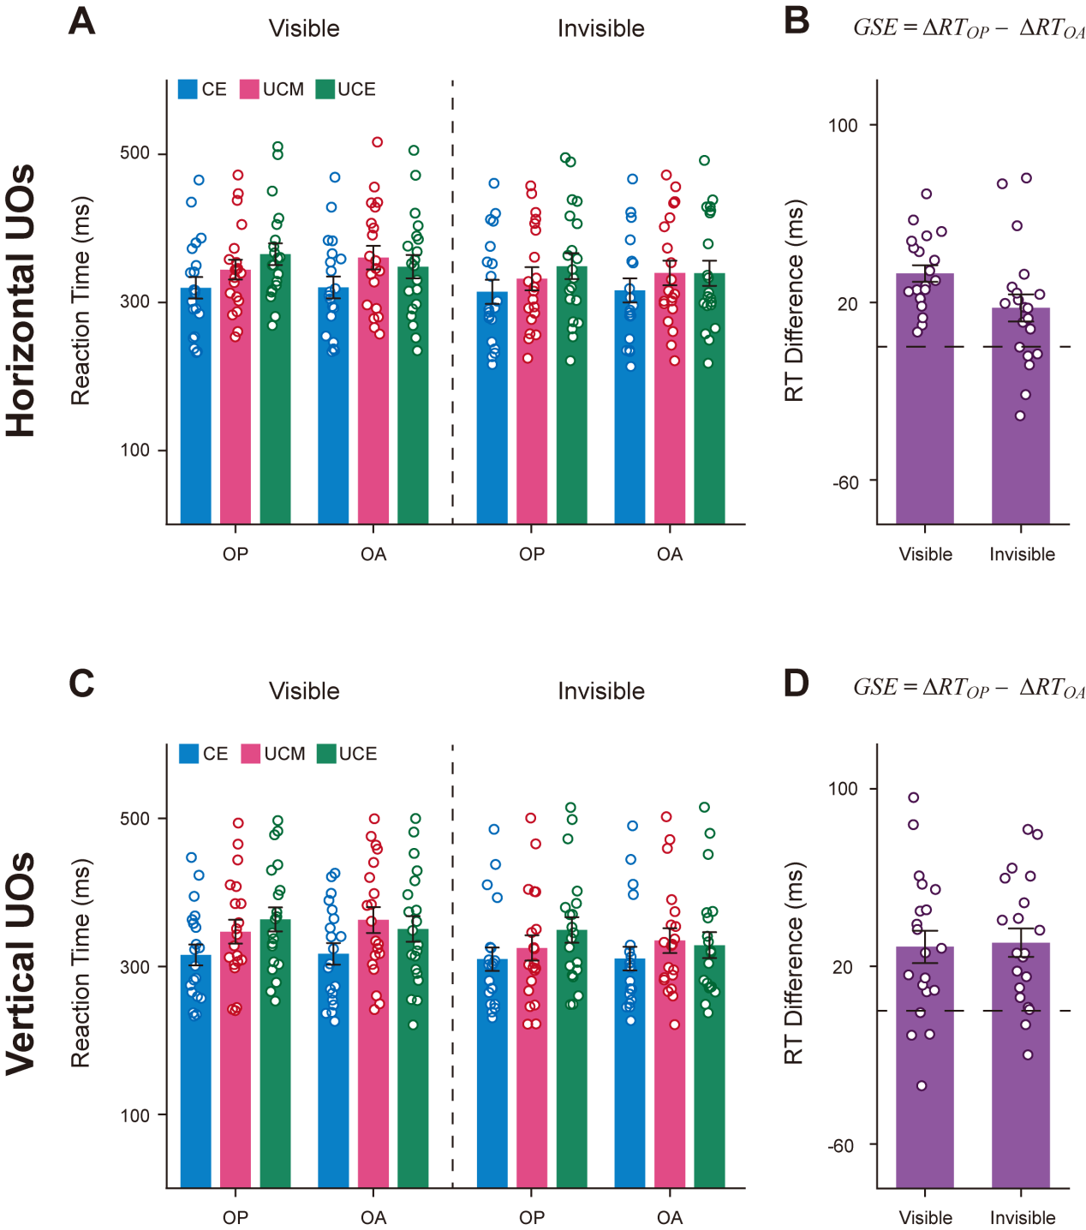
Fig. S2 Results of Horizontal- and Vertical-illusory Objects. Mean RTs in horizontal (A) and vertical (C) sessions are shown for CE, UCM, and UCE in the OP and OA trials for visible (left) and invisible (right) conditions. The gradual spread effect (GSE) for visible and invisible conditions in horizontal (B) and vertical (D) sessions. Results showed that the GSEs were significantly greater than zero in both the visible (the horizontal session: t(19) = 8.821, p < 0.001, Cohen’s d = 1.972; the vertical session: t(19) = 3.956, p = 0.001, Cohen’s d = 0.885) and invisible (the horizontal session: t(19) = 2.856, p = 0.010, Cohen’s d = 0.639; the vertical session: t(19) = 4.787, p < 0.001, Cohen’s d = 1.070) conditions. These results indicated the same qualitative conclusion between the horizontal and vertical UOs, suggesting that our awareness-independent gradual spread of object-based attention in Experiment 2 also couldn’t be derived by the hemifield difference between the uncued-middle and uncued-end targets, relative to the cue. Error bars denote 1 SEM calculated across participants.

