Supplementary Material
Mapping bridges between anxiety, depression, and somatic symptoms in primary care patients: a network perspective

Current Psychology

Content
1. Figure S1. Edge-weight accuracy for estimated parameters.
2. Figure S2. Average Correlations Between Centrality Indices (i.e., Expected Influence and Bridge Expected Influence).
3. Figure S3. Bootstrapped Difference Tests Between the Expected Influence of Nodes
4. Figure S4. Bootstrapped Difference Tests Between the Bridge Expected Influence of Nodes.
5. Figure S5. Network structure with communities and bridge symptoms

Figure S1.
Edge-weight accuracy for estimated parameters
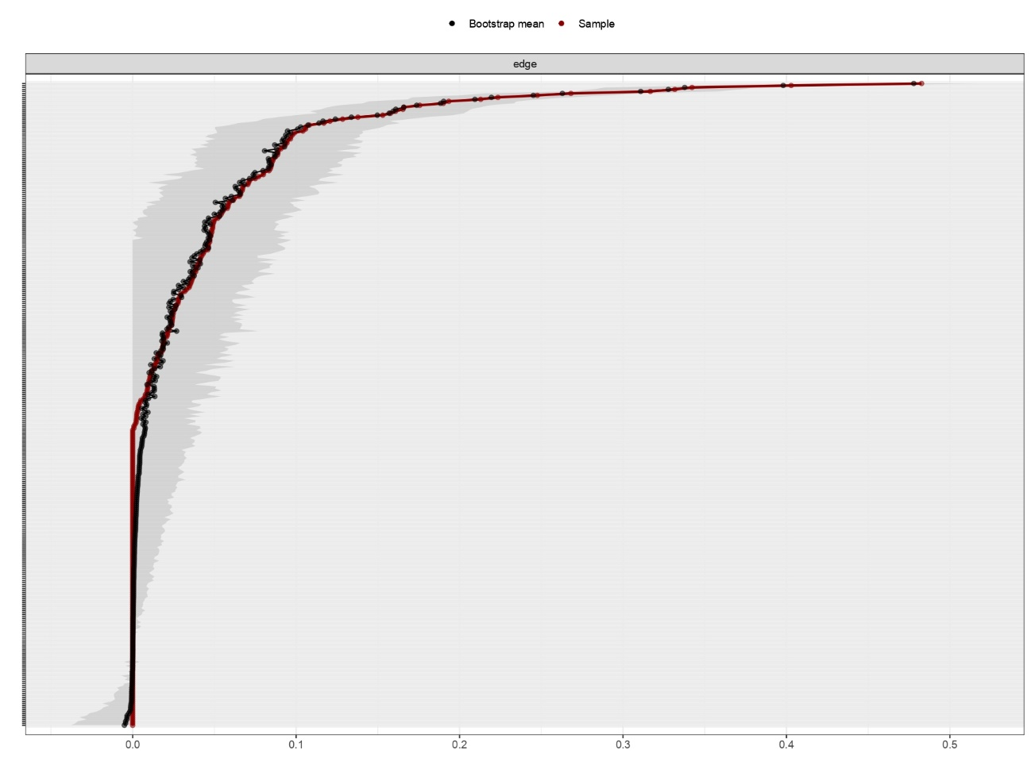
Note. The red line indicates the edge weight for the true data, ordered by the mean of the bootstrapped samples (the grey line). Results show that the original sample edge weights lie in the bootstrapped Cis. Accordingly, we can consider the estimated parameters to be reliable (Epskamp et al., 2018).

Figure S2.
Average Correlations Between Centrality Indices (i.e., Expected Influence and Bridge Expected Influence)
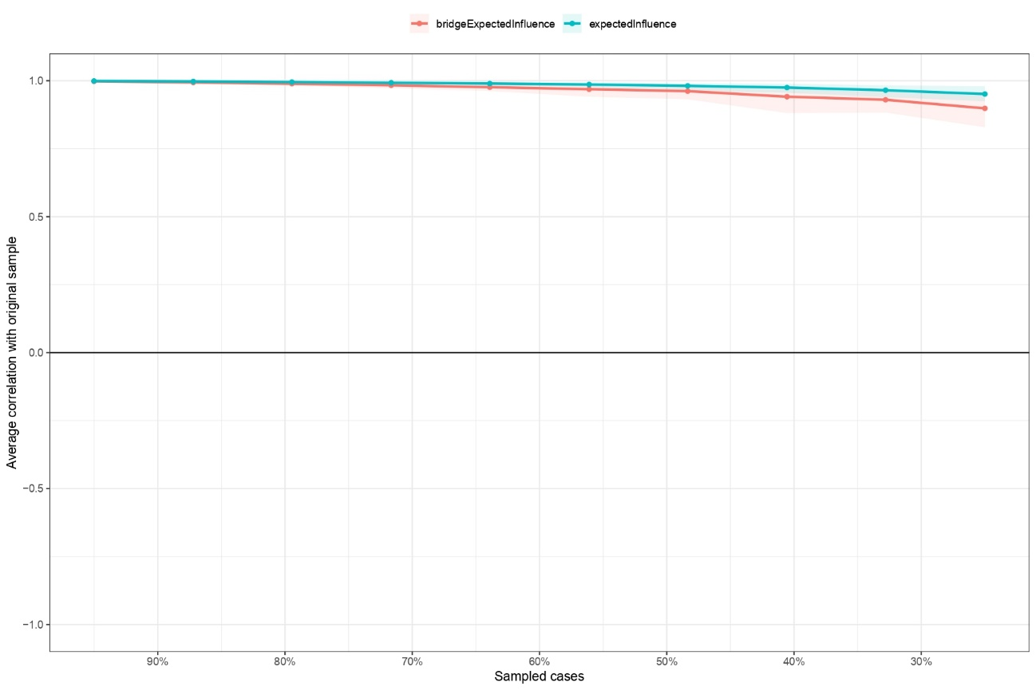
Note. The results of centrality stability analysis revealed that the CS-coefficient for expected influence was (CS (cor = 0.7) = 0.75) while for the bridge expected influence was (CS (cor = 0.7) = 0.75). Thus, stability analysis for centrality indexes revealed both metrics to be stable after sub-setting cases.

Figure S3
Bootstrapped Difference Tests Between the Expected Influence of Nodes

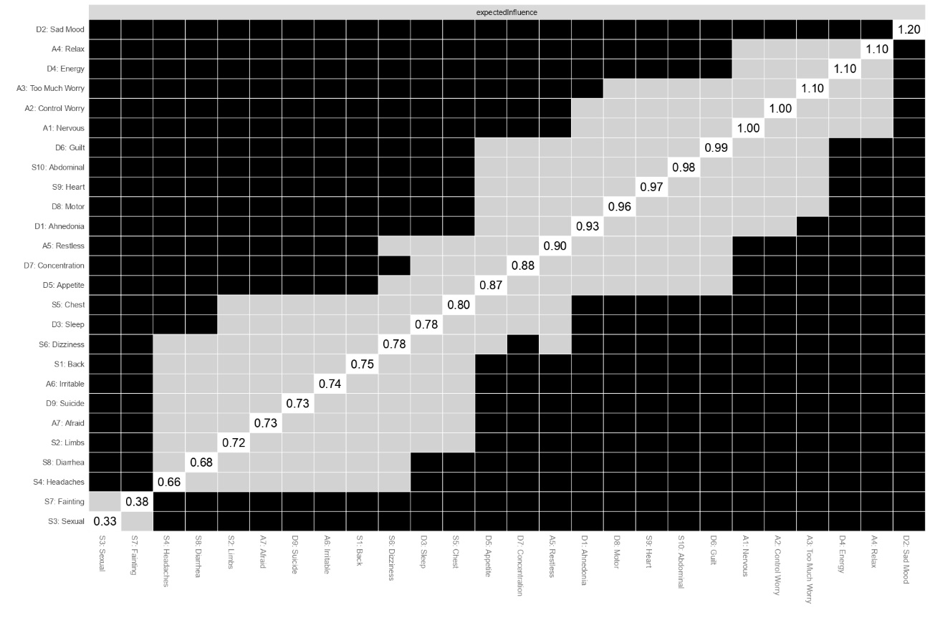
Note. Black boxes denote edges that significantly differ from one another, while gray boxes indicate edges that do not.

Figure S4
Bootstrapped Difference Tests Between the Bridge Expected Influence of Nodes

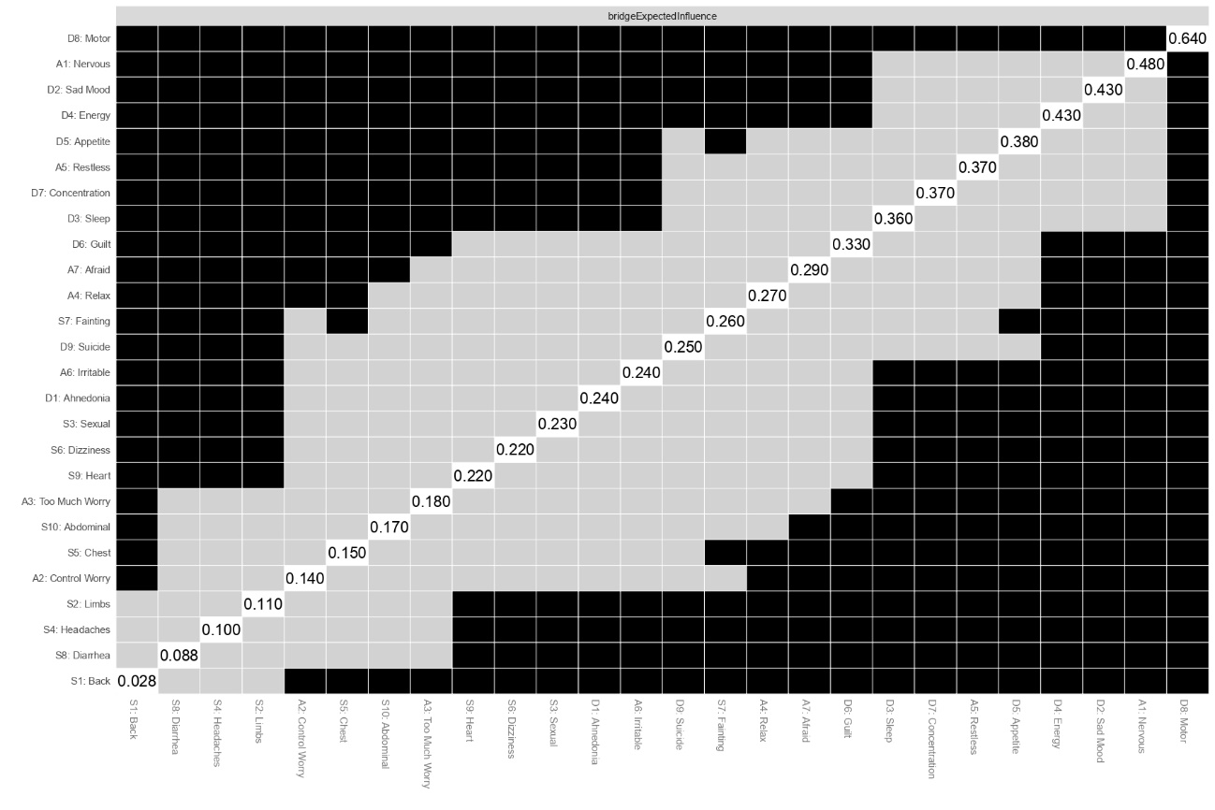
Note. Black boxes denote edges that significantly differ from one another, while gray boxes indicate edges that do not.

Figure S5
Network structure with communities and bridge symptoms

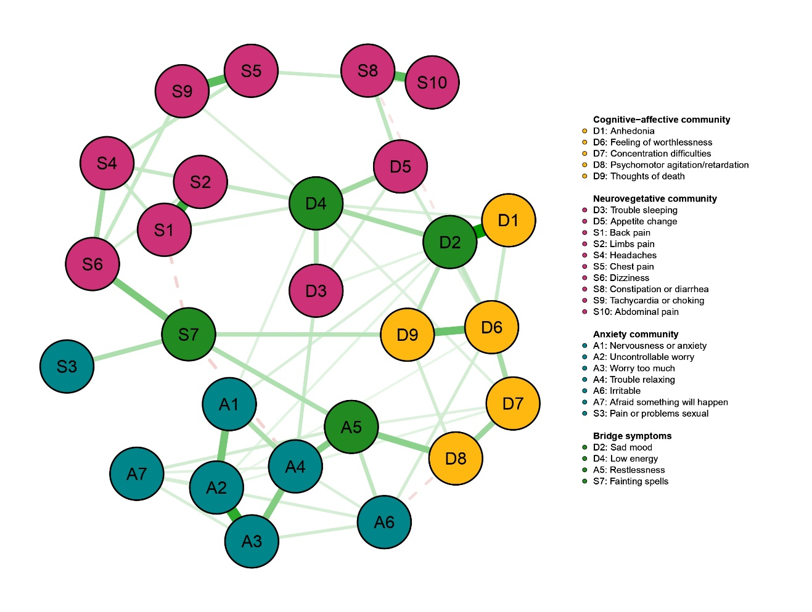
Note. Nodes are coloured according to the clusters derived from the communities analysis and bridge symptoms analysis. Green edges represent positive regularized partial correlations. Red edges negative regularized partial correlations.

References
Costenbader, E., & Valente, T. W. (2003). The stability of centrality measures when networks are sampled. Social Networks, 25(4), 283–307. https://doi.org/10.1016/S0378-8733(03)00012-1
Epskamp, S., Borsboom, D. & Fried, E.I. (2018). Estimating psychological networks and their accuracy: A tutorial paper. Behav Res 50, 195–212. https://doi.org/10.3758/s13428-017-0862-1

