Supplementary Material
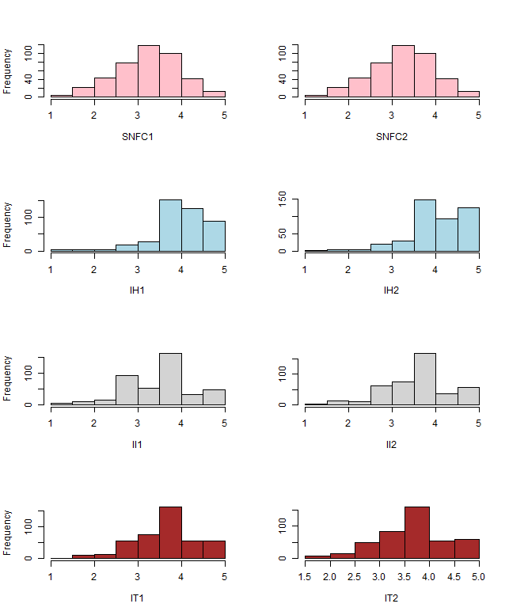
Figure A1. Histograms of the four intellectual virtue scales at timepoint 1 (pretest) and 2 (posttest).
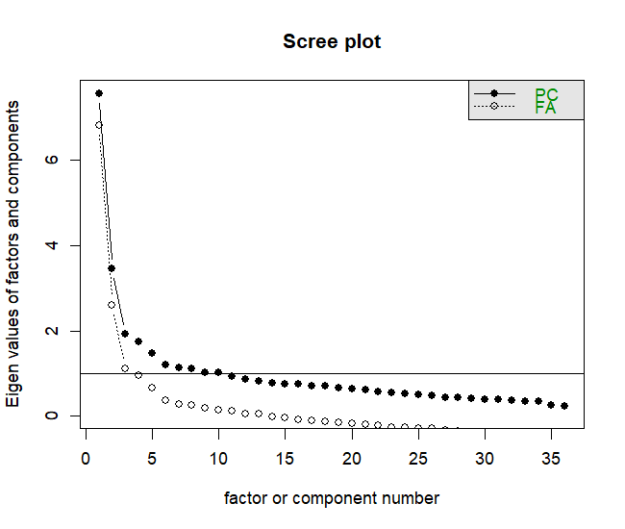
Figure A2. Scree plot for the full (36) time 1 intellectual virtue items.

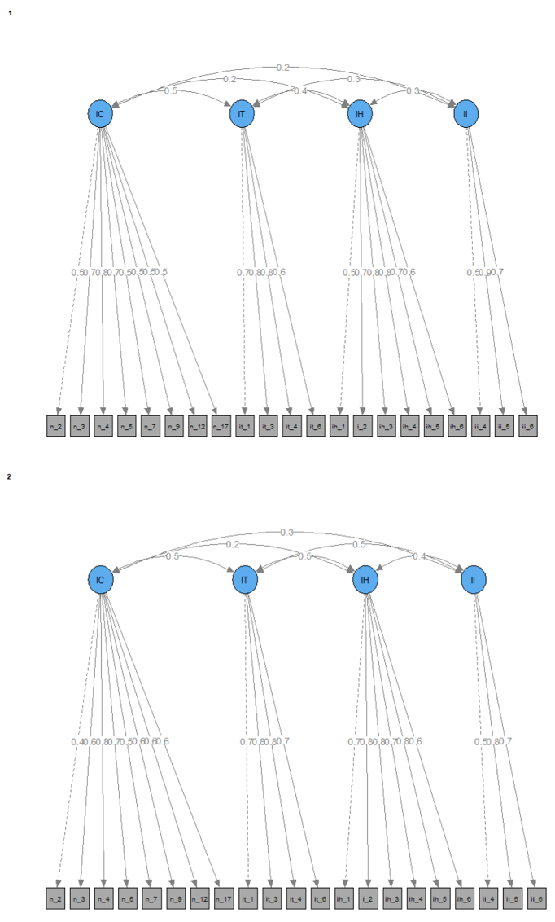

Figure A3. Loadings for virtue factors at both time points

Table A2. Model fit for Besser's Learning Index
 | χ² | df | p | CFI | TLI | SRMR | RMSEA (Lower) | RMSEA | RMSEA (Upper) | AIC | BIC
1 BVL Factor, no CU | 67.592 | 19 | 0 | 0.985 | 0.972 | 0.026 | 0.045 | 0.071 | 0.097 | 8046.65 | 8151.45
1 BVL Factor, 8 CU | 67.592 | 19 | 0 | 0.985 | 0.972 | 0.026 | 0.045 | 0.071 | 0.097 | 8046.65 | 8151.45
3 BVL Factors, no CU | 380.889 | 24 | 0 | 0.875 | 0.813 | 0.092 | 0.163 | 0.185 | 0.207 | 8349.947 | 8434.59
3 First-Level Factors, 1 Meta-factor, no CU | 380.889 | 24 | 0 | 0.875 | 0.813 | 0.092 | 0.163 | 0.185 | 0.207 | 8349.947 | 8434.59
3 First-Level Factors, 1 Meta-factor, 8 CU | 42.418 | 16 | 0 | 0.993 | 0.984 | 0.019 | 0.02 | 0.054 | 0.084 | 8027.476 | 8144.37
Note.

Table A3. Direct Effect Models
 | M1 | M2 | M3 | M4 | M5
SNF2~Treatment | -- | 0.17*  (0.07) | 0.18* (0.07) | 0.19*  (0.08) | 0.17*  (0.08)
IH2~Treatment | -- | -0.04 (0.09) | -0.05 (0.09) | -0.04 (0.09) | 0.04  (0.09)
II2~Treatment | -- | -0.05 (0.10) | -0.07 (0.10) | -0.03 (0.10) | 0.04  (0.10)
IT2~Treatment | -- | 0.01 (0.09) | 0.04 (0.09) | 0.05  (0.10) | 0.10  (0.09)
 | Model Fit
χ² | 1279.8 | 1340.618 | 1553.34 | 1628.02 | 2034.114
df | 779 | 817 | 931 | 1083 | 1463
p | 0 | 0 | 0 | 0 | 0
CFI | 0.944 | 0.941 | 0.933 | 0.945 | 0.963
TLI | 0.938 | 0.935 | 0.926 | 0.939 | 0.959
SRMR | 0.059 | 0.06 | 0.061 | 0.059 | 0.057
RMSEA (Lower) | 0.031 | 0.031 | 0.033 | 0.03 | 0.027
RMSEA | 0.035 | 0.036 | 0.037 | 0.034 | 0.031
RMSEA (Upper) | 0.04 | 0.04 | 0.041 | 0.038 | 0.035
AIC | 41698.3 | 41700.95 | 41692.09 | 37009.95 | 35200.86
BIC | 42200.4 | 42219.32 | 42259.05 | 37623.38 | 35963.08
Note. df = degrees of freedom; CFI = Comparative Fit Index; TLI = Tucker-Lewis Index; SRMR = Standardized Root Mean Square Residual; RMSEA = Root Mean Square Error of Approximation; BIC = Bayesian Information Criterion; CI = Confidence Interval. M1 = model without treatment indicator and no control variables; M2 = model with treatment indicator and pretest latent variables; M3 = same model as M2 with the addition of survey controls, such as cognitive reflection and the minutes spent on the survey at time 1 and time 2; M4 = same model as M3 with the addition of demographic variables; M5 = same model as M4 with the addition of academic variables (high school GPA, major, etc.).

Table A4. Latent Variable Models: Total and Indirect Effects by Covariate Inclusion
Parameter | Model 1  (n = 424) |  |  | Model 2  (n = 361)
Parameter | Estimateª | CI  (Lower – Upper) |  | Estimateª | CI  (Lower – Upper)
BVL Direct Effect | 0.723***  (0.093) | (0.541 - 0.905) |  | 0.770***  (0.099) | (0.576 - 0.965)
SNFC Total Effect | 0.000  (0.062) | (-0.121 - 0.122) |  | 0.16  (0.084) | (-0.005 - 0.324)
IH Total Effect | 0.021  (0.075) | (-0.126 - 0.169) |  | 0.015  (0.098) | (-0.178 - 0.208)
II Total Effect | 0.013  (0.074) | (-0.131 - 0.158) |  | 0.008  (0.094) | (-0.175 - 0.192)
IT Total Effect | 0.105  (0.092) | (-0.075 - 0.285) |  | 0.308**  (0.105) | (0.102 - 0.513)
SNFC Indirect Effect | 0.134**  (0.045) | (0.045 - 0.222) |  | 0.111*  (0.051) | (0.011 - 0.212)
IH Indirect Effect | 0.161**  (0.052) | (0.059 - 0.263) |  | 0.145**  (0.055) | (0.038 - 0.252)
II Indirect Effect | 0.218***  (0.061) | (0.097 - 0.338) |  | 0.189**  (0.063) | (0.065 - 0.313)
IT Indirect Effect | 0.239***  (0.057) | (0.127 - 0.35) |  | 0.259***  (0.064) | (0.134 - 0.384)
Note. ª = estimates are based upon standardized latent variables. Thus, the direct effect of the treatment on the mediator (BVL = Besser’s Virtue Learning) can be interpreted as an effect size. Model 1 does not have any covariates, besides T1 virtue scores, and is conducted on the full sample. Model 2 includes covariates (e.g., demographic, academic, and CRT and minutes on test). SNFC = shortened Need for Cognition; IH = Intellectual Humility; II = Intellectual Integrity; IT = Intellectual Tenacity; df = degrees of freedom; CFI = Comparative Fit Index; TLI = Tucker-Lewis Index; SRMR = Standardized Root Mean Square Residual; RMSEA = Root Mean Square Error of Approximation; BIC = Bayesian Information Criterion; CI = Confidence Interval.

Table A5. Exploratory Analysis: Grade and Satisfaction
 | Final  Grade  (Measured on a 4-point scale) |  | Satisfaction with Extra Credit Experience
 | Without Covariates | With  Covariates | Without Covariates | With  Covariates
IVC/Treatment | -0.009 (0.103) | 0.006 (0.089) | 0.144 (0.097) | 0.241* (0.095)
CRT1 |  | 0.046 (0.041) |  | -0.012 (0.044)
Min |  | 0.012 (0.029) |  | 0.006 (0.032)
Min2 |  | -0.002 (0.031) |  | 0.038 (0.034)
Low-Income |  | -0.066 (0.102) |  | -0.100 (0.109)
First-Generation |  | 0.016 (0.096) |  | 0.132 (0.102)
URM |  | 0.023 (0.102) |  | 0.373*** (0.110)
female |  | 0.052 (0.102) |  | 0.071 (0.108)
Entry Units Earned |  | 0.033* (0.015) |  | -0.0003 (0.016)
HS GPA |  | 0.006 (0.049) |  | -0.018 (0.053)
Course: Arts & Humanities |  | 1.079*** (0.144) |  | 0.227 (0.153)
Course: Education |  | 1.106*** (0.206) |  | 0.062 (0.220)
Term: Spring 2021 |  | -0.186 (0.188) |  | 0.303 (0.201)
Term: Spring 2022 |  | 0.165 (0.143) |  | 0.030 (0.153)
Term Winter 2022 |  | -0.190 (0.176) |  | 0.900*** (0.186)
Major: Art & Humanities |  | -0.059 (0.151) |  | 0.022 (0.159)
Major: Health Sciences |  | 0.017 (0.195) |  | 0.015 (0.210)
Major: Social Sciences |  | 0.074 (0.137) |  | -0.061 (0.146)
Constant | 0.003 (0.075) | -1.309*** (0.368) | -0.081 (0.069) | -0.726 (0.394)
Observations | 377 | 354 | 423 | 360
R² | 0.00002 | 0.340 | 0.005 | 0.218
Note: *p<0.05; **p<0.01; ***p<0.001; both dependent variables are standardized to have a mean of 0 and a standard deviation of 1.

Appendix: Scales used in Study
Need for Cognition
- I prefer complex to simple problems.
- I like to have the responsibility of handling a situation that requires a lot of thinking.
- Thinking is not my idea of fun.
- I would rather do something that requires little thought than something that is sure to challenge my thinking abilities.
- I try to anticipate and avoid situations where there is likely a chance I will have to think in depth about something.
- I find satisfaction in deliberating hard and for long hours.
- I only think as hard as I have to.
- I prefer to think about small, daily projects to long-term ones.
- I like tasks that require little thought once I’ve learned them.
- The idea of relying on my intellectual abilities in order to achieve my career/life goals appeals to me.
- I really enjoy a task that involves coming up with new solutions to problems.
- Learning new ways to think doesn’t excite me very much.
- I prefer my life to be filled with puzzles that I must solve.
- The notion of thinking abstractly is appealing to me.
- I would prefer a task that is intellectual, difficult, and important to one that is somewhat important but does not require much thought.
- I feel relief rather than satisfaction after completing a task that required a lot of mental effort.
- It’s enough for me that something gets the job done; I don’t care how or why it works.
- I usually end up deliberating about issues even when they do not affect me personally.
Intellectual Humility
- I question my own opinions, positions, and viewpoints because they could be wrong.
- I reconsider my opinions when presented with new evidence.
- I recognize the value in opinions that are different from my own.
- I accept that my beliefs and attitudes may be wrong.
- In the face of conflicting evidence, I am open to changing my opinions.
- I like finding out new information that differs from what I already think is true.
Intellectual Integrity
- I will get ahead by any means necessary.
- Slight ways of cheating in college are really not that bad.
- It is important to me to avoid intellectual self-deception.
- If I know that another student is being intellectually dishonest, I will encourage them to stop.
- If I notice someone intentionally deceiving someone, I will speak.
- If I notice someone unintentionally deceiving someone, I will speak.
Intellectual Tenacity
- When I encounter intellectually demanding tasks, I continue to push myself even though it is difficult.
- I sometimes lose interest in my intellectual interest
- Even if it takes a long time and lots of effort, I will not give up my intellectual interest
- If it gets more difficult to purse my intellectual interest
- I often have trouble juggling all my intellectual interest
- I can motivate myself to continue pursuing my intellectual interest
Cognitive Reflection Test
- A bat and a ball cost $1.10 in total. The bat costs a dollar more than the ball. How much does the ball cost? Please enter the amount the ball cost in cents below using a numbered response (e.g., 1,2, 3, etc.).
- If it takes 5 machines 5 min to make 5 widgets, how long would it take 100 machines to make 100 widgets? Please enter how long it would take the machines in minutes below using a numbered response (e.g., 1,2, 3, etc.).
- In a lake, there is a patch of lily pads. Every day, the patch doubles in size. If it takes 48 days for the patch to cover the entire lake, how long would it take for the patch to cover half of the lake? Please enter how long it would take in days below using a numbered response (e.g., 1,2, 3, etc.).
WHAT Intellectual virtue is
- I could tell you what the intellectual virtues are.
- I could describe different intellectual virtues and their role in education.
- I don't know much about intellectual virtues.
WHY intellectual virtue is important
- I understand why intellectual virtues are important.
- I understand the value of intellectual virtue to my own education.
- I don't think learning about intellectual virtues is worthwhile
HOW to exercise intellectual virtue
- I feel equipped to exercise intellectual virtue in my own life.
- I know how to exercise intellectual virtue.
- I'm not sure how I could implement changes consistent with intellectual virtue.
Liberal Arts Inclination (LAI)
Suppose that you have the opportunity to experience a well-rounded education where you learned things
outside your major and developed into a collaborative and critical thinker who can investigate answers for
yourself. However, in order to experience this kind of educational experience, you have to make certain
trade-offs. Below, 16 different trade-offs are presented. Please select whether you would take this trade-
off in order to gain the well-rounded education where you learned things outside your major and
developed into a collaborative and critical thinker who can investigate answers for yourself, or
whether the trade-off is too costly, and you would decline the well-rounded education. There are no right
or wrong answers. We are simply interested in your preferences.

For each item below, participants either chose:
0 = I would decline the well-rounded education
1 = I would take the trade-off and gain the well-rounded education
- No trade-off whatsoever
- Being slightly inconvenienced during the school term
- Having to push yourself harder than you prefer
- Being slightly busier
- Being much busier
- Experience additional academic stress and substantially less leisure time during your college
- education—with no chance of it affecting your grades
- Experience additional academic stress and substantially less leisure time during your college
- education—with a higher chance of earning less than ideal grades
- Having to trade attending your preferred college/university
- Having no time for student clubs
- Having to forgo traveling abroad opportunities
- Experience negative emotions and discouragement related to learning at times
- Earning a 3.5 cumulative college GPA instead of a 4.0
- Earning a 3.0 cumulative college GPA instead of a 4.0
- Having a one-year delayed graduation
- Having a two-year delayed graduation
- Earning $10,000 less a year after graduation
Metacognition
- I try to use strategies that have worked in the past
- I have a specific purpose for each strategy I use
- I learn best when I know something about the topic
- I use different learning strategies depending on the situation
- I can motivate myself to learn when I need to
- I am aware of what strategies I use when I study
- I use my intellectual strengths to compensate for my weaknesses
- I find myself using helpful learning strategies automatically
- I know when each strategy I use will be most effective
Satisfaction
- Overall, how satisfied or dissatisfied are you with your experience with the intellectual virtue modules?
- How effective was the module at introducing you to the concept of intellectual virtues?
- In comparison to other extra credit opportunities you may have encountered in the past, did you find this module more beneficial in terms of gaining a quality learning experience?
- How likely are you to recommend this module to friends or colleagues?

