Supplementary Information
Supplementary Figures (S1-S14)
The following Supplemetary Figures (S1-S14) show the category probability curves for individual DTS items with five response options (Strongly agree = 0; Mildly agree = 1; Agree and disagree equally= 2; Mildly disagree= 3; Strongly disagree= 4). The point at which two adjacent curves overlap represents the threshold.

Figure S1
Item 1 Category Probability Curves of the Response Scale
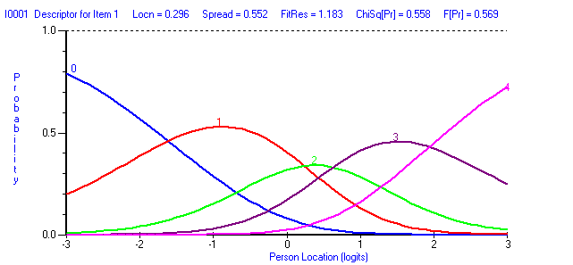
Figure S2
Item 2 Category Probability Curves of the Response Scale
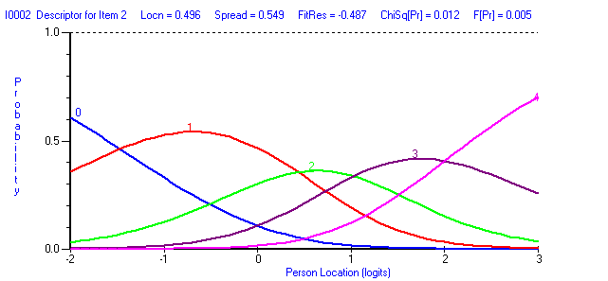

Figure S3
Item 3 Category Probability Curves of the Response Scale
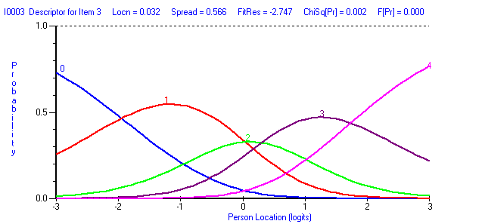Figure S4
Item 4 Category Probability Curves of the Response Scale
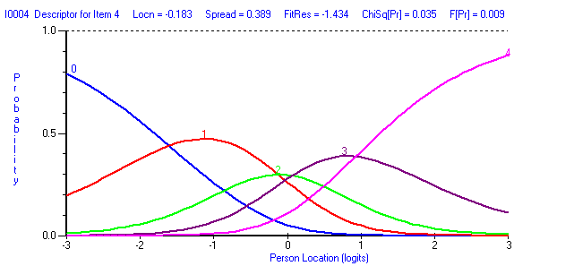

Figure S5
Item 5 Category Probability Curves of the Response Scale
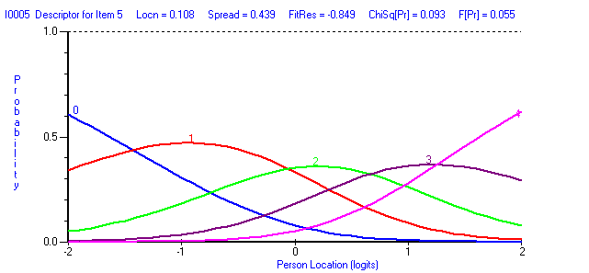

Figure S6
Item 7 Category Probability Curves of the Response Scale
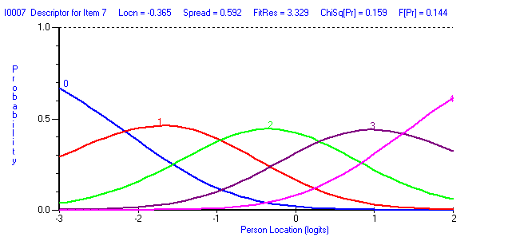

Figure S7
Item 8 Category Probability Curves of the Response Scale
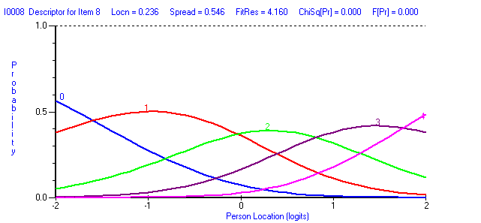

Figure S8
Item 9 Category Probability Curves of the Response Scale
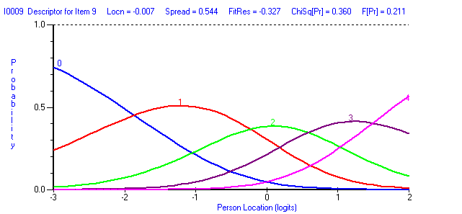

Figure S9
Item 10 Category Probability Curves of the Response Scale
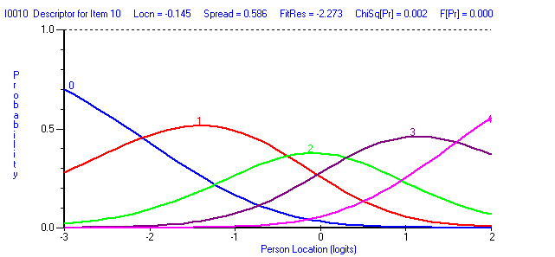

Figure S10
Item 11 Category Probability Curves of the Response Scale
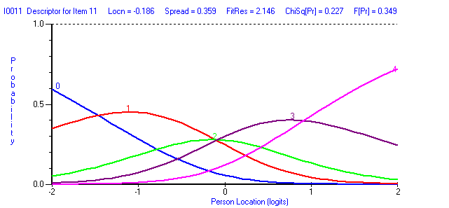

Figure S11
Item 12 Category Probability Curves of the Response Scale
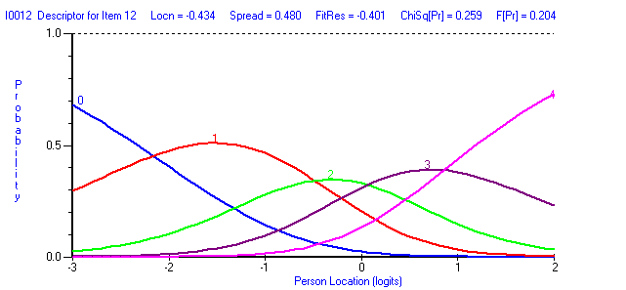

Figure S12
Item 13 Category Probability Curves of the Response Scale
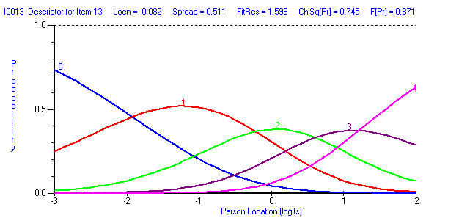

Figure S13
Item 14 Category Probability Curves of the Response Scale
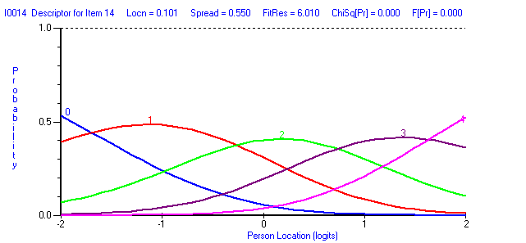
Figure S14
Item 15 Category Probability Curves of the Response Scale
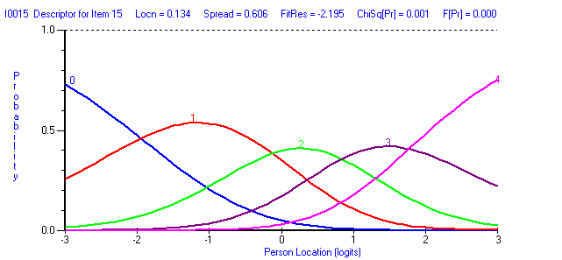

Supplementary Figures S15 – S17:
Figure S15
Item Characteristic Curves (ICCs) showing no DIF by Gender for Testlet 1 (Top), Testlet 2 (Middle), and Testlet 3 (Bottom) in the Final Analysis for All Countries
Note. Testlet 1 consists of items from from the Absorption and Regulation subscales of the DTS, Testlet 2 consists of items from from the Tolerance subscale, and Testlet 3 consists of items from the Appraisal subscale.
Figure S16
Item Characteristic Curves (ICCs) showing no DIF by Meditation for Testlet 1 (Top), Testlet 2 (Middle), and Testlet 3 (Bottom) in the Final Analysis for All Countries
Note. Testlet 1 consists of items from from the Absorption and Regulation subscales of the DTS, Testlet 2 consists of items from from the Tolerance subscale, and Testlet 3 consists of items from the Appraisal subscale.
Figure S17
Item Characteristic Curves (ICCs) showing no DIF by Country for Testlet 1 (Top), Testlet 2 (Middle), and Testlet 3 (Bottom) in the Final Analysis for All Countries
Note. Testlet 1 consists of items from from the Absorption and Regulation subscales of the DTS, Testlet 2 consists of items from from the Tolerance subscale, and Testlet 3 consists of items from the Appraisal subscale.

