Supplementary Materials
Mixed Design ANOVAs for OAQ-old and OAQ-new
As per our pre-registration, two separate mixed design (2 x 2) ANOVAs were conducted to examine whether there were changes in object attachment between groups (BSC vs HEP) and across time (T1 vs T2) for the old cherish item and the novel item. The dependent variables were scores on the Object Attachment Questionnaire for the old item (OAQ-old) and for the novel item (OAQ-new).
Results showed no significant main group effects for OAQ-old, F (1, 296) = 1.64, p = .20 and OAQ-new, F (1, 296) = 0.09, p = .76. There were also no significant main effects of time for OAQ-old, F (1, 296) = 1.41, p =. .24, and OAQ-new, F (1, 296) = 1.52, p = .22.
There was also no significant Time x Group interaction for OAQ-old, F (1, 5.13) = .05, p = .83. There was however a significant Time x Group interaction for OAQ-new, F (1, 296) = 4.44, p = .04. There was a decrease in OAQ-new for participants in the loneliness intervention whilst the health education program participants saw a slight increase (Figure S1). These results are similar to the ANCOVA findings reported in the main paper and are therefore only reported here in the Supplementary Materials.
Figure S1
Estimated Marginal Means in Object Attachment for a Novel Item (OAQ-new) at Time 1 and Time 2 for the Health Education Program and the Building Stronger Connections Intervention
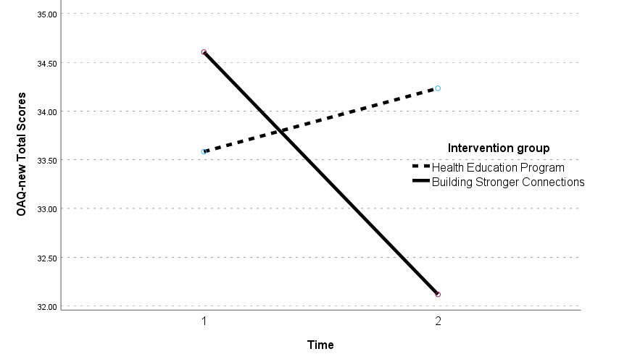

Links for the Loneliness Intervention and Active Control
Building Stronger Connections (Loneliness Intervention) condition
Connections video 1: https://echo360.net.au/media/408b1cb0-5d7a-407e-a042-dbf8d2b69996/public
Connections video 2: https://echo360.net.au/media/a6cc1e22-a662-4075-98f4-7482306bf22f/public
Connections video 3: https://echo360.net.au/media/437563ba-74a9-46f0-89f6-ae9fb1f78ddb/public
Connections video 4: https://echo360.net.au/media/3ee35533-eae8-4d04-a78e-7b38e144d1d3/public

Health Education Program (Active Control) condition
HEP video 1: https://echo360.net.au/media/43f0101d-8157-4c1e-b3d9-00e855f082ca/public
HEP video 2: https://echo360.net.au/media/b85751dc-de0d-4c3a-ab5c-7ad1c4c109d2/public
HEP video 3: https://echo360.net.au/media/7005c64e-0e96-4058-bdd2-a24df4c90ea1/public
HEP video 4: https://echo360.net.au/media/cd3a5b3d-d8db-40d1-aaa1-5fcd81f3985a/public

The Object attachment Task for Cherished Item (Object 1) and novel Item (Object 2)
In this section of the study, we are interested in finding out how people related with some objects around their home.
Object 1
Please think about the possessions in your home and select one item that is the most difficult to discard or recycle because you somehow feel attached to it, even though you know that the item is of low value and other people would have very little difficulty getting rid of it. This item should be objectively of low value and no longer used or useful. Examples of such items include old clothes, books, mementos, souvenirs, greeting cards, letters, bills, statements, CDs, records, cassette tapes, knick knacks, stationary, magazines, old games and toys, old electrical or phone items, jewellery, clothing accessories, gifts, and old homewares such as kitchen utensils, containers, and mugs.
Please write a short description of the item.
Brief description of item 1:____________________________________________________
[Complete the Object attachment questionnaire here]
Object 2
Please take a minute to imagine that you have been given the following keychain

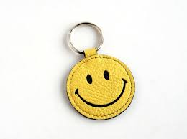

[Complete the Object attachment questionnaire]

Attention and Validity Check items
Research has suggested that a person’s favorite color can tell us a lot about the way that they think about other people. In this case, however, we would like you to ignore this question entirely. Instead, please choose all of the response options provided. In other words, regardless of your actual favorite color, click all of the answers.
□ Red
□ Blue
□ Yellow
□ Green
□ Purple
When you were in school, how hard did you work on your studies? In answering this question, please ignore everything else and select the final option indicating that you don’t really remember.
□ I worked incredibly hard in school
□ I worked moderately hard in school
□ I worked a little hard in school
□ I didn’t work hard at all
□ I don’t recall how hard I worked

Please also confirm that you have responded to the best of your ability to all questions. (We would appreciate it if you can respond honestly. We want to make sure that the data we collect is valid. Your response on this item will not affect payment or approval ratings.)
□ Yes – the data I have provided is valid and I consent to the data being used for research purposes
□ No – the data is not valid. Please do not use the data for research purposes.
Quiz questions after Building Stronger Connections videos
Video 1: According to the video, social isolation has negative health consequences that are as bad as drinking too much alcohol, smoking, or eating unhealthy food.
□ True
□ False

Video 2: According to the video, what are the characteristics of high quality contacts?
□ High quality contacts are frequent, person-to-person, and involve mutual support.
□ High quality contacts are informal, and must involve face-to-face, in-person contact.

Video 3: What is the main message of this video?
□ Social isolation can result in serious health problems.
□ The quality of our social interactions is more important than the number of friends we have.
□ Don’t wait for others to make contact with you. Take the initiative.

Video 4 Which one of the following myths was the focus of this last video?
□ Myth: Improving sleep will not improve your mental health.
□ Myth: You will not be lonely if you use social media.
□ Myth: Isolation lasts forever.

Quiz Questions after Health Education Program Videos
Video 1: According to the video, which one of the following provides the most up to date advice about what to eat?
□The food pyramid.
□The health eating plate.

Video 2: Accoridng to the video, which of the following is true?
□ All fats are unhealthy.
□ Health fats can be found in nuts.

Video 3: According to the video, which of the following statements is TRUE?
□ Taking long naps, especially after 3pm, will help you improve the quality of your sleep.
□ Avoid taking long naps, especially after 3pm.

Video 4: Which of the following statements is TRUE?
□ Exercise increases levels of stress
□ It is best to do exercise on your own without the distraction of other people
□ Regular physical activity will increase your energy levels.

