Supplementary material
The role of political fit and self-censorship at work for job satisfaction, social belonging, burnout, and turnover intentions. Current Psychology. Samantha Sinclair*, Artur Nilsson, & Kristoffer Holm. *Corresponding author. Department of Psychology, Linnæus University. samantha.sinclair@lnu.se.

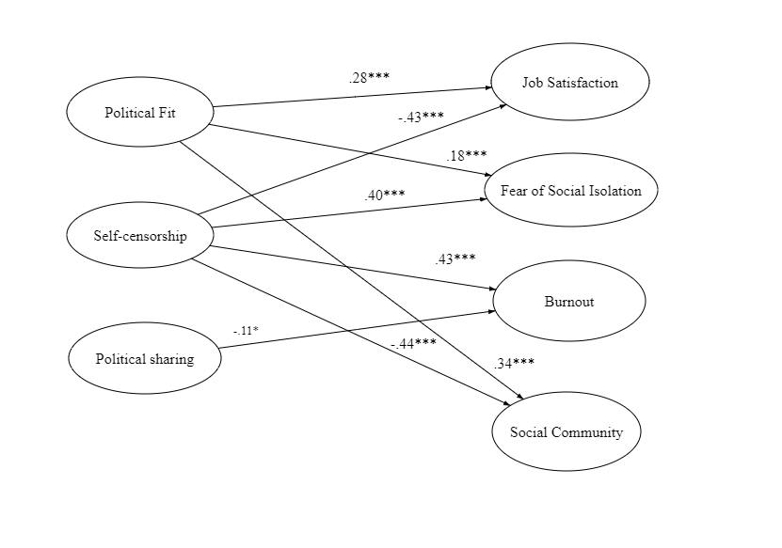

Figure A1. Structural equation model of the associations between the latent variables in the present study. Indicators for each latent construct, and non-significant paths, are omitted. All paths represent standardized β-values. * p < .05, ** p < .01, *** p < .001.

