Open For Business: How Leader Ambivalence Facilitates Upward Follower Communication via Perceptions of Increased Cognitive Flexibility and Responsiveness

Supplemental Materials
(All materials can also be found here: https://osf.io/4vzms/?view_only=c63bd6b76bc5491eb6811dc5dd6c2d83 )

Appendix A

Leader manipulation Study 1 (cf. Pauels, Rothman, & Schneider, n.d.)
Ambivalent personality Profile of John:
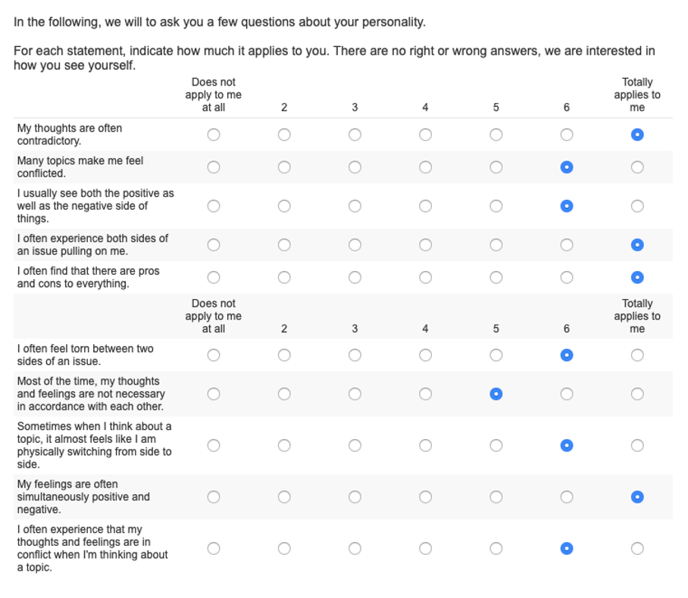
Non-ambivalent personality Profile of John:

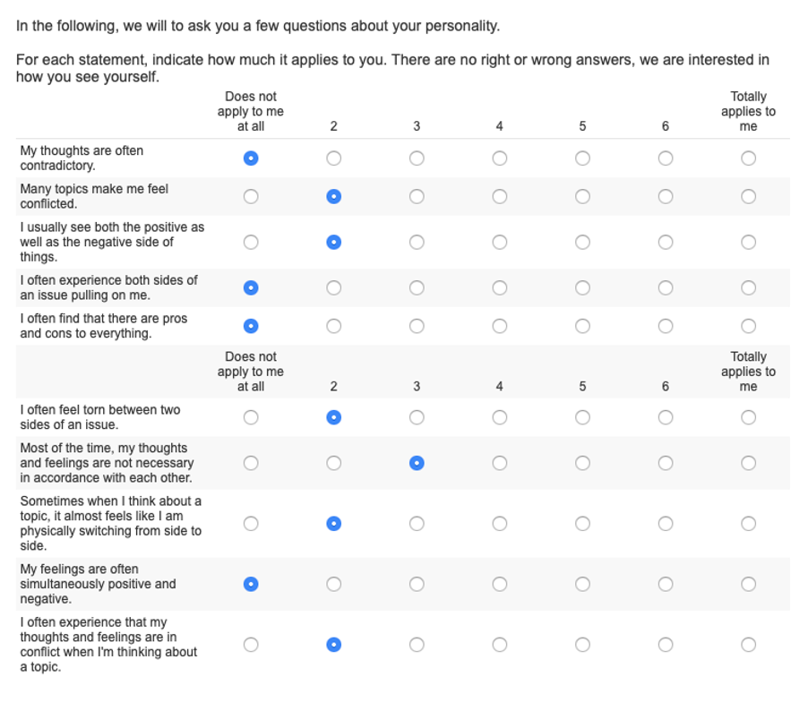

Appendix B
Measure Leader Cognitive Flexibility
We based the measurement of cognitive flexibility on the Cognitive Flexibility Scale by Martin and Rubin (1995). To fit the situation of evaluating a leader, we adapted the item wording of the original scale. The items were rated on a 7-point scale, from 1= "not at all" to 7 = "very much".
I would expect John in his role as senior manager...
...to communicate an idea in many different ways. (1)
...to avoid new and unusual situations. (2R)
...to feel like he never gets to make decisions. (3R)
...to be able to find workable solutions to seemingly unsolvable problems. (4)
...to seldom have choices when deciding how to behave. (5R)
...to be willing to work on creative solutions to problems. (6)
...to be able to act appropriately in any given situation. (7)
...to behave based on conscious decisions that he makes. (8)
...to have many possible ways of behaving in any given situation. (9)
...to have difficulty using his knowledge on a given topic in real-life situations. (10R)
...to be willing to listen and consider alternatives for handling a problem. (11)
…to have the self-confidence necessary to try different ways of behaving. (12)
We calculate the mean cognitive flexibility rating by averaging the responses (recoding items 2,3,5,10) across all items.

Reference
Martin, M., & Rubin, R. (1995). A New Measure of Cognitive Flexibility. Psychological Reports, 76, 623–626.

Appendix C
Measure Perceived Leader Responsiveness
We based the measurement of responsiveness on the Perceived Partner Responsiveness Scale by Reis, Lee, O'Keefe, and Clark (2018). To fit the situation of evaluating a leader we adapted the item wording of the original scale. The items were rated on a 7 -point scale, from 1= "not at all" to 7 = "very much":
I would expect John in his role as senior manager…
...to make the employees feel cared for. (1)
...to make the employees feel like their abilities and opinions are valued. (2)
...to be responsive to employees' needs. (3)
...to be interested in what employees are thinking and feeling. (4)
...to ignore the employees' side of the story. (5R)
...to ignore the things that are most important to the employees. (6R)
...to try to see where the employees are coming from (7).
...to dismiss the employees' concerns too easily. (8R)
...to NOT accept the employees' feelings and concerns. (9R)
...to really listen to the employees. (10)
...to be understanding towards the employees. (11)
We calculate the mean perceived responsiveness rating by averaging the responses (recoding items 5, 6,8, 9) across all items

Reference
Reis, H. T., Lee, K. Y., O'Keefe, S. D., & Clark, M. S. (2018). Perceived partner responsiveness promotes intellectual humility. Journal of Experimental Social Psychology, 79, 21–33.

Appendix D
Leader manipulation (cf. Pauels, Rothman, & Schneider, n.d.)
Ambivalent Leader Condition:

Your new supervisor John.
You have just started a new job at a medium-sized company. Your immediate supervisor, the department manager, is called John. At lunch, you ask your new colleagues about John. Here is how your colleagues describe your new supervisor:

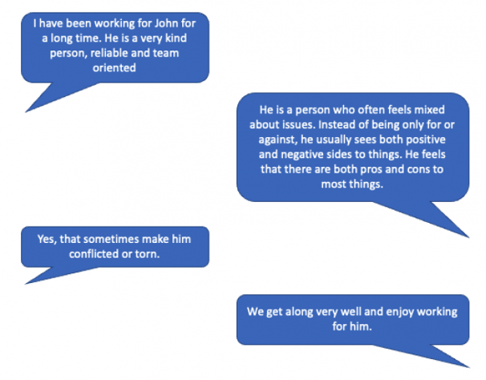

Non-Ambivalent Leader Condition

Your new supervisor John.
You have just started a new job at a medium-sized company. Your immediate supervisor, the department manager, is called John. At lunch, you ask your new colleagues about John. Here is how your colleagues describe your new supervisor:

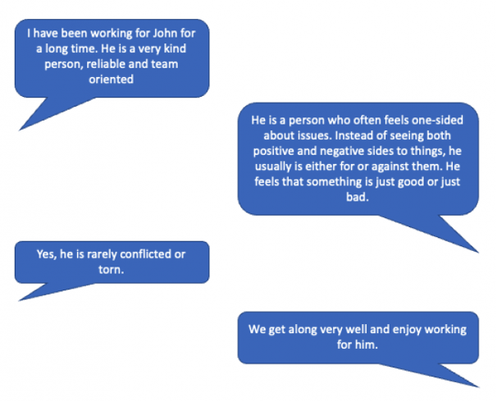

Appendix E
Speaking Up/ Upward Voice Measure (adapted from Liu et al., 2010)

We are also interested in how you would expect to interact with your new supervisor John based on your impression of him. Again, there are no right or wrong answers.
Items were rated on a scale from 1 (“Not at all”) to 7 (“Very much”)

1) I would develop and make recommendations to John concerning issues that affect the company.
2) I would speak up and influence John regarding issues that affect the company.
3) I would communicate my opinions about work issues to John even if my opinion is different, and John disagrees with me.
4) I would speak to John with new ideas for projects or changes in procedures.
5) I would give constructive suggestions to John to improve his work.
6) I would point out to John to eliminate redundant or unnecessary procedures.
7) If John made mistakes in his work, I would point them out and help him correct them.
8) I would try to persuade John to change organizational rules or policies that are nonproductive or counterproductive.
9) I would suggest to John to introduce new structures, technologies, or approaches to improve efficiency.

Liu, W., Zhu, R., & Yang, Y. (2010). I warn you because I like you: Voice behavior, employee identifications, and transformational leadership. The Leadership Quarterly, 21(1), 189-202.

Appendix F
Workplace scenarios
1. Idea of improvement
You notice that a delay in communication between upper management and your direct supervisor John limits the amount of time you and other employees of the marketing team have to complete a marketing campaign for the company. You have the idea to establish a direct email channel where upper management can send information directly to you and the marketing team. You think this could increase efficiency.

2. Response to dissatisfaction

Your supervisor John created an online reward system that allows employees to recognize each other’s extra work. John had been advocating for such a system for some time and finally gotten the go from upper management. While everyone in the department has access to the same system, you notice that it is significantly easier for the office staff to give each other recognition. In contrast, you and other colleagues who often have to go out to clients and take business trips have to take out extra time to give the reward. This has the potential to impact your and your colleagues bottom line, meaning that you would either have to work harder or risk getting disciplined. As a consequence, you feel dissatisfied and poorly treated.

3. Ethical or fairness concern

Your colleague, who also was hired recently, is anxious to create a good impression on your mutual supervisor John. Hence, to maximize his sales volume your new colleague, occasionally, exaggerates the value and benefits of the company products with full intention to persuade customers to purchase the products. You feel that this deception of the customers is unethical and might hurt the company's reputation in the long run.

