Table S 1 The revised 7-item generalized anxiety disorder scale in the outbreak stage of COVID-19
In the outbreak stage of COVID-19/In the stable stage of COVID-19 in your city, how often have you been bothered by the following problems? | None | A few days | More than a week | Almost every day
1. Feel nervous, anxious or on edge | 1 | 2 | 3 | 4
2. Not being able to stop or control worrying | 1 | 2 | 3 | 4
3. Worrying too much about different things | 1 | 2 | 3 | 4
4. Trouble relaxing | 1 | 2 | 3 | 4
5.Being so restless that it is hard to sit still | 1 | 2 | 3 | 4
6.Becoming easily annoyed or irritable | 1 | 2 | 3 | 4
7. Feeling afraid as if something awful might happen | 1 | 2 | 3 | 4

Table S 2 Exploratory Factor Analysis of Scales
Different periods | Scales | KMO | Cumulative Variance Explained (%) | p | Number of Factors
In the outbreak stage of COVID-19 | GAD-7 | 0.925 | 69.271 | <0.001 | 1
In the outbreak stage of COVID-19 | BFS | 0.703 | 75.498 | <0.001 | 1
In the outbreak stage of COVID-19 | UWES-S | 0.705 | 71.094 | <0.001 | 1
In the stable stage of COVID-19 | GAD-7 | 0.901 | 61.980 | <0.001 | 1
In the stable stage of COVID-19 | BFS | 0.707 | 78.089 | <0.001 | 1
In the stable stage of COVID-19 | UWES-S | 0.717 | 73.890 | <0.001 | 1

Table S 3 Structural Validity Analysis of Scales
 |  | χ²/df | SRMR | RMSEA | GFI | CFI | NFI
In the outbreak stage of COVID-19 | GAD-7 | 18.883 | 0.052 | 0.168 | 0.861 | 0.919 | 0.915
In the outbreak stage of COVID-19 | BFS | - | 0 | 0.686 | 1 | 1 | 1
In the outbreak stage of COVID-19 | UWES-S | - | 0 | 0.577 | 1 | 1 | 1
In the stable stage of COVID-19 | GAD-7 | 15.713 | 0.061 | 0.153 | 0.898 | 0.917 | 0.912
In the stable stage of COVID-19 | BFS | - | 0 | 0.734 | 1 | 1 | 1
In the stable stage of COVID-19 | UWES-S | - | 0 | 0.567 | 1 | 1 | 1

Table S 4 Convergent Validity Analysis of Scales
 |  | Item | Standardized Factor Loadings | AVE | CR
 | In the outbreak stage of COVID-19 | GAD-7-1 | 0.867 | 0.631 | 0.923
 | In the outbreak stage of COVID-19 | GAD-7-2 | 0.841 | 0.631 | 0.923
 | In the outbreak stage of COVID-19 | GAD-7-3 | 0.833 | 0.631 | 0.923
 | In the outbreak stage of COVID-19 | GAD-7-4 | 0.745 | 0.631 | 0.923
 | In the outbreak stage of COVID-19 | GAD-7-5 | 0.729 | 0.631 | 0.923
 | In the outbreak stage of COVID-19 | GAD-7-6 | 0.768 | 0.631 | 0.923
 | In the outbreak stage of COVID-19 | GAD-7-7 | 0.768 | 0.631 | 0.923
 | In the outbreak stage of COVID-19 | BFS-1 | 0.877 | 0.673 | 0.860
 | In the outbreak stage of COVID-19 | BFS-2 | 0.856 | 0.673 | 0.860
 | In the outbreak stage of COVID-19 | BFS-3 | 0.720 | 0.673 | 0.860
 | In the outbreak stage of COVID-19 | UWES-S-1 | 0.712 | 0.589 | 0.811
 | In the outbreak stage of COVID-19 | UWES-S-2 | 0.839 | 0.589 | 0.811
 | In the outbreak stage of COVID-19 | UWES-S-3 | 0.746 | 0.589 | 0.811
 | In the stable stage of COVID-19 | GAD-7-1 | 0.860 | 0.550 | 0.893
 | In the stable stage of COVID-19 | GAD-7-2 | 0.808 | 0.550 | 0.893
 | In the stable stage of COVID-19 | GAD-7-3 | 0.883 | 0.550 | 0.893
 | In the stable stage of COVID-19 | GAD-7-4 | 0.554 | 0.550 | 0.893
 | In the stable stage of COVID-19 | GAD-7-5 | 0.669 | 0.550 | 0.893
 | In the stable stage of COVID-19 | GAD-7-6 | 0.693 | 0.550 | 0.893
 | In the stable stage of COVID-19 | GAD-7-7 | 0.663 | 0.550 | 0.893
 | In the stable stage of COVID-19 | BFS-1 | 0.892 | 0.710 | 0.880
 | In the stable stage of COVID-19 | BFS-2 | 0.867 | 0.710 | 0.880
 | In the stable stage of COVID-19 | BFS-3 | 0.763 | 0.710 | 0.880
 | In the stable stage of COVID-19 | UWES-S-1 | 0.766 | 0.581 | 0.806
 | In the stable stage of COVID-19 | UWES-S-2 | 0.805 | 0.581 | 0.806
 | In the stable stage of COVID-19 | UWES-S-3 | 0.712 | 0.581 | 0.806
Table S 5 Discriminant Validity Analysis of Each Scale
 |  | GAD-7 | UWES-S | BFS
In the outbreak stage of COVID-19 | GAD-7 | 0.794
In the outbreak stage of COVID-19 | UWES-S | -0.260** | 0.767
In the outbreak stage of COVID-19 | BFS | -0.159** | 0.324** | 0.820
In the stable stage of COVID-19 | GAD-7 | 0.742
In the stable stage of COVID-19 | UWES-S | -0.284** | 0.762
In the stable stage of COVID-19 | BFS | -0.190** | 0.395** | 0.843
**: p<.001

Table S 6 Multidimensional Model Confirmatory Factor Analysis
 | Model | χ²/df | SRMR | RMSEA | GFI | CFI | NFI
In the outbreak stage of COVID-19 | Without Merging | 5.995 | 0.044 | 0.089 | 0.901 | 0.935 | 0.923
In the outbreak stage of COVID-19 | GAD-7+BFS | 20.062 | 0.138 | 0.174 | 0.746 | 0.745 | 0.736
In the outbreak stage of COVID-19 | GAD-7+BFS+UWES-S | 28.477 | 0.166 | 0.209 | 0.660 | 0.626 | 0.619
In the stable stage of COVID-19 | Without Merging | 5.314 | 0.051 | 0.083 | 0.919 | 0.938 | 0.925
In the stable stage of COVID-19 | GAD-7+BFS | 21.703 | 0.151 | 0.181 | 0.731 | 0.693 | 0.684
In the stable stage of COVID-19 | GAD-7+BFS+UWES-S | 29.537 | 0.174 | 0.213 | 0.643 | 0.570 | 0.563

Table S 7 Reliability analysis of Scales
 |  | Cronbach’s α | Cronbach’s α coefficient after item deletion | CITC
In the outbreak stage of COVID-19 | GAD-7 | 0.924 | 0.906-0.920 | 0.684-0.822
In the outbreak stage of COVID-19 | BFS | 0.838 | 0.729-0.844 | 0.626-0.745
In the outbreak stage of COVID-19 | UWES-S | 0.789 | 0.683-0.738 | 0.607-0.670
In the stable stage of COVID-19 | GAD-7 | 0.895 | 0.868-0.894 | 0.567-0.809
In the stable stage of COVID-19 | BFS | 0.859 | 0.757-0.874 | 0.653-0.782
In the stable stage of COVID-19 | UWES-S | 0.822 | 0.727-0.774 | 0.661-0.705

Table S 8 The revised benefit finding scale in the outbreak and the stable stages of COVID-19
 | Fully agree | Moderately agree | Uncertain | Moderately disagree | Fully disagree
1.The recurrence of the epidemic makes me more aware of the significance of my learning to society. | 5 | 4 | 3 | 2 | 1
2.The recurrence of the epidemic makes me realize that things are changeable and I have to do something more valuable in the future. | 5 | 4 | 3 | 2 | 1
3.The recurrence of the epidemic has made me have a clearer plan for the rest of my life and study. | 5 | 4 | 3 | 2 | 1

Table S 9 The revised student version of the Utrecht Work Engagement Scale in the outbreak stage of COVID-19
When the epidemic broke out (some time ago)/In the outbreak stage of COVID-19/In the stable stage of COVID-19 | Never | Alomost never | Rarely | Sometimes | Often | Very often | Always
1.I feel happy when I am studying intensely. | 1 | 2 | 3 | 4 | 5 | 6 | 7
2.I feel energetic when I am studying for a long time. | 1 | 2 | 3 | 4 | 5 | 6 | 7
3.I can concentrate and will not be distracted easily. | 1 | 2 | 3 | 4 | 5 | 6 | 7

Table S 10 Demographic characteristics in the outbreak and stable stages of COVID-19
Items | In the outbreak stage of COVID-19  N (%) | In the stable stage of COVID-19  N (%)
Age (M±SD) | 20.69±1.70 | 21.12±1.42
Age
≤ twenty-one years old | 775(61.4) | 775(61.4)
＞twenty-one years old | 487(38.6) | 487(38.6)
Gender
Male | 654(51.8) | 654(51.8)
Female | 608(48.2) | 608(48.2)
Education background
Junior college student | 813(64.4) | 813(64.4)
College student | 449(35.6) | 449(35.6)
Subjects
Natural science | 596(47.2) | 596(47.2)
Science | 367(29.1) | 339(26.9)
Engineering | 140(11.1) | 130(10.3)
Medicine | 50(4.0) | 59(4.7)
Agriculture | 39(3.1) | 68(5.4)
Social science | 666(52.8) | 666(52.8)
Literature | 132(10.5) | 137(10.9)
History | 26(2.1) | 35(2.8)
Economics | 24(1.9) | 19(1.5)
Philosophy | 150(11.9) | 154(12.2)
Management | 84(6.7) | 91(7.2)
Law | 22(1.7) | 15(1.2)
Education | 191(15.1) | 184(14.6)
Art | 37(2.9) | 31(2.5)
The distance between the school district and the nearest high-and-medium-risk area
More than five kilometers | 1163(92.2) | 1163(92.2)
Less than five kilometers | 99(7.8) | 99(7.8)

Table S 11 Comparison of the basic situation in the outbreak and stable stages of COVID-19
Items | In the outbreak stage of COVID-19  N (%) | In the stable stage of COVID-19  N (%) | χ² | p
Have you been vaccinated
No | 62(4.9) | 57(4.5) | 78.438 | <0.001
Have received the first | 143(11.3) | 31(2.5) | 78.438 | <0.001
Have received the second dose or the third dose | 1057(83.8) | 1174(93.0) | 78.438 | <0.001
Are you worried about being infected
Yes | 399(31.6) | 279(22.1) | 29.040 | <0.001
No | 863(68.4) | 983(77.9) | 29.040 | <0.001
What’s your attitude to follow the latest epidemic news
Active | 533(42.2) | 176(13.9) | 288.363 | <0.001
Passive attention (only be mentioned) | 568(45.0) | 695(55.1) | 288.363 | <0.001
No | 161(12.8) | 391(31.0) | 288.363 | <0.001
Do you have more trust in the medical workers when you see the efforts made by them to fight the epidemic?
Yes | 952(75.4) | 815(64.6) | 35.416 | <0.001
No | 310(24.6) | 447(35.4) | 35.416 | <0.001
Do you believe that the local government can control the epidemic
Yes | 1161(92.0) | 1230(97.5) | 37.788 | <0.001
No | 101(8.0) | 32(2.5) | 37.788 | <0.001

Table S 12 The validation of relationship among anxiety, benefit finding and academic engagement through structural equation modeling
Different periods | Path | Standardized Estimate | S.E. | C.R. | p
In the outbreak stage | Anxiety->academic engagement | -0.592 | 0.047 | -14.476 | <0.001
In the outbreak stage | Benefit finding->academic engagement | 0.596 | 0.039 | 14.011 | <0.001
In the outbreak stage | Gender->academic engagement | 0.487 | 0.057 | 13.340 | <0.001
In the outbreak stage | Age->academic engagement | 0.234 | 0.052 | 7.306 | <0.001
In the outbreak stage | Education->academic engagement | -0.016 | 0.050 | -0.525 | 0.600
In the outbreak stage | Distance->academic engagement | 0.043 | 0.089 | 1.403 | 0.161
In the outbreak stage | Majors->academic engagement | -0.022 | 0.048 | -0.726 | 0.468
In the stable stage | Anxiety->academic engagement | -0.542 | 0.079 | -12.812 | <0.001
In the stable stage | Benefit finding->academic engagement | 0.664 | 0.038 | 14.429 | <0.001
In the stable stage | Gender->academic engagement | 0.466 | 0.051 | 12.929 | <0.001
In the stable stage | Age->academic engagement | 0.159 | 0.045 | 5.182 | <0.001
In the stable stage | Distance->academic engagement | -0.147 | 0.080 | -4.820 | <0.001
In the stable stage | Education->academic engagement | 0.026 | 0.044 | 0.877 | 0.380
In the stable stage | Majors->academic engagement | -0.011 | 0.042 | -0.369 | 0.712

Table S 13 The model fit of the model in two different periods
 | CMIN/DF | GFI | RMR | NFI | RMSEA
In the outbreak stage | 13.692 | 0.849 | 0.095 | 0.819 | 0.100
In the stable stage | 14.841 | 0.843 | 0.106 | 0.791 | 0.105

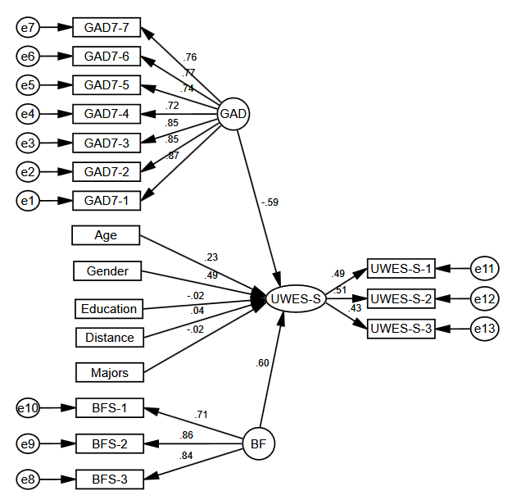
Figure S 1 The model to validate relationship among anxiety, benefit finding and academic engagement in the outbreak stage of COVID-19
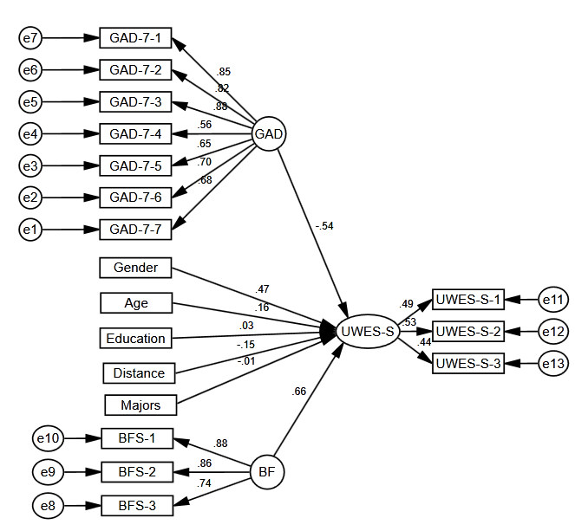
Fig. S 2 The model to validate relationship among anxiety, benefit finding and academic engagement in the stable stage of COVID-19

