Supplemental Online Material
Verbal (first row) and Non-Verbal (second row) Stimuli Used in the Construct Validity Study
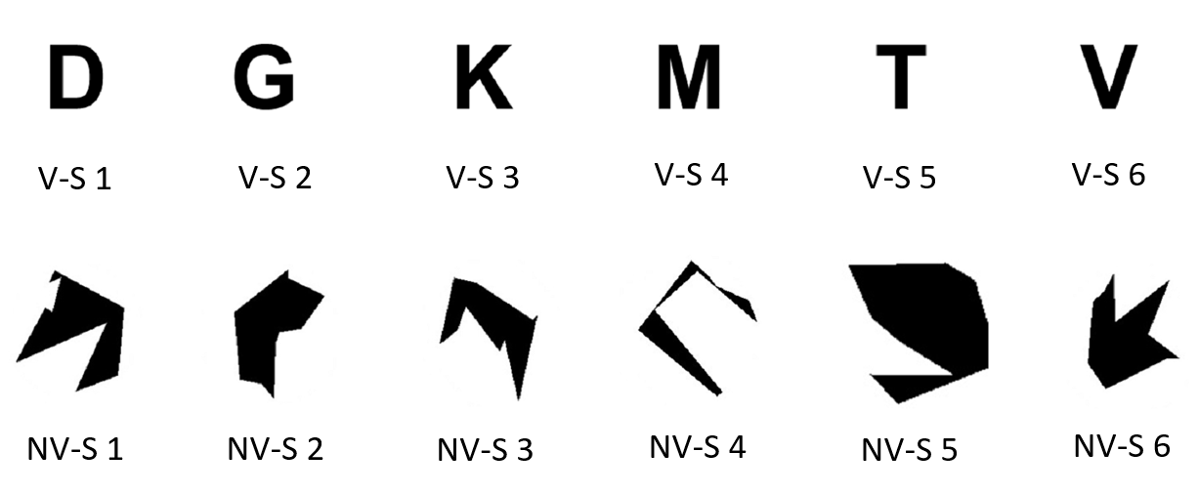
Note. In 0-back condition, for the verbal trials, V-S (verbal stimuli) 1 was the target for the first trial, V-S 4 was the target for the second trial, and V-S 6 was the target for the third trial. “V” for the third trial. For the non-verbal trials, NV-S (non-verbal stimuli) 1 was the target for the first trial, NV-S 4 was the target for the second trial, and NV-S 6 was the target for the third trial.

