Table S1
Descriptive statistics of home literacy environment items in the sample of mothers
Before dichotomization | % | After dichotomization | %
Number of adults’ books
0-10 | 51.8 | <=10 | 51.8
11-30 | 31.9 | >10 | 48.2
31-100 | 12.5
101-200 | 2.5
201-500 | 0.9
more than 500 | 0.3
Number of children’s books
0-10 | 32.4 | <=10 | 32.4
11-30 | 36.5 | >10 | 67.6
31-50 | 16.3
51-100 | 9.7
more than 100 | 5.2
Number of books that children have read in the last year
0-3 | 27.0 | <=6 | 47.8
4-6 | 20.8 | >6 | 52.2
7-15 | 26.4
> 16 | 25.9
Father’s reading frequency at home
＜=1h/week | 69.2 | <=1h/week | 69.2
1-5h/week | 26.0 | >1h/week | 30.8
6-10h/week | 3.4
>=10h/week | 1.4
Mother’s reading frequency at home
＜=1h/week | 62.4 | <=1h/week | 62.4
1-5h/week | 30.7 | >1h/week | 37.6
6-10h/week | 5.0
>=10h/week | 1.9
Frequency of shared reading at home in a typical week
never or rarely | 12.3 | less than 1 time/week | 40.8
1-2 times/month | 28.5 | 1 time or more/week | 59.2
1-2 times/week | 39.0
3 or more times a week | 20.2
Frequency of talks about past events in kindergarten
never or rarely | 4.0 | less than 3 times/week | 49.2
1-2 times/month | 13.8 | 3 times or more/week | 50.8
1-2 times/week | 31.4
3 or more times a week | 50.8
Onset age of shared reading at home
not started | 5.1 | after 3 years old | 28.4
4-5 years old | 5.4 | 3 years old or before | 71.6
3-4 years old | 17.8
2-3 years old | 37.0
1-2 years old | 25.8
before 1 year old | 8.8
Length of shared reading at home
<10 min | 27.1 | <20min | 71.9
10-20 min | 44.8 | >=20min | 28.1
20-30 min | 20.6
>30 min | 7.5

Table S2
Exploratory factor analysis for children’s emergent literacy skills
To explore the factorial structure, all 22 items of the instrument were subjected to the first iteration of exploratory factor analysis (EFA) with oblique rotation in the pretest sample. The Kaiser-Meyer-Olkin measure, KMO = 0.90, with Bartlett test p < 0.001, verified the sampling adequacy for the analysis. According to the prior construct, 4 factors were forced to be extracted. The item “Whether a child could recite nursery rhymes” was deleted in the first iteration of EFA due to inconsistency with our prior construct, which should have extracted to the factor of oral expression but was extracted to the factor of print awareness. In the second iteration of EFA, the item “Whether a child could understand Mandarin” was deleted also due to inconsistency with our prior construct, which should have extracted to the factor of listening comprehension but was extracted to the factor of oral expression. In the third iteration of EFA, the item “Whether a child could understand daily instructions” was deleted due to the cross-loadings on the factors of oral expression (0.30) and listening comprehension (0.43), with a difference less than 0.30. In the fourth iteration of EFA, the items “Whether a child could talk politely to others” and “Whether a child could write his or her own name” were deleted due to relatively low communalities (0.43, 0,45, respectively) than others. In the fifth iteration of EFA, the items that have low conceptual alignment with the other items in the same factor were deleted, including the items “Whether a child could speak clearly without stutter”, “Whether a child could communicate in Mandarin” and “Whether a child could respond when talking to him or her”.
In the last iteration of EFA, 14 items were retained. The Kaiser-Meyer-Olkin measure, KMO = 0.86, with Bartlett test p < 0.001, verified the sampling adequacy for the analysis. EFA results revealed that 4 factors accounted for 67.47% of the variance. The table below contains the last iteration results of EFA, including the factor loadings and factor names.
Loadings on children’s emergent literacy skills in the exploratory factor analysis
 | Factors
Measures | OE | PC | PA | LA |  | Communalities
The degree to which children pay attention to listening |  |  |  | 0.82 |  | 0.56
The degree to which children understand the storylines during story listening |  |  |  | 0.74 |  | 0.76
The degree to which children understand the emotions expressed in the story |  |  |  | 0.67 |  | 0.70
Whether children’s oral narratives are content-rich | 0.86 |  |  |  |  | 0.56
Whether children’s oral narratives are logistic | 0.76 |  |  |  |  | 0.67
Whether children’s oral narratives are coherent | 0.74 |  |  |  |  | 0.73
Whether children’s oral narratives are easy to understand | 0.68 |  |  |  |  | 0.63
Whether children can distinguish between the front and back cover of a book |  | 0.85 |  |  |  | 0.65
Whether children can distinguish between the up and down direction of the text |  | 0.81 |  |  |  | 0.75
Whether children know to turn the pages in order |  | 0.75 |  |  |  | 0.66
Whether children know the appropriate order when reading a page |  | 0.69 |  |  |  | 0.73
Whether children can distinguish Chinese characters from signs in daily life |  |  | 0.84 |  |  | 0.69
Whether children can distinguish Chinese characters from numbers |  |  | 0.76 |  |  | 0.66
Whether children can distinguish Chinese characters from English letters |  |  | 0.75 |  |  | 0.70
Note. Rotation method: oblique rotation. Factor loadings < 0.30 were blank. OE = Oral expression; PC = Print conventions; PA = Print awareness; LC = Listening comprehension

Table S3
Specific characteristics of items for home literacy environment, literacy interest and emergent literacy skills in the final sample
Items |  | M |  | SD |  | Min |  | Max
Number of adults’ books | 1.71 |  | 0.9 |  | 1 |  | 6
Number of children’s books | 2.14 |  | 1.11 |  | 1 |  | 5
Number of books that children have read in the last year | 2.47 |  | 1.14 |  | 1 |  | 4
Father’s reading frequency at home | 1.42 |  | 0.66 |  | 1 |  | 4
Mother’s reading frequency at home | 1.46 |  | 0.7 |  | 1 |  | 4
Frequency of shared reading at home in a typical week | 2.65 |  | 0.95 |  | 1 |  | 4
Frequency of talks about past events in kindergarten | 3.23 |  | 0.87 |  | 1 |  | 4
Onset age of shared reading at home | 3.95 |  | 1.22 |  | 1 |  | 6
Length of shared reading at home | 2.11 |  | 0.9 |  | 1 |  | 4
Frequency of children actively storytelling to others | 2.12 |  | 0.61 |  | 1 |  | 3
Frequency of children asking to be read to or read by themselves | 2.43 |  | 0.62 |  | 1 |  | 3
Frequency of children attempting to write | 2.36 |  | 0.61 |  | 1 |  | 3
The degree to which children pay attention while listening | 2.21 |  | 0.55 |  | 1 |  | 3
The degree to which children understand the storylines when listening to the story | 2.02 |  | 0.54 |  | 1 |  | 3
The degree to which children understand the emotions expressed in the story | 2.02 |  | 0.59 |  | 1 |  | 3
Whether children’s oral narratives are content-rich | 2.41 |  | 0.71 |  | 1 |  | 3
Whether children’s oral narratives are logistic | 2.26 |  | 0.59 |  | 1 |  | 3
Whether children’s oral narratives are coherent | 2.36 |  | 0.54 |  | 1 |  | 3
Whether children’s oral narratives are easy to understand | 2.26 |  | 0.57 |  | 1 |  | 3
Whether children can distinguish between the front and back cover of a book | 0.91 |  | 0.29 |  | 0 |  | 1
Whether children can distinguish between the up and down direction of the text | 0.90 |  | 0.30 |  | 0 |  | 1
Whether children know to turn the pages in order | 0.85 |  | 0.36 |  | 0 |  | 1
Whether children know the appropriate order when reading a page | 0.82 |  | 0.39 |  | 0 |  | 1
Whether children can distinguish Chinese characters from signs in daily life | 0.74 |  | 0.44 |  | 0 |  | 1
Whether children can distinguish Chinese characters from numbers | 0.83 |  | 0.38 |  | 0 |  | 1
Whether children can distinguish Chinese characters from English letters | 0.55 |  | 0.50 |  | 0 |  | 1

Table S4
Model Fit Indices of the LCA for the replication in two random folds
Classes | LL | k |  |  | AIC |  | BIC |  | aBIC |  | Entropy |  | LMR LR p-value |  | BLRT p-value | Class size
Fold 1 (n = 674)
1 | -4219.40 | 9 |  | 8456.80 |  | 8498.04 |  | 8469.46 |  | —— |  | —— |  | —— |  | ——
2 | -3882.10 | 19 |  | 7802.19 |  | 7889.25 |  | 7828.92 |  | 0.73 |  | <0.001 |  | <0.001 |  | 0.49/0.51
3 | -3796.82 | 29 |  | 7651.65 |  | 7784.53 |  | 7692.44 |  | 0.80 |  | <0.001 |  | <0.001 |  | 0.22/0.34/0.44
4 | -3748.75 | 39 |  | 7575.51 |  | 7754.21 |  | 7630.37 |  | 0.78 |  | 0.0001 |  | <0.001 |  | 0.13/0.34/0.39/0.14
5 | -3722.15 | 49 |  | 7542.30 |  | 7766.82 |  | 7611.23 |  | 0.78 |  | 0.0008 |  | <0.001 |  | 0.30/0.29/0.13/0.15/0.13
6 | -3707.63 | 59 |  | 7533.26 |  | 7803.60 |  | 7616.26 |  | 0.77 |  | 0.1250 |  | 0.0300 |  | 0.12/0.09/0.13/0.14/0.24/0.28
Fold 2 (n =722)
1 | -3946.05 | 9 |  | 7910.09 |  | 7950.71 |  | 7922.14 |  | —— |  | —— |  | —— |  | ——
2 | -3578.39 |  | 19 |  | 7194.78 |  | 7280.53 |  | 7220.21 |  | 0.79 | <0.001 |  | <0.001 |  | 0.58/0.42
3 | -3494.20 |  | 29 |  | 7046.40 |  | 7177.28 |  | 7085.21 |  | 0.84 | <0.001 |  | <0.001 |  | 0.24/0.39/0.37
4 | -3454.40 |  | 39 |  | 6986.80 |  | 7162.82 |  | 7038.99 |  | 0.78 | 0.0462 |  | <0.001 |  | 0.24/0.33/0.32/0.11
5 | -3427.99 |  | 49 |  | 6953.99 |  | 7175.14 |  | 7019.56 |  | 0.83 | 0.6548 |  | <0.001 |  | 0.32/0.27/0.20/0.13/0.08
Note. The selected class solution is bolded. LL = log likelihood; k = number of free parameters; AIC = Akaike’s information criterion; BIC = Bayesian information criterion; aBIC = adjusted Bayesian Information Criterion; LMRT = the Lo-Mendell Rubin adjusted likelihood ratio test; BLRT = bootstrapped likelihood ratio test.

Figure S1
Confirmatory factor analysis for children’s emergent literacy ability
Confirmatory factor analysis (CFA) was used in the final sample to verify the factorial validity of the children’s emergent literacy ability questionnaire. Due to that children’s emergent literacy ability questionnaire contained a mixture of continuous and dichotomous items, CFA with Weighted Least Squares Means and Variance adjusted (WLSMV) was used in the final sample. The goodness of fit for the estimated model was evaluated using the Comparative Fit Index (CFI), Tucker–Lewis index (TLI) and the Root Mean Square Error of Approximation (RMSEA). CFA results showed that the 4-factor model yielded an excellent fit to the data with CFI = 0.99, TLI = 0.99, RMSEA = 0.05, according to a good model fit criterion indicated by CFI and TLI values >.95, RMSEA value < .06. The figure below demonstrates the measurement model for children’s emergent literacy ability.
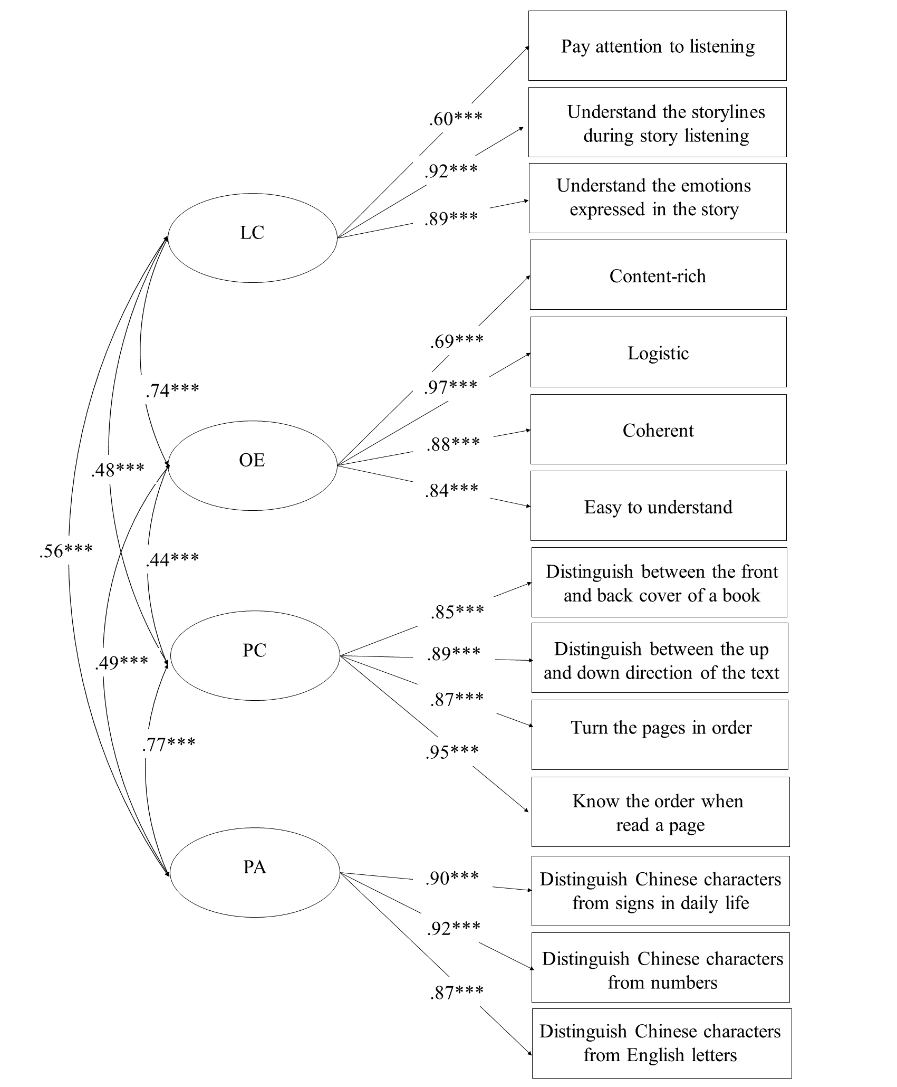
Note. All coefficients are standardized factor loadings. LC = Listening comprehension; OE = Oral expression; PC = Print conventions; PA = Print awareness. ***p < .001.

