Supplementary Materials 1: Sample attrition
Table S1. Sample attrition characteristics
 |  | Eligible sampleª | Excluded due to missing data^{b} | Main sample
 |  | (n=14804) | (n=78) | (n=14726)
School Year
 | Y8-9 | 10522 (71.1%) | 37 (47.4%) | 10485 (71.2%)
 | Y10-11 | 4282 (28.9%) | 41 (52.6%) | 4241 (28.8%)
Gender
 | Female/Other | 8588 (58.0%) | 39 (50.0%) | 8549 (58.1%)
 | Male | 6216 (42.0%) | 39 (50.0%) | 6177 (41.9%)
Self-harm
 | No | 7351 (49.7%) | 0 (0%) | 7351 (49.9%)
 | Yes | 2001 (13.5%) | 0 (0%) | 2001 (13.6%)
 | Missing | 5452 (36.8%) | 78 (100%) | 5374 (36.5%)
Anxiety & Depression
 | M (SD) | 53.9 (17.1) | - | 53.9 (17.1)
 | Missing | 822 (5.6%) | 78 (100%) | 744 (5.1%)
Loneliness
 | M (SD) | 5.19 (1.85) | - | 5.19 (1.85)
 | Missing | 1120 (7.6%) | 78 (100%) | 1042 (7.1%)
Time spent on social media
 | M (SD) | 2.65 (1.34) | - | 2.65 (1.34)
 | Missing | 3268 (22.1%) | 78 (100%) | 3190 (21.7%)
School night screen rules
 | No | 7618 (51.5%) | 0 (0%) | 7618 (51.7%)
 | Yes | 6263 (42.3%) | 0 (0%) | 6263 (42.3%)
 | Missing | 923 (6.2%) | 78 (100%) | 845 (5.7%)
Frequency of social media use before sleep
 | M (SD) | 3.10 (1.32) | - | 3.10 (1.32)
 | Missing | 404 (2.7%) | 78 (100%) | 326 (2.2%)
Meeting online strangers
 | Have not | 11743 (79.3%) | 0 (0%) | 11743 (79.7%)
 | Have | 105 (0.7%) | 0 (0%) | 105 (0.7%)
 | Missing | 2956 (20.0%) | 78 (100%) | 2878 (19.5%)
Regretting posting content online
 | M (SD) | 0.338 (0.669) | - | 0.338 (0.669)
 | Missing | 4298 (29.0%) | 78 (100%) | 4220 (28.7%)
Exposure to self-harm content online
 | M (SD) | 1.13 (1.10) | - | 1.13 (1.10)
 | Missing | 3984 (26.9%) | 78 (100%) | 3906 (26.5%)
Seeking help online
 | No | 14460 (97.7%) | 78 (100%) | 14382 (97.7%)
 | Yes | 344 (2.3%) | 0 (0%) | 344 (2.3%)
Note. ª In total, 33,453 students accessed the OxWell survey in 2021. Of this group, 3,240 were removed due to spending less than 10 min on the survey as questions of interest could not be reasonably reached in that time and 15,409 were removed due to falling outside the secondary-school range (Year groups 8-11). This has resulted in a sample of 14,804 eligible participants based on pre-defined inclusion criteria (https://osf.io/4zmg2). ^{b} Only participants who had data on at least two of the variables included in the model were included in the main sample.

Supplementary Materials 2: Measure coding
Table S2. OxWell 2021 measures included as variables in the current study and their associated coding
Variable | Question | Response options | Response coding
School Year | Recorded year group | Year 8 | 0 = Y8-9
School Year | Recorded year group | Year 9 | 0 = Y8-9
School Year | Recorded year group | Year 10 | 1 = Y10-11
School Year | Recorded year group | Year 11 | 1 = Y10-11
Gender | “Are you male or female?” | Male | 0 = Female| Other/ Prefer not to answer| Missing  1 = Male
Gender | “Are you male or female?” | Female | 0 = Female| Other/ Prefer not to answer| Missing  1 = Male
Gender | “Are you male or female?” | Other/ Prefer not to answer | 0 = Female| Other/ Prefer not to answer| Missing  1 = Male
Gender | “Are you male or female?” | Missing | 0 = Female| Other/ Prefer not to answer| Missing  1 = Male
Self-harm | “Have you ever deliberately self-harmed (for example by taking an overdose or deliberately injuring yourself in some other way)?” | No | 0 = No
Self-harm |  | Yes | 1 = Yes
Self-harm |  | Prefer not to say | Missing = Prefer not to say| Not sure what this means| Missing
Self-harm |  | Not sure what this means
Self-harm |  | Missing
Anxiety & Depression | RCADS-25 (Ebesutani et al., 2012) | 0-75 sum score | T-scores
Anxiety & Depression | RCADS-25 (Ebesutani et al., 2012) | Missing | Missing
Loneliness | UCLA-SF3 (Hughes et al., 2004; Russell, 1996) | 3-9 | 3-9
Loneliness | UCLA-SF3 (Hughes et al., 2004; Russell, 1996) | Missing | Missing
Time spent on social media | “About how many hours a day do you usually spend on social media?” | 0 hours | 0
Time spent on social media |  | 1 hour | 1
Time spent on social media |  | 2 hours | 2
Time spent on social media |  | 3 hours | 3
Time spent on social media |  | 4 hours or more | 4
Time spent on social media |  | Missing | Missing
School night screen rules | “On school nights (when you have lessons the next day), do you have a rule or set time in your house about when you are supposed to turn off or put away computers, phones or other electronics?” | No | 0 = No
School night screen rules |  | Yes | 1 = Yes
School night screen rules |  | Missing | Missing
Frequency of social media use before sleep | “How often do you use social media (e.g., TikTok and Instagram) in the hour before you intend to go to sleep?” | Never | 0
Frequency of social media use before sleep |  | Rarely (1-2 times a month) | 1
Frequency of social media use before sleep |  | Sometimes (1-2 times a week) | 2
Frequency of social media use before sleep |  | Often (3-4 times a week) | 3
Frequency of social media use before sleep |  | Daily | 4
Frequency of social media use before sleep |  | Missing | Missing
Exposure to self-harm content online | “Have you ever come across any content related to self-harm online?” | Never | 0
Exposure to self-harm content online |  | Once or twice | 1
Exposure to self-harm content online |  | A few times | 2
Exposure to self-harm content online |  | Weekly | 3
Exposure to self-harm content online |  | Daily | 4
Exposure to self-harm content online |  | Missing | Missing
Seeking help online | “Have you ever tried to ask for support for a mental health problem from a website or online forum?” | No | 0 = No
Seeking help online |  | Yes | 1 = Yes
Seeking help online |  | Would rather not say | Missing = Would rather not say| Missing
Seeking help online |  | Missing | Missing = Would rather not say| Missing
Meeting online strangers | “Have you ever met a person in the real world that you got to know first online?” | No | 0 = Have not (met someone older/an adult while alone)  1 = Have (met someone older/an adult in person while alone)  Missing = All missing
Meeting online strangers |  | Yes
Meeting online strangers |  | Missing
Meeting online strangers | “What was the age of the person that you met?” | About the same age
Meeting online strangers | “What was the age of the person that you met?” | Younger
Meeting online strangers | “What was the age of the person that you met?” | Older
Meeting online strangers | “What was the age of the person that you met?” | An adult
Meeting online strangers | “What was the age of the person that you met?” | Would rather not say
Meeting online strangers | “What was the age of the person that you met?” | Missing
Meeting online strangers | “Did you take someone with you when you met up with them?” | I went on my own
Meeting online strangers | “Did you take someone with you when you met up with them?” | I went with a parent/carer,
Meeting online strangers | “Did you take someone with you when you met up with them?” | I went with another adult,
Meeting online strangers | “Did you take someone with you when you met up with them?” | I went with my brother/sister
Meeting online strangers | “Did you take someone with you when you met up with them?” | I went with a friend
Meeting online strangers | “Did you take someone with you when you met up with them?” | Missing
Regretting posting content online | “Have you ever posted or done anything on the internet that you later regretted?” | No | 0
Regretting posting content online |  | Yes | -
Regretting posting content online |  | Would rather not say | Missing
Regretting posting content online |  | Missing | Missing
Regretting posting content online | “How often has this happened?” | Never | 0
Regretting posting content online | “How often has this happened?” | Once or twice | 1
Regretting posting content online | “How often has this happened?” | A few times | 2
Regretting posting content online | “How often has this happened?” | Weekly | 3
Regretting posting content online | “How often has this happened?” | Daily | 4
Regretting posting content online | “How often has this happened?” | Missing | Missing
Regretting posting content online | “How often has this happened?” | Not sure what this means
Regretting posting content online | “How often has this happened?” | Missing

Supplementary materials 3: Self-harm subsample
Table S3. Comparison between participants included in and excluded from self-harm
 |  | Included  (n=9352) | Excluded  (n=5374) | t or χ² statistic | df | p-value
School Year
 | Y8-9 | 6801 (72.7%) | 3684 (68.6%) | 28.74 | 1 | < .001
 | Y10-11 | 2551 (27.3%) | 1690 (31.4%) | 28.74 | 1 | < .001
Gender
 | Female/Other | 5356 (57.3%) | 3193 (59.4%) | 6.36 | 1 | .129
 | Male | 3996 (42.7%) | 2181 (40.6%)
Anxiety & Depression (TotT)
 | M (SD) | 52.3 (16.8) | 57.0 (17.1) | 15.42 | 9393 | < .001
 | Missing | 95 (1.0%) | 649 (12.1%)
Loneliness
 | M (SD) | 5.04 (1.84) | 5.49 (1.82) | 13.51 | 8911 | < .001
 | Missing | 132 (1.4%) | 910 (16.9%)
Time spent on social media
 | M (SD) | 2.59 (1.35) | 2.87 (1.28) | 9.32 | 3954 | < .001
 | Missing | 231 (2.5%) | 2959 (55.1%)
School night screen rules
 | No | 4837 (51.7%) | 2781 (51.7%) | 1.83 | 1 | .999
 | Yes | 4047 (43.3%) | 2216 (41.2%)
 | Missing | 468 (5.0%) | 377 (7.0%)
Frequency of social media use before sleep
 | M (SD) | 3.04 (1.34) | 3.19 (1.27) | 6.56 | 11394 | < .001
 | Missing | 185 (2.0%) | 141 (2.6%)
Meeting online strangers
 | Have not | 7588 (81.1%) | 2023 (37.6%) | 0.31 | 1 | .999
 | Have | 1649 (17.6%) | 588 (10.9%)
 | Missing | 115 (1.2%) | 2763 (51.4%)
Regretting posting content online
 | M (SD) | 0.325 (0.656) | 0.390 (0.713) | 3.84 | 3092 | .001
 | Missing | 968 (10.4%) | 3252 (60.5%)
Exposure to self-harm content online
 | M (SD) | 1.07 (1.09) | 1.43 (1.11) | 12.48 | 2467 | < .001
 | Missing | 288 (3.1%) | 3618 (67.3%)
Help seeking online
 | No | 9107 (97.4%) | 5275 (98.2%) | 8.71 | 1 | .035
 | Yes | 245 (2.6%) | 99 (1.8%)
Note. Continuous data comparisons were carried out using Welch Two Sample t-test. Categorical data comparisons were conducted using Pearson's Chi-squared test with Yates' continuity correction. Bonferroni multiple comparison correction across all tests. *p < .05. **p < .01. ***p < .001

Supplementary materials 4: Sensitivity analysis and multiple imputation
As our path analysis model included categorical variables, we utilized the Weighted Least Square Mean and Variance Adjusted Estimator (WLSMV) in our analysis presented in the manuscript. However, whilst WLSMV generally works well with missing data, it is not a full information method and thus may be biased (Asparouhov & Muthén, 2022). To ensure that our findings reported in the main manuscript were not biased, we have repeated our main analysis with the WLSMV estimator with 34 imputed data sets. The multiple imputation (MI) method used is based on a Bayesian estimation of an unrestricted model and uses Rubin (1987) method to pool the data.
Analysis with MI produced slightly higher averaged model fit statistics across all indices (Table S3) in comparison to the model fit statistics in the main analysis (Table S8). However, that did not qualitatively impact any of the previously made model choices. The originally proposed model still did not meet the predefined fit criteria, but addition of the covariance between the ‘Exposure to self-harm content’ and ‘Regretting posting content online’ sufficiently improved the model fit. Similarly, unconstrained models still fit the data significantly better than the constrained models in all the moderation analyses.
The differences between pathway estimation in the main manuscript analysis using WLSMV (Figure 1 and Table 6) and the sensitivity analysis using WLSMV with 34 MI datasets (Figure S1 and Table S4) was also minimal. In comparison to the main analysis, pooled estimations mostly changed some standardized coefficients (β) by up to three points at the level of the second decimal place without a substantial effect on their interpretation. However, a few changes are noteworthy. Specifically, some small or very small associations have changed in significance in the pooled moderation models in comparison to the models presented in the main manuscript. For instance, in the age moderation model, the small association between ‘Time spent on social media’ and ‘Seeking help online’ has lost its significance and the small association between ‘Meeting online strangers’ and ‘Anxiety & Depression’ has become significant for older adolescents (Y10-11). In the gender moderation model, the very small association between ‘Meeting online strangers’ and ‘Anxiety & Depression’, as well as very small covariance between ‘Meeting online strangers’ and ‘Regretting posting content online’ lost its significance in the male sample. Given that these changes in significance affected only, already tenuous, small or very small associations, we deemed the overall findings to be comparable between the models with and without MI and thus favoured the models with WLSMV reported in the main manuscript due to their ability to provide straightforward indirect pathway estimations.
Table S4. Mean model selection and fit statistics on multiple imputation datasets (34 imputations)
Model |  | χ²  (SD) | df | RMSEA  (SD) | CFI  (SD) | SRMR  (SD) | Δχ²  (SD) | Δdf | p^{g}
Main model
 | Proposed | 1368.03  (45.86) | 12 | .088  (.001) | .898  (.003) | .048  (<.001) | 1112.93  (50.88) | 1 | <.001
 | Final adjustedª | 244.61  (17.70) | 11 | .038  (.001) | .982  (.001) | .035  (<.001) | 1112.93  (50.88) | 1 | <.001
Moderation: age
 | Fully constrained^{b} | 234.84  (15.80) | 48 | .023  (.001) | .986  (.001) | .043  (<.001) | 45.56  (13.92) | 26 | .010
 | Unconstrained^{c} | 277.01  (25.69) | 22 | .040  (.002) | .981  (.002) | .042  (<.001) | 45.56  (13.92) | 26 | .010
Moderation: gender
 | Fully constrained^{b} | 518.47  (27.53) | 48 | .036  (.001) | .964  (.002) | .056  (<.001) | 263.36  (30.14) | 26 | <.001
 | Unconstrained^{c} | 302.53  (31.35) | 22 | .042  (.002) | .978  (.002) | .053  (<.001) | 263.36  (30.14) | 26 | <.001
Moderation: self-harm
 | Fully constrained^{b} | 277.13  (5.91) | 48 | .032  (<.001) | .966  (.001) | .054  (<.001) | 157.26  (4.39) | 26 | <.001
 | Unconstrained^{c} | 132.57  (6.38) | 22 | .033  (.001) | .984  (.001) | .042  (<.001) | 157.26  (4.39) | 26 | <.001
Note. ª Covariance between ‘Exposure to self-harm content’ and ‘Regretting posting content online’ added. ^{b} All model parameters constrained to be equal between groups. ^{c} Model parameters allowed to vary between groups. ^{g} p-values were manually estimated based on the pooled Δχ².

Figure S1. Standardized coefficients (β) for associations in path analysis in the a) whole sample, b) age moderation, c) gender moderation, and d) self-harm moderation.
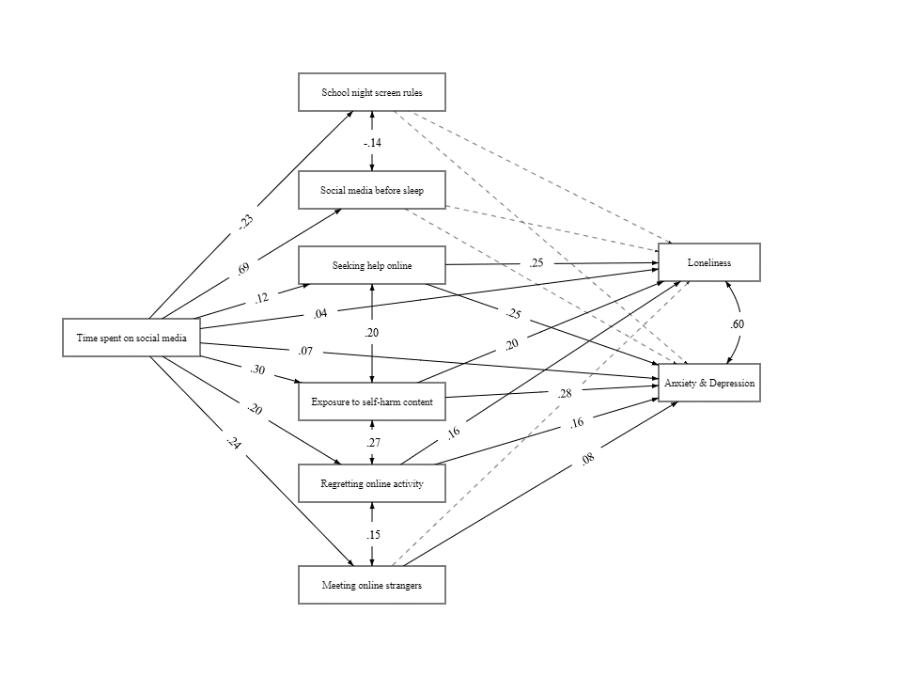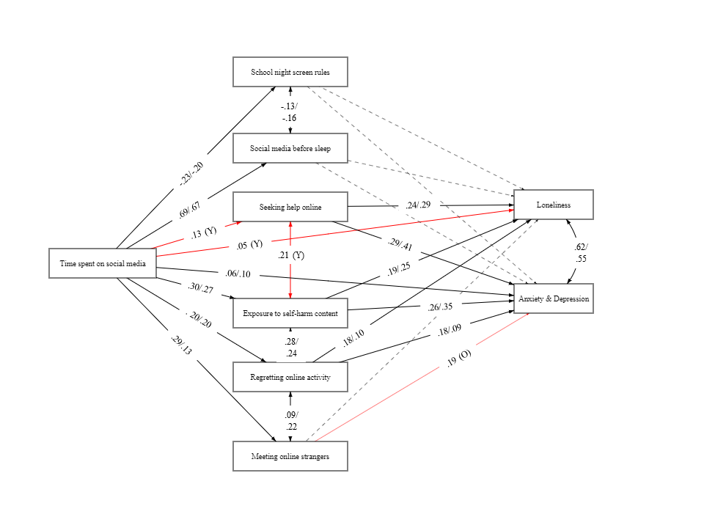
b)
a)
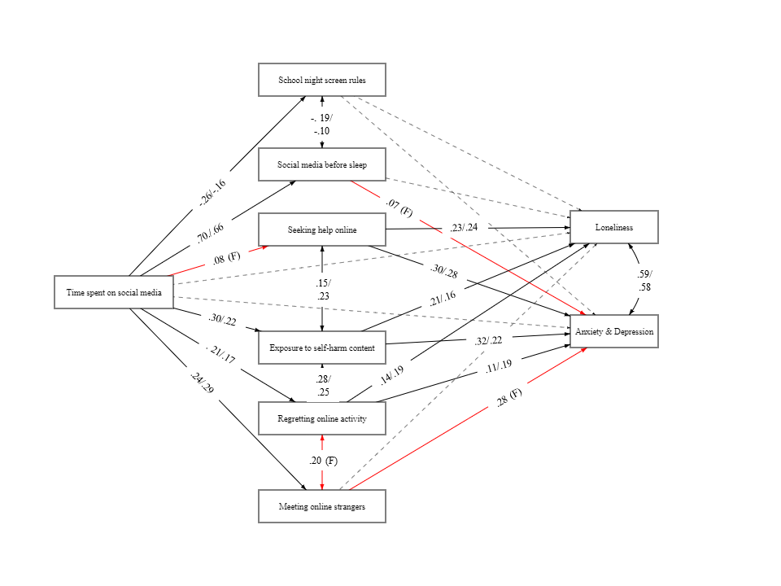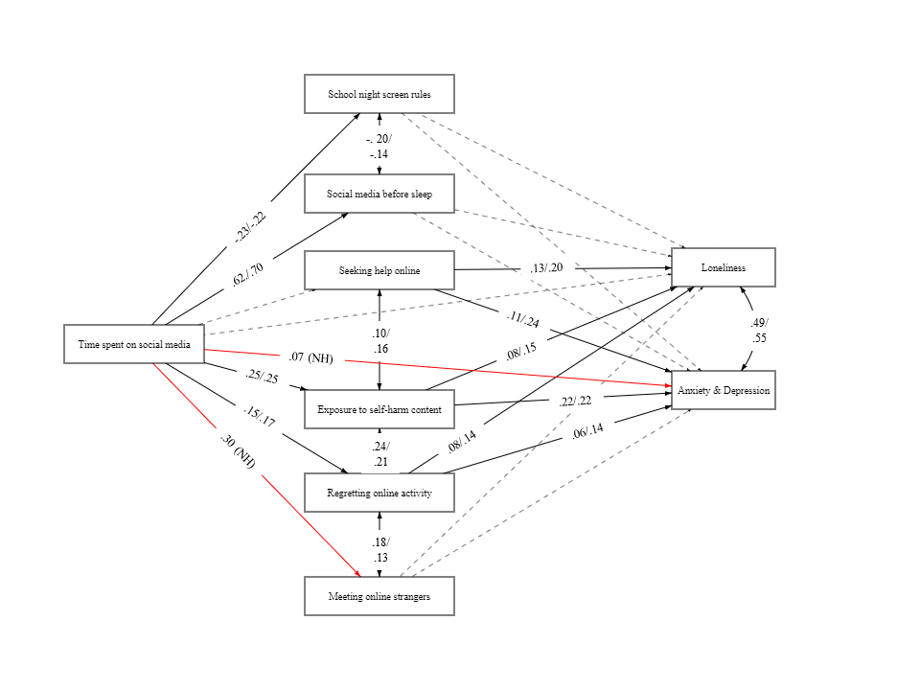
d)
c)
Note. Black lines represent significant associations (p<.05), dashed lines represent non-significant associations (p>.05), and red lines in moderation models represent associations that were only significant in one of the groups. Y = significant in younger age group (Y8-9) only. O = significant in older age group (Y10-11) only. F = significant in Female/Other gender group only. NH = significant in participants with no self-harm experience only.
Table S5. Unstandardized coefficients and standard errors for direct paths in the final models on multiple imputation datasets (34 imputations)
From | To | Main model |  | Moderation analyses
From | To |  |  | Age |  |  |  | Gender |  |  |  | Self-harm
From | To |  |  | Y8-9 |  | Y10-11 |  | Female/ Other |  | Male |  | Yes |  | No
From | To | B (SE) | p | B (SE) | p | B (SE) | p | B (SE) | p | B (SE) | p | B (SE) | p | B (SE) | p
Time spent on social media
 | School night screen rules | -0.18 (0.01) | <.001 | -0.18 (0.01) | <.001 | -0.16 (0.02) | <.001 | -0.22 (0.01) | <.001 | -0.12 (0.02) | <.001 | -0.20 (0.03) | <.001 | -0.17 (0.01) | <.001
 | Frequency of social media use before sleep | 0.69 (0.01) | <.001 | 0.71 (0.02) | <.001 | 0.65 (0.02) | <.001 | 0.69 (0.02) | <.001 | 0.70 (0.02) | <.001 | 0.60 (0.03) | <.001 | 0.73 (0.02) | <.001
 | Seeking help online | 0.09 (0.02) | <.001 | 0.10 (0.02) | <.001 | 0.07 (0.04) | .061 | 0.07 (0.02) | .006 | 0.04 (0.04) | .355 | -0.01 (0.04) | .851 | 0.06 (0.03) | .064
 | Exposure to self-harm content online | 0.25 (0.01) | <.001 | 0.25 (0.01) | <.001 | 0.24 (0.02) | <.001 | 0.28 (0.01) | <.001 | 0.17 (0.01) | <.001 | 0.25 (0.02) | <.001 | 0.18 (0.01) | <.001
 | Regretting posting content online | 0.10 (0.01) | <.001 | 0.10 (0.01) | <.001 | 0.11 (0.01) | <.001 | 0.12 (0.01) | <.001 | 0.08 (0.01) | <.001 | 0.12 (0.02) | <.001 | 0.07 (0.01) | <.001
 | Meeting online strangers | 0.19 (0.04) | <.001 | 0.22 (0.04) | <.001 | 0.11 (0.05) | .022 | 0.20 (0.05) | <.001 | 0.22 (0.05) | <.001 | 0.08 (0.05) | .133 | 0.24 (0.06) | <.001
 | Loneliness | 0.06 (0.02) | .010 | 0.06 (0.03) | .033 | 0.08 (0.04) | .070 | -0.01 (0.03) | .878 | -0.01 (0.04) | .831 | 0.08 (0.04) | .052 | 0.02 (0.03) | .613
 | Anxiety & Depression | 0.92 (0.21) | <.001 | 0.76 (0.31) | .015 | 1.30 (0.50) | .010 | -0.33 (0.50) | .499 | 0.40 (0.35) | .251 | 0.41 (0.41) | .314 | 0.68 (0.25) | .006
School night screen rules
 | Loneliness | -0.02 (0.02) | .257 | -0.03 (0.02) | .254 | 0.02 (0.04) | .672 | -0.01 (0.03) | 0.781 | -0.01 (0.03) | .757 | 0.02 (0.05) | .771 | -0.02 (0.02) | .503
 | Anxiety & Depression | -0.21 (0.18) | .234 | -0.1 (0.21) | .633 | 0.05 (0.35) | .895 | -0.17 (0.24) | .478 | 0.14 (0.26) | .595 | 0.11 (0.48) | .821 | -0.28 (0.19) | .150
Frequency of social media use before sleep
 | Loneliness | -<0.01 (0.02) | .813 | 0.01 (0.02) | .594 | -0.05 (0.04) | 0.133 | 0.04 (0.03) | .074 | -0.01 (0.02) | .769 | -0.02 (0.04) | .582 | 0.02 (0.02) | .293
 | Anxiety & Depression | 0.14 (0.16) | .376 | 0.21 (0.18) | .261 | -0.31 (0.35) | .377 | 0.94 (0.24) | <.001 | -0.15 (0.22) | .493 | 0.65 (0.4) | .101 | 0.06 (0.16) | .740
Seeking help online
 | Loneliness | 0.45 (0.04) | <.001 | 0.43 (0.05) | <.001 | 0.54 (0.07) | <.001 | 0.42 (0.05) | <.001 | 0.39 (0.07) | <.001 | 0.23 (0.07) | .001 | 0.31 (0.05) | <.001
 | Anxiety & Depression | 4.19 (0.38) | <.001 | 4.75 (0.96) | <.001 | 7.19 (1.07) | <.001 | 5.04 (0.73) | <.001 | 4.29 (1.62) | .008 | 1.72 (0.69) | .012 | 3.07 (0.47) | <.001
Exposure to self-harm content online
 | Loneliness | 0.34 (0.02) | <.001 | 0.32 (0.03) | <.001 | 0.42 (0.04) | <.001 | 0.35 (0.03) | <.001 | 0.27 (0.04) | <.001 | 0.12 (0.04) | .001 | 0.25 (0.03) | <.001
 | Anxiety & Depression | 4.33 (0.18) | <.001 | 3.96 (0.24) | <.001 | 5.39 (0.46) | <.001 | 4.78 (0.31) | <.001 | 3.19 (0.39) | <.001 | 2.99 (0.31) | <.001 | 2.86 (0.21) | <.001
Regretting posting content online
 | Loneliness | 0.44 (0.03) | <.001 | 0.51 (0.04) | <.001 | 0.27 (0.06) | <.001 | 0.37 (0.05) | <.001 | 0.52 (0.05) | <.001 | 0.14 (0.05) | .008 | 0.41 (0.04) | <.001
 | Anxiety & Depression | 3.98 (0.29) | <.001 | 4.62 (0.32) | <.001 | 2.21 (0.67) | .001 | 2.73 (0.71) | <.001 | 4.56 (0.40) | <.001 | 1.12 (0.47) | .018 | 3.44 (0.29) | <.001
Meeting online strangers
 | Loneliness | 0.04 (0.06) | .458 | -<0.01 (0.08) | .994 | 0.10 (0.11) | .329 | 0.16 (0.09) | .085 | 0.05 (0.08) | .523 | 0.08 (0.10) | .430 | -0.08 (0.09) | .375
 | Anxiety & Depression | 1.39 (0.48) | .004 | 1.23 (0.80) | .123 | 3.31 (1.16) | .004 | 4.57 (1.74) | .009 | 1.41 (0.75) | .061 | 1.71 (0.94) | .067 | 0.09 (0.54) | .863

Supplementary materials 5: Group comparisons
Table S6. Additional information on participants’ online behaviours in the total and moderation samples
 |  |  |  |  | Total |  |  | School Year |  |  |  |  |  | Gender |  |  |  | Self-harm
 |  |  |  |  | (n=14726) |  |  | Y8-9 |  | Y10-11 |  |  |  | Female/ Other |  | Male |  | No | Yes
 |  |  |  |  | (n=14726) |  |  | (n=10485) |  | (n=4241) |  |  |  | (n=8549) |  | (n=6177) |  | (n=7351) | (n=2001)
Frequency of social media use before sleep
 | “How often do you use social media (e.g., TikTok and Instagram) in the hour before you intend to go to sleep?”
 |  |  | Never |  | 1239 (8.4%) |  |  |  | 962 (9.2%) |  | 277 (6.5%) | *** |  | 538 (6.3%) | 701 (11.3%) |  | *** | 748 (10.2%) |  | 105 (5.2%) |  | ***
 |  |  | Rarely (1-2 times a month) |  | 1008 (6.8%) |  |  |  | 757 (7.2%) |  | 251 (5.9%) |  |  | 513 (6.0%) | 495 (8.0%) |  |  | 582 (7.9%) |  | 83 (4.1%)
 |  |  | Sometimes (1-2 times a week) |  | 1401 (9.5%) |  |  |  | 1064 (10.1%) |  | 337 (7.9%) |  |  | 747 (8.7%) | 654 (10.6%) |  |  | 808 (11.0%) |  | 134 (6.7%)
 |  |  | Often (3-4 times a week) |  | 2240 (15.2%) |  |  |  | 1581 (15.1%) |  | 659 (15.5%) |  |  | 1277 (14.9%) | 963 (15.6%) |  |  | 1201 (16.3%) |  | 288 (14.4%)
 |  |  | Daily |  | 8512 (57.8%) |  |  |  | 5894 (56.2%) |  | 2618 (61.7%) |  |  | 5305 (62.1%) | 3207 (51.9%) |  |  | 3859 (52.5%) |  | 1359 (67.9%)
 |  |  | Missing |  | 326 (2.2%) |  |  |  | 227 (2.2%) |  | 99 (2.3%) |  |  | 169 (2.0%) | 157 (2.5%) |  |  | 153 (2.1%) |  | 32 (1.6%)
Meeting online strangers
“Have you ever met a person in the real world that you got to know first online?”
 |  |  |  | No | 9611 (65.3%) |  |  | 7151 (68.2%) |  | 2460 (58.0%) |  |  | *** | 5851 (68.4%) |  | 3760 (60.9%) | ** | 6236 (84.8%) | 1352 (67.6%) |  |  | ***
 |  |  |  | Yes | 2237 (15.2%) |  |  | 1480 (14.1%) |  | 757 (17.8%) |  |  |  | 1258 (14.7%) |  | 979 (15.8%) |  | 1033 (14.1%) | 616 (30.8%)
 |  |  |  | Missing | 2878 (19.5%) |  |  | 1854 (17.7%) |  | 1024 (24.1%) |  |  |  | 1440 (16.8%) |  | 1438 (23.3%) |  | 82 (1.1%) | 33 (1.6%)
 | “What was the age of the person that you met?”
 |  |  |  | Adult | 38 (0.3%) |  |  | 26 (0.2%) |  | 12 (0.3%) |  |  |  | 15 (0.2%) |  | 23 (0.4%) |  | 22 (0.3%) | 8 (0.4%)
 |  |  |  | Older | 242 (1.6%) |  |  | 158 (1.5%) |  | 84 (2.0%) |  |  |  | 133 (1.6%) |  | 109 (1.8%) |  | 101 (1.4%) | 73 (3.6%)
 |  |  |  | Same | 2228 (15.1%) |  |  | 1494 (14.2%) |  | 734 (17.3%) |  |  |  | 1262 (14.8%) |  | 966 (15.6%) |  | 1111 (15.1%) | 564 (28.2%)
 |  |  |  | Would rather not say | 37 (0.3%) |  |  | 31 (0.3%) |  | 6 (0.1%) |  |  |  | 18 (0.2%) |  | 19 (0.3%) |  | 20 (0.3%) | 9 (0.4%)
 |  |  |  | Younger | 96 (0.7%) |  |  | 70 (0.7%) |  | 26 (0.6%) |  |  |  | 44 (0.5%) |  | 52 (0.8%) |  | 45 (0.6%) | 27 (1.3%)
 |  |  |  | Missing | 12085 (82.1%) |  |  | 8706 (83.0%) |  | 3379 (79.7%) |  |  |  | 7077 (82.8%) |  | 5008 (81.1%) |  | 6052 (82.3%) | 1320 (66.0%)
 | “Did you take someone with you when you met up with them? I went:”
 |  |  |  | On my own | 617 (4.2%) |  |  | 377 (3.6%) |  | 240 (5.7%) |  |  | * | 290 (3.4%) |  | 327 (5.3%) | *** | 277 (3.8%) | 194 (9.7%) |  |  | **
 |  |  |  | With a friend | 1311 (8.9%) |  |  | 871 (8.3%) |  | 440 (10.4%) |  |  |  | 766 (9.0%) |  | 545 (8.8%) |  | 645 (8.8%) | 329 (16.4%)
 |  |  |  | With a parent/carer | 221 (1.5%) |  |  | 160 (1.5%) |  | 61 (1.4%) |  |  |  | 147 (1.7%) |  | 74 (1.2%) |  | 111 (1.5%) | 56 (2.8%)
 |  |  |  | With another adult | 39 (0.3%) |  |  | 33 (0.3%) |  | 6 (0.1%) |  |  |  | 21 (0.2%) |  | 18 (0.3%) |  | 13 (0.2%) | 14 (0.7%)
 |  |  |  | With my brother/sister | 57 (0.4%) |  |  | 41 (0.4%) |  | 16 (0.4%) |  |  |  | 43 (0.5%) |  | 14 (0.2%) |  | 19 (0.3%) | 24 (1.2%)
 |  |  |  | Missing | 12481 (84.8%) |  |  | 9003 (85.9%) |  | 3478 (82.0%) |  |  |  | 7282 (85.2%) |  | 5199 (84.2%) |  | 6286 (85.5%) | 1384 (69.2%)
Regretting posting content online
 | “Have you ever posted or done anything on the internet that you later regretted?”
 |  |  |  | No | 7791 (52.9%) |  |  | 5723 (54.6%) |  | 2068 (48.8%) |  |  | ** | 4522 (52.9%) |  | 3269 (52.9%) | *** | 5406 (73.5%) | 888 (44.4%) |  |  | ***
 |  |  |  | Yes | 2867 (19.5%) |  |  | 2006 (19.1%) |  | 861 (20.3%) |  |  |  | 1792 (21.0%) |  | 1075 (17.4%) |  | 1321 (18.0%) | 865 (43.2%)
 |  |  |  | Missing | 4068 (27.6%) |  |  | 2756 (26.3%) |  | 1312 (30.9%) |  |  |  | 2235 (26.1%) |  | 1833 (29.7%) |  | 624 (8.5%) | 248 (12.4%)
 | “How often has this happened?”
 |  |  |  | Never | 209 (1.4%) |  |  | 156 (1.5%) |  | 53 (1.2%) |  |  |  | 117 (1.4%) |  | 92 (1.5%) | ** | 131 (1.8%) | 32 (1.6%) |  |  | ***
 |  |  |  | Once or twice | 2077 (14.1%) |  |  | 1466 (14.0%) |  | 611 (14.4%) |  |  |  | 1252 (14.6%) |  | 825 (13.4%) |  | 1096 (14.9%) | 526 (26.3%)
 |  |  |  | A few times | 702 (4.8%) |  |  | 478 (4.6%) |  | 224 (5.3%) |  |  |  | 478 (5.6%) |  | 224 (3.6%) |  | 272 (3.7%) | 251 (12.5%)
 |  |  |  | Weekly | 82 (0.6%) |  |  | 60 (0.6%) |  | 22 (0.5%) |  |  |  | 61 (0.7%) |  | 21 (0.3%) |  | 23 (0.3%) | 41 (2.0%)
 |  |  |  | Daily | 48 (0.3%) |  |  | 31 (0.3%) |  | 17 (0.4%) |  |  |  | 28 (0.3%) |  | 20 (0.3%) |  | 12 (0.2%) | 24 (1.2%)
 |  |  |  | Missing | 11608 (78.8%) |  |  | 8294 (79.1%) |  | 3314 (78.1%) |  |  |  | 6613 (77.4%) |  | 4995 (80.9%) |  | 5817 (79.1%) | 1127 (56.3%)
 | “Which of the following was this:”
 | Photo/video of yourself |  |  |  | 1822 (12.4%) |  |  | 1272 (12.1%) |  | 550 (13.0%) |  |  |  | 1239 (14.5%) |  | 583 (9.4%) | *** | 799 (10.9%) | 598 (29.9%) |  |  | ***
 | Photo/video of someone else |  |  |  | 356 (2.4%) |  |  | 246 (2.3%) |  | 110 (2.6%) |  |  |  | 231 (2.7%) |  | 125 (2.0%) |  | 135 (1.8%) | 137 (6.8%) |  |  | ***
 | Public comment |  |  |  | 925 (6.3%) |  |  | 653 (6.2%) |  | 272 (6.4%) |  |  |  | 561 (6.6%) |  | 364 (5.9%) |  | 409 (5.6%) | 317 (15.8%) |  |  | ***
 | Private comment |  |  |  | 454 (3.1%) |  |  | 297 (2.8%) |  | 157 (3.7%) |  |  |  | 270 (3.2%) |  | 184 (3.0%) |  | 214 (2.9%) | 154 (7.7%) |  |  | ***
 | Sending money to someone |  |  |  | 97 (0.7%) |  |  | 60 (0.6%) |  | 37 (0.9%) |  |  |  | 55 (0.6%) |  | 42 (0.7%) |  | 36 (0.5%) | 40 (2.0%) |  |  | ***
 | Buying/doing something illegal |  |  |  | 183 (1.2%) |  |  | 114 (1.1%) |  | 69 (1.6%) |  |  |  | 114 (1.3%) |  | 69 (1.1%) |  | 53 (0.7%) | 87 (4.3%) |  |  | ***
Exposure to self-harm content online
 | “Have you ever come across any content related to self-harm online?”
 |  |  |  | Never | 4075 (27.7%) |  |  | 3137 (29.9%) |  | 938 (22.1%) |  |  | *** | 2006 (23.5%) |  | 2069 (33.5%) | *** | 3320 (45.2%) | 299 (14.9%) |  |  | ***
 |  |  |  | Once or twice | 2861 (19.4%) |  |  | 2099 (20.0%) |  | 762 (18.0%) |  |  |  | 1718 (20.1%) |  | 1143 (18.5%) |  | 1976 (26.9%) | 458 (22.9%)
 |  |  |  | A few times | 2642 (17.9%) |  |  | 1822 (17.4%) |  | 820 (19.3%) |  |  |  | 1812 (21.2%) |  | 830 (13.4%) |  | 1386 (18.9%) | 654 (32.7%)
 |  |  |  | Weekly | 904 (6.1%) |  |  | 633 (6.0%) |  | 271 (6.4%) |  |  |  | 655 (7.7%) |  | 249 (4.0%) |  | 359 (4.9%) | 340 (17.0%)
 |  |  |  | Daily | 338 (2.3%) |  |  | 216 (2.1%) |  | 122 (2.9%) |  |  |  | 248 (2.9%) |  | 90 (1.5%) |  | 97 (1.3%) | 175 (8.7%)
 |  |  |  | Missing | 3906 (26.5%) |  |  | 2578 (24.6%) |  | 1328 (31.3%) |  |  |  | 2110 (24.7%) |  | 1796 (29.1%) |  | 213 (2.9%) | 75 (3.7%)
Seeking help online
 | “Regarding this support, are you:”
 |  |  |  | Currently offered | 48 (0.3%) |  |  | 35 (0.3%) |  | 13 (0.3%) |  |  |  | 39 (0.5%) |  | 9 (0.1%) |  | 13 (0.2%) | 23 (1.1%)
 |  |  |  | Not been offered | 47 (0.3%) |  |  | 32 (0.3%) |  | 15 (0.4%) |  |  |  | 39 (0.5%) |  | 8 (0.1%) |  | 9 (0.1%) | 22 (1.1%)
 |  |  |  | Previously been offered | 164 (1.1%) |  |  | 105 (1.0%) |  | 59 (1.4%) |  |  |  | 135 (1.6%) |  | 29 (0.5%) |  | 39 (0.5%) | 78 (3.9%)
 |  |  |  | Been turned away | 73 (0.5%) |  |  | 52 (0.5%) |  | 21 (0.5%) |  |  |  | 65 (0.8%) |  | 8 (0.1%) |  | 24 (0.3%) | 29 (1.4%)
 |  |  |  | Missing | 14394 (97.7%) |  |  | 10261 (97.9%) |  | 4133 (97.5%) |  |  |  | 8271 (96.7%) |  | 6123 (99.1%) |  | 7266 (98.8%) | 1849 (92.4%)
Note. Continuous data comparisons were carried out using Welch Two Sample t-test. Categorical data comparisons were conducted using Pearson's Chi-squared test with Yates' continuity correction. Bonferroni multiple comparison correction across all tests. *p < .05. **p < .01. ***p < .001

Table S7. Cross-tabulated moderation information
 |  | Total |  | School Year |  |  | Gender |  |  | Self-harm
 |  | (n=14726) |  | Y8-9 | Y10-11 |  | Female/Other | Male |  | No | Yes
 |  | (n=14726) |  | (n=10485) | (n=4241) |  | (n=8549) | (n=6177) |  | (n=7351) | (n=2001)
School Year
 | Y8-9 | 10485 (71.2%) |  | 10485 (100%) | 0  (0%) | *** | 6025  (70.5%) | 4460 (72.2%) |  | 5454 (74.2%) | 1347 (67.3%) | ***
 | Y10-11 | 4241 (28.8%) |  | 0  (0%) | 4241  (100%) |  | 2524  (29.5%) | 1717 (27.8%) |  | 1897 (25.8%) | 654  (32.7%)
Gender
 | Female/Other | 8549 (58.1%) |  | 6025  (57.5%) | 2524 (59.5%) |  | 8549  (100%) | 0 (0%) | *** | 3772 (51.3%) | 1584 (79.2%) | ***
 | Male | 6177 (41.9%) |  | 4460  (42.5%) | 1717 (40.5%) |  | 0  (0%) | 6177  (100%) |  | 3579 (48.7%) | 417  (20.8%)
Self-harm
 | No | 7351 (49.9%) |  | 5454  (52.0%) | 1897 (44.7%) | *** | 3772  (44.1%) | 3579 (57.9%) | *** | 7351  (100%) | 0  (0%) | ***
 | Yes | 2001 (13.6%) |  | 1347  (12.8%) | 654  (15.4%) |  | 1584  (18.5%) | 417  (6.8%) |  | 0  (0%) | 2001  (100%)
 | Missing | 5374 (36.5%) |  | 3684  (35.1%) | 1690 (39.8%) |  | 3193  (37.3%) | 2181 (35.3%) |  | 0  (0%) | 0  (0%)
Note. Comparisons conducted using Pearson's Chi-squared test Yates' continuity and Bonferroni multiple comparison corrections. *p < .05. **p < .01. ***p < .001

Supplementary materials 6: Correlation analyses
Table S8. Spearman correlation matrix for model variables in the self-harm moderation sample
 | 1 | 2 | 3 | 4 | 5 | 6 | 7 | 8
- Anxiety & Depression | -
- Loneliness | .70*** | -
- Time spent on social media | .25*** | .17*** | -
- School night screen rules | -.06*** | -.04** | -.17*** | -
- Frequency of social media use before sleep | .18*** | .13*** | .62*** | -.23*** | -
- Meeting online strangers | .04** | .02 | .04** | -.03 | .04** | -
- Regretting posting content online | .29*** | .26*** | .19*** | -.06*** | .19*** | .07*** | -
- Exposure to self-harm content online | .42*** | .33*** | .27*** | -.09*** | .22*** | .05*** | .31*** | -
- Help seeking online | .15*** | .13*** | .04** | .01 | .02 | <.01 | .09*** | .11***
Note. Bonferroni multiple comparison correction across all tests. *p < .05. **p < .01. ***p < .001

Supplementary materials 7: SEM
Table S9. Model selection and fit statistics
Model |  | χ² | df | RMSEA | CFI | SRMR | Δχ² | Δdf | p
Main model
 | Proposed | 918.68 | 12 | .072 | .914 | .051 | 740.80 | 1 | <.001
 | Final adjustedª | 184.20 | 11 | .033 | .984 | .037 | 740.80 | 1 | <.001
Moderation: age
 | Fully constrained^{b} | 177.95 | 48 | .019 | .988 | .041 | 47.06 | 26 | .007
 | Unconstrained^{c} | 180.93 | 22 | .031 | .985 | .037 | 47.06 | 26 | .007
Moderation: gender
 | Fully constrained^{b} | 401.61 | 48 | .032 | .966 | .060 | 226.71 | 26 | <.001
 | Unconstrained^{c} | 196.09 | 22 | .033 | .983 | .049 | 226.71 | 26 | <.001
Moderation: self-harm
 | Fully constrained^{b} | 252.48 | 48 | .030 | .968 | .054 | 143.43 | 26 | <.001
 | Unconstrained^{c} | 120.15 | 22 | .031 | .985 | .041 | 143.43 | 26 | <.001
Note. ª Covariance between ‘Exposure to self-harm content’ and ‘Regretting posting content online’ added. ^{b} All model parameters constrained to be equal between groups. ^{c} Model parameters allowed to vary between groups.

Table S10. Unstandardized coefficients and standard errors for direct paths in the final models
From | To | Main model |  | Moderation analyses
From | To |  |  | Age |  |  |  | Gender |  |  |  | Self-harm
From | To |  |  | Y8-9 |  | Y10-11 |  | Female/ Other |  | Male |  | Yes |  | No
From | To | B (SE) | p | B (SE) | p | B (SE) | p | B (SE) | p | B (SE) | p | B (SE) | p | B (SE) | p
Time spent on social media
 | School night screen rules | -0.18 (0.01) | <.001 | -0.18 (0.01) | <.001 | -0.16 (0.02) | <.001 | -0.22 (0.01) | <.001 | -0.11 (0.02) | <.001 | -0.20 (0.03) | <.001 | -0.17 (0.01) | <.001
 | Frequency of social media use before sleep | 0.69 (0.01) | <.001 | 0.70 (0.02) | <.001 | 0.64 (0.02) | <.001 | 0.69 (0.02) | <.001 | 0.69 (0.02) | <.001 | 0.60 (0.03) | <.001 | 0.73 (0.02) | <.001
 | Seeking help online | 0.09 (0.02) | <.001 | 0.09 (0.02) | <.001 | 0.09 (0.04) | .022 | 0.07 (0.02) | .005 | 0.04 (0.04) | .383 | -0.01 (0.04) | .844 | 0.06 (0.03) | .073
 | Exposure to self-harm content online | 0.25 (0.01) | <.001 | 0.25 (0.01) | <.001 | 0.24 (0.02) | <.001 | 0.28 (0.01) | <.001 | 0.17 (0.01) | <.001 | 0.25 (0.02) | <.001 | 0.19 (0.01) | <.001
 | Regretting posting content online | 0.11 (0.01) | <.001 | 0.10 (0.01) | <.001 | 0.11 (0.01) | <.001 | 0.12 (0.01) | <.001 | 0.08 (0.01) | <.001 | 0.12 (0.02) | <.001 | 0.07 (0.01) | <.001
 | Meeting online strangers | 0.20 (0.03) | <.001 | 0.24 (0.40) | <.001 | 0.13 (0.05) | .003 | 0.22 (0.04) | <.001 | 0.22 (0.05) | <.001 | 0.07 (0.05) | .154 | 0.23 (0.06) | <.001
 | Loneliness | 0.07 (0.03) | .004 | 0.08 (0.03) | .012 | 0.08 (0.04) | .061 | <0.01 (0.03) | .997 | -0.01 (0.04) | .873 | 0.08 (0.04) | .053 | 0.02 (0.03) | .580
 | Anxiety & Depression | 0.96 (0.22) | <.001 | 0.85 (0.27) | .002 | 1.65 (0.40) | <.001 | 0.19 (0.30) | .526 | 0.32 (0.32) | .323 | 0.50 (0.41) | .225 | 0.69 (0.24) | .005
School night screen rules
 | Loneliness | -0.02 (0.02) | .268 | -0.03 (0.03) | .278 | 0.02 (0.04) | .680 | -0.01 (0.03) | .695 | -0.01 (0.03) | .676 | 0.02 (0.05) | .682 | -0.02 (0.02) | .544
 | Anxiety & Depression | -0.21 (0.18) | .235 | -0.10 (0.21) | .633 | 0.05 (0.35) | .895 | -0.19 (0.24) | .417 | 0.11 (0.26) | .659 | 0.14 (0.48) | .771 | -0.28 (0.20) | .148
Frequency of social media use before sleep
 | Loneliness | -0.01 (0.02) | .594 | <0.01 (0.02) | .845 | -0.06 (0.04) | .118 | 0.04 (0.03) | .136 | -0.01 (0.02) | .744 | -0.01 (0.04) | .729 | 0.02 (0.02) | .272
 | Anxiety & Depression | 0.10 (0.16) | .560 | 0.20 (0.18) | .274 | -0.34 (0.34) | .323 | 0.81 (0.23) | <.001 | -0.07 (0.22) | .738 | 0.65 (0.4) | .104 | 0.05 (0.17) | .750
Seeking help online
 | Loneliness | 0.45 (0.04) | <.001 | 0.43 (0.05) | <.001 | 0.50 (0.07) | <.001 | 0.41 (0.05) | <.001 | 0.39 (0.07) | <.001 | 0.23 (0.07) | .001 | 0.31 (0.05) | <.001
 | Anxiety & Depression | 4.22 (0.37) | <.001 | 4.37 (0.43) | <.001 | 4.00 (0.72) | <.001 | 4.04 (0.45) | <.001 | 3.39 (0.67) | <.001 | 1.75 (0.69) | .011 | 3.03 (0.47) | <.001
Exposure to self-harm content online
 | Loneliness | 0.34 (0.02) | <.001 | 0.32 (0.03) | <.001 | 0.38 (0.04) | <.001 | 0.34 (0.03) | <.001 | 0.27 (0.04) | <.001 | 0.11 (0.04) | .002 | 0.24 (0.03) | <.001
 | Anxiety & Depression | 4.35 (0.18) | <.001 | 3.98 (0.22) | <.001 | 4.88 (0.31) | <.001 | 4.54 (0.23) | <.001 | 3.35 (0.29) | <.001 | 2.96 (0.31) | <.001 | 2.86 (0.21) | <.001
Regretting posting content online
 | Loneliness | 0.44 (0.03) | <.001 | 0.50 (0.03) | <.001 | 0.30 (0.06) | <.001 | 0.37 (0.04) | <.001 | 0.52 (0.04) | <.001 | 0.16 (0.06) | .004 | 0.41 (0.04) | <.001
 | Anxiety & Depression | 4.05 (0.26) | <.001 | 4.63 (0.28) | <.001 | 2.79 (0.54) | <.001 | 3.43 (0.42) | <.001 | 4.50 (0.33) | <.001 | 1.20 (0.48) | .013 | 3.43 (0.28) | <.001
Meeting online strangers
 | Loneliness | 0.04 (0.06) | .539 | -<0.01 (0.07) | .991 | 0.09 (0.11) | .379 | 0.15 (0.09) | .081 | 0.05 (0.08) | .540 | 0.07 (0.1) | .467 | -0.09 (0.09) | .331
 | Anxiety & Depression | 1.31 (0.51) | .011 | 0.91 (0.62) | .144 | 1.77 (0.95) | .061 | 2.54 (0.81) | .002 | 1.26 (0.62) | .041 | 1.72 (0.95) | .069 | 0.08 (0.54) | .886

Table S11. Standardized coefficients (β), unstandardized coefficients (B) and standard errors (SE) for indirect paths in the main model
Path | Via | β | B (SE) | p
Time spent on social media -> Loneliness
Total indirect |  | .13 | 0.18 (0.02) | <.001
 | School night screen rules | <.01 | <0.01 (<0.01) | .270
 | Frequency of social media use before sleep | -.01 | -0.01 (0.01) | .594
 | Seeking help online | .01 | 0.01 (0.01) | .532
 | Exposure to self-harm content online | .03 | 0.04 (<0.01) | <.001
 | Regretting posting content online | .06 | 0.09 (0.01) | <.001
 | Meeting online strangers | .03 | 0.04 (0.01) | <.001
Time spent on social media -> Anxiety & Depression
Total indirect |  | .18 | 2.28 (0.19) | <.001
 | School night screen rules | <.01 | 0.04 (0.03) | .238
 | Frequency of social media use before sleep | .01 | 0.07 (0.11) | .561
 | Seeking help online | .02 | 0.27 (0.10) | .009
 | Exposure to self-harm content online | .03 | 0.42 (0.03) | <.001
 | Regretting posting content online | .08 | 1.10 (0.06) | <.001
 | Meeting online strangers | .03 | 0.39 (0.09) | <.001

Table S12. Standardized coefficients (β), unstandardized coefficients (B) and standard errors (SE) for indirect paths in the age moderation model
Path | Via | Age
Path | Via | Y8-9 |  |  | Y10-11
Path | Via | β | B (SE) | p | β | B (SE) | p
Time spent on social media -> Loneliness
Total indirect |  | .13 | 0.18 (0.03) | <.001 | .10 | 0.14 (0.04) | <.001
 | School night screen rules | <.01 | 0.01 (<0.01) | .282 | <.01 | -<0.01 (0.01) | .679
 | Frequency of social media use before sleep | <.01 | <0.01 (0.02) | .845 | -.02 | -0.04 (0.02) | .116
 | Seeking help online | <.01 | <0.01 (0.02) | .991 | .01 | 0.01 (0.01) | .372
 | Exposure to self-harm content online | .04 | 0.05 (0.01) | <.001 | .02 | 0.04 (0.01) | <.001
 | Regretting posting content online | .06 | 0.08 (0.01) | <.001 | .06 | 0.09 (0.01) | <.001
 | Meeting online strangers | .03 | 0.04 (0.01) | <.001 | .03 | 0.04 (0.02) | .032
Time spent on social media -> Anxiety & Depression
Total indirect |  | .18 | 2.25 (0.25) | <.001 | .13 | 1.85 (0.32) | <.001
 | School night screen rules | <.01 | 0.02 (0.04) | .634 | <.01 | -0.01 (0.06) | .895
 | Frequency of social media use before sleep | .01 | 0.14 (0.13) | .276 | -.02 | -0.22 (0.22) | .321
 | Seeking help online | .02 | 0.22 (0.15) | .137 | .02 | 0.23 (0.12) | .060
 | Exposure to self-harm content online | .04 | 0.46 (0.04) | <.001 | .02 | 0.32 (0.07) | <.001
 | Regretting posting content online | .08 | 1.00 (0.07) | <.001 | .09 | 1.18 (0.11) | <.001
 | Meeting online strangers | .03 | 0.41 (0.12) | .001 | .03 | 0.34 (0.15) | .025

Table S13. Standardized coefficients (β), unstandardized coefficients (B) and standard errors (SE) for indirect paths in the gender moderation model
Path | Via | Gender
Path | Via | Female/ Other |  |  | Male
Path | Via | β | B (SE) | p | β | B (SE) | p
Time spent on social media -> Loneliness
Total indirect |  | .15 | 0.23 (0.03) | <.001 | .09 | 0.11 (0.03) | .001
 | School night screen rules | <.01 | <.01 (0.01) | .695 | <.01 | <0.01 (<0.01) | .678
 | Frequency of social media use before sleep | .02 | 0.03 (0.02) | .138 | <.01 | -0.01 (0.02) | .743
 | Seeking help online | .02 | 0.03 (0.02) | .058 | .01 | 0.01 (0.02) | .541
 | Exposure to self-harm content online | .03 | 0.05 (0.01) | <.001 | .03 | 0.04 (0.01) | <.001
 | Regretting posting content online | .06 | 0.09 (0.01) | <.001 | .04 | 0.05 (0.01) | <.001
 | Meeting online strangers | .02 | 0.03 (0.01) | .007 | .01 | 0.02 (0.02) | .407
Time spent on social media -> Anxiety & Depression
Total indirect |  | .22 | 3.11 (0.27) | <.001 | .11 | 1.27 (0.28) | <.001
 | School night screen rules | <.01 | 0.04 (0.05) | .419 | <.01 | -0.01 (0.03) | .659
 | Frequency of social media use before sleep | .04 | 0.56 (0.16) | .001 | <.01 | -0.05 (0.15) | .737
 | Seeking help online | .04 | 0.55 (0.16) | .001 | .03 | 0.28 (0.15) | .055
 | Exposure to self-harm content online | .03 | 0.42 (0.06) | <.001 | .03 | 0.36 (0.04) | <.001
 | Regretting posting content online | .09 | 1.27 (0.09) | <.001 | .05 | 0.56 (0.07) | <.001
 | Meeting online strangers | .02 | 0.28 (0.10) | .008 | .01 | 0.13 (0.15) | .403

Table S14. Standardized coefficients (β), unstandardized coefficients (B) and standard errors (SE) for indirect paths in the self-harm moderation model
Path | Via | Self-harm
Path | Via | Yes |  |  | No
Path | Via | β | B (SE) | p | β | B (SE) | p
Time spent on social media -> Loneliness
Total indirect |  | .08 | 0.09 (0.03) | .002 | .03 | 0.04 (0.03) | .193
 | School night screen rules | <.01 | <0.01 (<0.01) | .545 | <.01 | <0.01 (0.01) | .682
 | Frequency of social media use before sleep | .01 | 0.02 (0.02) | .274 | -.01 | -0.01 (0.03) | .728
 | Seeking help online | -.02 | -0.02 (0.02) | .358 | <.01 | 0.01 (0.01) | .486
 | Exposure to self-harm content online | .02 | 0.03 (<0.01) | <.001 | .01 | 0.02 (0.01) | .009
 | Regretting posting content online | .04 | 0.05 (0.01) | <.001 | .02 | 0.03 (0.01) | .002
 | Meeting online strangers | .02 | 0.02 (0.01) | .100 | <.01 | -<0.01 (0.01) | .843
Time spent on social media -> Anxiety & Depression
Total indirect |  | .11 | 1.05 (0.22) | <.001 | .10 | 1.34 (0.28) | <.001
 | School night screen rules | .01 | 0.05 (0.03) | .154 | <.01 | -0.03 (0.10) | .771
 | Frequency of social media use before sleep | <.01 | 0.04 (0.12) | .751 | .03 | 0.39 (0.24) | .106
 | Seeking help online | <.01 | 0.02 (0.12) | .886 | .01 | 0.12 (0.09) | .205
 | Exposure to self-harm content online | .02 | 0.24 (0.03) | <.001 | .01 | 0.14 (0.06) | .02
 | Regretting posting content online | .05 | 0.53 (0.05) | <.001 | .05 | 0.73 (0.10) | <.001
 | Meeting online strangers | .02 | 0.19 (0.11) | .100 | <.01 | -0.01 (0.07) | .843

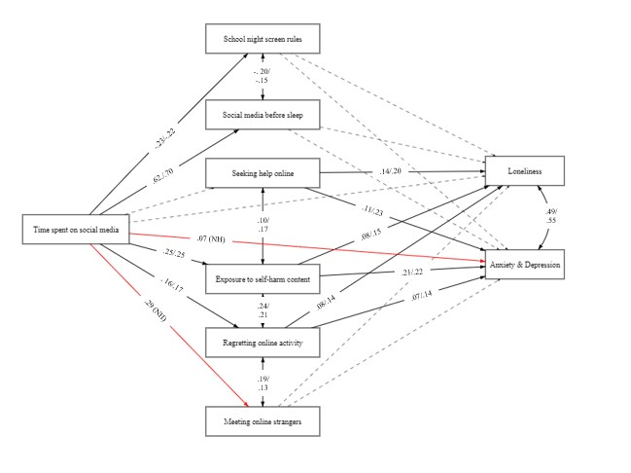
Figure S2. Structural equation model depicting standardised coefficients (β) in path analysis of time spent on social media and online behaviours with anxiety and depression and loneliness as a function of self-harm. Note. Black lines represent significant associations (p<.05), dashed lines represent non-significant associations (p>.05), and red lines in moderation models represent associations that were only significant in one of the groups. NH = significant in participants with no self-harm experience only.

