Basic Instructions for Participants

On the next screen, you will read a short description of a research study. Please imagine yourself as a participant in this study and try to vividly imagine actually being in the situation described.

When you are done reading through this scenario, we will ask you a series of questions about the scenario, and about yourself.
Milgram Scenario for Participants

You agree to be a part of a study of learning and punishment. The experimenter explains the premise behind the experiment. He says to you, “There is very little research to date about how punishment affects learning. Because of the lack of knowledge, we have questions about the effects different people have on each other as teachers and learners and what effect punishment will have in this situation.”

After you are given the purpose of the study you are then introduced to a man who is also participating in the study. The experimenter holds a hat out in front of you two and tells you both to pick a role randomly out of the hat. You choose the role of the teacher and he chooses the role of the learner.

You both are taken to an adjacent room and the learner is strapped into an electric chair. The experimenter says the straps are to avoid excessive movement while the learner is being shocked. You see an electrode being attached to the learner's wrist along with electrode paste. The electrode paste prevents burns and blisters when the learner is shocked. The learner asks if the shocks will hurt and the experimenter says to the learner, “while they can be extremely painful, the shocks will not cause any permanent damage to the tissue.” After the learner is strapped in, the experimenter gives you a sample shock on your wrist at 45 volts. The learner also mentions that they have had heart issues in the past and asks if this will be a problem. The experimenter answers that there should be no problem. You and the teacher then go to another room with a generator.

The experimenter describes that the task will be a paired-associate task. You are going to read a word to the learner and then four other words and he must push the button to indicate which word, 1,2,3 or 4, goes with the first word. After the directions are explained the experimenter takes you into the other room to show you the generator that administers the shocks. The generator has 30 switches–from 15 volts to 450 volts.

Now the study has started. You begin asking the learner the words and he gets the first few correct. You ask him another question and he gets the answer incorrect. The experimenter tells you to give him a shock and announce the voltage. You announce 15 voltages and press the switch. You hear a loud buzzing. You continue on and every time the learner gets the questions incorrect the experimenter tells you to shock them on the next higher voltage level.

As time goes on you start to feel uncomfortable shocking the learner. If and when you tell the experimenter you want to stop, he says to you, “Please continue.” You continue on shocking the learner until once again you say you do not want to continue. The experimenter replies, “The experiment requires you to continue.” You indicate again that you wish to be done. Then the experimenter says, “It is absolutely essential that you continue.”. You refuse again. Then the experimenter says, “You have no other choice, you must go on.” Only if you refuse a fourth and final time, the experimenter explains to you that the experiment is complete and will continue on to explain the aims of the study.

The question is, at what voltage level, if any, do you think you would disobey and end the study?
Baseline Results Condition

As you make your prediction, it may be useful for you to know that when this study was conducted in real life, 65% of participants continued all the way to the 30th and final voltage level.

Shock Machine Image

Here is a photo of the shock machine used in the study described to you. There are 30 total voltage switches on the machine.

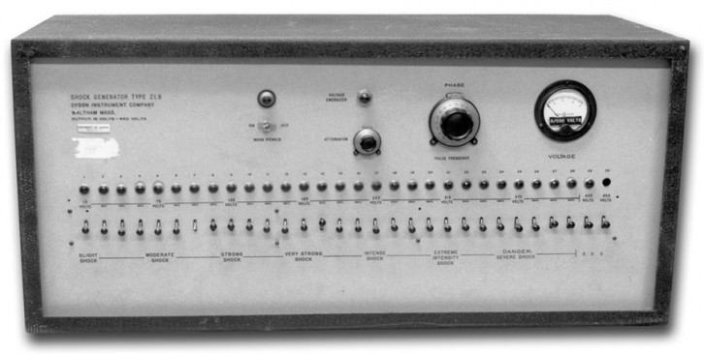

Shock Scale with Descriptions

Please indicate using the scale below where you think YOU would have stopped the study.

Please indicate using the scale below where you think THE AVERAGE PERSON would have stopped the study.

Switch Volts Label
1 15 Slight Shock
2 30
3 45
4 60
5 75 Moderate Shock
6 90
7 105
8 120
9 135 Strong Shock
10 150
11 165
12 180
13 195 Very Strong Shock
14 210
15 225
16 240
17 255 Intense Shock
18 270
19 285
20 300

*At this point, you hear the learner knocking on the wall. From this point on, they give no more answers, and you are instructed that a “no answer” counts as a wrong answer.

21 315 Extreme Intensity Shock
22 330
23 345
24 360
25 375 Danger Severe Shock
26 390
27 405
28 420
29 435 XXX
30 450

Right-wing Authoritarianism Scale (Short Version)

--from Zakrisson, I. (2005). Construction of a short version of the Right-Wing Authoritarianism (RWA) scale. Personality and Individual Differences, 39, 863-872.

1 = Strongly Disagree; 7 = Strongly Agree
1. Our country needs a powerful leader, in order to destroy the radical and immoral currents prevailing in society today.
2. Our country needs free thinkers, who will have the courage to stand up against traditional ways, even if this upsets many people.
3. The ‘‘old-fashioned ways’’ and ‘‘old-fashioned values’’ still show the best way to live.
4. Our society would be better off if we showed tolerance and understanding for untraditional values and opinions.
5. God’s laws about abortion, pornography and marriage must be strictly followed before it is too late, violations must be punished.
6. The society needs to show openness towards people thinking differently, rather than a strong leader, the world is not particularly evil or dangerous.
7. It would be best if newspapers were censored so that people would not be able to get hold of destructive and disgusting material.
8. Many good people challenge the state, criticize the church and ignore ‘‘the normal way of living’’.
9. Our forefathers ought to be honored more for the way they have built our society, at the same time we ought to put an end to those forces destroying it.
10. People ought to put less attention to the Bible and religion, instead they ought to develop their own moral standards.
11. There are many radical, immoral people trying to ruin things; the society ought to stop them.
12. It is better to accept bad literature than to censor it.
13. Facts show that we have to be harder against crime and sexual immorality, in order to uphold law and order.
14. The situation in the society of today would be improved if troublemakers were treated with reason and humanity.
15. If the society so wants, it is the duty of every true citizen to help eliminate the evil that poi- sons our country from within.
Big-5 Personality Inventory (Short Version)

--from Rammstedt, B., & John, O. P. (2007). Measuring personality in one minute or less: A 10-item short version of the Big Five Inventory in English and German. Journal of Research in Personality, 41, 203-212.

1 = Disagree strongly
2 = Disagree a little
3 = Neither agree nor disagree
4 = Agree a little
5 = Agree strongly

I see myself as someone who:
…is reserved
…is generally trusting
…tends to be lazy
…is relaxed, handles stress well
…has few artistic interests
…is outgoing, sociable
…tends to find fault with others
…does a thorough job
…gets nervous easily
…has an active imagination

Manipulation and Knowledge Checks

Please select one below:
Following the study description I was told of the results from a previous study.
___NO
___YES
If YES: What percentage were you told continued to the end of the shock machine? ____

Have you ever heard of the Milgram Shock Study prior to this study?
___NO
___YES

Demographic Questions

Age: _____

Gender:
___Female
___Male
___Other

Please indicate your highest level of educational attainment:
___Did not graduate high school
___High school graduate or equivalent (e.g., G.E.D.)
___Some College
___Associate’s Degree
___Bachelor’s Degree
___Master’s Degree
___Doctorate-Level Degree

