Mental Health and Academic Engagement: Practice-Based Evidence from a Pre-Post Study on Students Attending a University Counselling Service – Supplementary Materials
Mixed models Diagnostic
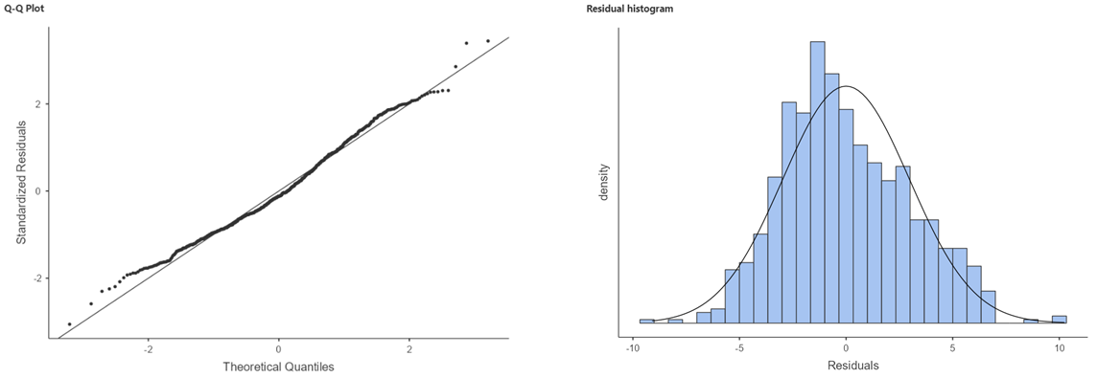
Figure 1 GAD-7 Residual Plots
Figure 2 - BDI-II Residual Plots
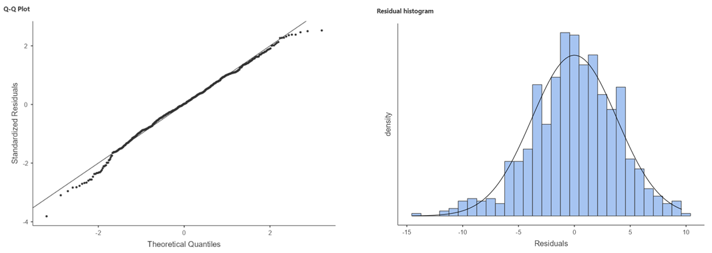
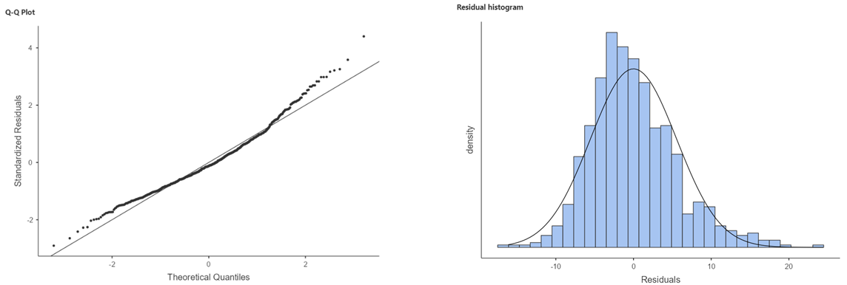
Figure 3 - ERQ-10 Cognitive Reappraisal Residual Plots
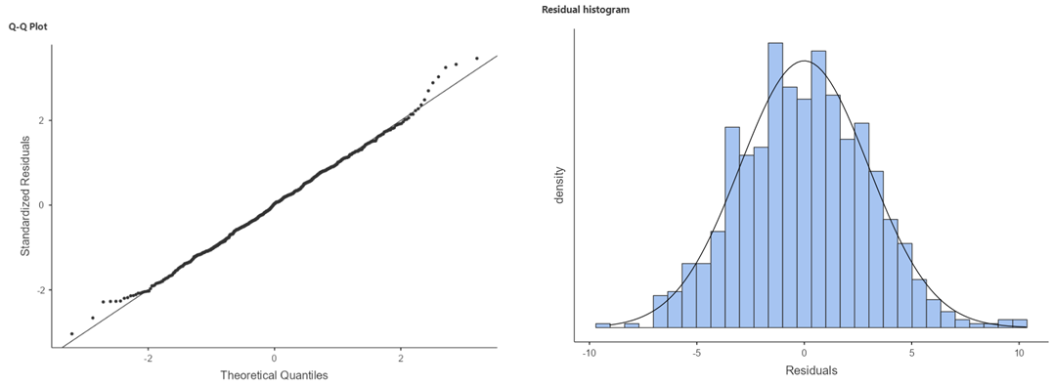
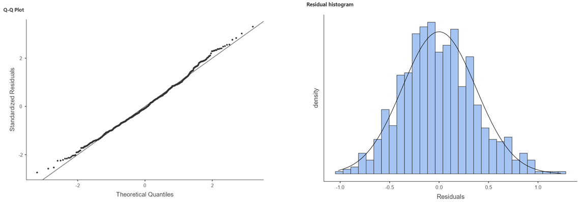
Figure 4- CORE-OM All Items Less Risk subscale Residual Plot
Figure 5 - ERQ-10 - Expressive Suppression Residual Plots

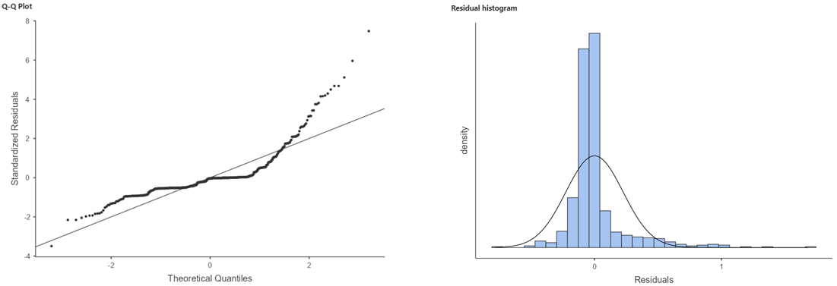
Figure 6 - CORE-OM Risk subscale Residual Plot
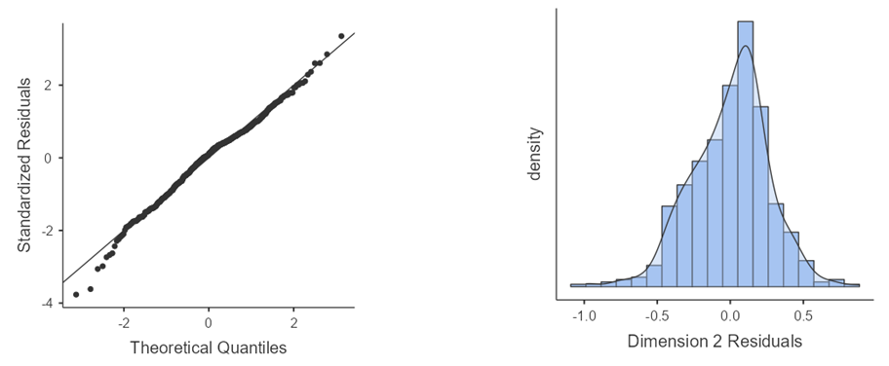
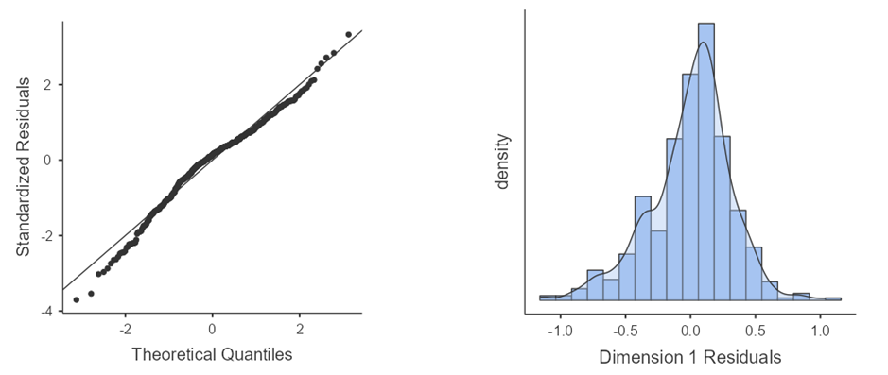
Figure 7 - University value and sense of belonging Residual plots
Figure 8 - Perception of the capability to persist in the university choice Residual Plots
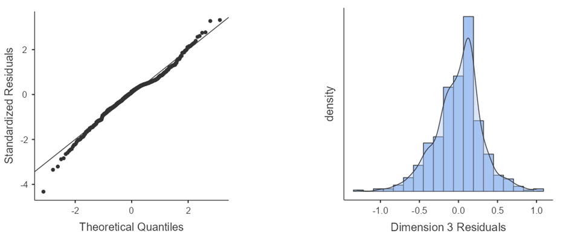
Figure 9 - Value of University Course Residual Plots

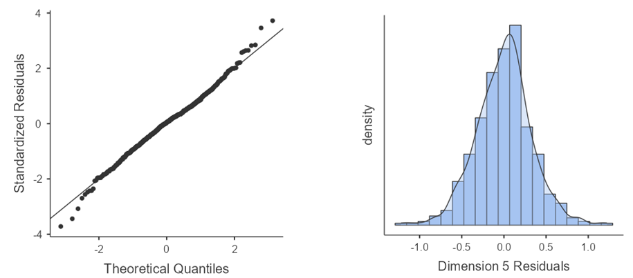
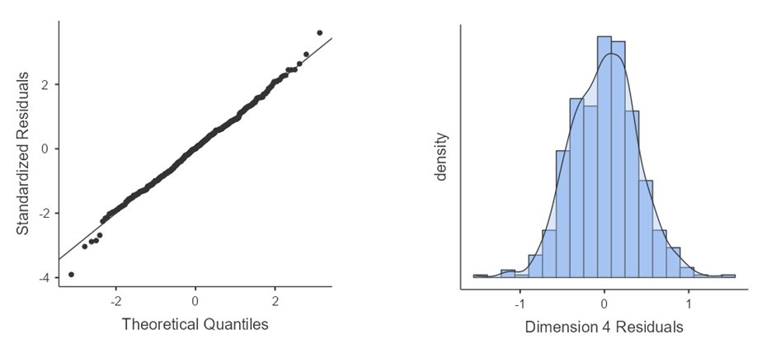
Figure 10- Relationships with University Peers Residual Plots
Figure 11 - Integration between university and relational net Residual Plots
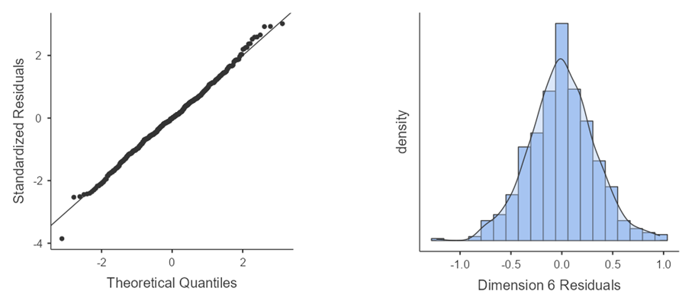
Figure 12 - Relationships with University Professors Residual Plots

Table S1 Skewness and kurtosis values for all outcome variables at pre- and post-intervention
 | Time
 | Pre |  | Post
Psychological otucomes | Skewness | Kurtosis | Skewness | Kurtosis
Anxiety severity (GAD-7) | -0.010 | -0.771 | 0.840 | 0.134
Depression severity (BDI-II) | 0.584 | -0.017 | 1.497 | 2.650
Cognitive Reappraisal (ERQ-10) | -0.231 | -0.067 | -0.501 | 0.335
Expressive Suppression (ERQ-10) | -0.028 | -0.670 | 0.191 | -0.482
All items minus Risk (CORE-OM) | -0.022 | -0.473 | 0.722 | 0.317
Risk (CORE-OM) | 2.599 | 7.668 | 3.719 | 17.004
SAES dimensions
Perception of the capability to persist in the university choice | -0.848 | 0.075 | -1.049 | 0.741
University value and sense of belonging | -0.472 | -0.224 | -0.649 | -0.172
Value of university course | -0.353 | -0.362 | -0.506 | -0.370
Integration between university and relational net | 0.063 | -1.086 | -0.097 | -0.985
Relationships with university peers | -0.008 | -0.851 | -0.253 | -0.687
Relationships with university professors | 0.009 | -0.140 | -0.060 | 0.239

Table S2 - Correlation matrix of Pre-intervention Psychological Outcomes scores and Age
 |  | 1 | 2 | 3 | 4 | 5 | 6
1. Age | Pearson's r | —
 | df | —
 | p-value | —
2.GAD-7 | Pearson's r | -0.026 | —
 | df | 370 | —
 | p-value | 0.614 | —
3.BDI-II | Pearson's r | 0.007 | 0.617*** | —
 | df | 370 | 370 | —
 | p-value | 0.899 | < .001 | —
4.ERQ-CR | Pearson's r | 0.035 | -0.246*** | -0.360*** | —
 | df | 370 | 370 | 370 | —
 | p-value | 0.504 | < .001 | < .001 | —
5.ERQ-ES | Pearson's r | -0.023 | 0.125* | 0.270*** | -0.041 | —
 | df | 370 | 370 | 370 | 370 | —
 | p-value | 0.663 | 0.016 | < .001 | 0.435 | —
6. CORE-OM All items less Risk | Pearson's r | -0.016 | 0.674*** | 0.832*** | -0.293*** | 0.307*** | —
 | df | 370 | 370 | 370 | 370 | 370 | —
 | p-value | 0.765 | < .001 | < .001 | < .001 | < .001 | —
7. CORE-OM Risk | Pearson's r | -0.025 | 0.325*** | 0.504*** | -0.202*** | 0.165** | 0.467***
 | df | 370 | 370 | 370 | 370 | 370 | 370
 | p-value | 0.626 | < .001 | < .001 | < .001 | 0.001 | < .001
Note. * p < .05, ** p < .01, *** p < .001

Table S3 - Correlational Matrix of Pre-intervention AE dimensions scores and Age
 |  | 1 | 2 | 3 | 4 | 5 | 6
1.Age | Pearson's r | —
 | df | —
 | p-value | —
2.Perception of the capability to persist in the university choice | Pearson's r | -.265*** | —
 | df | 278 | —
 | p-value | < .001 | —
3.University value and sense of belonging | Pearson's r | -.061 | .672*** | —
 | df | 278 | 278 | —
 | p-value | .312 | < .001 | —
4.Value of university course | Pearson's r | -.048 | .593*** | .714*** | —
 | df | 278 | 278 | 278 | —
 | p-value | .427 | < .001 | < .001 | —
5.Integration between university and relational net | Pearson's r | -.034 | .256*** | .489*** | .356*** | —
 | df | 278 | 278 | 278 | 278 | —
 | p-value | .567 | < .001 | < .001 | < .001 | —
6.Relationships with university peers | Pearson's r | -.190** | .361*** | .404*** | .410*** | .351*** | —
 | df | 278 | 278 | 278 | 278 | 278 | —
 | p-value | .001 | < .001 | < .001 | < .001 | < .001 | —
7.Relationships with university professors | Pearson's r | .001 | .331*** | .347*** | .394*** | .174** | .276***
 | df | 278 | 278 | 278 | 278 | 278 | 278
 | p-value | .990 | < .001 | < .001 | < .001 | .003 | < .001
Note. * p < .05, ** p < .01, *** p < .001

Table S4 - Standardized factor loadings for the correlated six-factor model of the SAES
Latent | Observed | Estimate | SE | Lower | Upper | β | z | p
Persistence | In my opinion, University education is not worth all the time, money and effort it takes me | 1.000 | 0.000 | 1.000 | 1.000 | 0.588
Persistence | Sometimes I think about leaving university | 1.261 | 0.135 | 0.997 | 1.525 | 0.760 | 9.36 | <.001
Persistence | I would leave University right away if I had an alternative | 1.072 | 0.118 | 0.841 | 1.304 | 0.724 | 9.08 | <.001
Persistence | I’d better do other things than go to University | 1.222 | 0.127 | 0.973 | 1.470 | 0.801 | 9.64 | <.001
Belonging | I think University is good for me | 1.000 | 0.000 | 1.000 | 1.000 | 0.786
Belonging | University engagement is part of my life plans | 1.016 | 0.072 | 0.876 | 1.156 | 0.793 | 14.22 | <.001
Belonging | University has a great importance in my life | 0.903 | 0.071 | 0.765 | 1.042 | 0.727 | 12.79 | <.001
Belonging | Despite the difficulties I sometimes encounter in university life, I think it is worth continuing my studies | 0.858 | 0.067 | 0.726 | 0.989 | 0.727 | 12.78 | <.001
Belonging | I take University education seriously | 0.881 | 0.091 | 0.703 | 1.060 | 0.572 | 9.68 | <.001
Belonging | Going to University is a great opportunity for me | 0.895 | 0.071 | 0.757 | 1.033 | 0.723 | 12.70 | <.001
Course value | The course of study I’m attending is an opportunity for me | 1.000 | 0.000 | 1.000 | 1.000 | 0.838
Course value | I am convinced that my decision to enroll in this University was the right one for me | 1.009 | 0.075 | 0.862 | 1.157 | 0.702 | 13.44 | <.001
Course value | I find my studies very significant for my professional plans | 1.058 | 0.058 | 0.945 | 1.172 | 0.859 | 18.26 | <.001
Course value | I’m sure the degree course I’m attending is the right place for me | 1.189 | 0.069 | 1.054 | 1.323 | 0.831 | 17.30 | <.001
Course value | I like the course of study I’m attending | 1.156 | 0.063 | 1.031 | 1.280 | 0.859 | 18.25 | <.001
Course value | The course of study I’m attending is interesting | 1.096 | 0.058 | 0.982 | 1.210 | 0.875 | 18.84 | <.001
Course value | The course of study I’m attending is functional to the achievement of my professional goals | 1.129 | 0.066 | 0.999 | 1.258 | 0.825 | 17.08 | <.001
Integration | I discuss with my family about my University path | 1.000 | 0.000 | 1.000 | 1.000 | 0.797
Integration | I talk about my professional plans with my friends | 0.786 | 0.064 | 0.661 | 0.911 | 0.675 | 12.32 | <.001
Integration | I talk about my professional plans with my family | 1.264 | 0.080 | 1.108 | 1.420 | 0.980 | 15.88 | <.001
Peers | Studying with other students is useful to me | 1.000 | 0.000 | 1.000 | 1.000 | 0.561
Peers | I feel like I’m part of a group of friends at university | 1.827 | 0.179 | 1.476 | 2.179 | 0.889 | 10.18 | <.001
Peers | I like to meet friends at university | 1.358 | 0.137 | 1.090 | 1.626 | 0.843 | 9.92 | <.001
Peers | I’ve made meaningful friends with some college colleagues | 1.709 | 0.173 | 1.370 | 2.047 | 0.838 | 9.89 | <.001
Peers | I have good relationships with my university colleagues | 1.377 | 0.139 | 1.106 | 1.649 | 0.847 | 9.95 | <.001
Professors | Teachers clarify what they expect of us students | 1.000 | 0.000 | 1.000 | 1.000 | 0.742
Professors | Teachers are usually available to discuss my work | 1.126 | 0.084 | 0.962 | 1.291 | 0.818 | 13.43 | <.001
Professors | My teachers respect me as a person | 1.092 | 0.079 | 0.937 | 1.248 | 0.838 | 13.76 | <.001
Professors | My teachers are interested in my opinions and what I say | 1.188 | 0.085 | 1.022 | 1.354 | 0.858 | 14.05 | <.001

Table S5 - Standardized factor loadings for the second-order CFA model of the SAES
Latent | Observed | Estimate | SE | Lower | Upper | β | z | p
Persistence | In my opinion, University education is not worth all the time, money and effort it takes me | 1.000 | 0.000 | 1.000 | 1.000 | 0.584
Persistence | Sometimes I think about leaving university | 1.271 | 0.137 | 1.003 | 1.539 | 0.760 | 9.28 | <.001
Persistence | I would leave University right away if I had an alternative | 1.079 | 0.120 | 0.844 | 1.314 | 0.723 | 9.00 | <.001
Persistence | I’d better do other things than go to University | 1.000 | 0.000 | 1.000 | 1.000 | 0.584
Belonging | I think University is good for me | 1.000 | 0.000 | 1.000 | 1.000 | 0.793
Belonging | University engagement is part of my life plans | 0.996 | 0.070 | 0.858 | 1.133 | 0.784 | 14.14 | <.001
Belonging | University has a great importance in my life | 0.885 | 0.070 | 0.749 | 1.022 | 0.720 | 12.72 | <.001
Belonging | Despite the difficulties I sometimes encounter in university life, I think it is worth continuing my studies | 0.855 | 0.066 | 0.726 | 0.984 | 0.731 | 12.96 | <.001
Belonging | I take University education seriously | 0.865 | 0.090 | 0.688 | 1.041 | 0.567 | 9.61 | <.001
Belonging | Going to University is a great opportunity for me | 0.895 | 0.069 | 0.760 | 1.031 | 0.73 | 12.94 | <.001
Course value | The course of study I’m attending is an opportunity for me | 1.000 | 0.000 | 1.000 | 1.000 | 0.838
Course value | I am convinced that my decision to enroll in this University was the right one for me | 1.007 | 0.075 | 0.860 | 1.154 | 0.701 | 13.42 | <.001
Course value | I find my studies very significant for my professional plans | 1.058 | 0.058 | 0.944 | 1.171 | 0.859 | 18.28 | <.001
Course value | I’m sure the degree course I’m attending is the right place for me | 1.188 | 0.069 | 1.054 | 1.323 | 0.831 | 17.32 | <.001
Course value | I like the course of study I’m attending | 1.154 | 0.063 | 1.030 | 1.278 | 0.858 | 18.24 | <.001
Course value | The course of study I’m attending is interesting | 1.096 | 0.058 | 0.982 | 1.210 | 0.875 | 18.88 | <.001
Course value | The course of study I’m attending is functional to the achievement of my professional goals | 1.128 | 0.066 | 0.999 | 1.258 | 0.825 | 17.11 | <.001
Integration | I discuss with my family about my University path | 1.000 | 0.000 | 1.000 | 1.000 | 0.791
Integration | I talk about my professional plans with my friends | 0.786 | 0.064 | 0.660 | 0.912 | 0.669 | 12.23 | <.001
Integration | I talk about my professional plans with my family | 1.283 | 0.083 | 1.121 | 1.446 | 0.988 | 15.50 | <.001
Peers | Studying with other students is useful to me | 1.000 | 0.000 | 1.000 | 1.000 | 0.561
Peers | I feel like I’m part of a group of friends at university | 1.829 | 0.179 | 1.477 | 2.181 | 0.89 | 10.19 | <.001
Peers | I like to meet friends at university | 1.359 | 0.137 | 1.091 | 1.628 | 0.843 | 9.90 | <.001
Peers | I’ve made meaningful friends with some college colleagues | 1.709 | 0.173 | 1.370 | 2.047 | 0.838 | 9.89 | <.001
Peers | I have good relationships with my university colleagues | 1.374 | 0.138 | 1.103 | 1.645 | 0.847 | 9.95 | <.001
Professors | Teachers clarify what they expect of us students | 1.000 | 0.000 | 1.000 | 1.000 | 0.740
Professors | Teachers are usually available to discuss my work | 1.130 | 0.084 | 0.965 | 1.295 | 0.819 | 13.40 | <.001
Professors | My teachers respect me as a person | 1.095 | 0.080 | 0.939 | 1.252 | 0.838 | 13.71 | <.001
Professors | My teachers are interested in my opinions and what I say | 1.192 | 0.085 | 1.025 | 1.358 | 0.858 | 14.01 | <.001
Second-Order Structure
Engagement | Belonging | 1.000 | 0.000 | 1.000 | 1.000 | 0.967
Engagement | Persistence | 0.721 | 0.087 | 0.551 | 0.891 | 0.805 | 8.29 | <.001
Engagement | Course value | 0.864 | 0.075 | 0.717 | 1.011 | 0.819 | 11.54 | <.001
Engagement | Integration | 0.665 | 0.100 | 0.469 | 0.862 | 0.460 | 6.65 | <.001
Engagement | Peers | 0.476 | 0.076 | 0.328 | 0.624 | 0.498 | 6.30 | <.001
Engagement | Professors | 0.449 | 0.072 | 0.308 | 0.589 | 0.440 | 6.24 | <.001

Table S6 - Univariate tests of MANCOVA on Pre-intervention psychological outcomes scores
Factor | Dependent Variable | df | F | p | η_{p}²
Gender | GAD-7 | 1 | 629.653 | .013 | .017
 | BDI-II | 1 | 136.377 | .244 | .004
 | ERQ-CR | 1 | 0.11067 | .740 | .000
 | ERQ-ES | 1 | 915.820 | .003 | .024
 | CORE-OM All items less Risk | 1 | 203.115 | .155 | .006
 | CORE-OM Risk | 1 | 876.106 | .003 | .023
Age | GAD-7 | 1 | .51244 | .475 | .001
 | BDI-II | 1 | .00102 | .975 | .000
 | ERQ-CR | 1 | .48747 | .485 | .001
 | ERQ-ES | 1 | .03767 | .846 | .000
 | CORE-OM All items less Risk | 1 | .17433 | .677 | .000
 | CORE-OM Risk | 1 | .06338 | .801 | .000
Residuals | GAD-7 | 369
 | BDI-II | 369
 | ERQ-CR | 369
 | ERQ-ES | 369
 | CORE-OM All items less Risk | 369
 | CORE-OM Risk | 369

Table S7 - Univariate tests of MANCOVA on Pre-intervention AE dimensions scores
Factor | Dependent Variable | df | F | p | η_{p}²
Gender | Perception of the capability to persist in the university choice | 1 | 1.9823 | .160 | .007
 | University value and sense of belonging | 1 | 6.6532 | .010 | .023
 | Value of university course | 1 | 1.4015 | .237 | .005
 | Integration between university and relational net | 1 | 3.1195 | .078 | .011
 | Relationships with University Peers | 1 | 3.0697 | .081 | .011
 | Relationships with University Professors | 1 | .3253 | .569 | .001
Age | Perception of the capability to persist in the university choice | 1 | 23.0053 | < .001 | .077
 | University value and sense of belonging | 1 | 1.7447 | .188 | .006
 | Value of university course | 1 | .8722 | .351 | .003
 | Integration between university and relational net | 1 | .6043 | .438 | .002
 | Relationships with University Peers | 1 | 11.9852 | < .001 | .041
 | Relationships with University Professors | 1 | .0027 | .959 | .000
Residuals | Perception of the capability to persist in the university choice | 277
 | University value and sense of belonging | 277
 | Value of university course | 277
 | Integration between university and relational net | 277
 | Relationships with University Peers | 277
 | Relationships with University Professors | 277

