Appendix A
Consumer Digital Media Exposure Scale
How much time do you spend on average each day on the following activities?
Select the appropriate answer.
1. not at all
2. less than 1 hour
3. from 1 to 2 hours
4. from 2 to 4 hours
5. from 4 to 6 hours
6. more than 6 hours

1. I browse shopping offers online.
2. I shop online.
3. I compare prices of products/services online
4. I see advertisements for products/services online
5. I listen to recommendations about products/services from people I admire
6. I follow fashion and/or makeup vlogs/blogs.
7. I follow travel vlogs/blogs.
8. I follow cooking vlogs/blog
9. I follow gaming vlogs/blogs.

World Assumptions Scale (Janoff-Bulman, 1989;
Polish version by Załuski & Gajdosz, 2012) – adapted by authors to Polish adolescents
Using the scales below, indicate the extent to which you agree with the following statements. Please answer honestly and do not skip any statements.
- strongly disagree
- disagree
- slightly disagree
- slightly agree
- agree
- strongly agree
3 (R). Bad events are distributed to people at random. (M: randomness)
5. The good things that happen in this world far outnumber the bad. (B)
6 (R). The course of our lives is largely determined by chance. (M: randomness)
8 (R). I often think that I am no good at all. (S-W: self-worth)
9. There is more good than evil in the world. (B)
11. People's misfortunes result from mistakes they have made. (M: controllability)
12 (R). People don't really care what happens to the next person. (M: randomness)
15 (R). Life is too full of uncertainties that are determined by chance. (M: randomness)
16. When I think about it, I consider myself very lucky. (S-W: luck)
18 (R). I have a low opinion of myself. (S-W: self-worth)
19. By and large, good people get what they deserve in this world. (M: controllability)
20. Through our actions we can prevent bad things from happening to us. (M: controllability)
24 (R). In general, life is mostly a gamble. (M: randomness)
25. The world is a good place. (B)
26. People are basically kind and helpful. (B)
28. I am very satisfied with the kind of person I am. (S-W luck)
29. When bad things happen, it is typically because people have not taken necessary actions to protect themselves. (M: controllability)
30. If you look closely enough, you will see that world is a full of goodness. (B)
31 (R). I have reason to be ashamed of my personal character. (S-W: self-worth)
32. I am luckier than most people. (S-W: luck)
—
B: benevolence of the world
S-W: self-worthiness (self-worth & luck)
M: meaningfulness (controllability & randomness)

Note: For statements marked (R). the ratings must be changed before adding the results (1=6, 2=5, 3=4, 4=3, 5=2, 6=1)

Aspiration Index (Kasser et al., 2013, Study 4;
Polish version by Zawadzka et al., 2021a) – shortened scale
This set of questions asks you about goals you may have for the future. Using the scale below, rate each item by filling in how important each goal has been to you in the past month. Try to use the entire scale when rating the items.
1 | 2 | 3 | 4 | 5 | 6 | 7 | 8 | 9
Not at all important | A little important |  | Moderately important |  |  | Very important | Extremely important
1. To be very wealthy/rich (MAT).
2. To grow up and learn new things (NON-MAT).
3. To be famous and admired by many people (MAT).
4. To have strong, close relationships with people (NON-MAT).
5. To keep up with fashion, have stylish clothes and hairstyles, and an attractive image (MAT).
6. To help people and work towards creating a better world (NON-MAT).
7. To be healthy.
8. To discover a religious path and live according to your religious beliefs.
9. To experience many pleasures in life.
10. To feel safe.
11. To be like others.

MAT – materialistic goals, NON-MAT – non-materialistic goals
Meaning in Life Scale
– based on items from The Multidimensional Existential Meaning Scale
(George & Park, 2016)

1. Rate your existence:
0 = completely pointless
10 = purposeful and meaningful

2. Rate your goals in life:
0 = I have no goals and am not striving for anything
10 = I have very clear goals and aspirations

Appendix B
To test the scale measuring Digital Consumer Media Exposure, we conducted both an Exploratory Factor Analysis (EFA) and a Confirmatory Factor Analysis (CFA). A principal components EFA (rotation: Equamax, N = 679) identified a one-factor structure based on the scree plot and eigenvalues greater than 1. The Kaiser–Meyer–Olkin measure of sampling adequacy was excellent, KMO = .942, and Bartlett’s test of sphericity was significant, χ²(36) = 5116.54, p < .001. The one-factor solution accounted for 70.11% of the variance. Also, a CFA (N = 679) was conducted to test the goodness of fit of the one-factor model. The tested model showed a good fit to the data: CMIN/df = 3.80, CFI = .989, GFI = .975, RMSEA = .064, 90% CI [.050, .079] (Hu & Bentler, 1999). Overall, the CFA indicated a satisfactory fit of the one-factor model for the nine items in our sample, with factor loadings ranging from .72 to .88. The path diagram for the final CFA model is presented in Figure 1.
Figure 1.
Confirmatory Factor Analysis Path Diagram for the One-Factor Digital Consumer Media Exposure Scale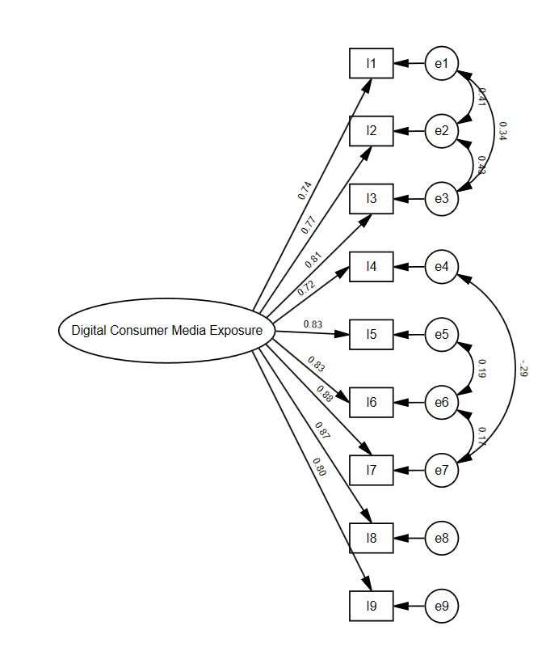
Note. The full content of the statements is available in Appendix A.

Appendix C
To adapt the World Assumption Scale (WAS), we conducted both an Exploratory Factor Analysis (EFA) and a Confirmatory Factor Analysis (CFA). First, a principal components EFA (rotation: oblimin, N = 278) identified a five-factor structure based on the scree plot and eigenvalues greater than 1. Items with weak factor loadings were subsequently removed. Next, a CFA (N = 401) was conducted to assess the goodness of fit of the five-factor model. The tested model, comprising the factors of self-worth, luck, benevolence of the world, controllability, and randomness, showed a good fit to the data: CMIN/df = 2.72, CFI = .915, GFI = .901, RMSEA = .066, 90% CI [.058, .073] (Hu & Bentler, 1999). Overall, the CFA indicated a satisfactory fit of the five-factor model for 20 items, with factor loadings ranging from .56 to .85. The path diagram for the final CFA model is presented in Figure 2.

Figure 2.
Confirmatory Factor Analysis Path Diagram for the Five-Factor World Assumptions Scale for Adolescents
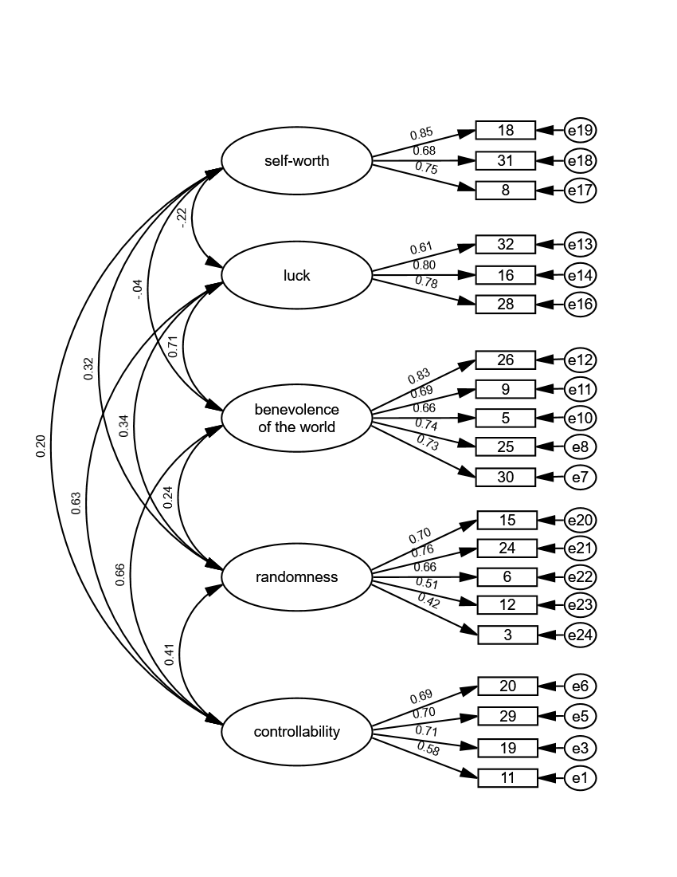
Note. The full content of the statements is available in Appendix A.
Appendix D
Figure 3.
Results of Additional Serial Multiple Mediating Test (Model 6) for World Assumption: Self-Worth and Materialism as Mediators
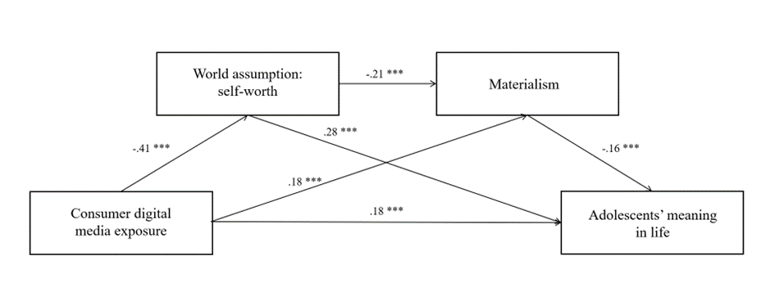
Table 5.
Indirect Effects of World Assumption: Self-Worth and Materialism
Indirect model | Pathway | B | BootSE | BootLLCI | BootULCI
Indirect 1 | DCME→WA_S-W→AML | -.12 | .02 | -.155 | -.081
Indirect 2 | DCME→MAT→AML | -.03 | .01 | -.047 | -.012
Indirect 3 | DCME→WA_S-W→MAT → AML | -.01 | .00 | -.024 | -.006
Note. DCME - consumer digital media exposure, WA_S-W – world assumption: self-worth, MAT - materialism, AML - adolescents’ meaning in life; BootSE - boots for standard error approximation, LLCI - lower level of confidence interval, ULCI - upper level of confidence interval.

