Figure 4. Virtual Reality Gambling Scenario

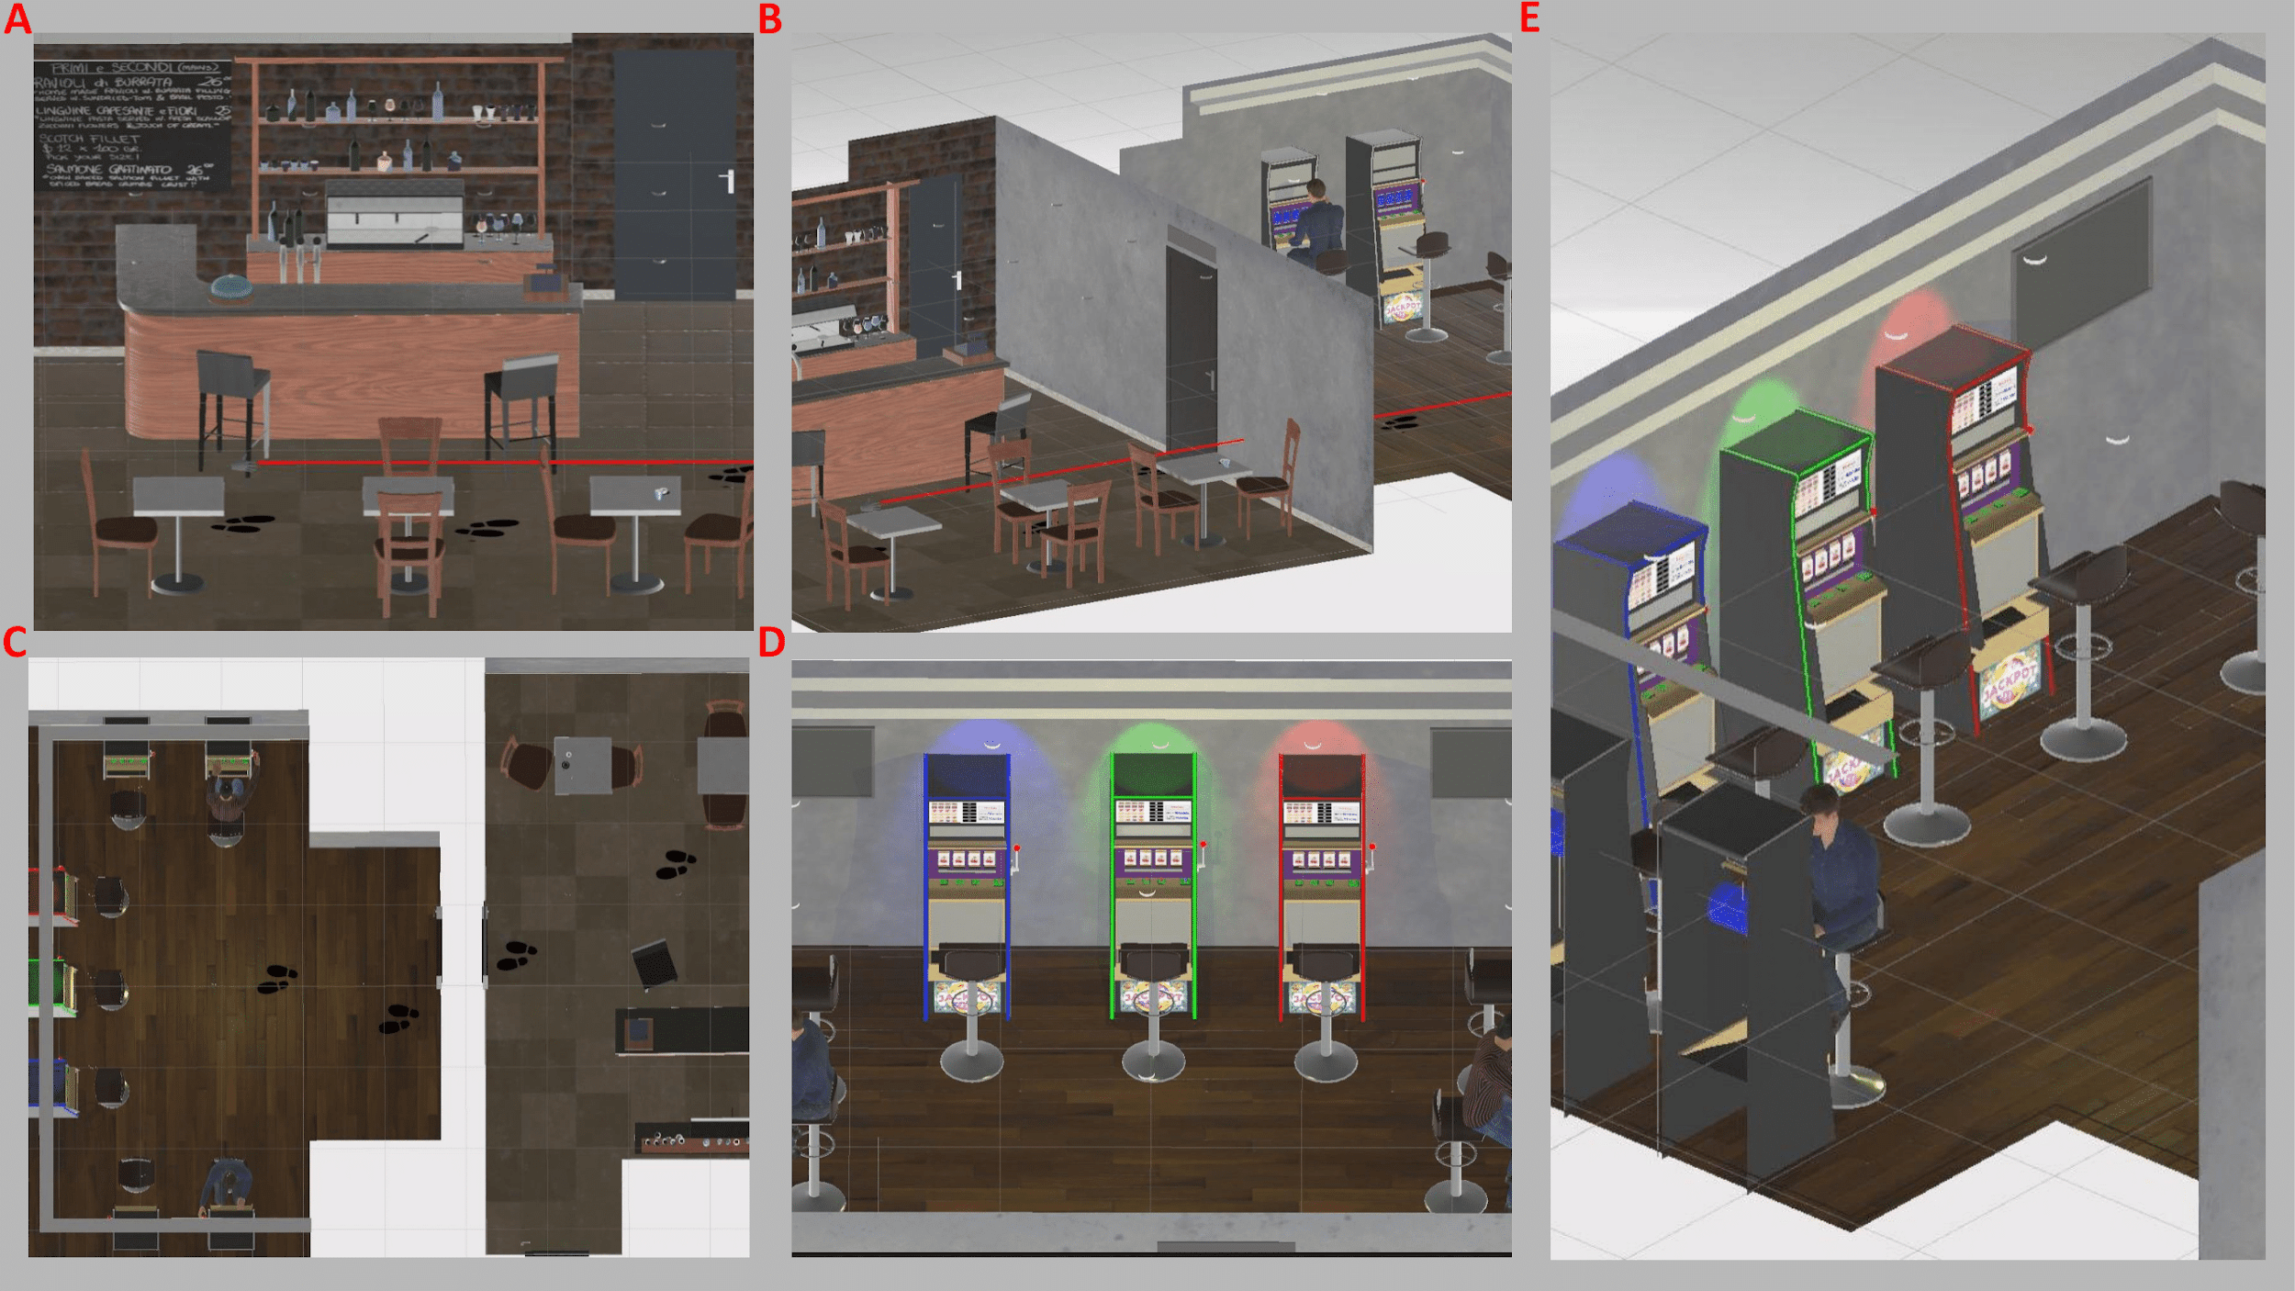

Figure 5. Slot-machine outcomes

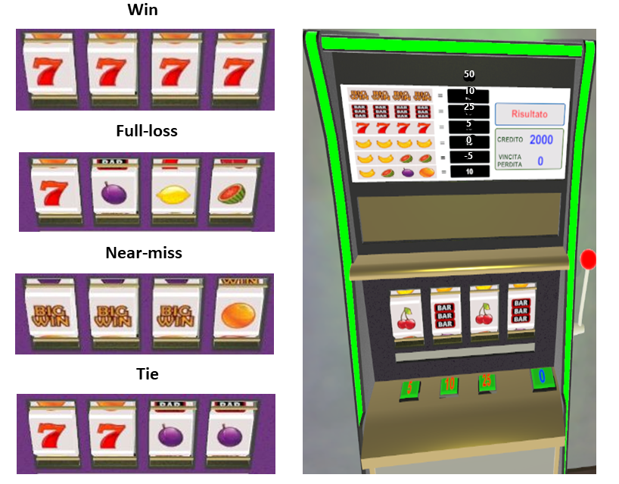

Figure 6. Win minus Loss difference wave at FCz between groups.
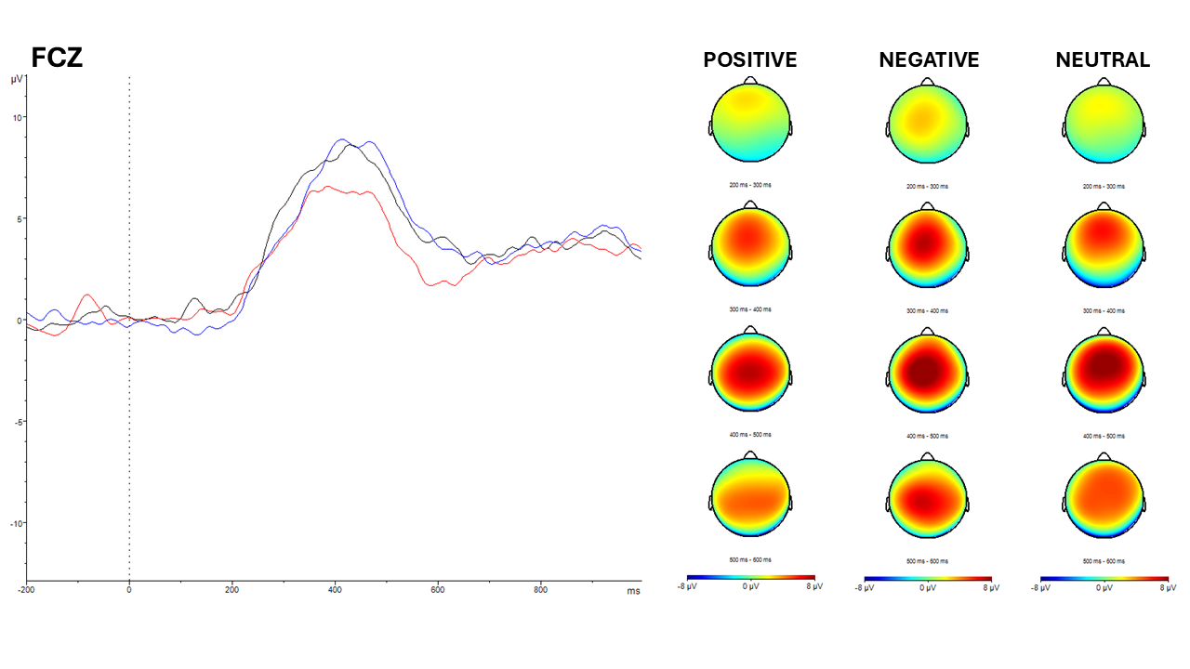
Note: Black line = Negative Group; Red Line = Positive Group; Blue Line = Neutral Group.
Figure 7. Win minus Near-miss difference wave at FCz between groups.
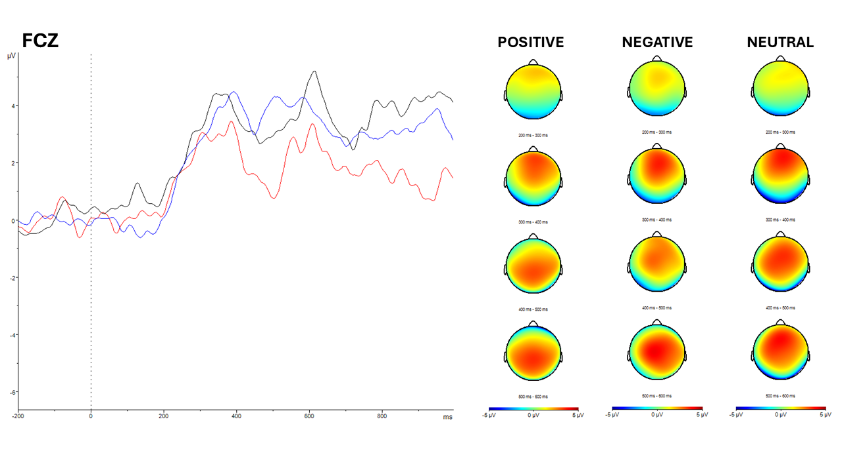Note: Black line = Negative Group; Red Line = Positive Group; Blue Line = Neutral Group.

