Supplementary Material

Table S1: Summary Table of the Instruments Cited
Scale Name | Numbers of items | Factor Structure | Cronbach’s α | Limitations
Hope Index Scale (Obayuwana et al., 1982) | 60 | Multidimensional | Not specified | Lack of factorial analysis and absence of internal reliability and stability
Miller Hope Scale (Miller & Powers, 1988) | 40 | Multidimensional | 0.93 | Excessive number of items, poor internal structure stability, and limited differentiation between hope and desire
Herth Hope Scale (Herth, 1991) | 30 | Multidimensional | 0.75-0.94 | Construct instability across different validation contexts and low explained variance
Comprehensive Trait Hope Scale (Scioli et al., 2011; Magnano et al., 2019) | 56 | Multidimensional | 0.71–0.74 (dimensional score)  0.82 (total score) | Poor integration among dimensions, lengthy and impractical scale, overlap with related constructs, and limited rigor in cross-cultural validity
SRPB – WHOQOL-SRPB Questionnaire (Skevington et al., 2013) | >100 | Multidimensional | 0.83-0.90 (dimensional score)  0.85 (total score) | Lengthy and impractical scale, uncertain factorial structure, and partial cross-cultural validity
Dispositional Hope Scale (Snyder, 2002) | 12 | Multidimensional | 0.74-0.84 | Limited focus on the cognitive domain, lack of interpretative norms for scores, overlap with the self-efficacy construct, and limited cultural sensitivity
Visions about future (Ginevra et al., 2017) | 19 | Multidimensional | 0.78-0.86 | Limitations related to the cross-cultural design, which restricts the ability to infer causal relationships among the constructs assessed.Literature and systematic reviews have pointed out that the external validity of the Visions about Future scale remains limited, as further validation in diverse populations is needed.

Study I
Table S2. Descriptive statistics for items of PHS (N = 200)
Item | M | SD | Var. | Sk | K
1 | 2.52 | 1.47 | 2.15 | -0.15 | -0.82
2 | 2.64 | 1.05 | 1.21 | -0.38 | -0.07
3 | 2.75 | 1.28 | 1.63 | -0.36 | -0.30
4 | 3.04 | 1.26 | 1.60 | -0.46 | -0.15
5 | 2.77 | 1.33 | 1.77 | -0.39 | -0.41
6 | 2.45 | 1.35 | 1.85 | -0.15 | -0.68
Note: M = Mean; SD = Standard Deviation; Sk. = Skewness; K = Kurtosis;

Table S3 Pearson Correlations and Polychoric Correlations of PHS items (N = 200)
Item | r-tot. | 1 | 2 | 3 | 4 | 5 | 6
1 | 0.69 | -
2 | 0.70 | 0.60 (0.62) | -
3 | 0.86 | 0.65 (0.69) | 0.69 (0.70) | -
4 | 0.75 | 0.60 (0.63) | 0.61 (0.61) | 0.70 (0.75) | -
5 | 0.83 | 0.59 (0.63) | 0.62 (0.65) | 0.84 (0.87) | 0.69 (0.71) | -
6 | 0.71 | 0.52 (0.54) | 0.49 (0.54) | 0.70 (0.74) | 0.58 (0.59) | 0.72 (0.75) | -
Note: r-tot = Adjusted Item to total correlation; All items correlation were significant (p < 0.001); The polychoric correlations are reported in parentheses.

Table S4. Explorative Factor Analysis (Robust Maximum Likelihood) and Parallel Analysis based on Minimum Rank Factor Analysis (N = 200)
Exploratory Factor Analysis (EFA) – Robust Maximum likelihood
Variable | Eigenvalue | Proportion of Variance | Cumulative Proportion of Variance
1 | 4.176 | 0.696 | 0.696
2 | 0.566 | 0.943 | -
3 | 0.423 | 0.716 | -
Optimized Parallel Analysis (PA)
Variable | Real-data eigenvalues | Mean of random eigenvalues | 95 Percentile of random eigenvalues
1 | 79.010* | 33.992 | 42.093
2 | 8.729 | 26.606 | 31.559
3 | 3.766 | 19.706 | 24.027
Notes: PA = * Advised number of dimensions: 1; Number of random correlation matrices: 500; Method for random correlation matrices: Permutation of raw data.

Study II
Table S5. Pearson correlations for Convergent Validity of PHS (N = 405)
 | 1 | 2 | 3 | 4 | 5 | 6 | 7 | 8 | 9
1. PHS | -
2. LOT-R | 0.60* | -
3. IMHC-GL | 0.52* | 0.45* | -
4. IMHC-EMO | 0.48* | 0.43* | 0.78* | -
5. IMHC-SOC | 0.34* | 0.29* | 0.81* | 0.47* | -
6. IMHC-PSY | 0.51* | 0.46* | 0.92* | 0.71* | 0.55* | -
7. GAD | -0.30* | -0.44* | -0.31* | -0.29* | -0.17* | -0.34* | -
8. PHQ | -0.32* | -0.48* | -0.36* | -0.41* | -0.17* | -0.39* | 0.75* | -
9. DFS | -0.21* | -0.44* | -0.29* | -0.21* | -0.25* | -0.28* | 0.52* | 0.50* | -
Note: PHS = Perceived Hope Scale; LOT-R = Life Orientation Test – Revised; IMHC-GL = global score of Italian Mental Health Continuum–Short Form; IMHC-EMO = Emotional well-being (dimension of IMHC); IMHC-SOC = Social well-being (dimension of IMHC); IMHC-PSY = Psychological well-being (dimension of IMHC); GAD-7 = Generalized Anxiety Disorder; PHQ = Patient Health Questionnaire; DFS = Dark Future Scale. * p < 0.001

Figure S1. Item Information Curves (IIC) for each PHS item
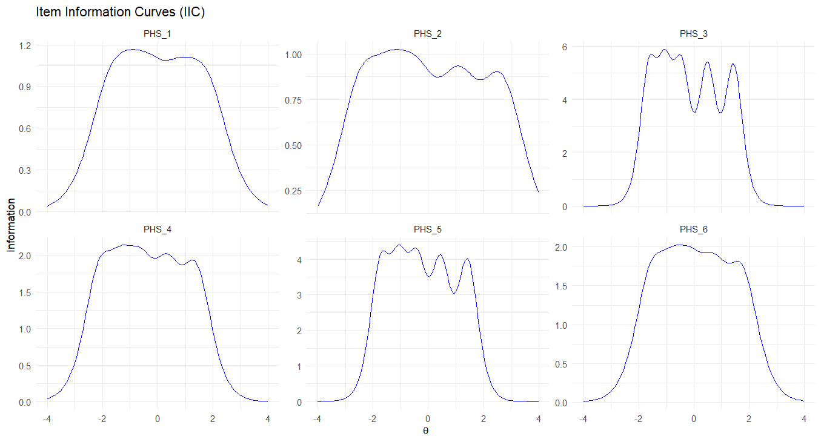

Figure S2. Test Information Function (TIF) for the PHS scale
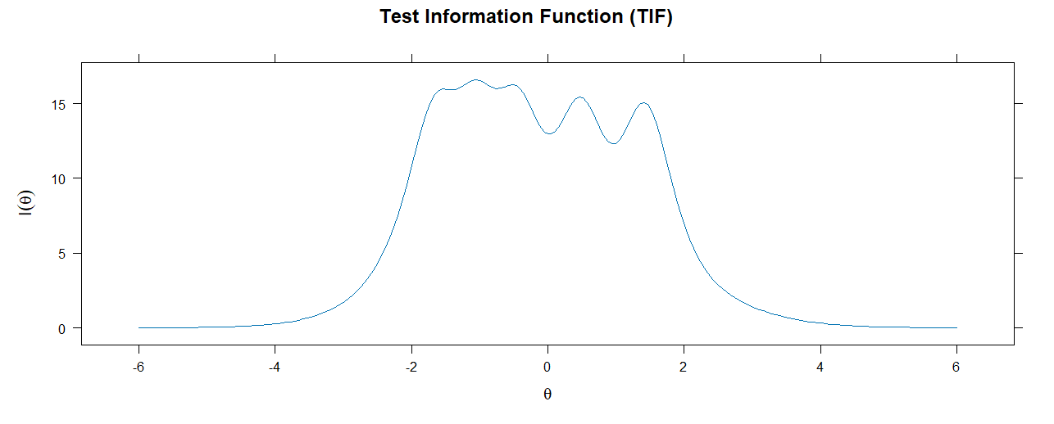

Figure S3. IRT-based Reliability Function across the latent trait continuum

