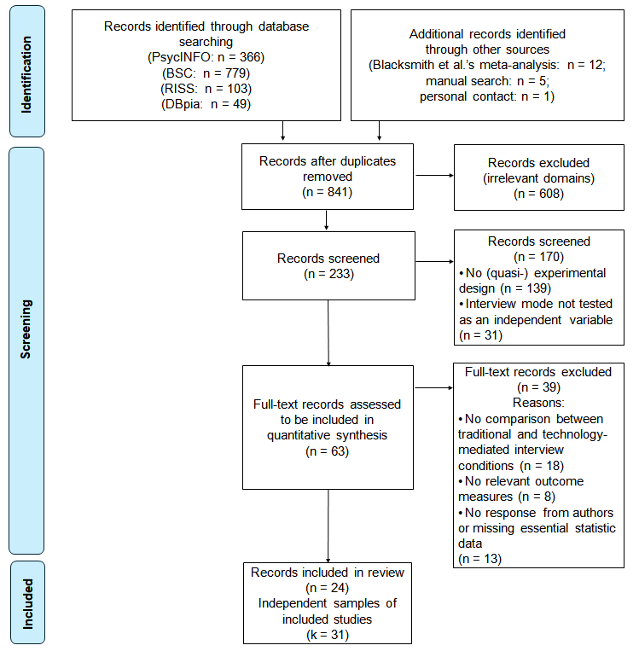
Fig. S1 Flow diagram of study search

