Supplementary Materials
In addition to the evaluative responses, we also assessed behavioral responses of guilt and shame related to repair and withdraw, respectively (Cohen et al., 2011), which may be differently connected to selfishness and self-regulation. According Tangney (1995), guilt relates to focusing on the wrong behavior, involving concern for the consequences of one’s behavior. This may motivate behaviors related to caring for a victim and making reparations. That is, guilt repair is largely aimed at restoring behaviors or actions that have negatively affected others. Selfishness may hamper the execution of this aim. Instead, shame focuses on the self who committed a wrongful act, being more concerned with themselves as the instigators of the wrongdoing. This may elicit personal distress and results in little empathic responsiveness towards others. Using the assessment by Cohen et al. (2011), shame withdraw is a response to anticipated unworthiness in the eyes of others, by actively avoiding or escaping situations in which one might have a shameful confrontation with others. Such shame-driven behaviors signal their more maladaptive function, and in that sense, shame withdraw in itself might be perceived as selfish. In addition, similar to regret, shame has been shown to elicit behaviors related to poor self-control (e.g., substance use, antisocial behavior) (Lynch et al., 2012; Tangney et al., 2011), whereas guilt elicits responses related to positive behaviors that require self-control, such as empathic responsiveness (Dost & Yagmurlu, 2008). The behavioral consequences of shame and guilt may thus be differently related to both selfishness and self-control as compared to their evaluative aspects and hence we examined these associations in more detail, and we explored the interactions between selfishness and self-control for the behavioral aspects of guilt and shame.
Results
We assessed the extent to which associations with self-control were contingent upon selfishness. In all models, we adjusted for sex, age, educational level, and for evaluative responses (“guilt repair”, “shame withdraw”) of the guilt and shame.
In the first set of models, egocentricity and self-control were unrelated to guilt repair (see Table S1). In the second step, we tested whether the associations between egocentricity and guilt repair differed at various levels of self-control. Self-control moderated the association between egocentricity and guilt repair (b = -.18, SE = .09, 95% CI = -.36, -.01). That is, analyses indicate that egocentricity was positively associated with guilt repair in participants who reported lower levels of self-control, whereas egocentricity was negatively associated with guilt repair in participants who reported higher levels of self-control (see Figure S1), though these slopes did not significantly differ from zero.
For self-interest, main effects of self-interest and self-control were partly similar to those in the models with egocentricity (see Table S2). Here, we also found that self-interest was associated with more guilt repair, but only at low levels of self-control (b = .19, SE = .06, 95% CI = .06, .31) (see Figure S2).
In a final set of models, we examined associations with shame withdraw. In the model including egocentricity, egocentricity was positively associated with shame withdraw, whereas self-control was not associated to shame withdraw (see Tabel S1). In the model including self-interest, self-interest was positively associated with shame withdraw, whereas self-control was negatively associated to shame withdraw (see Tabel S2). Moreover, no significant moderation effects of self-control with egocentricity or self-interest were found.
Discussion
In general, the findings pertaining to the main associations of selfishness and self-control with shame withdraw and guilt repair echo those of negative self-evaluation and negative behavioral evaluation, respectively. In that sense, these findings are in line with the general hypotheses we formulated with respect to guilt and shame. That is, higher levels of self-interest and lower self-control were associated with reporting more shame withdraw, whereas lower selfishness and higher self-control and were associated with reporting more guilt repair. When it comes to the interplay between selfishness and self-control, it is important to notice that the results for guilt repair suggest that high self-control helps in the execution of self-interested behavior (i.e., low guilt repair) for highly egocentric people. Conversely, without high self-control, high egocentricity does not impair other-oriented behavior (i.e., high guilt repair). By contrast, for self-interest, the results suggest that at high levels of self-control, self-interest does not matter. But at low levels of self-control, self-interest helps in showing other-oriented behavior (i.e., high guilt repair). Thus if someone feels guilty and is not egocentric, it is in his self-interest that guilt is repaired. These findings further deepen our understanding of the different linkages of selfishness and self-control with behavioral consequences of shame and guilt. Moreover, more research is needed to understand the disparities between egocentricity and self-interest, which may be linked to the more deviant nature of egocentricity (at least, as it was assessed in the current study) and the more general nature of self-interest (spanning selfishness across a range of deviant and non-deviant behaviors).
References
Cohen, T. R., Scott T. Wolf, S. T., Panter, A. T., & Insko, C. A. (2011). Introducing the GASP Scale: A new measure of guilt and shame proneness. Journal of Personality and Social Psychology, 100(5), 947–966. https://doi.org/10.1037/a0022641
Dost, A., & Yagmurlu, B. (2008). Are constructiveness and destructiveness essential features of guilt and shame feelings respectively? Journal for the Theory of Social Behaviour, 38(2), 109–129. https://doi.org/10.1111/j.1468-5914.2008.00362.x
Lynch, J. S., Hill, E. D., Nagoshi, J. L., & Nagoshi, C. T. (2012). Mediators of the shame-guilt-psychological adjustment relationship. Scandinavian Journal of Psychology, 53(5), 437–443. https://doi.org/10.1111/j.1467-9450.2012.00967.x
Tangney, J. P. (1995). Shame and guilt in interpersonal relationships. In J. P. Tangney & K. W. Fischer (Eds.), Self-conscious emotions: The psychology of shame, guilt, embarrassment, and pride (pp. 114–139). Guilford Press.
Tangney, J. P., Stuewig, J., & Hafez, L. (2011). Shame, guilt and remorse: Implications for offender populations. Journal of Forensic Psychiatry & Psychology, 22(5), 706. https://doi.org/10.1080/14789949.2011.617541

Table S1
Regression Analyses of Egocentricity on Regret Frequency, Guilt, and Shame
 |  | B | SE |  | LB | UB
DV: Guilt Repair
 | Guilt NBE | .45 | .05 | *** | .36 | .54
 | Self-control | -.09 | .08 |  | -.25 | .07
 | Egocentricity | .03 | .11 |  | -.18 | .25
 | Callousness | -.44 | .10 | *** | -.63 | -.24
 | Antisociality | -.24 | .11 | * | -.46 | -.03
 | R² | 45.4%
DV: Shame Withdraw
 | Shame NSE | .30 | .05 | *** | .20 | .40
 | Self-control | .02 | .10 |  | -.17 | .21
 | Egocentricity | .70 | .13 | *** | .45 | .95
 | Callousness | .23 | .12 |  | -.01 | .47
 | Antisociality | .37 | .13 | ** | .11 | .62
 | R² | 27.6%

Note. All analyses were controlled for sex, age in years, and educational level. DV = Dependent variable.

Table S2
Regression Analyses of Self-Interest on Regret Frequency, Guilt, and Shame
 |  | B | SE |  | LB | UB
DV: Guilt Repair
 | Guilt NBE | .53 | .04 | *** | .45 | .60
 | Self-control | .09 | .06 |  | -.03 | .21
 | Self-interest | .05 | .05 |  | -.04 | .14
 | Other-interest | .13 | .04 | ** | .05 | .21
 | R² | 43.7%
DV: Shame Withdraw
 | Shame NSE | .12 | .05 | ** | .03 | .21
 | Self-control | -.29 | .08 | *** | -.44 | -.14
 | Self-interest | .22 | .06 | *** | .11 | .33
 | Other-interest | -.00 | .05 |  | -.11 | .10
 | R² | 15.7%
Note. All analyses were controlled for sex, age in years, and educational level. DV = Dependent variable.

Figure S1
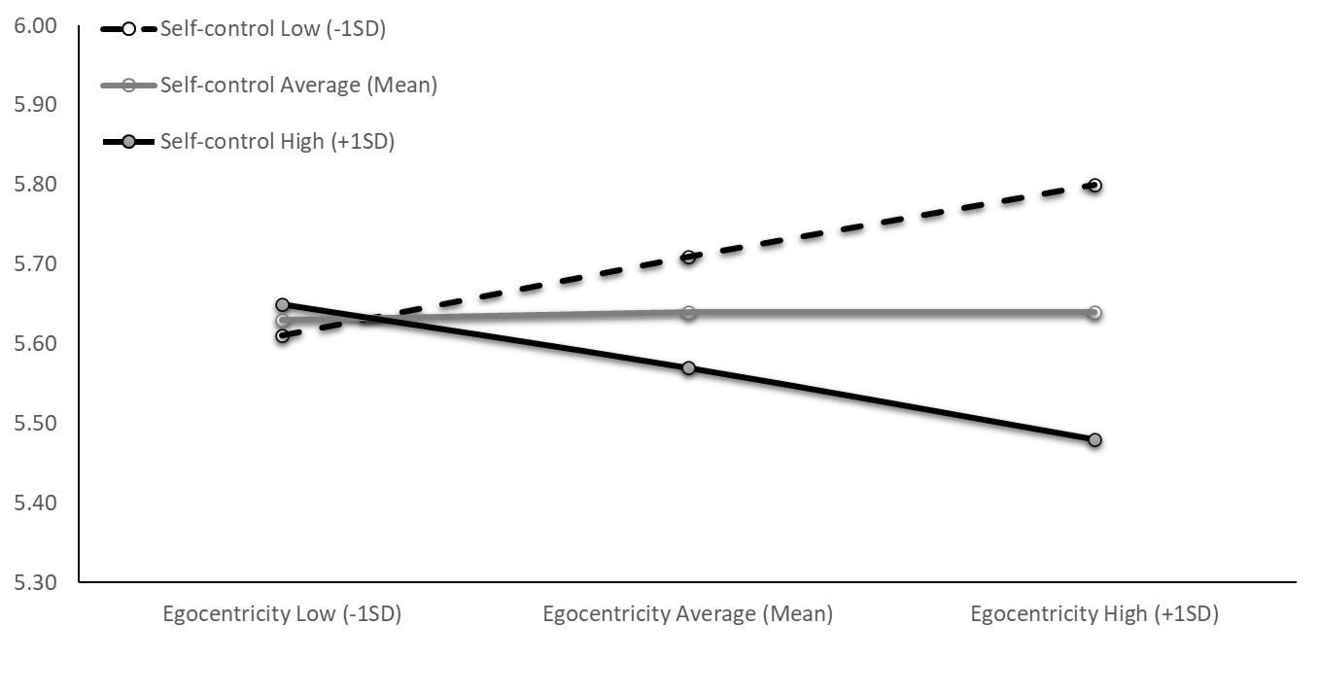
Associations between Low, Average, and High Levels of Egocentricity and Guilt Repair at Low, Average, and High Levels of Self-Control
Guilt Repair

Figure S2
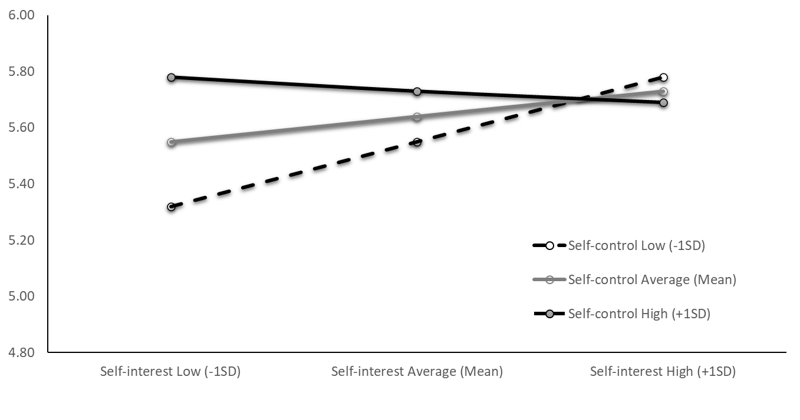
Associations between Low, Average, and High Levels of Self-Interest and Guilt Repair at Low, Average, and High Levels of Self-Control
Guilt Repair

