Appendix A
Note. Because the actual confederates’ photos are confidential and cannot be reproduced, the images shown here are AI-generated illustrations; participants viewed the original profile photos during the study.
- A sample profile image (Study 1)
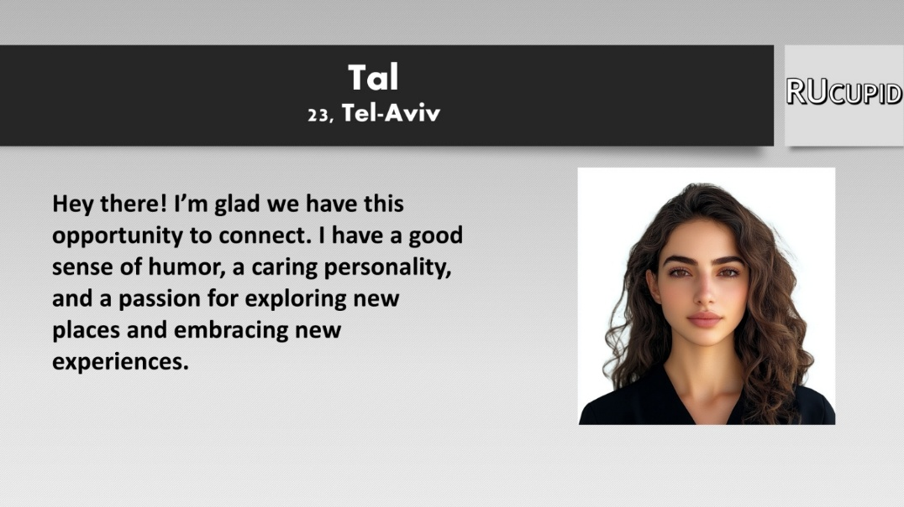
- A sample profile image (Study 3)

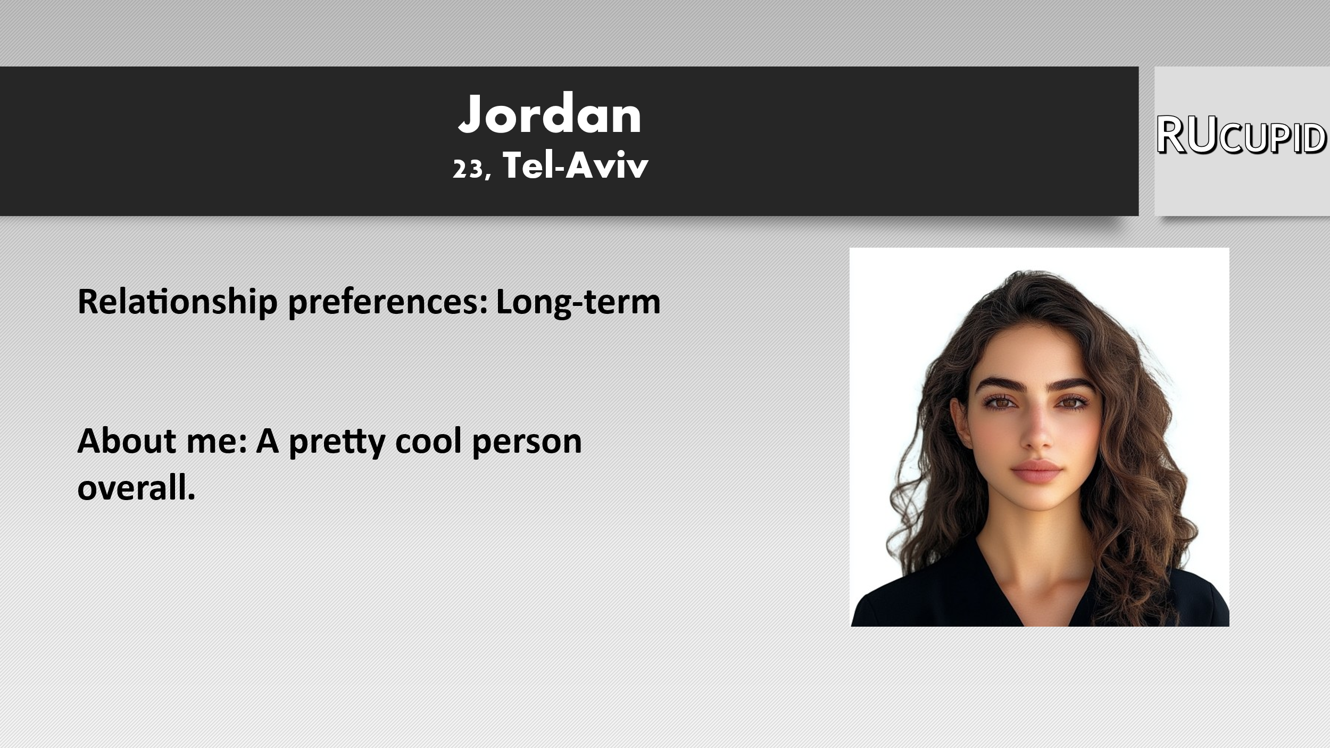
.
Appendix B
- The self-description in the high self-disclosure condition (Study 1)
“Hi, I’m Tal/Yarin/Rom. It’s very nice to meet you. I live in a big city and am passionate about surfing, sports, and fitness. I’m an economics student working in the field. I’m on the lookout for a meaningful connection with someone who can engage and captivate me. I’m all about looking ahead, staying focused on my goals, and embracing life with positivity. Whether it’s going out for a good time or meeting upbeat individuals, I’m there. I find joy in simplicity and bring a vibrant enthusiasm to life; boredom isn’t in my vocabulary. While I can be super serious, when necessary, I also know how to embrace my inner child and bring some humor into the mix. I’m a hard worker with big aspirations. I recently went through a tough breakup that I initiated. Despite the deep love we shared, I realized I needed more than just games and a lack of seriousness. Honesty is key for me, and I’m not a fan of games or lies. I don’t buy into the idea of platonic friendships between men and women, so I hope you’re on the same page. Weekends find me in nature, hiking and enjoying the outdoors—you’re welcome to join! In this dating realm, let’s not forget there’s a person on the other side—respect is a must. In a nutshell, I’m here to meet a partner who matches my energy. Bonus points if you’re an animal lover!”

- The two self-descriptions in the high self-disclosure condition (Study 3)
- I’m a huge animal lover. Love going out and having fun—heading to the beach, hiking in nature, playing sports, going to movies, concerts, and hitting up good restaurants. I eat everything! The best concert I’ve ever been to was Coldplay—it was absolutely insane! Highly recommend. The last show I watched was about Jeffrey Dahmer. What a psychopath! Can’t believe that actually happened. One show I’ll probably never watch is “Savri Maranan” lol. I really value a good sense of humor and love being around happy people who know how to enjoy life and laugh. Honesty and being straightforward are super important to me. I’m not really one to argue with people—I’m pretty go-with-the-flow, easygoing, and like to create a chill vibe. Super close with my family—they’re all amazing people.”

- “Living with roommates and my dog. Really into sunrises—I can wake up at 5 AM just to catch one. It fills me up for the whole day. Love hanging out and going out with friends. Totally addicted to sports and really into music—I listen whenever I can lol. I’d say I’m spontaneous, sensitive, and have a huge passion for life. Curious and love exploring and traveling the world. Just got back from Spain—it was awesome! Can’t wait to travel again! Next destination will be Australia. Need to experience the vibes there! See the landscapes, meet people, and miss home a bit. What matters is who you’re with. I can say I’ve surrounded myself with people I really love and who make me feel good. That’s one of the things I’m truly grateful for.”
Appendix C
The statistics for the Self-disclosure × Gender interactions (Study 2)
Profile Owners’ Perceived Sexual Attractiveness. The Self-disclosure × Gender interaction was not significant, F(1, 128) = 1.14, p = .288, η_{p}² = .009.
Profile Owners’ Perceived Social Attractiveness. The Self-disclosure × Gender interaction was not significant, F(1, 128) = 1.04, p = .310, η_{p}² = .008.
Profile Owners’ Perceived Interest in a Long-Term Relationship. The Self-disclosure × Gender interaction was not significant, F(1, 128) = 0.19, p = .891, η_{p}² = .000.
Profile Owners’ Perceived Interest in Casual Sex. The Self-disclosure × Gender interaction was not significant, F(1, 128) = 0.60, p = .807, η_{p}² = .000.
Participants’ Interest in Casual Sex. The Self-disclosure × Gender interaction was not significant, F(1, 128) = 0.51, p = .821, η_{p}² = .000.
Participants’ Interest in a Long-Term Relationship. The Self-disclosure × Gender interaction was not significant, F(1, 128) = 0.30, p = .585, η_{p}² = .002.
.

Appendix D
Full results of Study 3
To examine whether the effects of self-disclosure manipulation on perceptions of profile owners and viewers’ relationship intentions were moderated by the manipulation of relationship intentions, we conducted a series of 3 (Self-disclosure: Low, Moderate, High) × 2 (Relationship Intentions: Short-term, Long-term) ANOVAs with repeated measures on both factors. Table 3 presents the relevant means and standard deviations.
The analysis of profile owners’ perceived sexual attractiveness yielded a significant effect for the manipulations of self-disclosure, F(2, 218) = 7.02, p < .001, η_{p}² = .061, 95% CI [0.01, 0.12], such that profile owners in the low self-disclosure condition were perceived as significantly less sexually attractive (M = 2.87, SD = 1.10) than those in the moderate (M = 3.15, SD = 1.05) and high self-disclosure (M = 3.18, SD = 0.92) conditions. Neither the effect of relationship intentions, F(1, 109) = 0.31, p = .576, η_{p}² = .003, 95% CI [0.00, 0.05], nor the Self-disclosure × Intentions interaction, was significant, F(2, 218) = 1.21, p = .300, η_{p}² = .011, 95% CI [0.00, 0.04].
The analysis of profile owners’ perceived social attractiveness yielded a significant effect for the manipulations of self-disclosure, F(2, 218) = 96.94, p < .001, η_{p}² = .471, 95% CI [0.37, 0.54], such that profile owners in the low self-disclosure condition were perceived as significantly less socially attractive (M = 2.82, SD = 0.68) than those in the moderate (M = 3.37, SD = 0.70) and high self-disclosure conditions (M = 3.68, SD = 0.66). Additionally, profile owners in the moderate self-disclosure condition were perceived as significantly less socially attractive than those in the high self-disclosure condition. The effect of relationship intentions was also significant, F(1, 109) = 47.11, p < .001, η_{p}² = .302, 95% CI [0.16, 0.42], such that profile owners in the short-term condition were perceived as significantly less socially attractive (M = 3.12, SD = 0.66) than those in the long-term condition (M = 3.45, SD = 0.70). The Self-disclosure × Intentions interaction was not significant, F(2, 218) = 1.45, p = .235, η_{p}² = .013, 95% CI [0.00, 0.05].
The analysis of profile owners’ perceived interest in a long-term relationship yielded a significant effect for the manipulations of self-disclosure, F(2, 218) = 93.73, p < .001, η_{p}² = .462, 95% CI [0.37, 0.54], and a significant effect for relationship intentions, F(1, 109) = 589.64, p < .001, η_{p}² = .844, 95% CI [0.79, 0.88]. Profile owners were perceived as more interested in long-term relationships across self-disclosure conditions and when the profiles indicated a preference for long-term rather than short-term relationships. These effects were qualified by a significant Self-disclosure × Relationship Intentions interaction, F(2, 218) = 14.51, p < .001, η_{p}² = .117, 95% CI [0.04, 0.19]. Simple effects tests revealed that the manipulations of self-disclosure affected profile owners’ perceived interest in a long-term relationship in both the short-term, F(2, 108) = 45.19, p < .001, η_{p}² = .456, 95% CI [0.31, 0.55], and long-term conditions, F(2, 108) = 32.07, p < .001, η_{p}² = .373, 95% CI [0.22, 0.48]. Self-disclosure made more of a difference in the short-term than the long-term condition (see Table 3).
The analysis of profile owners’ perceived interest in casual sex yielded a significant effect for the manipulations of self-disclosure, F(2, 218) = 23.72, p < .001, η_{p}² = .179, 95% CI [0.09, 0.26], and a significant effect of relationship intentions, F(1, 109) = 430.81, p < .001, η_{p}² = .798, 95% CI [0.73, 0.84]. Interest in engaging in casual sex with profile owners decreased across self-disclosure conditions and when the profiles indicated a preference for long-term rather than short-term relationships. These effects were qualified by a significant Self-disclosure × Relationship Intentions interaction, F(2, 218) = 4.83, p = .009, η_{p}² = .042, 95% CI [0.01, 0.10]. Simple effects tests revealed that the manipulations of self-disclosure affected profile owners’ perceived interest in casual sex in both the short-term, F(2, 108) = 14.38, p < .001, η_{p}² = .210, 95% CI [0.08, 0.33], and long-term conditions, F(2, 108) = 8.71, p < .001, η_{p}² = .139, 95% CI [0.03, 0.25]. Self-disclosure made more of a difference in the short-term than the long-term condition.
The analysis of participants’ interest in casual sex yielded a significant effect of relationship intentions, F(1, 109) = 8.36, p = .005, η_{p}² = .071, 95% CI [0.01, 0.17], such that participants expressed greater interest in casual sex with the profile owners when the profile indicated a preference for short-term relationships (M = 2.64, SD = 1.45) than when the profile indicated a preference for long-term relationships (M = 2.44, SD = 1.36). Neither the effect of self-disclosure, F(2, 218) = 1.66, p = .192, η_{p}² = .015, 95% CI [0.00, 0.05], nor the Self-disclosure × Relationship Intentions interaction, was significant, F(2, 218) = 0.59, p = .552, η_{p}² = .005, 95% CI [0.00, 0.03].
The analysis of participants’ interest in a long-term relationship yielded a significant effect for the manipulations of self-disclosure, F(2, 218) = 18.35, p < .001, η_{p}² = .144, 95% CI [0.06, 0.22], and a significant effect of relationship intentions, F(1, 109) = 19.57, p < .001, η_{p}² = .152, 95% CI [0.05, 0.27]. Interest in forming a long-term relationship with profile owners increased across self-disclosure conditions and when the profiles indicated a preference for long-term rather than short-term relationships. These effects were qualified by a significant Self-disclosure × Relationship Intentions interaction, F(2, 218) = 4.54, p = .012, η_{p}² = .040, 95% CI [0.01, 0.10]. Simple effects tests revealed that the manipulations of self-disclosure affected participants’ interest in a long-term relationship in both the short-term, F(2, 108) = 17.53, p < .001, η_{p}² = .245, 95% CI [0.11, 0.36], and long-term conditions, F(2, 108) = 6.42, p = .002, η_{p}² = .106, 95% CI [0.01, 0.21]. Self-disclosure made more of a difference in the short-term than the long-term condition.

