Supplementary Tables
Table S1. Survey Questionnaire
Table S2. List of Pro-climate Behaviors (Stimulus of Experiments)
Table S3. Linear Mixed-Effects Moderation Models of Predispositions on Social Conformity (Full Model Estimates)

Supplementary Figures
Figure S1. Schematic of Experimental Procedure
Figure S2. ERP Waveforms at Fz and Pz electrodes
Figure S3. Topography of ERP Components

Table S1. Survey Questionnaire
No. | Items
Biosperic Value
1 | Preventing pollution
2 | Respecting the earth: live in harmony with other species
3 | Unity with nature: fitting into nature
4 | Protecting the environment: preserving nature
Nature Relatedness Scale (Nisbet et al., 2009)
1 | I enjoy being outdoors, even in unpleasant weather
2 | Some species are just meant to die out or become extinct ᴿ
3 | Humans have the right to use natural resources any way we want ᴿ
4 | My ideal vacation spot would be a remote, wilderness area
5 | I always think about how my actions affect the Environment
6 | I enjoy digging in the earth and getting dirt on my hands
7 | My connection to nature and the environment is a part of my spirituality
8 | I am very aware of environmental issues
9 | I take notice of wildlife wherever I am
10 | I don’t often go out in nature ᴿ
11 | Nothing I do will change problems in other places on the planet ᴿ
12 | I am not separate from nature, but a part of nature
13 | The thought of being deep in the woods, away from civilization, is frightening ᴿ
14 | My feelings about nature do not affect how I live my life ᴿ
15 | Animals, birds and plants have fewer rights than humans ᴿ
16 | Even in the middle of the city, I notice nature around me
17 | My relationship to nature is an important part of who I am
18 | Conservation is unnecessary because nature is strong enough to recover from any human impact
19 | The state of nonhuman species is an indicator of the future for humans
20 | I think a lot about the suffering of animals
Personal Norms
1 | I feel personally obliged to do climate change actions
2 | I feel morally obliged to do climate change actions
3 | I feel guilty when I do not pro-environmental behaviors

Table S2. List of Pro-climate Behaviors (Stimulus of Experiments)
No. | Items
1 | Participate in car sharing.
2 | Support local farmer's markets and eat local food.
3 | Minimize red meat and dairy consumption.
4 | Eat seasonal fruit and vegetables.
5 | Buy organic food.
6 | Check the ingredients and labels on your food because some ingredients are more harmful for the environment than others.
7 | Grow your own home garden.
8 | Avoid consuming highly processed foods.
9 | Walk or use your bicycle instead of a car, because it is better for your health and reduces congestion within a city.
10 | Educate yourself on alternative protein sources such as nuts, lentils, and leafy greens.
11 | Use the stairs instead of the elevator/escalator.
12 | Switch off your electronic devices to lower energy consumption and enjoy the real world.
13 | Discover green areas around your neighborhood.
14 | Go “plogging” (jogging while picking up trash).
15 | Educate yourself on how to recycle properly.
16 | Read a book about climate change or listen to a podcast on environmental issues.
17 | Watch a documentary about the environmental impact of the food industry.
18 | Use social media to share climate-related information and spread awareness.
19 | Talk about the importance of nature, animals and environmental protection with your family and friends.  30
20 | Share ideas for sustainable behavioral change to friends and family who don't know where to start.
21 | Encourage family planning to minimize your ecological footprint.
22 | Engage in conversations about the role of women and men in the environmental arena.
23 | Donate old clothes or household items to those in need.
24 | Learn about the intersection between energy, poverty, and the climate.
25 | Educate yourself about ecofeminist perspectives and how they can be valuable to sustainable climate action.
26 | Use a reusable water bottle to avoid plastic waste.
27 | Buy shampoo and/or soap bars instead of using toiletries in plastic bottles.
28 | Use natural detergents to clean your house.
29 | Switch your plastic toothbrush out for a bamboo one and turn off the tap while you are brushing your teeth.
30 | Choose clothing made of organic fibers instead of synthetic-made items because they release microplastics when washed.
31 | Research how to make homemade dishwasher products and try it for yourself.
32 | Educate yourself on how chemical products can contaminate water resources.
33 | Consider switching to a green energy provider.
34 | Inform yourself about where your electricity comes from and how it is produced.
35 | Replace incandescent lights with LEDs because they are more energy efficient.
36 | Adjust your heating to the necessary temperature.
37 | Take shorter showers. You can sing outside too!
38 | Install a solar panel for your home.
39 | Be aware of the energy your home consumes.
40 | Improve the insulation of your house.
41 | Make people aware of the fact that climate change will have economic consequences.
42 | Buy fairtrade products.
43 | Become a micro lender to empower green entrepreneurs.
44 | Buy products from companies with a lower carbon footprint.
45 | When upgrading your technology or appliances, donate your old devices because their parts may still be of use.
46 | In order to improve your city's air quality, turn empty rooftops into green spaces.
47 | Buy locally made products.
48 | Share electrical items with people around your neighborhood.
49 | Learn about and advocate against climate injustices.
50 | Write an inclusive sustainability blog to bring awareness to how climate change is affecting diverse groups.
51 | Increase awareness of the negative impacts climate change has on poor communities.
52 | Have conversations about how changes in the environment are affecting communities.
53 | Turn off all your lights when you are no longer using them.
54 | Take public transport and leave your car at home as much as you can.
55 | Buy second hand items to give it a longer life.
56 | Buy clothing made of reused or recycled materials.
57 | Get your food in zero-waste stores.
58 | Stop using plastic straws and buy a metal or bamboo one, or even better, stop using them at all.
59 | Buy organic cotton and other more earth friendly materials.
60 | Favor eco-tourism for your next vacation.
61 | Repair your clothes instead of buying new ones.
62 | Donate your clothes instead of throwing them away.
63 | Learn about how to properly dispose of your refrigerators and air conditioners.
64 | Use your social media platform to promote and raise awareness about the climate crisis.
65 | Dispel climate myths. Teach people what separates fact from fiction.
66 | Minimize your air travel. If you have to fly, try to purchase UN-certified carbon offsets.
67 | Clean up a beach close to you with friends and family.
68 | Try to buy fish or seafood coming from a sustainable source.
69 | Use natural mineral sunscreen.
70 | Do not buy products made from threatened species such as ivory.
71 | Leave plants and trees in their natural habitat.
72 | Plant trees.
73 | Converse with people who are marginalized by climate injustices.
74 | Organize or participate in a flea market & give old things a new life.
75 | Form inclusive social networking campaigns for climate change engagement.
76 | Donate to sustainable development projects.
77 | Donate to organizations that support climate migrants.
78 | Get involved in your local association that helps homeless and people living in poverty.
79 | Join networks with environmentally sensitive people to exchange tips and experiences.
80 | Organize or take part in an environmental world cafe.
81 | Participate in an environmental committee at your school or workplace.
82 | Support sustainable, female-owned businesses.
83 | Invest in solar energy.
84 | Encourage the government to subsidise renewable energy production.
85 | Advocate for corporate social responsibility.
86 | Invest in innovative green technologies.
87 | Advocate for fossil fuel divestment by both corporations and institutions.
88 | Lobby for the installation of recycling stations in your town.
89 | Assess the carbon footprint of your workplace.
90 | Give a voice to climate migrants.
91 | Donate to sustainable initiatives that aim to eliminate malnutrition and food insecurity.
92 | Lobby for more green spaces in your area such as parks and forests.
93 | Support the elimination of single-use plastics in your community.
94 | Donate to organizations involved in fighting climate change.
95 | Get involved in your community and organize climate actions and ecofriendly initiatives.
96 | Organize green initiatives in your workplace.
97 | Engage in projects that protect coral reefs.
98 | Support efforts to clean up the ocean's garbage patch by donating to organizations committed to such work.
99 | Donate to conservation projects.
100 | Use scratch paper for printing.
101 | Use water filled into a cup or basin to wash your face or brush your teeth.
102 | Don't use single-use products.
103 | Purchase recycled paper.
104 | Use the products until the end of its life cycle.
105 | Eat less meat and more vegetarian meals.
106 | Support political candidates who pledge the policy commitments related to environment and climate change on the election.
107 | Use reusable grocery bags.
108 | Use the power saving mode on the phone.
109 | Wear lightweight clothing in summer and warmer clothes in winter.
110 | Use the power saving program when you won’t be using the computer.
111 | Use paperless billings instead of receiving a mailed copy.
112 | Use your handkerchiefs instead of paper towels or hand dryers.
113 | Don’t overfill your refrigerator with food.
114 | Buy refills for items you already own, such as hand sanitizers and fabric softeners.
115 | Avoid leftovers.
116 | Put a plastic bottle in your toilet tank.

Table S3. Linear Mixed-Effects Moderation Models of Predispositions on Social Conformity (Full Model Estimates)
 | Immediate social conformity |  |  |  | Sustained social conformity
 | b | S.E. | 95% CI | p | b | S.E. | 95% CI | p
Moderator: Biospheric Value (BV)
Intercept | -1.50 | 0.65 | [-2.77, -0.22] | 0.022 | -1.02 | 0.95 | [-2.89, 0.85] | 0.286
Deviation: MI | -1.59 | 0.72 | [-3.00, -0.19] | 0.026 | -2.67 | 0.89 | [-4.41, -0.93] | 0.003
Deviation: HI | -3.90 | 0.70 | [-5.27, -2.53] | <0.001 | -5.92 | 0.87 | [-7.62, -4.22] | <0.001
Direction: Pro-climate | 2.64 | 0.72 | [1.23, 4.05] | <0.001 | 6.10 | 0.89 | [4.35, 7.84] | <0.001
Moderator: BV | -0.70 | 1.14 | [-2.94, 1.54] | 0.541 | -1.18 | 1.66 | [-4.42, 2.07] | 0.477
MI × Pro | 3.26 | 1.01 | [1.27, 5.24] | 0.001 | 2.87 | 1.26 | [0.40, 5.33] | 0.023
HI × Pro | 8.02 | 1.02 | [6.01, 10.02] | <0.001 | 12.88 | 1.27 | [10.39, 15.37] | <0.001
MI × BV | -0.46 | 1.29 | [-3.00, 2.08] | 0.722 | 3.36 | 1.60 | [0.22, 6.50] | 0.036
HI × BV | -0.84 | 1.27 | [-3.32, 1.64] | 0.506 | 2.61 | 1.57 | [-0.46, 5.68] | 0.096
Pro × BV | 0.59 | 1.30 | [-1.95, 3.14] | 0.649 | 4.02 | 1.61 | [0.87, 7.17] | 0.012
MI × Pro × BV | -0.33 | 1.83 | [-3.92, 3.27] | 0.858 | -4.77 | 2.27 | [-9.22, -0.32] | 0.036
HI × Pro × BV | -0.74 | 1.85 | [-4.36, 2.88] | 0.690 | -4.97 | 2.29 | [-9.45, -0.48] | 0.030
Marginal R² / Conditional R² | 0.053 / 0.128 |  |  |  | 0.100 / 0.163
Moderator: Nature Relatedness (NR)
Intercept | -1.50 | 0.66 | [-2.78, -0.21] | 0.022 | -1.02 | 0.95 | [-2.87, 0.84] | 0.283
Deviation: MI | -1.58 | 0.72 | [-2.98, -0.18] | 0.027 | -2.67 | 0.89 | [-4.41, -0.93] | 0.003
Deviation: HI | -4.03 | 0.70 | [-5.40, -2.66] | <0.001 | -6.08 | 0.87 | [-7.79, -4.38] | <0.001
Direction: Pro-climate | 2.62 | 0.72 | [1.21, 4.03] | <0.001 | 6.08 | 0.89 | [4.34, 7.83] | <0.001
Moderator: NR | 0.96 | 1.46 | [-1.91, 3.82] | 0.511 | 3.32 | 2.08 | [-0.76, 7.41] | 0.110
MI × Pro | 3.27 | 1.01 | [1.28, 5.25] | 0.001 | 2.86 | 1.26 | [0.40, 5.33] | 0.022
HI × Pro | 8.20 | 1.02 | [6.20, 10.20] | <0.001 | 13.07 | 1.27 | [10.59, 15.56] | <0.001
MI × NR | -2.32 | 1.64 | [-5.53, 0.89] | 0.156 | -0.77 | 2.03 | [-4.75, 3.20] | 0.703
HI × NR | 1.18 | 1.59 | [-1.94, 4.31] | 0.459 | 3.06 | 1.98 | [-0.82, 6.93] | 0.122
Pro × NR | -4.82 | 1.65 | [-8.06, -1.59] | 0.003 | -3.87 | 2.04 | [-7.88, 0.14] | 0.059
MI × Pro × NR | 4.50 | 2.31 | [-0.04, 9.03] | 0.052 | 1.27 | 2.87 | [-4.35, 6.90] | 0.657
HI × Pro × NR | 1.78 | 2.34 | [-2.82, 6.38] | 0.447 | -0.43 | 2.91 | [-6.13, 5.27] | 0.883
Marginal R² / Conditional R² | 0.055 / 0.130 |  |  |  | 0.102 / 0.165
Moderator: Personal Norm (PN)
Intercept | -1.52 | 0.65 | [-2.80, -0.24] | 0.020 | -1.05 | 0.95 | [-2.91, 0.82] | 0.272
Deviation: MI | -1.56 | 0.71 | [-2.96, -0.15] | 0.030 | -2.64 | 0.89 | [-4.38, -0.90] | 0.003
Deviation: HI | -4.02 | 0.70 | [-5.39, -2.65] | <0.001 | -6.04 | 0.87 | [-7.73, -4.34] | <0.001
Direction: Pro-climate | 2.62 | 0.72 | [1.22, 4.03] | <0.001 | 6.09 | 0.89 | [4.35, 7.83] | <0.001
Moderator: PN | 2.06 | 1.04 | [0.02, 4.10] | 0.047 | 3.21 | 1.49 | [0.29, 6.13] | 0.031
MI × Pro | 3.24 | 1.01 | [1.26, 5.22] | 0.001 | 2.82 | 1.25 | [0.36, 5.27] | 0.025
HI × Pro | 8.19 | 1.02 | [6.19, 10.19] | <0.001 | 12.98 | 1.27 | [10.49, 15.46] | <0.001
MI × PN | -2.93 | 1.17 | [-5.22, -0.64] | 0.012 | -1.12 | 1.45 | [-3.96, 1.72] | 0.440
HI × PN | 0.13 | 1.15 | [-2.12, 2.39] | 0.909 | 0.72 | 1.42 | [-2.07, 3.51] | 0.612
Pro × PN | -5.06 | 1.16 | [-7.33, -2.79] | <0.001 | -5.21 | 1.43 | [-8.02, -2.40] | <0.001
MI × Pro × PN | 4.58 | 1.62 | [1.40, 7.76] | 0.005 | 0.69 | 2.01 | [-3.25, 4.64] | 0.730
HI × Pro × PN | 2.02 | 1.64 | [-1.19, 5.23] | 0.217 | 0.50 | 2.03 | [-3.48, 4.47] | 0.807
Marginal R² / Conditional R² | 0.057 / 0.132 |  |  |  | 0.104 / 0.167
Note: N = 47 participants, 113 items, 5,311 observations
*Reference category: Deviation(Congruent) and Direction(Anti-climate)

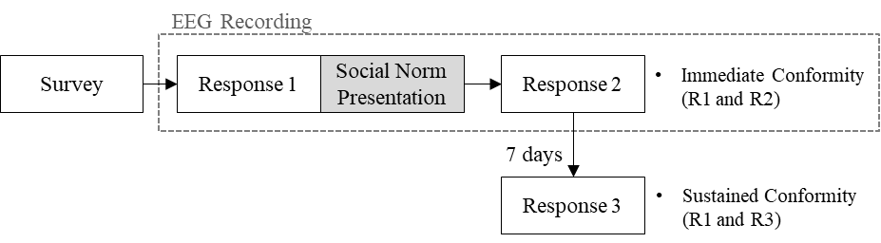
Figure S1. Schematic of Experimental Procedure. The experimental sequence consisted of a preliminary survey followed by the main social conformity session with EEG recording. Participants first reported their intention to engage in 113 climate behaviors (R1). Subsequently, social norm was represented, after which participants were asked to re-evaluate their intention (R2). A follow-up assessment was conducted seven days later (R3). Immediate conformity was quantified by the change between R1 and R2, while sustained conformity was determined by comparing R1 and R3.

- Feedback-related Negativity (30 subjects)
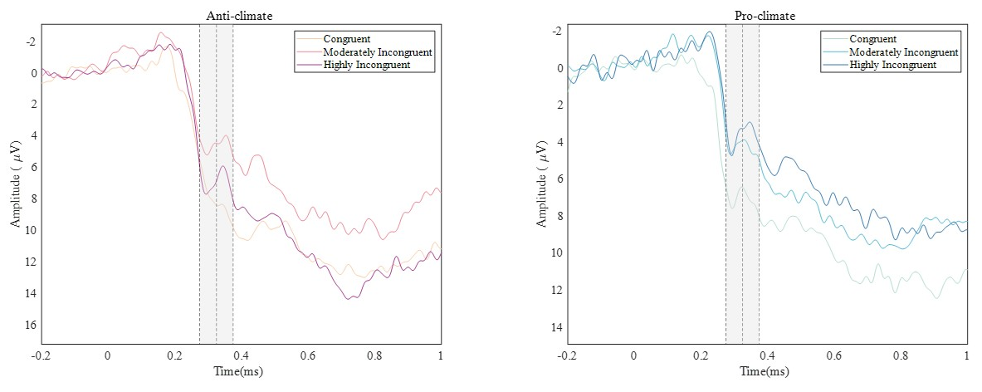
- Late Positive Potential (46 subjects)
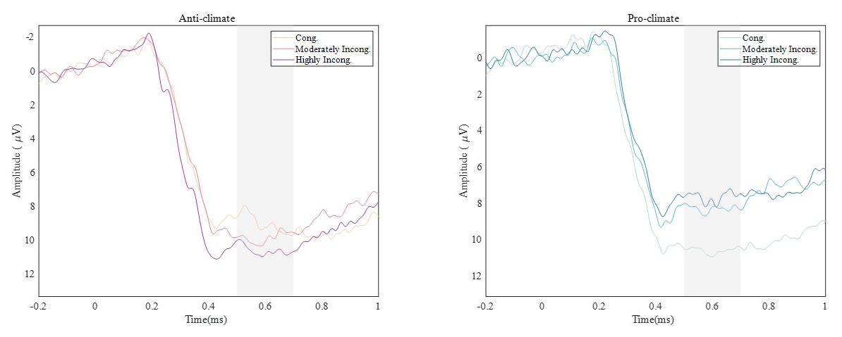
Figure S2. ERP Waveforms at Fz and Pz electrodes: Deviation Condition and Time, Divided by Direction (a) Anti-climate and (b) Pro-climate with Labeled Time Domains of FRN at Fz and LPP at Pz.

- Feedback-related Negativity at Fz
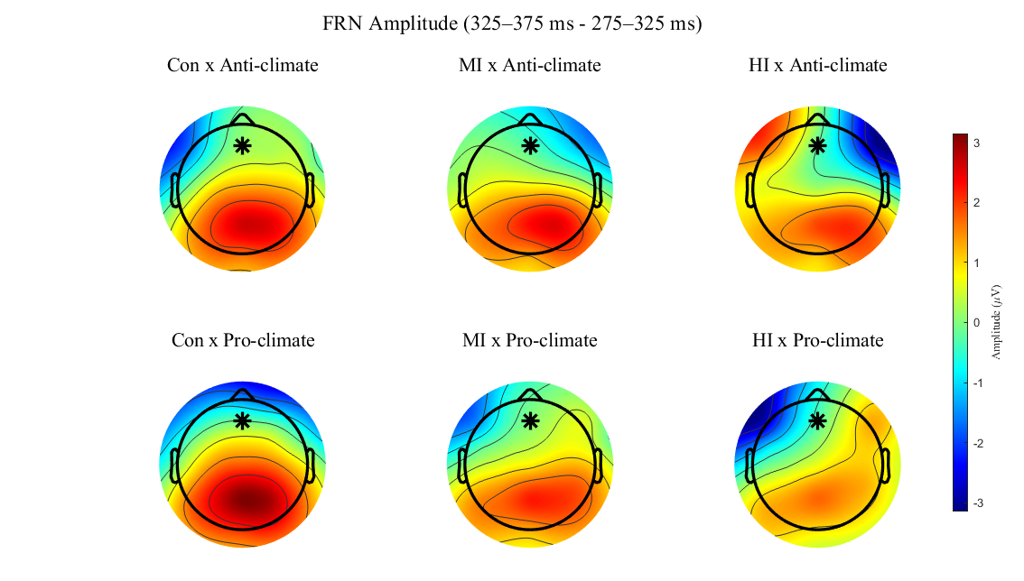
- Late Positive Potential at Pz
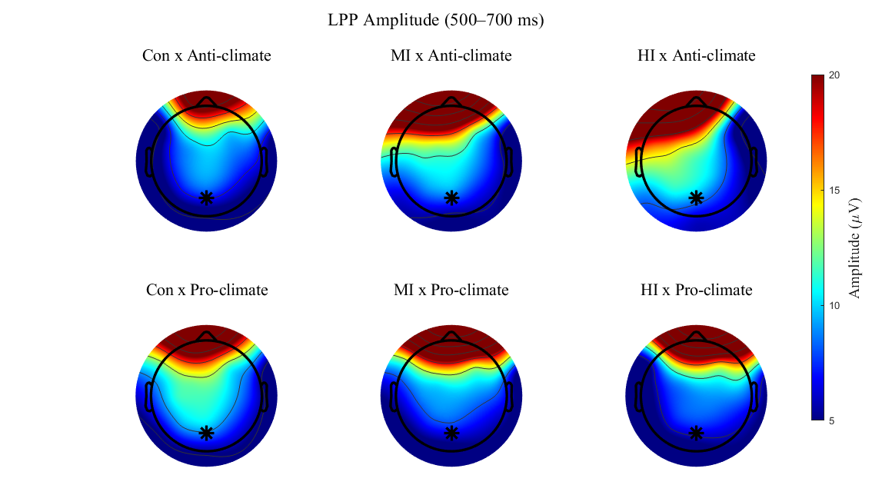
Figure S3. Topography of ERP Components. (a) FRN and (b) LPP in Response to Deviation × Direction Conditions of Social Norms.

