APPENDIX 3. Ratios by Area

The selected European countries are divided into eight areas based on geographic and cultural proximities, following the regional groupings proposed by United Nations (M49 regions) (UN, 2023). For analytical purposes, we have made two divisions within the M49 regions. Southern Europe is divided into Southwestern Europe (Italy, Portugal and Spain), Southeastern Europe (Albania, Bulgaria, Croatia, Montenegro, North Macedonia and Serbia) and Insular Mediterranean countries (Cyprus and Malta). Central-Western Europe includes Austria, France, Germany and Flemish-speaking Belgium. Central-Eastern Europe is composed by Czech Republic, Hungary, Poland and Slovakia. Finally, Northern Europe is also divided into Northwestern Europe (Denmark, Finland, Norway and Sweden), Northeastern Europe (Latvia and Lithuania) and Anglo-Saxon (Ireland and Northern Ireland).

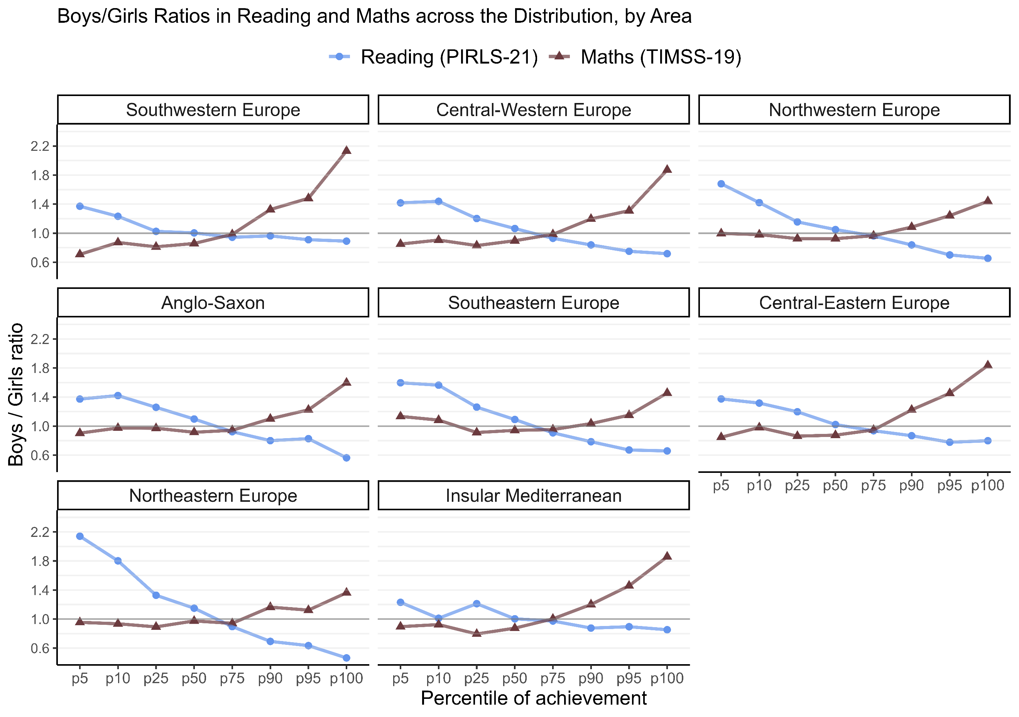
Fig. 1 Boys / Girls ratios in Reading and Maths across the Distribution of Performance, by Area

