Supplementary figures and tables

Article title: Kinetic and Quantitative Analysis of [¹⁸F]SMBT-1 PET Imaging for Monoamine Oxidase B
Journal name: Annals of Nuclear Medicine
Author names:
Kotaro Hiraoka^{1,3}, Berihu Mesfin¹, Yingying Wu¹, Yuki Shimizu², Asuka Kikuchi^{1,3}, Ryuichi Harada⁴, Aiko Ishiki⁵, Yoshihito Funaki², Shozo Furumoto^{2,3}, Shunji Mugikura³, Nobuyuki Okamura⁴, Akio Kikuchi⁶, Kazuhiko Yanai⁷, Hiroyuki Arai⁸, Hiroshi Watabe^{9,3}, Manabu Tashiro^{1,3}
Affiliation:
¹Nuclear Medicine Laboratory, Research Center for Accelerator and Radioisotope Science, Tohoku University, Sendai, Japan.
²Radiopharmaceutical Laboratory, Research Center for Accelerator and Radioisotope Science, Tohoku University, Sendai, Japan.
³Department of Diagnostic Radiology, Tohoku University Hospital, Tohoku University, Sendai, Japan
⁴Division of Pharmacology, Faculty of Medicine, Tohoku Medical and Pharmaceutical University, Sendai, Japan.
⁵Division of Geriatric and Community Medicine, Tohoku Medical and Pharmaceutical University, Sendai, Japan.
⁶Department of Occupational Therapy, Yamagata Prefectural University of Health Sciences, Yamagata, Japan.
⁷Department of Pharmacology, Tohoku University Graduate School of Medicine, Sendai, Japan.
⁸Department of Geriatrics and Gerontology, Institute of Development, Aging and Cancer, Tohoku University, Sendai, Japan.
⁹Radiation Protection and Safety Control Laboratory, Research Center for Accelerator and Radioisotope Science, Tohoku University, Sendai, Japan.
e-mail address of corresponding author: khiraoka@raris.tohoku.ac.jp

Supplementary Fig. 1 Plasma time-activity curves, fractions of unmetabolized [¹⁸F]SMBT-1, and tissue time-activity curves of brain regions (the temporal cortex of Subject 2 and 3). pTAC, plasma time-activity curve; tTAC, tissue time-activity curve

Supplementary Fig. 2 Representative curve fittings by 1TCM and 2TCM (temporal cortex of Subject 1). The dots and lines represent the measured tissue time-activity curves and model fit, respectively. 1TCM, a one-tissue compartment model; 2TCM, a two-tissue compartment model; Vt, total distribution volume; AIC, Akaike information criterion.

Supplementary Fig. 3 Representative Logan plot (temporal cortex of Subject 1). C_Tissue and C_plasma represent the measured time-course of radioactivity in the tissues and arterial plasma, respectively. The starting time of the linear section was fitted using an error criterion of 10%. Vt, Total distribution volume.

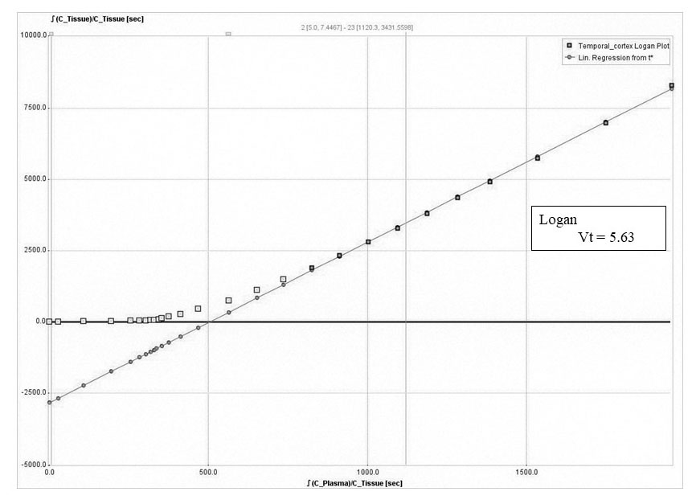
Supplementary Fig. 4. Correlations betweens Vts estimated by 1TCM, 2TCM, and Logan graphical analysis. Vt, Total distribution volume; 1TCM, a one-tissue compartment model; 2TCM, a two-tissue compartment model

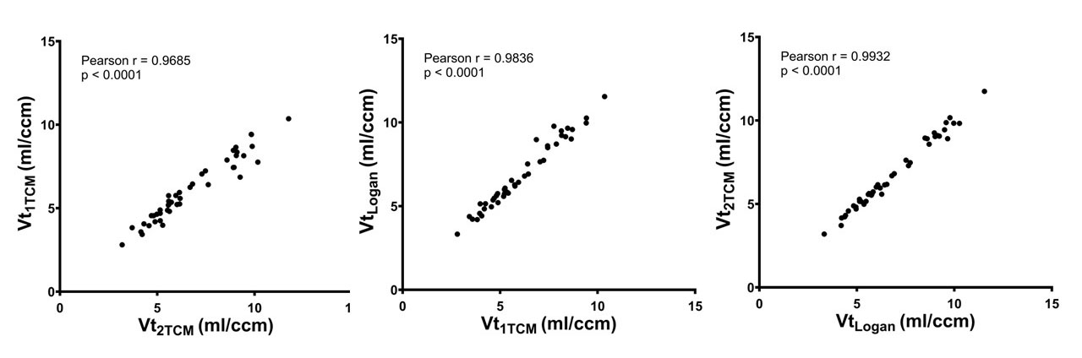

Supplementary Table 1. Comparison of χ2 criterion and AIC of the 1TCM and the 2TCM (n = 3)

 | χ² (mean) |  | AIC (mean)
 | 1TCM | 2TCM | 1TCM | 2TCM
Cerebral deep white matter | 11.74 | 6.24 | 72.82 | 54.08
Pallidum | 9.76 | 5.13 | 67.25 | 50.29
Caudate | 5.84 | 4.14 | 53.55 | 46.08
Thalamus | 10.74 | 5.66 | 70.82 | 54.61
Cingulate cortex | 13.16 | 7.54 | 76.15 | 62.43
Insular cortex | 13.39 | 8.12 | 76.89 | 64.80
Parietal cortex | 12.25 | 6.80 | 74.15 | 59.24
Amygdala | 10.76 | 7.97 | 69.42 | 62.50
Temporal cortex | 11.30 | 6.51 | 71.52 | 57.35
Frontal cortex | 12.52 | 6.83 | 74.73 | 59.13
Occipital cortex | 13.34 | 7.41 | 76.28 | 60.94
Putamen | 8.66 | 4.56 | 63.54 | 47.23
Cerebellar cortex | 17.07 | 11.54 | 83.27 | 71.84
Cerebellar white matter | 17.63 | 10.28 | 84.75 | 70.40
Subcortical white matter | 12.48 | 8.20 | 74.28 | 61.78
1TCM, a one-tissue compartment model; 2TCM, a two-tissue compartment model; AIC, Akaike's information criterion

Supplementary Table 2. Total distribution volumes estimated by the Logan graphical method (n =3)

 |  | Vt (ml/ccm)
 |  | mean | SD
Logan | Cerebral deep white matter | 5.81 | 0.57
 | Pallidum | 9.38 | 0.29
 | Caudate | 8.91 | 0.31
 | Thalamus | 8.83 | 1.12
 | Cingulate cortex | 6.88 | 0.71
 | Insular cortex | 6.84 | 0.64
 | Parietal cortex | 5.18 | 0.49
 | Amygdala | 10.30 | 0.88
 | Temporal cortex | 5.96 | 0.34
 | Frontal cortex | 5.54 | 0.56
 | Occipital cortex | 4.71 | 0.35
 | Putamen | 9.24 | 0.56
 | Cerebellar cortex | 3.98 | 0.47
 | Cerebellar white matter | 5.07 | 0.49
 | Subcortical white matter | 5.72 | 0.46
Vt, Total distribution volume; SD, standard deviation

Supplementary Table 3. SUVs and SUVR-1 referenced various brain regions (n =6)

Time frame: 30 to 50 min after [¹⁸F]SMBT-1 injection
 | SUV (g/ml) |  | SUVR-1
Reference region |  |  | Cerebral deep WM |  | Subcortical WM |  | Cerebellar CTX |  | Cerebellar WM
 | mean | SD | mean | SD | mean | SD | Mean | SD | mean | SD
Cerebral deep white matter | 1.70 | 0.43 | 0.00 | 0.00 | -0.07 | 0.06 | 0.30 | 0.16 | 0.05 | 0.09
Pallidum | 3.13 | 0.56 | 0.89 | 0.18 | 0.76 | 0.22 | 1.46 | 0.40 | 0.99 | 0.24
Caudate | 2.41 | 0.34 | 0.47 | 0.23 | 0.37 | 0.24 | 0.91 | 0.38 | 0.54 | 0.25
Thalamus | 3.02 | 0.67 | 0.80 | 0.09 | 0.67 | 0.12 | 1.33 | 0.27 | 0.88 | 0.15
Cingulate cortex | 2.28 | 0.67 | 0.33 | 0.09 | 0.23 | 0.06 | 0.72 | 0.17 | 0.40 | 0.13
Insular cortex | 2.00 | 0.49 | 0.18 | 0.09 | 0.09 | 0.04 | 0.52 | 0.14 | 0.23 | 0.09
Parietal cortex | 1.82 | 0.44 | 0.08 | 0.10 | 0.00 | 0.04 | 0.38 | 0.09 | 0.12 | 0.07
Amygdala | 2.54 | 0.61 | 0.51 | 0.13 | 0.40 | 0.13 | 0.96 | 0.32 | 0.59 | 0.19
Temporal cortex | 1.83 | 0.49 | 0.07 | 0.07 | -0.01 | 0.02 | 0.39 | 0.13 | 0.12 | 0.09
Frontal cortex | 1.75 | 0.46 | 0.03 | 0.10 | -0.05 | 0.05 | 0.32 | 0.10 | 0.07 | 0.08
Occipital cortex | 1.58 | 0.36 | -0.06 | 0.09 | -0.13 | 0.04 | 0.21 | 0.07 | -0.02 | 0.06
Putamen | 2.81 | 0.53 | 0.69 | 0.17 | 0.57 | 0.16 | 1.20 | 0.31 | 0.78 | 0.19
Cerebellar cortex | 1.33 | 0.35 | -0.22 | 0.09 | -0.28 | 0.06 | 0.00 | 0.00 | -0.19 | 0.04
Cerebellar white matter | 1.62 | 0.40 | -0.04 | 0.08 | -0.11 | 0.05 | 0.23 | 0.07 | 0.00 | 0.00
Subcortical white matter | 1.83 | 0.47 | 1.08 | 0.06 | 0.00 | 0.00 | 0.39 | 0.11 | 0.13 | 0.07
Time frame: 50 to 70 min after [¹⁸F]SMBT-1 injection
 | SUV (g/ml) |  | SUVR-1
Reference region |  |  | Cerebral deep WM |  | Subcortical WM |  | Cerebellar CTX |  | Cerebellar WM
 | mean | SD | mean | SD | mean | SD | Mean | SD | mean | SD
Cerebral deep white matter | 1.55 | 0.26 | 0.00 | 0.00 | -0.01 | 0.03 | 0.54 | 0.21 | 0.14 | 0.11
Pallidum | 2.87 | 0.45 | 0.87 | 0.17 | 0.84 | 0.15 | 1.86 | 0.37 | 1.13 | 0.27
Caudate | 2.29 | 0.30 | 0.50 | 0.15 | 0.48 | 0.13 | 1.30 | 0.36 | 0.71 | 0.25
Thalamus | 2.70 | 0.58 | 0.74 | 0.14 | 0.72 | 0.16 | 1.68 | 0.46 | 0.99 | 0.30
Cingulate cortex | 1.95 | 0.35 | 0.26 | 0.03 | 0.24 | 0.04 | 0.94 | 0.29 | 0.44 | 0.16
Insular cortex | 1.74 | 0.24 | 0.13 | 0.06 | 0.12 | 0.03 | 0.74 | 0.23 | 0.29 | 0.13
Parietal cortex | 1.47 | 0.23 | -0.05 | 0.05 | -0.06 | 0.04 | 0.46 | 0.16 | 0.08 | 0.10
Amygdala | 2.41 | 0.35 | 0.57 | 0.16 | 0.55 | 0.13 | 1.42 | 0.45 | 0.79 | 0.27
Temporal cortex | 1.59 | 0.22 | 0.04 | 0.06 | 0.02 | 0.04 | 0.60 | 0.25 | 0.18 | 0.14
Frontal cortex | 1.48 | 0.23 | -0.04 | 0.05 | -0.05 | 0.03 | 0.47 | 0.19 | 0.09 | 0.11
Occipital cortex | 1.25 | 0.17 | -0.18 | 0.08 | -0.19 | 0.06 | 0.25 | 0.10 | -0.07 | 0.08
Putamen | 2.53 | 0.33 | 0.65 | 0.13 | 0.63 | 0.10 | 1.54 | 0.37 | 0.89 | 0.24
Cerebellar cortex | 1.02 | 0.19 | -0.34 | 0.09 | -0.35 | 0.08 | 0.00 | 0.00 | -0.25 | 0.05
Cerebellar white matter | 1.37 | 0.26 | -0.11 | 0.09 | -0.13 | 0.08 | 0.35 | 0.08 | 0.00 | 0.00
Subcortical white matter | 1.56 | 0.24 | 0.01 | 0.03 | 0.00 | 0.00 | 0.56 | 0.19 | 0.15 | 0.10
Time frame: 70 to 90 min after [¹⁸F]SMBT-1 injection
 | SUV (g/ml) |  | SUVR-1
Reference region |  |  | Cerebral deep WM |  | Subcortical WM |  | Cerebellar CTX |  | Cerebellar WM
 | mean | SD | mean | SD | mean | SD | Mean | SD | mean | SD
Cerebral deep white matter | 1.24 | 0.24 | 0.00 | 0.00 | 0.04 | 0.03 | 0.68 | 0.22 | 0.18 | 0.12
Pallidum | 2.48 | 0.59 | 0.98 | 0.15 | 1.05 | 0.18 | 2.34 | 0.59 | 1.35 | 0.37
Caudate | 1.95 | 0.43 | 0.56 | 0.10 | 0.62 | 0.11 | 1.63 | 0.43 | 0.85 | 0.27
Thalamus | 2.18 | 0.57 | 0.74 | 0.12 | 0.80 | 0.17 | 1.94 | 0.55 | 1.06 | 0.34
Cingulate cortex | 1.48 | 0.32 | 0.19 | 0.03 | 0.23 | 0.04 | 1.00 | 0.30 | 0.41 | 0.16
Insular cortex | 1.33 | 0.25 | 0.07 | 0.05 | 0.11 | 0.03 | 0.80 | 0.22 | 0.27 | 0.12
Parietal cortex | 1.11 | 0.22 | -0.11 | 0.03 | -0.07 | 0.03 | 0.50 | 0.19 | 0.06 | 0.10
Amygdala | 1.97 | 0.40 | 0.58 | 0.15 | 0.64 | 0.13 | 1.67 | 0.44 | 0.87 | 0.27
Temporal cortex | 1.22 | 0.23 | -0.01 | 0.05 | 0.02 | 0.04 | 0.66 | 0.25 | 0.17 | 0.14
Frontal cortex | 1.10 | 0.21 | -0.12 | 0.05 | -0.09 | 0.03 | 0.48 | 0.17 | 0.04 | 0.09
Occipital cortex | 0.98 | 0.18 | -0.21 | 0.04 | -0.18 | 0.04 | 0.32 | 0.14 | -0.07 | 0.08
Putamen | 2.04 | 0.41 | 0.64 | 0.10 | 0.69 | 0.10 | 1.75 | 0.41 | 0.94 | 0.25
Cerebellar cortex | 0.74 | 0.12 | -0.40 | 0.08 | -0.37 | 0.08 | 0.00 | 0.00 | -0.29 | 0.04
Cerebellar white matter | 1.05 | 0.16 | -0.15 | 0.09 | -0.12 | 0.09 | 0.42 | 0.07 | 0.00 | 0.00
Subcortical white matter | 1.20 | 0.22 | -0.03 | 0.03 | 0.00 | 0.00 | 0.62 | 0.20 | 0.14 | 0.11
SUV, standardized uptake value; SUVR, standardized uptake value ratio; Cerebral deep WM, cerebral deep white matter; Subcortical WM, subcortical white matter; Cerebellar CTX, cerebellar cortex; Cerebellar WM, cerebellar white matter; SD, standard deviation.

Supplementary Table 4. Parameter estimation results from compartmental model analysis with vB fixed at 3%, 5%, and not fixed. (frontal and temporal cortices of one subject)

Model | Brain regions | vB | Parameters
 |  |  | vB | K1 | k2 | Vt
1TCM | Frontal cortex | fixed to 3% | 0.030 | 0.256 | 0.044 | 5.762
 |  | fixed to 5% | 0.050 | 0.253 | 0.043 | 5.916
 |  | not fixed | 0.096 | 0.246 | 0.039 | 6.302
 | Temporal cortex | fixed to 3% | 0.030 | 0.228 | 0.038 | 5.942
 |  | fixed to 5% | 0.050 | 0.225 | 0.037 | 6.111
 |  | not fixed | 0.086 | 0.220 | 0.034 | 6.442
Model | Brain regions | vB | Parameters
 |  |  | vB | K1 | k2 | k3 | k4 | Vt
2TCM | Frontal cortex | fixed to 3% | 0.030 | 0.915 | 8.000 | 2.630 | 0.051 | 5.956
 |  | fixed to 5% | 0.050 | 0.296 | 0.221 | 0.417 | 0.119 | 6.024
 |  | not fixed | 0.094 | 0.252 | 0.046 | 0.004 | 0.000 | 8.590 x 10⁹⁷
 | Temporal cortex | fixed to 3% | 0.030 | 0.780 | 8.000 | 2.859 | 0.046 | 6.141
 |  | fixed to 5% | 0.050 | 0.250 | 0.116 | 0.175 | 0.092 | 6.276
 |  | not fixed | 0.083 | 0.226 | 0.041 | 0.005 | 0.004 | 13.060
vB, blood volume; 1TCM, a one-tissue compartment model; 2TCM, a two-tissue compartment model; Vt, Total distribution volume

