SUPPORTING INFORMATION FOR:
The Lipidome and Proteome of Oil Bodies from Helianthus annuus (common sunflower)

SMALL ANGLE NEUTRON SCATTERING (SANS)
Time-of-Flight Small Angle Neutron Scattering (SANS) was carried out on the Sans2d beam line at ISIS of the Rutherford Appleton Laboratory (Harwell, Oxon.). Samples were housed in 300 μL rectangular quartz cells (Hellma GmbH & Co. KG, Müllheim, Baden-Württemberg, Germany), which were in turn held in a custom-built ceramic centrally-controlled rack. The temperature of the sample chamber was controlled using a thermostated air-conditioning system and set at 20·0°C ± 0·5. Diffraction patterns were recorded using a sample-detector distance of 4·00 m. The detector was a 1 m², 77,000-pixel surface and housed in a cylindrical vacuum tank 3·25 m in diameter and 13 m long at a pressure of 0·5 mBar.
Small Angle Neutron Scattering (SANS) – oil body isolation and preparation—De-hulled Helianthus annuus seeds (~100 g) were mixed with a solution of lipase inhibitors (FIPI, 5 mg; D609, 10 mg; U73122, 10 mg; BPBA, 1 g; n-butanol, 5 mL) and Tris-base (0·1 M, pH 7·5, 200 mL) and ground using a Silverson high-shear mixer L 5 M (Silverson Ltd, Chesham, Buckinghamshire, UK. Operated at <2 krpm) with the dilution of the mixture (addition of 200 mL Tris-base 0·1 M, pH 7·5) with successively narrowing mesh sizes of the homogeniser work head (5 mm mesh, then 2·5 mm, then 1·5 mm). The resulting suspension was made up to a total volume of 1·4 L (Tris-base 0·1 M, pH 7·5) and the mixture fractionated by centrifugation (9,950 × g, 20 min, 4°C). The uppermost layer was removed. This material constituted the crude OBs for SANS experiments. In order to prepare purified OBs for comparison, this material was resuspended in aqueous solution (~4:1 v/v) before centrifugation (2,800 × g, 20 min, 4°C). The aqueous suspensions used were: Tween 20 (1% v/v, ddH₂O), NaCl (2 M, ddH₂O), Urea (8 M, ddH₂O). Material produced after these steps constituted purified OBs for SANS experiments. Data from these experiments informed optimization of the OB isolation protocol for the lipidomics and proteomics data (see above).

PROTEIN ANALYSIS
Bradford Assay—Protein isolates from OB fractionation were assayed for protein content using Bradford’s assay, with BSA (Thermo Scientific BSA standard, Product number 23209; 2·0 mg/mL in saline, supplemented with sodium azide) for calibration. Bradford’s reagent was purchased from Bio-Rad (Hemel Hempstead, Hertfordshire, UK) and used as directed.
SDS-Poly-Acrylamide Gel Electrophoresis—Dried protein residue from the OB fractionation was dissolved in urea-containing buffer (Capuano et al.⁷, 1 mg/160 µL/40 µL β-mercaptoethanol [reducing]) before being heated (95°C, 10 min). The samples (15-25 µL/well) were loaded on to a pre-cast 12% tris-glycine gel and run (~60 min, 120 V). The gel was washed (3 × 50 mL ddH₂O) and stained according to the manufacturer’s instructions (Bio-Rad G-250, 50 mL, 3 h), and destaining (ddH₂O, 50 mL, 3 h). Gels were scanned on a Bio-Rad GS-800 densitometer with Bio-Rad Quantity One (4.4.1) software. Quantitative densitometry of SDS-PAGE gels was performed using ImageJ version 1.46r on reducing lanes of gel electrophoresis of three different protein isolates (arising from three different oil body isolations) that had been kept (4°C) for less than two weeks.
Protein Mass Spectrometry—Protein bands were excised from gels and processed in gel pieces using the ProteomeWorks MassPREP robotic liquid handling station (Waters Ltd., Elstree, Hertfordshire, UK). The samples were incubated in 100 µL of de-staining solution (50 mM ammonium bicarbonate, 50% acetonitrile) for 10 min three times at 40°C and, following removal of the final aliquot, the sample was dehydrated by incubation at 40°C in 50 µL of acetonitrile for 5 min, the acetonitrile was removed and incubation was continued for 10 min to allow evaporation to occur. The sample was further processed by incubation at 40°C in 50 µL of reducing solution (10 mM dithiothreitol, 100 mM ammonium bicarbonate) for 30 min and, following removal of the reducing solution, incubation at 40°C in 50 µL of alkylation solution (55 mM iodoacetamide, 100 mM ammonium bicarbonate) for 20 min. The gel pieces were then washed at 40°C in 50 µL of 100 mM ammonium bicarbonate for 10 minutes, 50 µL of acetonitrile for 5 min and dehydrated by double 40°C washes in 50 µL of acetonitrile for 5 min and evaporation for 5 min. The microtitre® plate containing the gel slices was cooled to 6°C for 10 min before addition of 30 µL per well of trypsin gold (Promega), diluted to 10 ng.µL⁻¹ in 50 mM ammonium bicarbonate. The plate was incubated at 6°C for a further 20 min to permit trypsin entry into the gel plugs with minimal autocatalysis before incubation at 40°C for 4 h. Samples were stored at 4°C until MS analysis.
Samples were analysed by LC-ESI-tandem MS on a Q-TOF2 mass spectrometer fitted with a nano-lockspray ESI (electrospray ionization) source (Waters Ltd, UK). Peptides were delivered on-line to the MS via a CapLC HPLC system. The mass spectrometer was operated with a capillary voltage of 3000 V in positive ion mode, using argon as the collision gas. Tandem MS data were acquired using an automated data-dependent switching between survey MS and MS/MS scanning based upon ion intensity, mass and charge state (data directed analysis (DDATM)). Charge state recognition was used to select doubly, triply and quadruply charged precursor peptide ions for fragmentation. Up to four precursor masses per survey MS scan were chosen for tandem MS acquisition. Collision energy was automatically selected based on charge and mass of each precursor and varied from 15 to 55 eV. The lockmass molecule, Glu-1-fibrinopeptide, was scanned for 1 s, every 30 s throughout the run.
ProteinLynxGlobalServer version 2.0 (Waters, Ltd) was used to apply the lockmass recalibration and to process the uninterpreted MS data into peak list (pkl) files which were searched against all entries in Swissprot and/or NCBInr databases using the web version of the Mascot MS/MS ions search tool (http://www.matrixscience.com/). Carbamidomethylation of cysteine and oxidation of methionine were set as variable modifications. One missed cleavage by trypsin was accepted. Other than file type (Micromass pkl) and instrument type (ESI-QUAD-TOF), all remaining search values were the preset defaults.

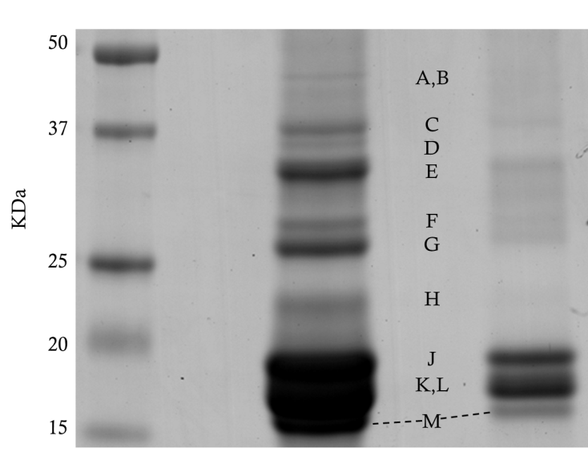
Supplementary Figure 1. Reducing SDS-PAGE of OBs. Lanes: 1, marker; 2, 80 µg/mL sample buffer); 3, 8 µmg/mL sample buffer). Peptide identification shown in Table 1.

NUCLEAR MAGNETIC RESONANCE SPECTROSCOPY (NMR)
Samples were prepared in a known ternary solvent system, referred to as CUBO (Bosco et al. 1997; Culeddu et al. 1998; Murgia et al. 2003; Cremonini et al. 2004), consisting of dimethylformamide (5 mL), triethylamine (1·5 mL) and guanidinium chloride (500 mg), modified to include 20% deuteriated dimethylformamide for lipidome samples. Samples were sonicated (Ultrasonicator USC1700D, VWR (Lutterworth, Leicestershire, UK), power 9, 25°C, 15 min) before spectroscopy. Wilmad® 507PP tubes were used. Sample concentration varied, but was typically >20 mg lipid (s) per sample (600 µL).
Lipidome samples —were run on a Bruker Avance III 800 MHz spectrometer, equipped with a QCI cryoprobe probe. Phosphorous experiments were acquired using inverse gated proton decoupling. Spectra were averaged over 1312 transients with 3882 complex points with a spectral width of 14·98 ppm. An overall recovery delay of 8·4 s was used. Data were processed using an exponential line broadening window function of 1.5 Hz prior to zero filling to 32768 points and Fourier transform.
Data was processed using TopSpin 3.1 or ACD labs 12.0 software. Resonances were deconvoluted within TopSpin. Subsequent integrations above a noise threshold of 0·01% of the total ³¹P were used to establish the molar quantity of a given phosphorus environment.
Commercially available soya lecithin (Ransom Consumer Healthcare, Bradford, West Yorkshire, UK) was used to reference the shifts of the resonances observed, and thence identify resonances. Additional signals were identified using lyso-phosphatidylserine (Supplementary Figure 5), phosphatidylinositol 4-phosphate (Supplementary Figure 6) and lyso-phosphatidylglycerol (Supplementary Figure 7), with the latter also as the quantitative standard in lipidome samples. Spectra and shifts of these lipids can be found in the Table 2.

Isolation of the fatty acid residues of the lipid fraction
OB lipid fraction (50 mg, freshly isolated) was dissolved in water (double distilled, 10 mL), ethanol (10 mL) and NaOH (1 g) and stirred for 16 h. After this time, the reaction mixture was quenched (5 M HCl, 25 mL), diluted (diethyl ether, 100 mL), washed (water, 2 × 100 mL) and dried (MgSO₄). The organic solution was concentrated to dryness under reduced pressure to afford a clear, yellowish oil (32 mg).
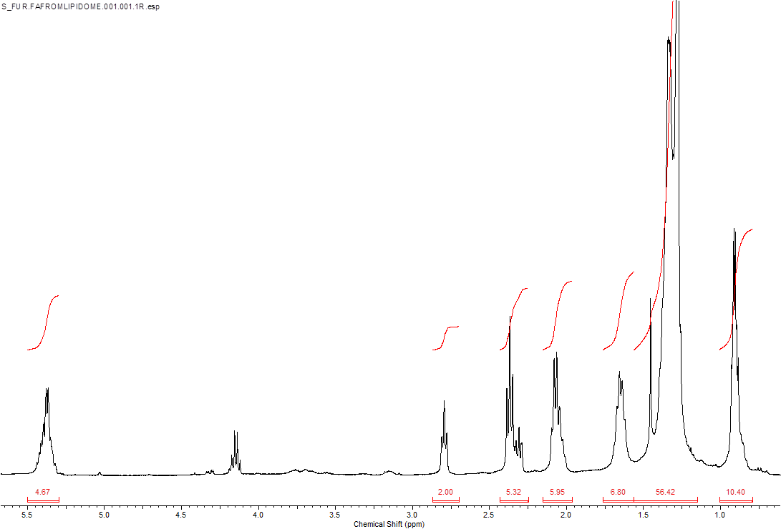
Supplementary Figure 2. ¹H NMR spectrum of the fatty acids isolated from the lipidome of OBs from Helianthus annuus. Data: δ_{H} (400 MHz, CDCl₃), *5·4 (4H, m, olefinic protons), †*2·8 (2H, t, J = 6·2 Hz, -CH:CH-CH₂-CH:CH-), *2·4 (2H, t, J = 7·2 CH₂CH:CH-CH₂C), 2·1 (2H, m, RCH₂COOH) , 2·1 (2H, m, RCH₂CH₂COOH), 1·4 (m, fatty acid methylenes), 0·9 (3H, methyls) ppm. †linoleic acid only; *resonances from unsaturated fatty acids only.

Fatty acid analysis
The ¹H spectrum above was calibrated to the olefin protons (4H), showing integrations of 10·40 for the methyls (0·9 ppm), suggesting ~2·3:1 for linoleic acid : palmitic acid. The signal at 2·6 ppm is consistent with that of the methylene (s) between two or more olefin bonds. This is calibrated to 2H as there is only one such methylene in linoleic acid (C18:2). This calibration indicates that there are olefinic protons in fatty acids that do not have such protons as the signal at 5·4 ppm is greater than that of linoleic acid (4H), suggesting that linoleic acid and oleic acid (C18:1) are in a ratio of 6:1 (4:0·67). However, methyl (0·8 ppm) and α-proton signals (2·1 ppm) suggest the presence of fatty acids without olefin bonds (MS evidence indicates palmityl residues, C16:0) as their integrations are too large to account for the linoleic acid (3H methyl and 2H α-protons) and oleic acid (1·0 H equivalent for methyl signal and 0·67H for α-protons signal). This suggests that the ratio of palmitic:linoleic:oleic acids is approximately 2:1:0·25. In the carbon spectrum (Supplementary Figure 3) The resonance shifts are consistent with those of oleic acid (130·1, 129·7 ppm) and linoleic acid (130·2, 130·0, 128·1, 127·0 ppm)^{1,2}. Integrations of the signals are consistent with the ratio of 4:1 measured in the proton spectrum (Supplementary Figure 2).

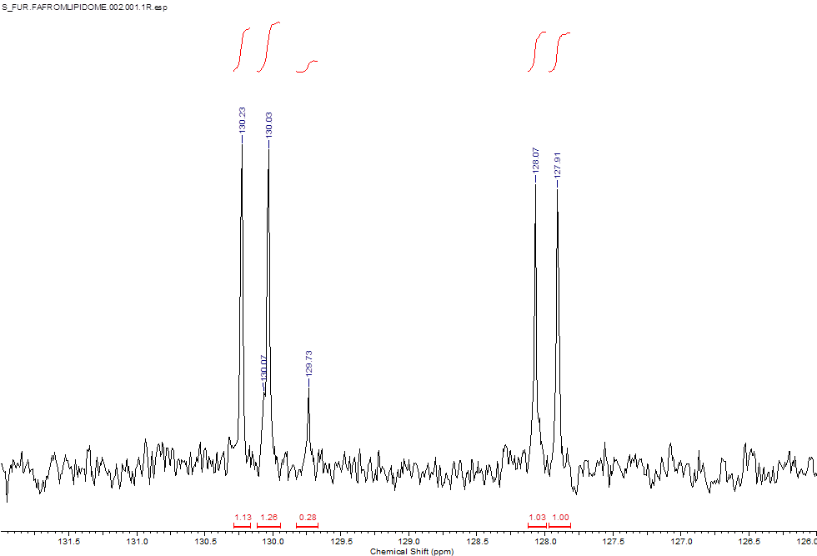
Supplementary Figure 3. Expanded ¹³C proton spectrum of the fatty acids isolated from the lipidome of OBs from Helianthus annuus.

Lipid references
The following were used as lipid references.

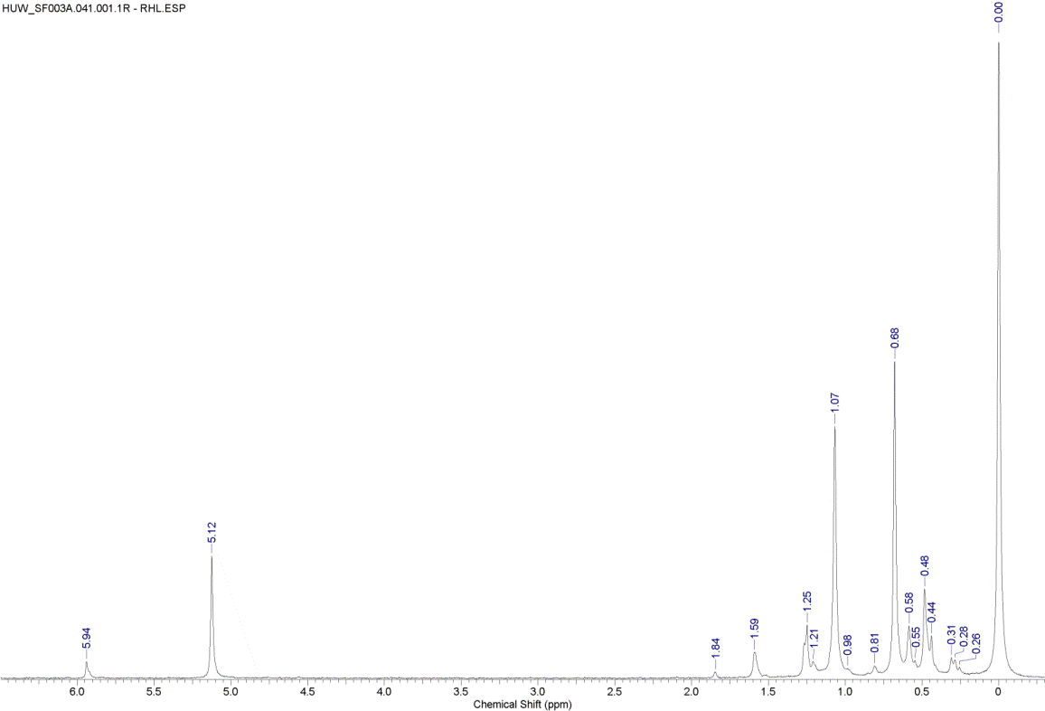
Supplementary Figure 4. Soya lecithin, used as a calibration reference (3-6). δ_{P} (800 MHz, DMF/TEA/guanidinium chloride, 10:3:1, ‘CUBO’⁴⁻⁶), 5·94 (lyso-phosphatidic acid), 5·12 (phosphatidic acid), 1·84 (lyso-phosphatidyl glycerol) 1·59 (lyso-phosphatidylinositol), 1·25 and 1·21 (phosphatidylglycerols), 1·07 (phosphatidylinositol), 0·98, 0·81, 0·68, 0·58 (phosphatidylethanolamine), 0·55 (phosphatidylserine), 0·48, 0·44 (lyso-phosphatidylcholine), 0·31, 0·28, 0·26, 0·00 (phosphatidylcholine, referenced to 0·00) ppm.

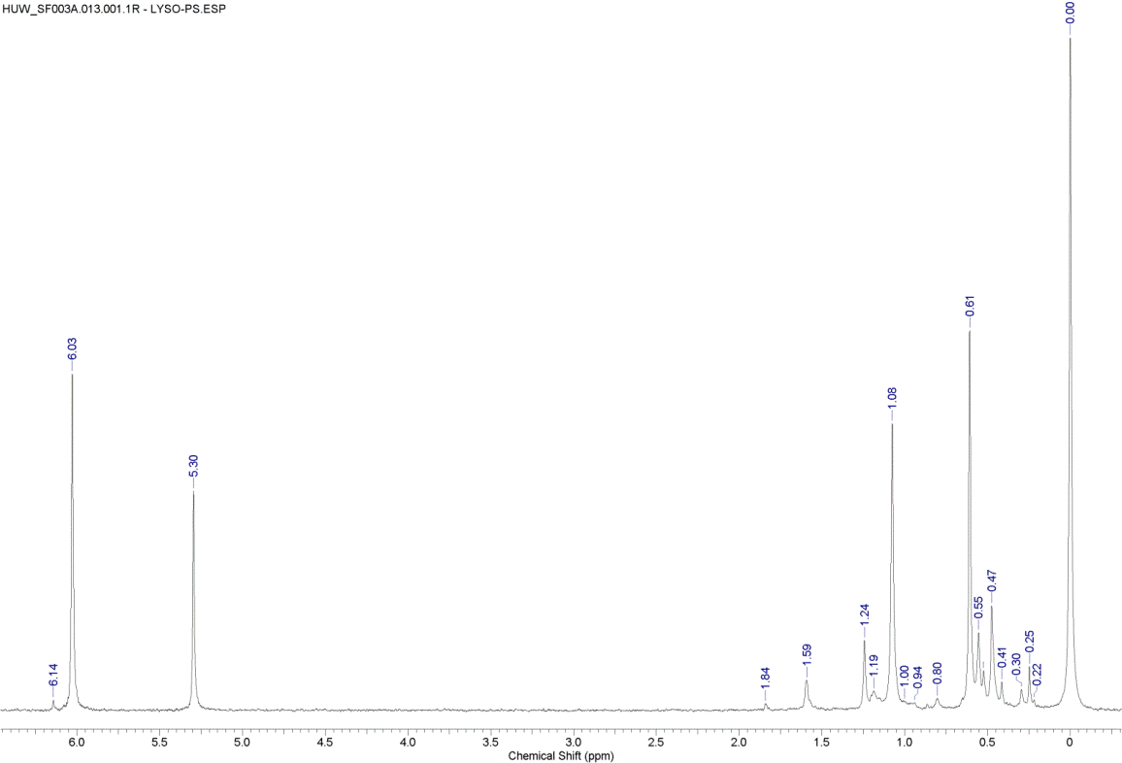
Supplementary Figure 5. lyso-Phosphatidylserine with Soya Lecithin. δ_{P} (800 MHz, CUBO solv. ⁴⁻⁶), 6·14 (sn-2-O-lyso-phosphatidylserine), 6·03 (lyso-phosphatidylserine and lyso-phosphatidic acid), 5·30 (phosphatidic acid), 1·84 (lyso-phosphatidyl glycerol) 1·59 (lyso-phosphatidylinositol), 1·24 and 1·19 (phosphatidylglycerols), 1·08 (phosphatidylinositol), 1·00, 0·94, 0·80, 0·61, 0.55 (phosphatidylethanolamine), 0·52 (phosphatidylserine), 0·47, 0·41 (lyso-phosphatidylcholine), 0·30, 0·25, 0·22, 0·00 (phosphatidylcholine, referenced to 0·00) ppm.

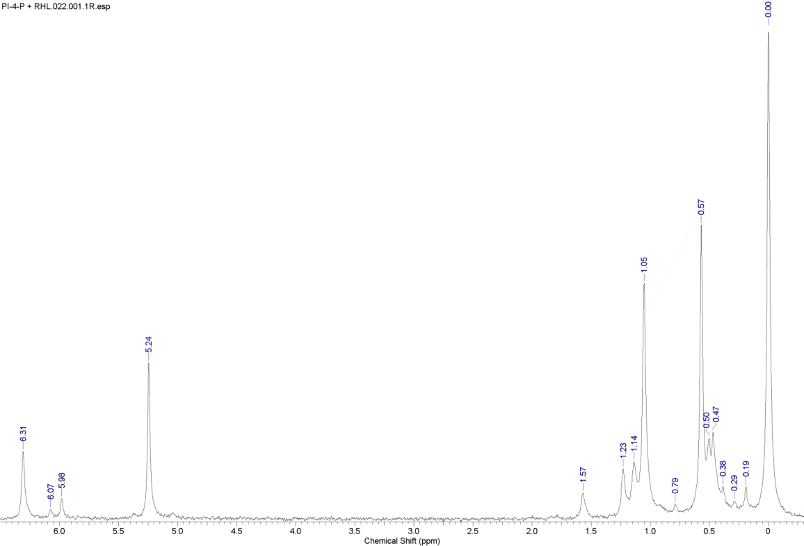
Supplementary Figure 6. Phosphatidylinositol 4-phosphate and Soya Lecithin. δ_{P} (800 MHz, CUBO solv. ⁴⁻⁶), 6·31 (phosphate mono-ester of phosphatidylinositol 4-phosphate) 6·07 (sn-2-O-lyso-phosphatidylserine), 5·98 (lyso-phosphatidylserine and lyso-phosphatidic acid), 5·24 (phosphatidic acid), 1·57 (lyso-phosphatidylinositol), 1·23 (phosphatidylglycerol), 1·14 (phosphate di-ester of phosphatidylinositol 4-phosphate), 1·05 (phosphatidylinositol), 0·79, 0.57 (phosphatidylethanolamine), 0·50 (phosphatidylserine), 0·47, 0·38 (lyso-phosphatidylcholine), 0·29, 0·19, 0·00 (phosphatidylcholine, referenced to 0·00) ppm

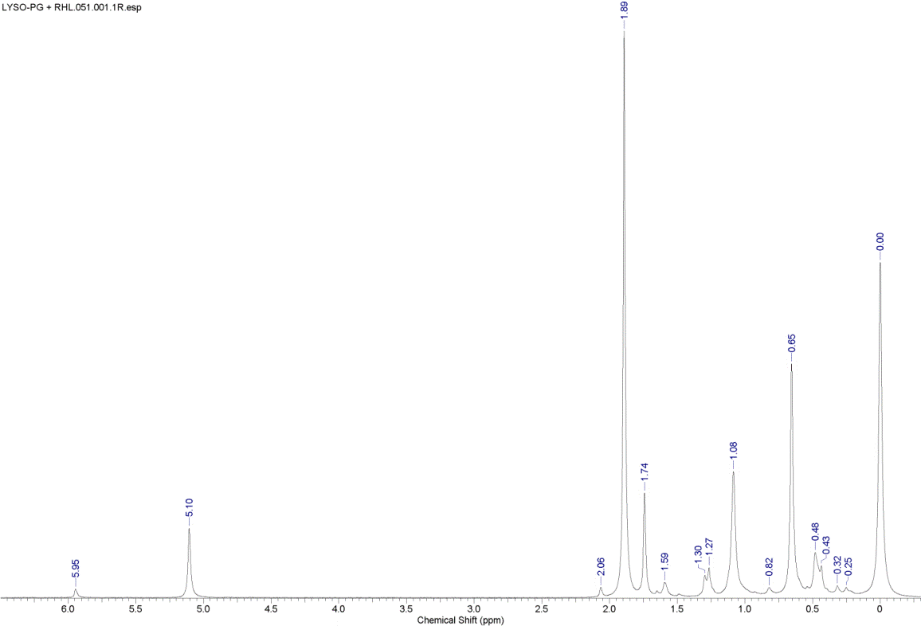
Supplementary Figure 7. lyso-Phosphatidylglycerol and Soya Lecithin. δ_{P} (800 MHz, CUBO solv. ⁴⁻⁶), 5·95 (lyso-phosphatidic acid), 5·10 (phosphatidic acid), 2·06, 1·89 (lyso- phosphatidylglycerol), 1·74 (sn-2-O-lyso-phosphatidylglycerol), 1·59 (lyso-phosphatidylinositol), 1·30 and 1·27 (phosphatidylglycerol), 1·08 (phosphatidylinositol), 0·82, 0.65 (phosphatidylethanolamine), 0·48, 0·43, (lyso-phosphatidylcholine), 0·32, 0·25, 0·00 (phosphatidylcholine, referenced to 0·00) ppm.
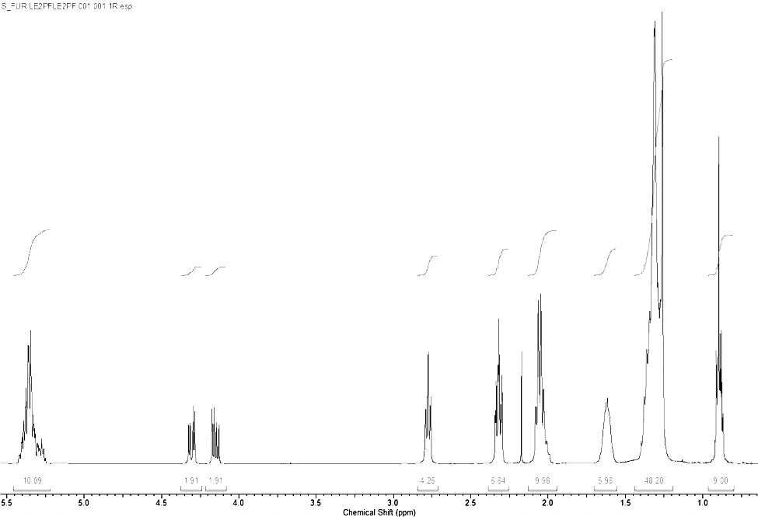
Supplementary Figure 8. Triacylglyceride (oil) fraction from OBs. δ_{H} (400 MHz, CUBO solv. ⁴⁻⁶), 5·35 (10H, m, olefinic protons and gly-2H), 4·31 (2H, dd, J = 11·8, 4·2 Hz, gly-1 and gly-3), 4·15 (2H, dd, J = 11·9, 5·9 Hz, gly-1 and gly-3), 2·78 (4H, t, J = 6·4 Hz, -CH:CH-CH₂-CH:CH-), 2·32 (6H, t, J = 8·0 Hz, -CH₂COOR), 2·05 (10H, m, -CH₂CH₂CH:CH-), 1·62 (6H, m, -CH₂CH₂COOR), 1·42-1·20 (~48H, m, methylenes), 0·89 (9H, 3 × t, J = 8·0 Hz, methyls). Mass spectrometry data can be found in Supplementary Figures 17-19

LC-MS LIPID PROFILING OF OIL BODY EXTRACTS
All extracted oil body fractions were diluted 1:1000 in isopropanol:chloroform (1:1) and 10 µL was injected for LC-MS analysis Accurate mass LC-MS was performed using an Accela LC and Exactive mass spectrometer (ThermoFisher Scientific) in ES+ and ES- modes. The LC column used was a Phenomenex Gemini C18, 100 × 2·1 mm (3 µm particle size) with gradient separation at 45°C, analysis time 30 min, flow rate 0·3 mL/min. Mobile phase A consisted of 0·1% ammonium acetate in water, pH 6·0, and mobile phase B was 56% acetonitrile, 40% isopropanol and 5% water with 0·1% ammonium acetate. Ions were monitored the range m/z 100 to 1500. The calibrated mass accuracy was 1 (ES+) and 2 (ES-) milli mass units and the resolution was 10- 25,000 FWHM.
A hybrid quadrupole linear ion trap (4000 QTRAP) from ABI (Warrington, UK) and a Shimadzu LC-10AVP (Milton Keynes, UK) was used to provide product ion information to aid identification with particular respect to head group and fatty acid residue detail. LC conditions were as described above. The precursor ion ranges acquired were from m/z 200 to 1200 and product ions were acquired in the range m/z 85 to 1200. Specific precursor ion scans were created to analyse phosphatidylcholines (ES +, phosphocholine, m/z 184), phosphoethanolamines (ES -, PE head group m/z 196) and, phosphatidylserines, phosphatidic acid and phosphatidylglycerols (ES -, phosphoglycerol, m/z 153).
LipidMaps databases (http://www.lipidmaps.org/data/standards/index.html). were used to assist in identification of extracted lipids The LipidMaps prediction tool download was also used to generate the theoretical masses of product ions which in conjunction with the fatty acid residues, was used to assign identities. The accurate mass of phosphatidylbutanol was confirmed by infusing a further purified oil body extract (diluted 1:1000 in methanol) directly into the mass spectrometer.
The complexity of the lipidome was evidenced by the variety of ions observed in its nominal mass (Supplementary Figure 9). This led us to several other techniques, noted below.
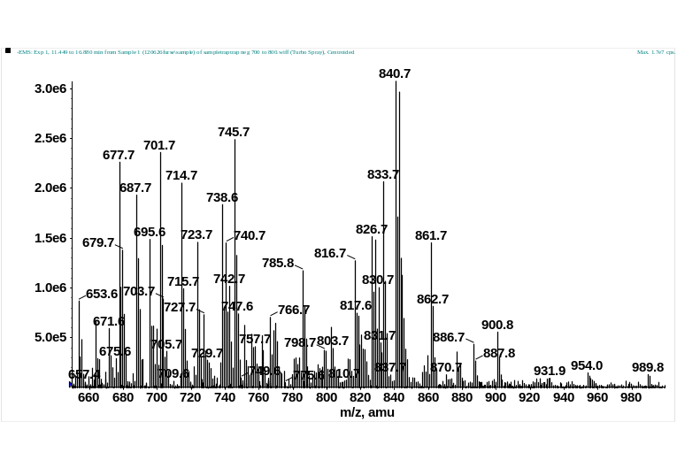
Supplementary Figure 9. A summed enhanced MS spectrum (nominal mass) of the lipidome in –ES mode indicates the sample complexity. All extracted oil body fractions were diluted 1:1000 in isopropanol:chloroform (1:1) and 10 µL was injected for LC-MS analysis. Some highlights: m/z 833 PI (C18:2/C16:0), m/z 861 PI (C18:2/C18:0), m/z 738.5 PE (C18:2/C18:2), m/z 745.5 PG C18:2/C16:0 and m/z 714.5 PE (C18:2/C16:0)

A hybrid quadrupole linear ion trap from ABI (Warrington, UK) the 4000 Qtrap was used to provide product ion information to aid identification with particular respect to head group and fatty acid residue detail. Precursor ion scans were created to analyse phosphatidylcholines (ES +ve phosphocholine, m/z 184), phosphoethanolamines (ES -ve PE headgroup m/z 196) and as a group, phosphatidylserines, phosphatidic acid and phosphatidylglycerols (ES -ve, phosphoglycerol, m/z 153). These were used to trigger subsequent MS/MS quadrupole-ion trap experiments. An example of precursor ion MS/MS is shown in Supplementary Figures 10 and 11.
Supplementary Figure 10 shows an LC chromatogram of a precursor ion trace in ES +ve mode, m/z 184 and Supplementary Figure 11 an example of a typical MS/MS spectrum, PC (18:2/16:0). Although, some structural information has been provided, no attempt has been made to determine acyl or double bond positions. In each case, the source parameters were similar, the nebulising, drying and curtain gases were set to 10, 30 and 10 (arbitrary units) respectively and the temperature was set to 400°C. The ion spray voltage was set to 4 kV or -4.5 kV for +ve or -ve ES respectively. The declustering potentials were ramped from 30 to 65 V (+ve ES) or -30 to -65 V (-ve ES). The collision energies for the three precursor ion scan methods were ramped from 30 to 80 V (ES+) or -30 to 80 (ES-). The precursor ion ranges acquired were from m/z 200 to 1200 and product ions were acquired in the range m/z 85 to 1200.
The LC conditions were as follows: The column used was a Phenomenex Gemini C18, 100mm by 2·1mm (3 µm particle size). A gradient over 30 min from A to B was used to elute the lipids, the profile of which was as follows: at time 0·0%B, increasing to 100%B over 15mins, followed by 10mins at 100%B. The proportion was reduced to the starting point for re-equilibration for 5mins. The column was held at 45°C, and the total flow was 0.3mL/min. Mobile phase A consisted of 0·1% ammonium acetate in water, pH 6·0, and mobile phase B was 56% acetonitrile, 40% isopropanol and 5% water with 0.1% ammonium acetate modifier as above. A modular system, Shimadzu LC-10AVP (Milton Keynes, UK) was used with the Qtrap.

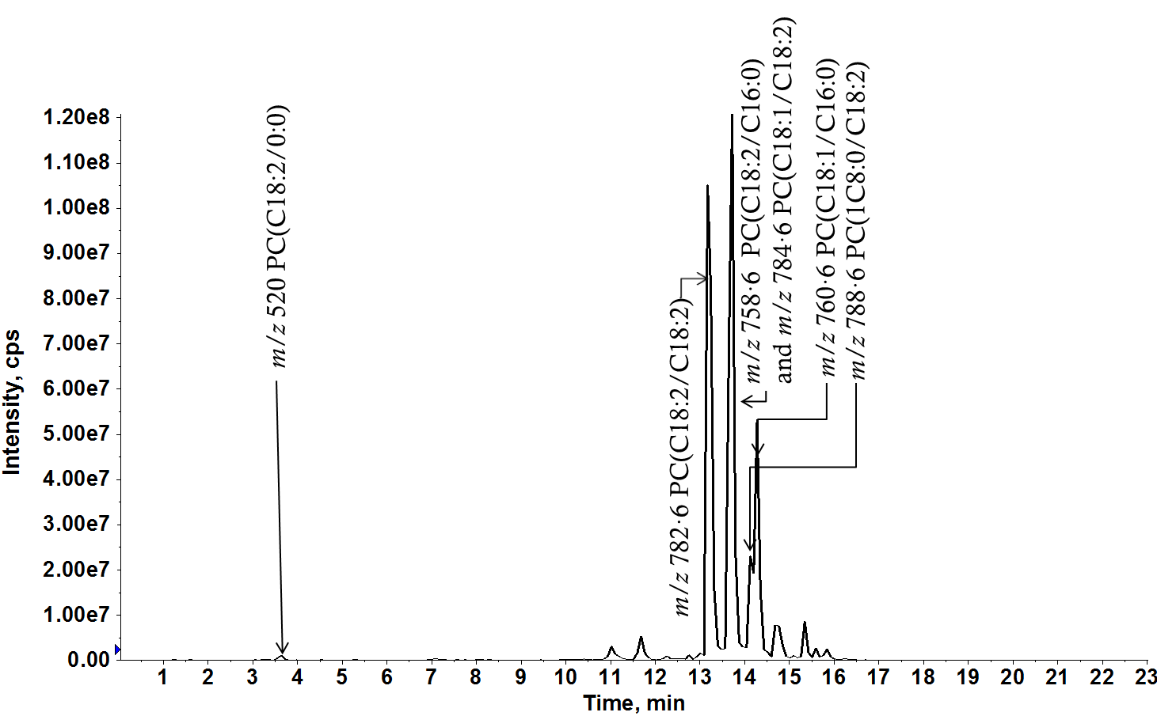
Supplementary Figure 10. LC-MS precurosr ion analysis showing the PC species identified (precursors of m/z 184) observed, with subsequently identified fatty acid composition. All extracted oil body fractions were diluted 1:1000 in isopropanol:chloroform (1:1) and 10 µL was injected for LC-MS analysis using a hybrid quadrupole linear ion trap (4000 QTRAP) as described in the main paper methods section.

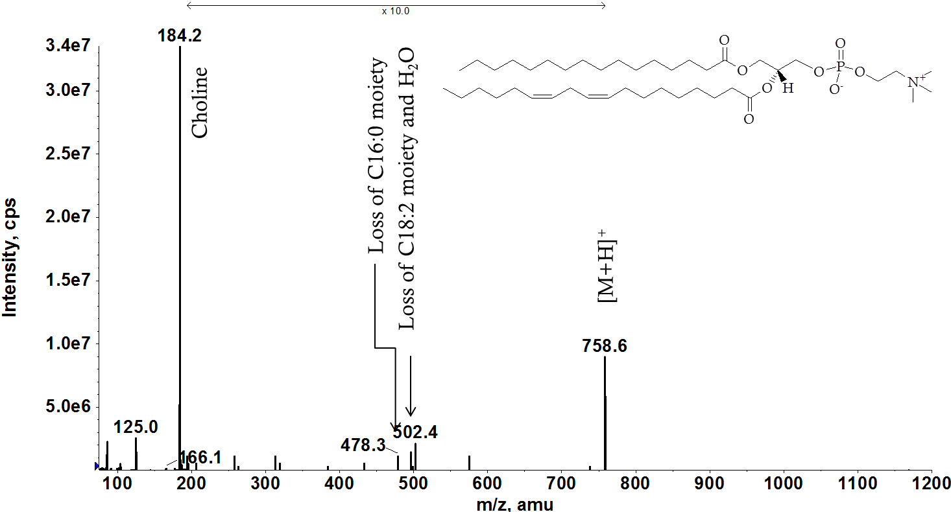
Supplementary Figure 11. Example of PC MS/MS fragmentation to identify acyl chains (PC (C18:2/C16:0). All extracted oil body fractions were diluted 1:1000 in isopropanol:chloroform (1:1) and 10 µL was injected for LC-MS analysis using a hybrid quadrupole linear ion trap (4000 QTRAP) as described in the main paper methods section.
The following figures show MS/MS spectra for PA (Supplementary Figure 12), PG (Supplementary Figure 13), PI (Supplementary Figure 14) and PE (Supplementary Figure 15) were selected as showing representative fatty acid residues, palmitic acid (nominal mass m/z 255, C16:0 and linolenic acid m/z 279).
Using an ABI A hybrid quadrupole linear ion trap from ABI (Warrington, UK), the 4000 Qtrap, was used to create a generic method, where enhanced mode MS/MS ion trap experiments were triggered on the basis of intensity or targeted interest, here in –ve ion ES mode. Samples were introduced into the MS source using the LC method described previously. Thus in each case, the source parameters were similar, the nebulising, drying and curtain gases were set to 10, 30 and 10 (arbitrary units) respectively and the temperature was set to 400°C. Source parameters were as described for precursor ion scans. The mass spectrometer operated in enhanced (ion trap mode) with default values, and the enhance product ion spectra, likewise, with a ramped collision energy of -50 uA and CAD set to high.

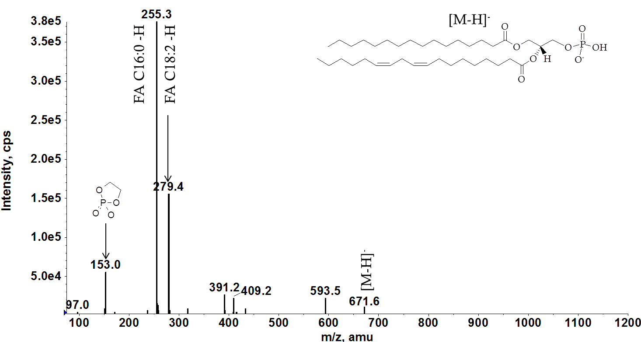
Supplementary Figure 12. Example of PA MS/MS fragmentation to identify fatty acid residues. All extracted oil body fractions were diluted 1:1000 in isopropanol:chloroform (1:1) and 10 µL was injected for LC-MS analysis using a hybrid quadrupole linear ion trap (4000 QTRAP).

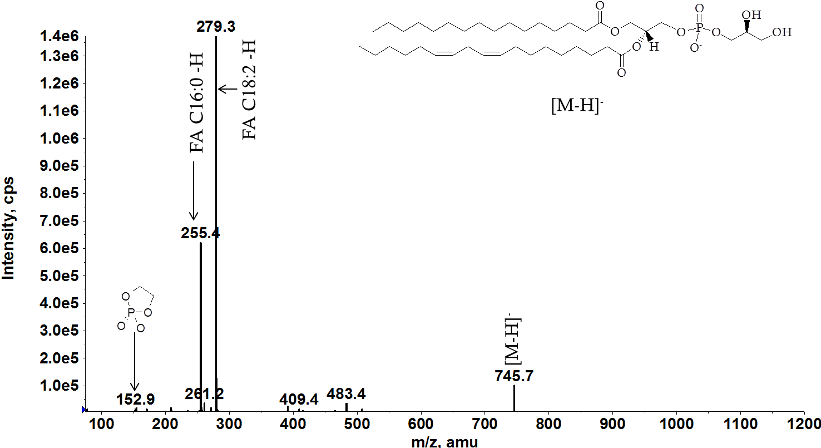
Supplementary Figure 13. Example of PG MS/MS fragmentation to identify fatty acid residues. All extracted oil body fractions were diluted 1:1000 in isopropanol:chloroform (1:1) and 10 µL was injected for LC-MS analysis using a hybrid quadrupole linear ion trap (4000 QTRAP).

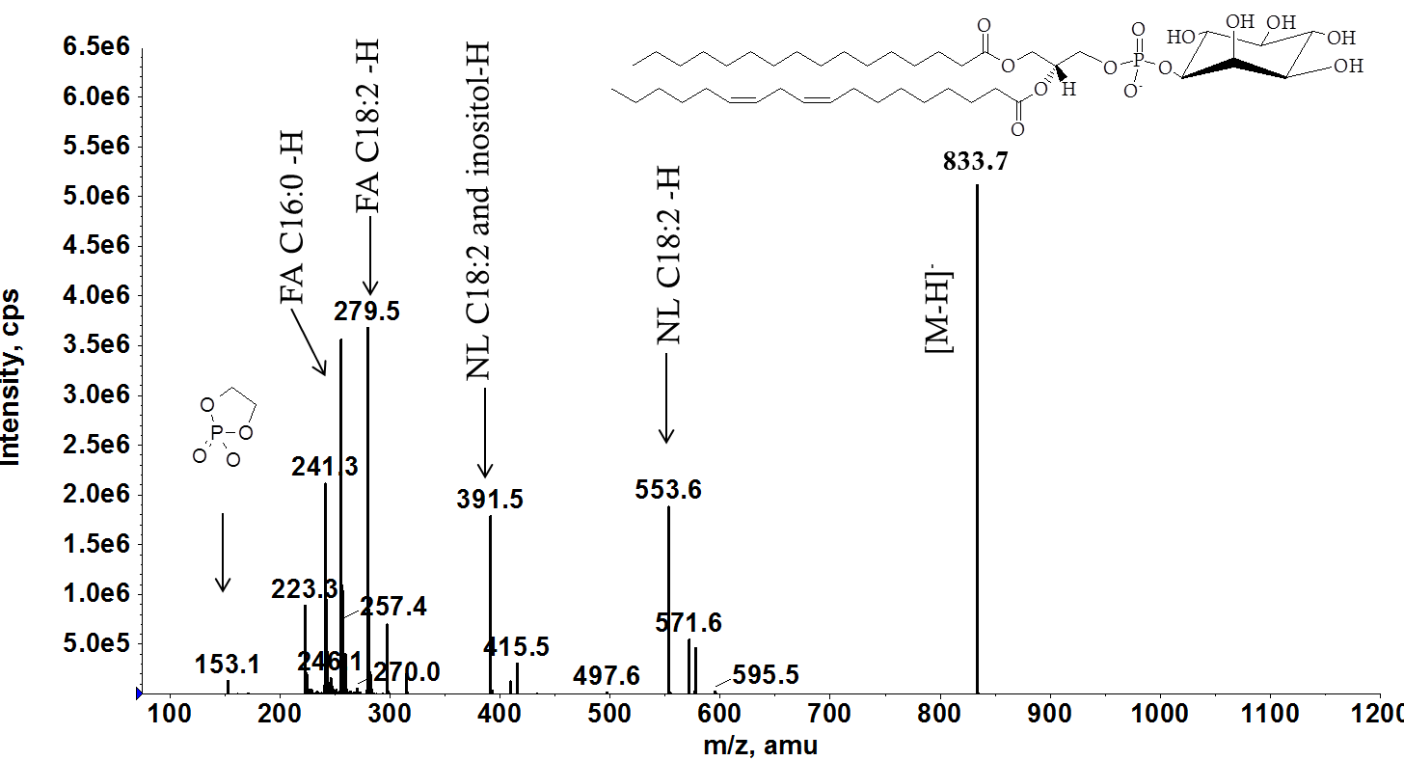
Supplementary Figure 14. Example of PI MS/MS fragmentation to identify fatty acid residues. All extracted oil body fractions were diluted 1:1000 in isopropanol:chloroform (1:1) and 10 µL was injected for LC-MS analysis using a hybrid quadrupole linear ion trap (4000 QTRAP).
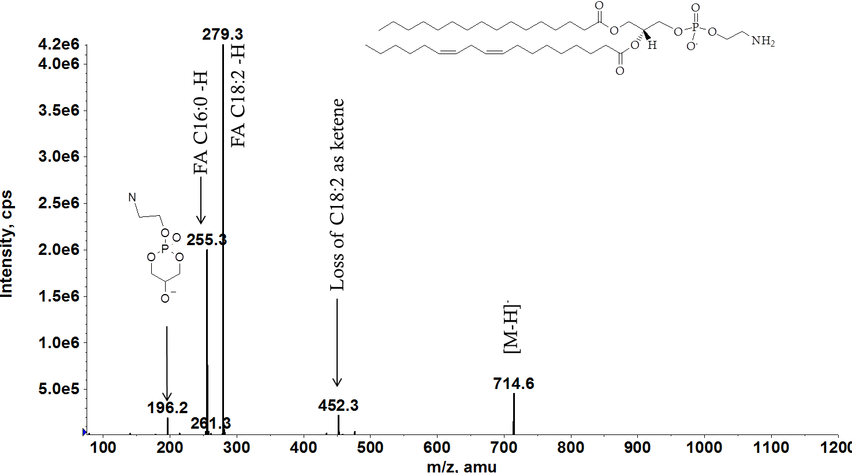
Supplementary Figure 15. Example of PE MS/MS fragmentation to identify fatty acid residues. All extracted oil body fractions were diluted 1:1000 in isopropanol:chloroform (1:1) and 10 µL was injected for LC-MS analysis using a hybrid quadrupole linear ion trap (4000 QTRAP).
Triglycerides
The triglycerides present in the OBs represents around 99% of the mass of the organelle. Despite this, it consists of only a handful of fatty acid species, and thus triglycerides (Supplementary Figure 16), of which three dominant species were identified by fragmentation (Supplementary Figures 17-19).

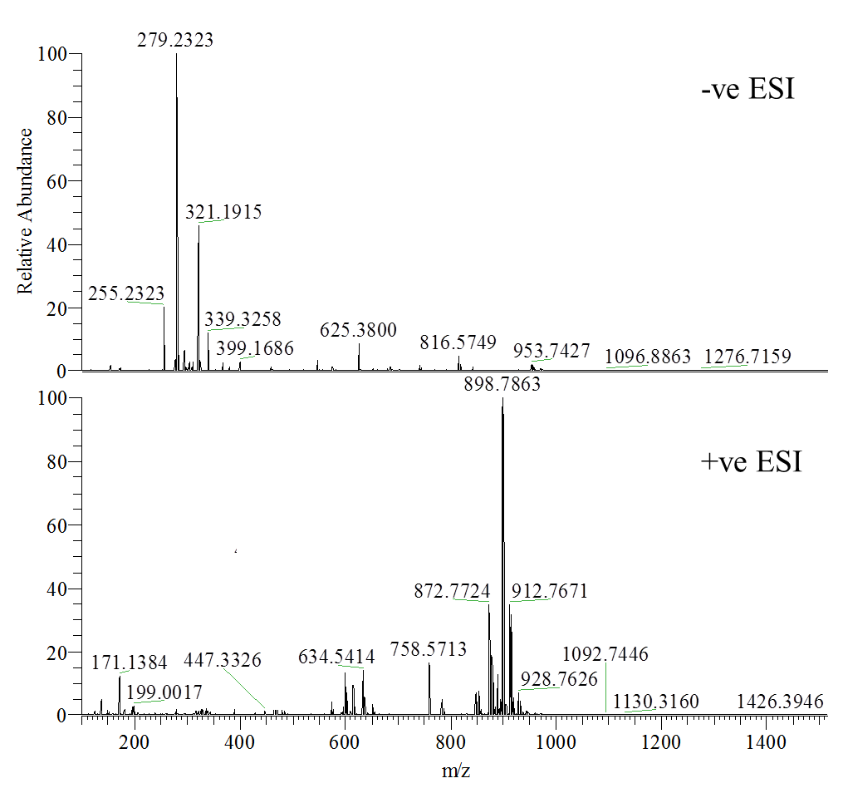
Supplementary Figure 16. Confirmation of presence of triglycerides using HRMS. All extracted oil body fractions were diluted 1:1000 in isopropanol:chloroform (1:1) and 10 µL was injected for analysis by HRMS as described in the main paper methods section.

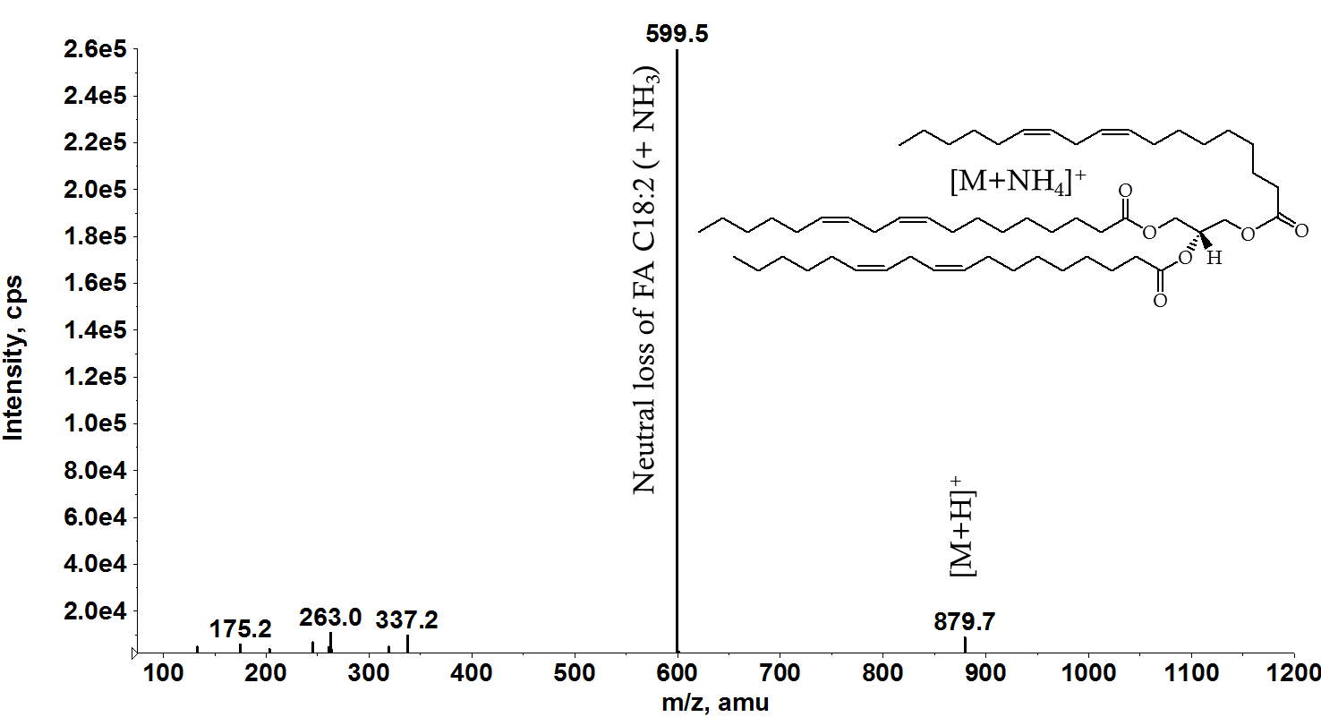
Supplementary Figure 17. MS/MS fragmentation to confirm the identity of the dominant triglyceride species – trilinoleoylglyceride. All extracted oil body fractions were diluted 1:1000 in isopropanol:chloroform (1:1) and 10 µL was injected for LC-MS analysis using a hybrid quadrupole linear ion trap (4000 QTRAP) as described in the main paper methods section.

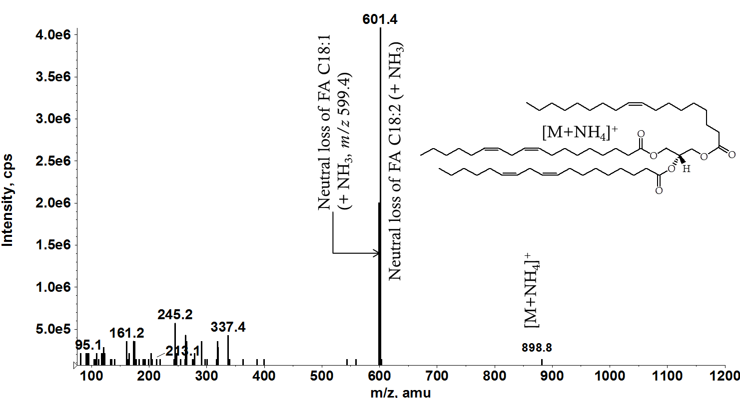
Supplementary Figure 18. MS/MS fragmentation to confirm the identity of the dominant triglyceride species – dilinoleoyloleoylglyceride. All extracted oil body fractions were diluted 1:1000 in isopropanol:chloroform (1:1) and 10 µL was injected for LC-MS analysis using a hybrid quadrupole linear ion trap (4000 QTRAP) as described in the main paper methods section.

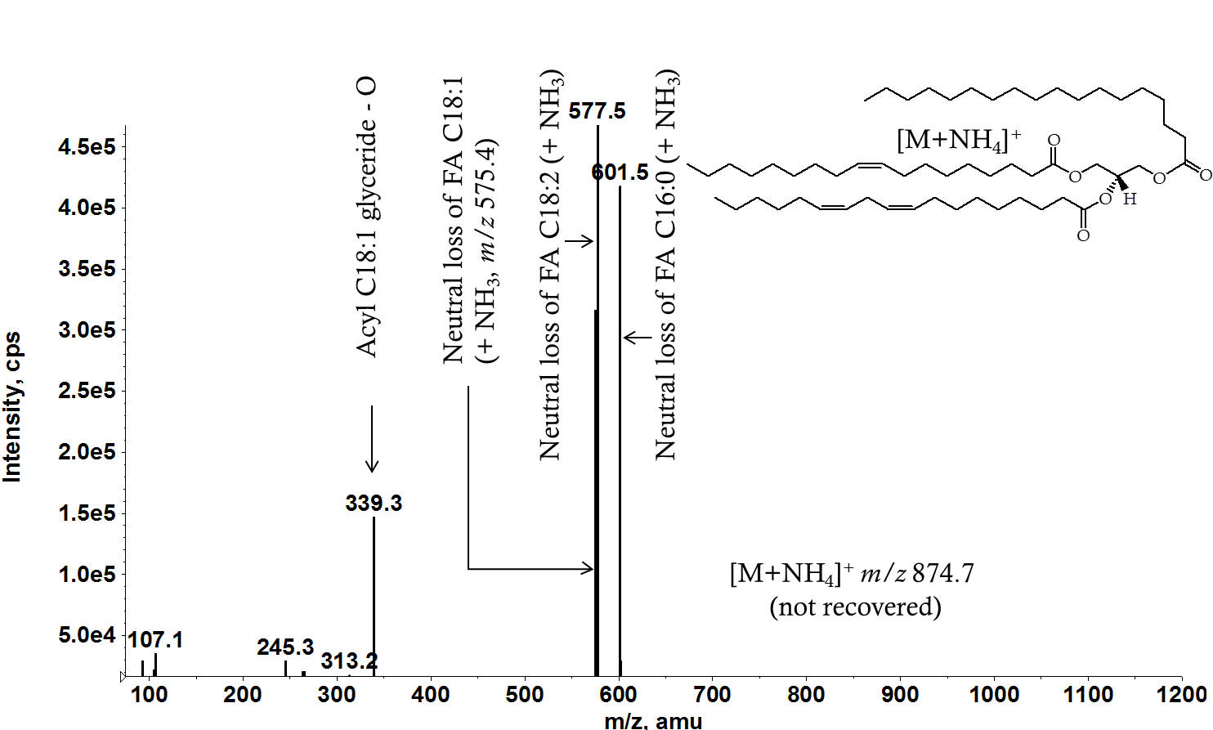
Supplementary Figure 19. MS/MS fragmentation to confirm the identity of the dominant triglyceride species – linoleoyloleoylpalmitoylglyceride. All extracted oil body fractions were diluted 1:1000 in isopropanol:chloroform (1:1) and 10 µL was injected for LC-MS analysis using a hybrid quadrupole linear ion trap (4000 QTRAP) as described in the main paper methods section.
PLD ASSAY
Phospholipase D (PLD) Assay—A grinding buffer of BPBA (2 g); n-butanol (100 mL), Tris-base (aq., 0·1 M, pH 7·5, 1·9 L, cOmplete ULTRA protease inhibition tablets (used as directed)) was made up immediately before use. Total volume: 2 L. De-hulled Helianthus annuus seeds (250 g) were suspended in grinding buffer (500 mL) and ground using a Silverson high-shear mixer L 5 M (Silverson Ltd, Chesham, Buckinghamshire, UK. Operated at <2 krpm) with the dilution of the mixture (addition of 500 mL Tris-base 0·1 M, pH 7·5) with successively narrowing mesh sizes of the homogeniser work head (5 mm mesh, then 2·5 mm, then 1·5 mm). The resulting suspension was made up to a total volume of 2·5 L (Tris-base 0·1 M, pH 7·5) and stirred (air-tight amber glass bottle, 4°C) for the duration. Aliquots (450 mL, taken at 24 h, 48 h, 72 h, 9 days) were fractionated by centrifugation (9,950 × g, 20 min, 4°C). The uppermost layer was removed, resuspended aqueous solution (~4:1 v/v) before centrifugation (2,800 × g, 20 min, 4°C). The aqueous suspensions used were: Tris-base (0·01 M, pH 7·5), Tween 20 (1% v/v, with Tris-base 0·01 M, pH 7·5, ddH₂O), NaCl (2 M, with Tris-base 0·01 M, pH 7·5, ddH₂O), urea (8 M, with Tris-base 0·01 M, pH 7·5, ddH₂O), and finally Tris-base (0·01 M, pH 7·5). The suspensions in aqueous urea were agitated at room temperature for 30 min, before centrifugation. The OBs were dried and fractionated as above.
The presence of microbial cells in the assays was tested at four and nine days using a selective Pseudomonas CFC medium (Oxoid Ltd.) and for spore-forming bacteria, Nutrient agar (Oxoid Ltd.). Both were prepared according to the manufacturer’s instructions. Plates were incubated at 4°C, 25°C and 42°C and examined for cellular growth after 72 h.

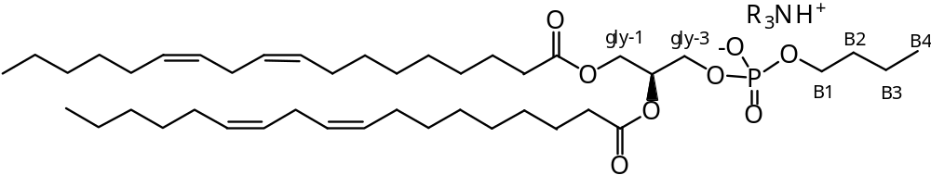
Supplementary Figure 20. The structure of PB, with the glyceride portion shown to the left of the phosphorus nucleus, and the butanol-derived section to the right of it. ‘gly’ refers to stereospecific numbering of the glyceryl moiety, where ‘B’ is the prefix used for numbering the carbons of the butyl chain, used for assigning NMR spectra (see above). The combination of data from 31P HSQC, 13C HSQC, 13C HMBC and TOCSY NMR spectra have indicated the following shifts for resonances with phosphorus in the PB head group. δH (CDCl₃, 800 MHz) 5·24 (1H, m, Gly-2-CH), 4·40 (1H, dd, J = 3·5, 11·7 Hz, Gly-1-CHH), 4·18 (1H, dd, J = 6·4, 12·1, Gly-1-CHH), 3·98 (2H, ddd, J = 5·7, 4·8, 11·4 Hz, Gly-3-CH₂), 3·87 (2H, q, J = 6·5 Hz, POCH₂CH₂CH₂CH₃, referred to as B1), 1·61 (2H, m, POCH₂CH₂CH₂CH₃, “B2”), 1·40 (2H, m, POCH₂CH₂CH₂CH₃, “B3”), 0·92 (3H, t, J = 7·3, Hz, POCH₂CH₂CH₂CH₃, “B4”) ppm. δ_{C} (CDCl₃, 201·24 MHz) 70·3 (1C, s, Gly-2-CH), 65·5 (1C, d, J_{C-P} = 5·1 Hz, POCH₂CH₂CH₂CH₃, referred to as B1), 63·4 (1C, s, Gly-3-CH₂), 62·7 (1C, s, Gly-1-CH₂), 32·8 (1C, s, POCH₂CH₂CH₂CH₃, “B2”), 19·0 (1C, s, POCH₂CH₂CH₂CH₃, “B3”), 13·8 (1C, s, POCH₂CH₂CH₂CH₃, “B4”) ppm.

REFERENCES

1. Davis, A. L., Mc Neill, G. P., and Caswell, D. C. Chemistry and Physics of Lipids, 1999, 97, 155-165.
2. Gunstone, F. D., Pollard, M. R., Scrimgeour, C. M., and Vedanayagam, H. S. Chemistry and Physics of Lipids, 1977, 18, 115-129.
3. Bosco, M., Culeddu, N., Toffanin, R., and Pollesello, P. Analytical Biochemistry, 1997, 245, 38-47.
4. Cremonini, M. A., Laghi, L., and Placucci, G. Journal of the Science of Food and Agriculture , 2004, 84, 786-790.
5. Culeddu, N., Bosco, M., Toffanin, R., and Pollesello, P. Magnetic Resonance in Chemistry 1998, 36, 907-912.
6. Murgia, S., Mele, S., and Monduzzi, M. Lipids , 2003, 38, 585-591.
7. Capuano, F.; Bond, N. J.; Gatto, L.; Beaudoin, F.; Napier, J. A.; Benvenuto, E.; Lilley, K. S.; Baschieri, S. Analytical Chemistry 2011, 83, 9267.

