Supplementary information
Table S1. Comparison of the main data of the three ALG-AD pilot facilities
 | ALG-AD pilot plants
Main input / output | Langage-SU | CNRS-UBO | Innolab-UG
Greenhouse (m²) | 140 | x | 52
Subsystem 1
Location | Plymouth, UK | Lamballe/Brest, France | Pittem/Oostkamp, Belgium
Feedstock | Food waste and dairy wastewater | 70 % sludge, 30 % solid pig manure | 80 % food waste,  20 % manure and glycerine
Feedstock amount (ktons/yr) | 10 | 156 | 138
Feedstock pre-treatment | Pasteurisation at 70 ̊C | x | x
Digester size (m³) | 3,000 | 15,000 | 20,000
Energy source | AD plant | Electricity Grid | Electricity Grid
Energy consumption (MWh/yr) | 40 | 36 | 1
Subsystem 2
Digestate volume (ktons/yr) | 80 | 156 | 160
Digestate treatment | Filtration | Centrifuge + evaporation | Centrifuge + Paper filtration
Digestate consumption (tons/yr) | 4 | 4.3 | 1.6
Subsystem 3
Microalgae species | Scenedesmus sp. | Aurantiochytrium m. | Chlorella vulgaris
Cultivation type | Phototrophic + Mixotrophic | Heterotrophic | Phototrophic
Cultivation period (days/yr) | 333 | 365 | 333
Photobioreactor volume (L) | 7,000  vertical tubes | 2,400  column | 800  horizontal tubes
Lighting | Fluorescent lamps | x | x
Freshwater treatment | Bleach + sodium thyosulphate | x | UV
Water consumption (m³/yr) | 840 | 870 | 94
Additives | x | Yeast extract + peptone + sea salt | x
Heating | Heat pump | Electric heater + blower | x
Cooling | Spraying water | x | x
Air/CO₂ | CO₂ bottle | Air blower > 1 m³/min | CO₂ bottle
Carbon source and amount (g/L) | Dextrose 10 | Corn syrup 900 | x
Filtration membrane mesh size | 0.2 µm | 300 kd | 0.2 µm
Centrifugation | Yes | x | x
Biomass productivity (g/L/day) | 0.075 - 2.5 | 2 | 0.14
Subsystem 4
Biomass post-treatment | Hydrolysation | Hydrolysation | Hydrolysation
Enzyme | Protease | Protease | Protease
Temperature ( ̊C) | 50 | 50 | 50
Drying | Spray drying | Spray drying | Spray drying
Drying agent | Modified starch | Modified starch | Modified starch
Algal biomass powder (kg/yr) | 484 | 964 | 38.5

Table S2 Materials used to model the equipment and machinery used on site
Material | Quantity (kg)
Carbon dioxide cylinder
St. Steel | 100
Heat pump
ABS | 12.4
Refrigerant | 2.4
Titanium | 46.5
Culture pump
glass fibre | 0.5
polyphenylene sulfide | 0.8
polypropylene | 1
Aluminium | 0.3
St. Steel | 6
Centrifuge
Electric motor | 5.8
polypropylene | 5
St. Steel | 183
Membrane skid
ABS | 9
Polyvinylchloride | 0.5
Mobile pump
polypropylene | 3.5
St. Steel | 6
Blower
St. Steel | 125
Circulation pump
Iron | 15
St. Steel | 7
Decanter centrifuge
Electric motor | 10
Ferrite | 200
Galvanized steel | 300
St. Steel | 800
Glucose pump
Aluminium | 8
Rubber | 2
Tangential flow membrane
Polyethylene | 15
Polyvinylfluoride | 50
St. Steel | 100
Circulation pump
Electric motor | 2.5
Ceramic | 1
St. Steel | 8
Feed pump
St. Steel | 20
Membrane filter
ABS | 7
Polyvinylchloride | 0.5
Polyvinylfluoride | 3
St. Steel | 35
UV-treatment setup
Copper | 0.5
Mercury | 0.0003
St. Steel | 2.5
Quartz | 1.1

Table S3 Data used to replace data from the base scenario for the sensitivity analysis, all data are coming from existing processes in ecoinvent v3.5 database and adjusted accordingly
Scenario | Facility | SS1 | CHP plant | SS1 | CO₂ separation and handling | SS3 | Cultivation | Quantity | Unit
Internal use of heat from the AD pant | Langage-SU |  |  | Heat exchanger + pipelines | 0.03 | items
Internal use of heat from the AD pant | Langage-SU |  |  | Heat from CHP | 34,426 | kWh/yr
Internal use of heat from the AD pant | CNRS-UBO |  |  | Heat exchanger + pipelines | 0.02 | items
Internal use of heat from the AD pant | CNRS-UBO |  |  | Heat from CHP | 11,000 | kWh/yr
Internal use of CO₂ | Langage-SU |  | Butyldiglycol acetate |  | 364 | kg/yr
Internal use of CO₂ | Langage-SU |  | Chemical factory |  | 300 | kg/yr
Internal use of CO₂ | Langage-SU |  | electricity |  | 4.76E+05 | MJ/yr
Internal use of CO₂ | Langage-SU |  | Natural gas from high pressure network |  | 1.49E+05 | kg/yr
Internal use of CO₂ | Innolab-UG |  | Butyldiglycol acetate |  | 2.84E+04 | kg/yr
 | Innolab-UG |  | Chemical factory |  | 2,000 | kg/yr
 | Innolab-UG |  | electricity |  | 3.7 | MJ/yr
 | Innolab-UG |  | Natural gas from high pressure network |  | 1.16E+07 | kg/yr
Internal use of electricity | CNRS-UBO | CHP unit_heat 0.5 MW |  |  | 0.20 | items
Internal use of electricity | CNRS-UBO | CHP unit_electrical 0.5 MW |  |  | 0.07 | items
Internal use of electricity | CNRS-UBO | CHP plant |  |  | 0.20 | items
Internal use of electricity | Innolab-UG | CHP unit_heat 6.4 MW |  |  | 0.8/15 | items
Internal use of electricity | Innolab-UG | CHP unit_electrical 1 MW |  |  | 3.64/15 | items

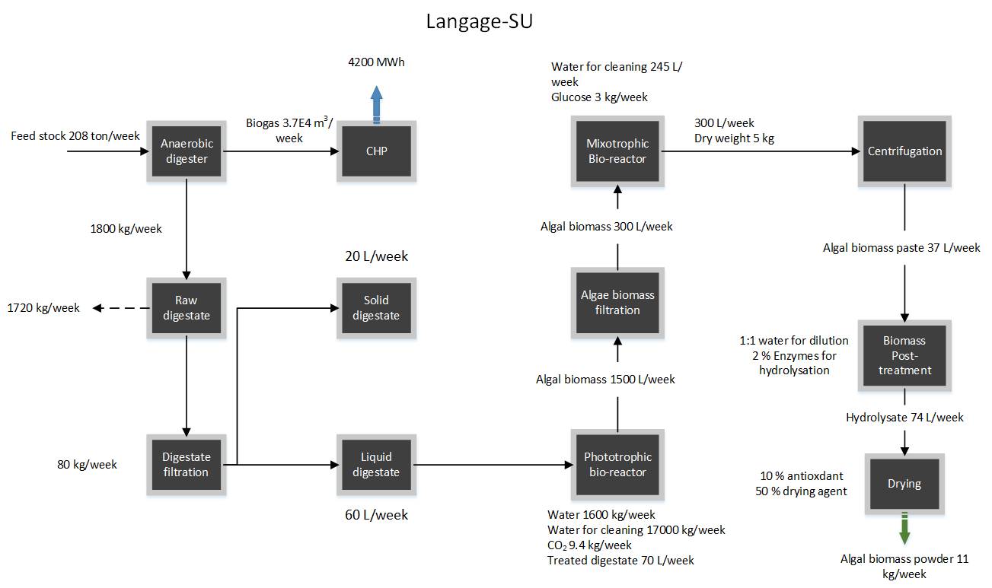
Figure S1 Mass balance diagram showing inputs and outputs of the system processes of ALG-AD pilot plant Langage-SU

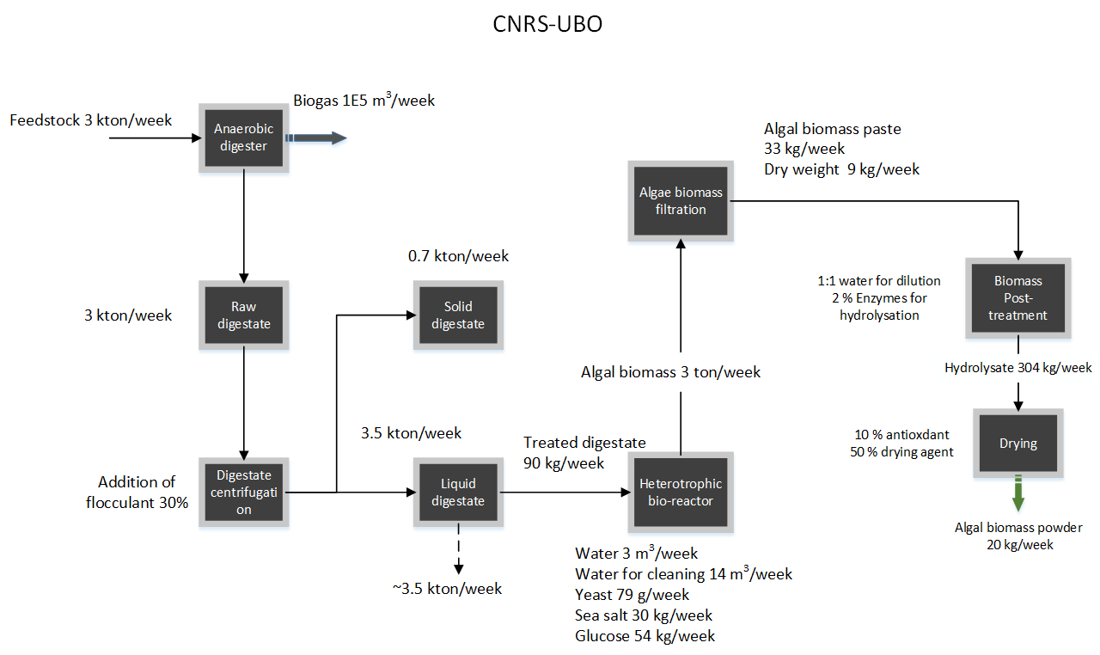
Figure S2 Mass balance diagram showing inputs and outputs of the system processes of the ALG-AD pilot plant CNRS-UBO
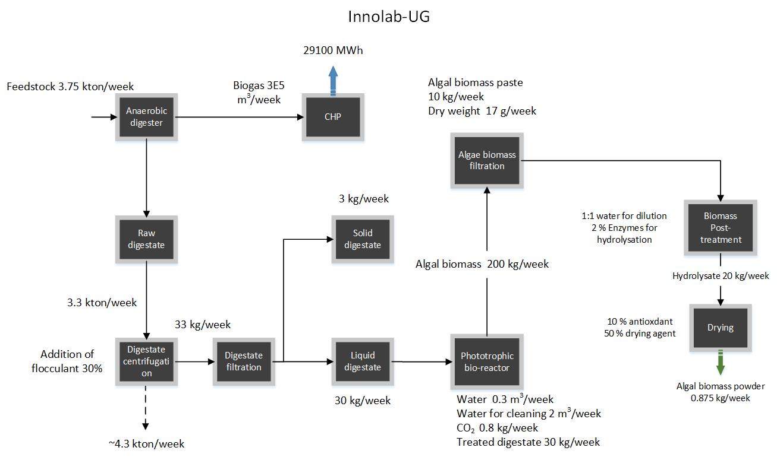
Figure S3 Mass balance diagram showing inputs and outputs of the system processes of the ALG-AD pilot plant Innolab-UG

