Supplementary Material

Deacetylation and mechanical refining pathway for the bioconversion of sugarcane bagasse

Note S1: Modeling the kinetics of methane production. A modified stacked sigmoidal function (Eq. S1; Boltzmann double sigmoid) was used to model the kinetics of CH₄ volumetric production (Volpi et al., 2022).
$V_{CH_{4}}^{STP}\left(t\right)=V_{CH_{4}}^{max}×\left(\frac{p}{1+e^{\frac{4r_{1}×\left(t_{1}-t\right)}{V_{CH_{4}}^{max}×p}}}+\frac{1-p}{1+e^{\frac{4r_{2}×\left(t_{2}-t\right)}{V_{CH_{4}}^{max}×\left(1-p\right)}}}\right)$ (Eq. S1)
In Eq. S1, $V_{CH4}^{STP}$ is the specific CH₄ production (NmLCH₄ gVS⁻¹) as a function of time t, $V_{CH_{4}}^{max}$ is the maximum specific volumetric production reached in the experiment (NmLCH₄ gVS⁻¹), p is the proportion between ordinate values of the first and second stacked sigmoids, t₁ and t₂ are the times (d) when the maximum rates are reached, and r₁ and r₂ are the maximum rates of CH₄ production for the first and second sigmoidal pattern, respectively (NmLCH₄ gVS⁻¹ d⁻¹). Data was processed using the Excel Solver.

Note S2: Method for spectroscopic characterization of lignin in alkaline liquor. Lignin from the alkaline liquors was precipitated in acid media, and the precipitate was characterized by Fourier-transform infrared (FTIR) and 2D heteronuclear single quantum coherence (HSQC) spectroscopies. FTIR spectra were acquired by applying the lignin samples on top of the diamond crystal of the attenuated total reflection (ATR) accessory of the FTIR instrument. The spectra were measured in duplicates. HSQC 2D spectra were recorded on a 500 MHz Nuclear Magnetic Resonance (NMR) spectrometer equipped with triple resonance. Samples were solubilized in dimethyl sulfoxide (DMSO), and the experiments were performed with spectral widths of 2.0 to 14 ppm for ¹H and -10 to 190 ppm for ¹³C. The central DMSO solvent peak was used as an internal reference (δ_{C} 39.5 ppm; δ_{H} 2.50 ppm). The relative signal intensities were determined from the following regions of the HSQC spectra: (i) aliphatic (δ_{C}/δ_{H} 8.0–52.5/0.5–3.0 ppm); (ii) oxygenated aliphatic (δ_{C}/δ_{H} 52.5–90.0/3.0–6.0); and (iii) aromatic (δ_{C}/δ_{H} 90.0–155.0/6.0–9.2 ppm).

Table S1. Composition of raw and treated bagasse deacetylated at laboratory and pilot scales. Data presented in percentage (g_{component}/100 g_{bagasse}; dry basis).
Exp. | Scale | Alkali loading  (g_{NaOH}/kg_{Bagasse}) | Temperature  (°C) | Time  (h) | Yield  (%) | Cellulose  (%) | Xylan  (%) | Acetyl groups  (%) | Lignin  (%) | Ashes  (%)
Set #1 | Raw bagasse | - | - | - | - | 39.45 ± 0.20 | 21.23 ± 0.03 | 3.08 ± 0.01 | 23.28 ± 0.03 | 5.18 ± 0.30
Set #1 | Laboratory | 48 | 70 | 3 | 84.20 | 45.73 ± 0.62 | 24.36 ± 0.19 | 0.28 ± 0.00 | 24.83 ± 0.12 | 2.65 ± 0.15
Set #1 | Laboratory | 70 | 70 | 3 | 83.33 | 49.02 ± 0.02 | 23.48 ± 0.07 | 0.00 ± 0.00 | 20.92 ± 0.24 | 1.77 ± 0.11
Set #1 | Laboratory | 100 | 70 | 3 | 70.14 | 53.12 ± 0.86 | 26.62 ± 1.64 | 0.00 ± 0.00 | 16.56 ± 0.46 | 2.65 ± 0.17
Set #1 | Pilot | 70 | 70 | 3 | 84.44 | 48.02 ± 0.13 | 23.35 ± 0.19 | 0.00 ± 0.00 | 20.90 ± 0.11 | 3.33 ± 0.28
Set #1 | Pilot | 100 | 92 | 2 | 65.20 | 57.17 ± 0.62 | 26.63 ± 0.33 | 0.00 ± 0.00 | 13.11 ± 0.47 | 3.99 ± 0.03
Set #2 | Raw bagasse | - | - | - | - | 40.45 ± 1.11 | 23.10 ± 0.49 | 3.32 ± 0.18 | 25.08 ± 0.15 | 2.95 ± 0.20
Set #2 | Laboratory | 48 | 70 | 3 | 88.93 | 47.36 ± 0.86 | 25.74 ± 0.46 | 0.51 ± 0.03 | 21.44 ± 0.67 | 1.12 ± 0.08
Set #2 | Laboratory | 70 | 70 | 3 | 85.98 | 49.21 ± 0.78 | 26.15 ± 0.39 | 0.04 ± 0.02 | 18.23 ± 0.22 | 1.38 ± 0.12
Set #2 | Laboratory | 100 | 70 | 3 | 77.40 | 53.05 ± 0.85 | 26.46 ± 0.48 | 0.00 ± 0.00 | 14.80 ± 0.54 | 1.73 ± 0.20

Table S2. Parameters obtained from the kinetic modeling of mono-digested and co-digested substrates. The lag phases t₁ (2.8 days) and t₂ (11.3 days) are well separated for the alkaline liquor.
 | Alkaline liquor | Vinasse | Alkaline liquor + Vinasse
V_{max} (NmLCH₄ gVS⁻¹) | 616.5 | 262.5 | 350.6
t₁ (d) | 2.8 | 3.0 | 2.8
t₂ (d) | 11.3 | 4.4 | 2.1
r₁ (NmLCH₄ gVS⁻¹ d⁻¹) | 109.7 | 193.2 | 107.3
r₂ (NmLCH₄ gVS⁻¹ d⁻¹) | 10.0 | 7.7 | 7.9
p | 0.15 | 0.21 | 0.17
R² | 0.97 | 0.97 | 0.97

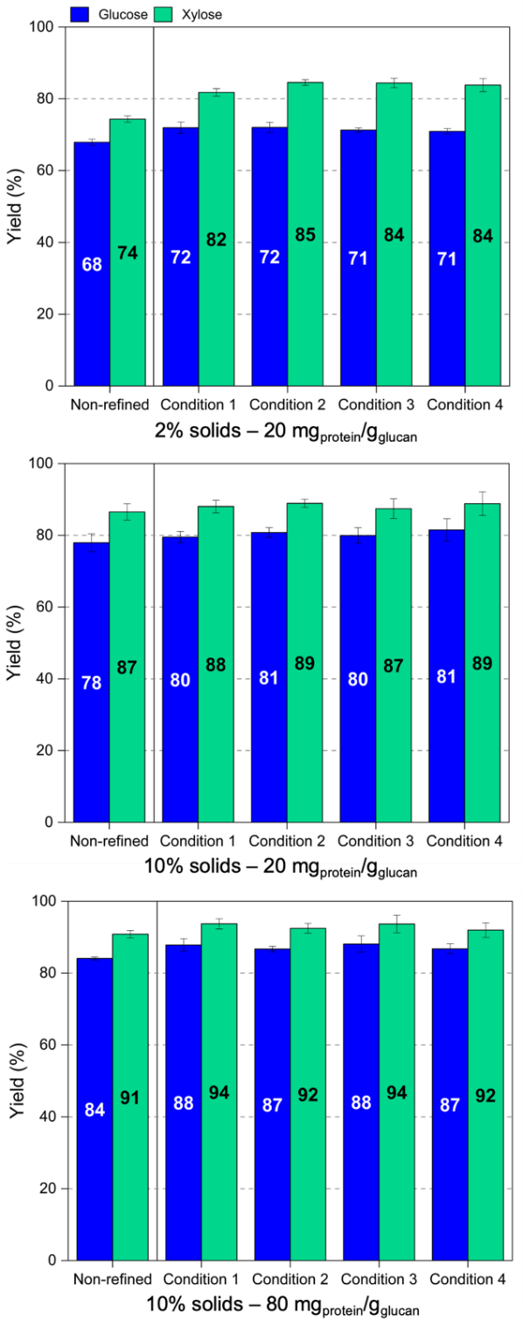
Fig. S1 Sugars yield of deacetylated (non-refined) and deacetylated and mechanical refined (DMR) bagasse (set #1) treated with high alkali loadings at pilot scale. Enzymatic hydrolysis was conducted at 2–10% solids and 20–80 mg of protein per gram of glucan. Refining conditions refer to disk rotation (rpm) and feeding time (sec/kg) as follows: condition 1: 1200 rpm and 100 sec/kg; condition 2: 1200 rpm and 120 sec/kg; condition 3: 1200 rpm and 160 sec/kg; condition 4: 600 rpm and 160 sec/kg.
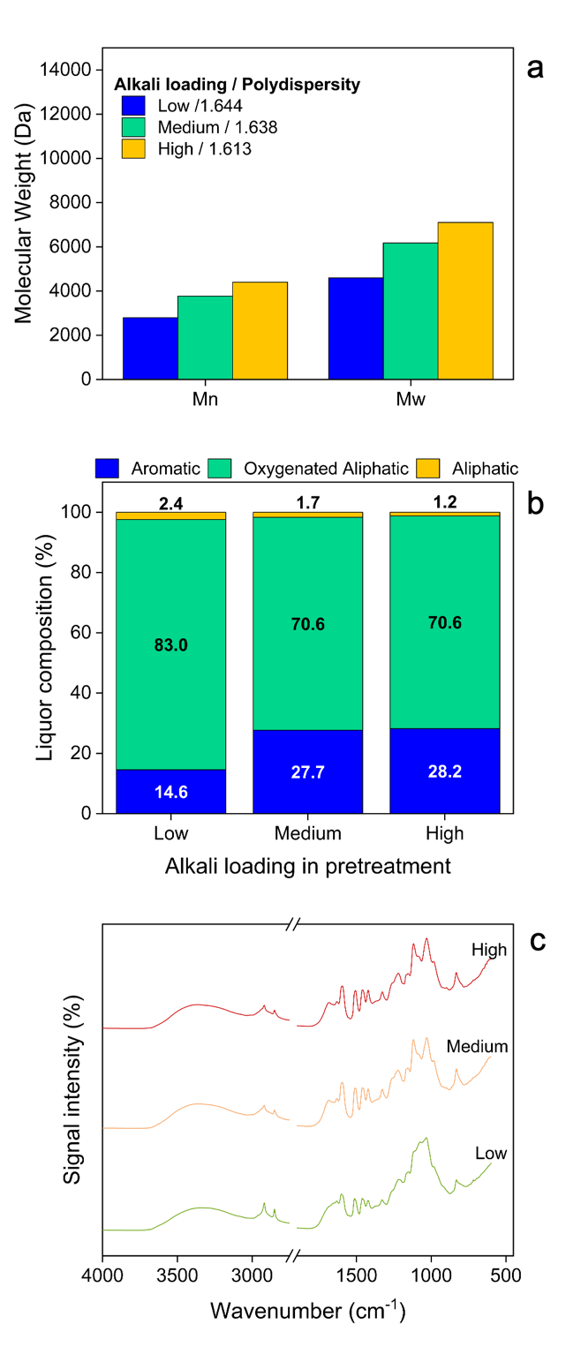
Fig. S2 Characterization of the lignins from alkaline liquor obtained at low, medium, and high alkali loadings (set #2). (a) Number-average (Mn) and weight-average (Mw) molecular weights. Polydispersity (Mw/Mn) is indicated in the legend. (b) Relative signal intensity of the main HSQC spectral regions. Aliphatic (δ_{C}/δ_{H} 8.0–52.5/0.5–3.0 ppm), oxygenated aliphatic (δ_{C}/δ_{H} 52.5–90.0/3.0–6.0 ppm), and aromatic (δ_{C}/δ_{H} 90.0–155/6.0–9.2 ppm) (c) FTIR spectra showing similar profiles between the samples, but discriminating higher intensity of C-H aliphatic band (3055–2730 cm⁻¹) for the lignin from the low alkali loading.

