Thermokinetic, thermodynamic, and pyrolysis analysis of agro-industrial biomass for bioenergy: insights from isoconversional models and neural networks

Marcelo L. Cocco¹, Edilton N. Silva¹, Jamilson Silva Jr¹, Thais L. C. Gomes², Lucas Meili², Gercílio A. Almeida Jr³, and Robson C. Sousa¹*

¹LaFTOP - Laboratory of Transport Phenomena and Unit Operations, Center of Agricultural Sciences and Engineering (CCAE), Federal University of Espírito Santo (UFES), Alto Universitário, 29500-000, Guararema, Alegre, ES, Brazil.

²Laboratory of Processes, Center of Technology, Federal University of Alagoas, Maceió, Alagoas 57072-900, Brazil.

³ Department of Animal Science, Center of Agricultural Sciences and Engineering, Federal University of Espírito Santo, Alto Universitário, 29500-000, Guararema, Alegre, ES, Brazil.

* Corresponding author: Laboratory of Transport Phenomena and Unit Operations (LaFTOP), Center of Agricultural Sciences and Engineering, Federal University of Espírito Santo, Alto Universitário, 29500-000, Guararema, Alegre, ES, Brazil. e-mail: robson.sousa@ufes.br

SUPPLEMENTARY MATERIAL
Table S1 – Data of the activation energy and R² values at each conversion level by the Friedman, KAS, and FWO methods for the compost barn.
$$α$$ | Friedman |  |  | KAS |  |  | FWO
$$α$$ | E_{a} (kJ.mol⁻¹) | R² |  | E_{a} (kJ.mol⁻¹) | R² |  | E_{a} (kJ.mol⁻¹) | R²
0.15 | 144.70 | 0.85 |  | 127.22 | 0.84 |  | 129.44 | 0.86
0.20 | 171.97 | 0.97 |  | 144.83 | 0.92 |  | 146.45 | 0.93
0.25 | 190.40 | 0.99 |  | 150.86 | 0.94 |  | 139.63 | 0.90
0.30 | 198.44 | 1.00 |  | 187.79 | 0.97 |  | 187.61 | 0.97
0.35 | 195.15 | 1.00 |  | 163.53 | 0.98 |  | 164.66 | 0.98
0.40 | 202.95 | 0.98 |  | 186.87 | 0.99 |  | 186.96 | 0.99
0.45 | 208.21 | 0.98 |  | 179.81 | 0.99 |  | 180.34 | 0.99
0.50 | 222.68 | 1.00 |  | 237.93 | 0.98 |  | 235.71 | 0.98
0.55 | 306.41 | 0.95 |  | 222.53 | 0.98 |  | 221.20 | 0.99
0.60 | 376.69 | 0.81 |  | 276.95 | 0.81 |  | 273.22 | 0.82

Table S2 – Activation energy data and R² values at each conversion level by the Friedman, KAS, and FWO methods for orange pomace.
$$α$$ | Friedman |  |  | KAS |  |  | FWO
$$α$$ | E_{a} (kJ.mol⁻¹) | R² |  | E_{a} (kJ.mol⁻¹) | R² |  | E_{a} (kJ.mol⁻¹) | R²
0.05 | 158.93 | 0.99 |  | 118.90 | 0.93 |  | 120.40 | 0.94
0.10 | 209.66 | 0.96 |  | 172.59 | 0.99 |  | 171.70 | 0.99
0.15 | 227.49 | 0.99 |  | 199.56 | 0.99 |  | 165.06 | 0.99
0.20 | 259.06 | 0.98 |  | 201.27 | 0.98 |  | 199.30 | 0.99
0.25 | 362.57 | 0.97 |  | 261.61 | 0.97 |  | 256.82 | 0.97
0.30 | 439.38 | 0.95 |  | 393.36 | 0.95 |  | 382.29 | 0.96
0.35 | 560.14 | 0.94 |  | 422.79 | 0.93 |  | 410.48 | 0.94
0.40 | 798.91 | 0.82 |  | 795.64 | 0.83 |  | 765.27 | 0.83
0.45 | 359.63 | 0.82 |  | 827.22 | 0.92 |  | 795.55 | 0.92
0.50 | 896.89 | 0.96 |  | 947.24 | 0.93 |  | 909.93 | 0.93
0.55 | 489.72 | 0.80 |  | 669.05 | 0.96 |  | 645.60 | 0.96
0.60 | 275.90 | 0.98 |  | 426.78 | 0.94 |  | 415.38 | 0.95
0.65 | 615.06 | 0.91 |  | 530.40 | 0.90 |  | 514.07 | 0.91

Table S3 – Activation energy data and R² values at each conversion level by the Friedman, KAS, and FWO methods for the banana pseudostem.
$$α$$ | Friedman |  |  | KAS |  |  | FWO
$$α$$ | E_{a} (kJ.mol⁻¹) | R² |  | E_{a} (kJ.mol⁻¹) | R² |  | E_{a} (kJ.mol⁻¹) | R²
0.05 | 10.98 | 0.91 |  | - | - |  | 10.00 | 0.90
0.10 | 59.47 | 0.99 |  | 45.21 | 1.00 |  | 50.43 | 1.00
0.15 | 62.10 | 0.83 |  | 52.60 | 0.99 |  | 43.65 | 0.99
0.20 | 15.15 | 0.97 |  | 79.18 | 0.88 |  | 83.86 | 0.90
0.25 | 177.44 | 0.99 |  | 16.36 | 0.99 |  | 165.11 | 0.99
0.30 | 169.92 | 1.00 |  | 15.98 | 0.98 |  | 153.48 | 0.98
0.35 | 163.42 | 1.00 |  | 16.16 | 1.00 |  | 162.32 | 1.00
0.40 | 166.23 | 0.99 |  | 134.86 | 0.97 |  | 137.40 | 0.98
0.45 | 169.47 | 1.00 |  | 133.95 | 1.00 |  | 136.62 | 1.00
0.50 | 151.11 | 0.89 |  | 167.74 | 0.99 |  | 168.84 | 0.98
0.55 | 161.79 | 0.98 |  | 150.58 | 1.00 |  | 152.62 | 1.00
0.60 | 190.62 | 0.98 |  | 167.26 | 1.00 |  | 168.58 | 1.00
0.65 | 215.14 | 0.99 |  | 203.43 | 1.00 |  | 203.12 | 1.00
0.70 | 200.01 | 0.98 |  | 178.10 | 1.00 |  | 179.17 | 1.00
0.75 | 251.46 | 0.87 |  | 294.04 | 1.00 |  | 289.59 | 0.98

Table S4 – Data of activation energy and R² values at each conversion level by the Friedman, KAS, and FWO methods for coconut shells.
$$α$$ | Friedman |  |  | KAS |  |  | FWO
$$α$$ | E_{a} (kJ.mol⁻¹) | R² |  | E_{a} (kJ.mol⁻¹) | R² |  | E_{a} (kJ.mol⁻¹) | R²
0.15 | 27.63 | 0.99 |  | 37.54 | 1.00 |  | 41.60 | 1.00
0.20 | 33.22 | 0.96 |  | 56.87 | 1.00 |  | 61.30 | 1.00
0.25 | 9.26 | 0.75 |  | 12.98 | 1.00 |  | 52.64 | 1.00
0.30 | 248.69 | 0.99 |  | 20.13 | 1.00 |  | 202.47 | 1.00
0.35 | 305.46 | 0.99 |  | 24.50 | 0.99 |  | 243.95 | 0.99
0.40 | 304.20 | 0.98 |  | 305.27 | 0.98 |  | 299.11 | 0.98
0.45 | 330.93 | 0.97 |  | 361.31 | 0.96 |  | 352.62 | 0.96
0.50 | 226.81 | 0.98 |  | 308.20 | 0.97 |  | 302.30 | 0.97
0.55 | 360.28 | 0.97 |  | 275.35 | 1.00 |  | 271.21 | 1.00
0.60 | 454.22 | 0.92 |  | 347.03 | 0.97 |  | 339.55 | 0.97

Table S5 – Heating rate sets, conversion ranges, and average correlation coefficients adopted for the isoconversional analysis of the biomasses.
Biomasses | Selected  heating rates (°C min⁻¹) | Discarded heating rates (°C min⁻¹) | Conversion range (α) | Average R²
Orange pomace | 5, 15, 20 and 25 | 10 | 0.05 – 0.65 | 0.94
Banana pseudostem | 5, 10 and 15 | 20 and 25 | 0.05 – 0.75 | 0.98
Compost barn | 5, 20 and 25 | 10 | 0.15 – 0.60 | 0.94
Coconut shell | 5, 20 and 25 | 10 and 15 | 0.15 – 0.60 | 0.98

Table S6 – Average predictive performance of the MLP models under external validation by heating-rate exclusion.
Biomasses | RMSE (%) | MAE (%) | R²
Orange pomace | 5.00 | 4.17 | 0.93
Banana pseudostem | 5.17 | 4.53 | 0.97
Compost barn | 2.89 | 2.56 | 0.98
Coconut shell | 1.79 | 1.58 | 0.99

Fig. S1 – Variation of the enthalpy (ΔH) as a function of conversion (α), obtained from the data of the Friedman method, for a heating rate of 20 °C.min⁻¹.

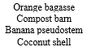
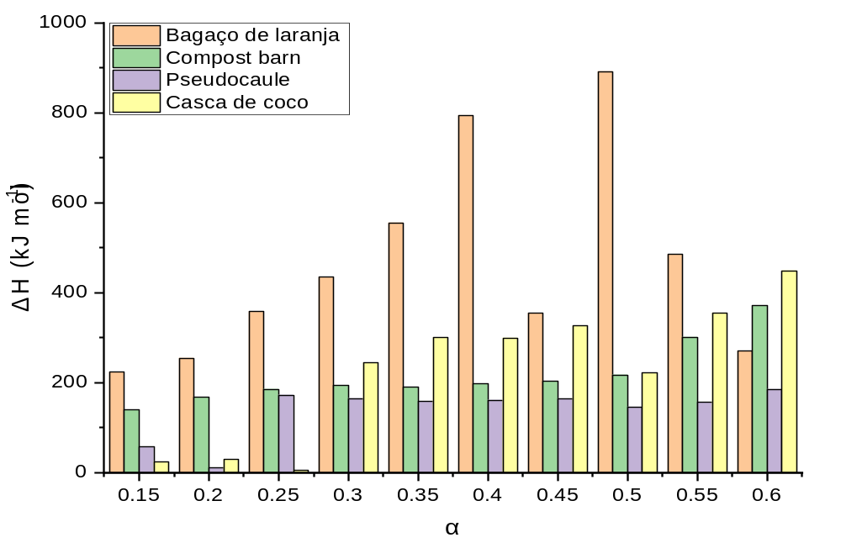

Fig. S2 – Gibbs free energy (ΔG) as a function of conversion (α), obtained from the data of the Friedman method, for a heating rate of 20 °C.min⁻¹.
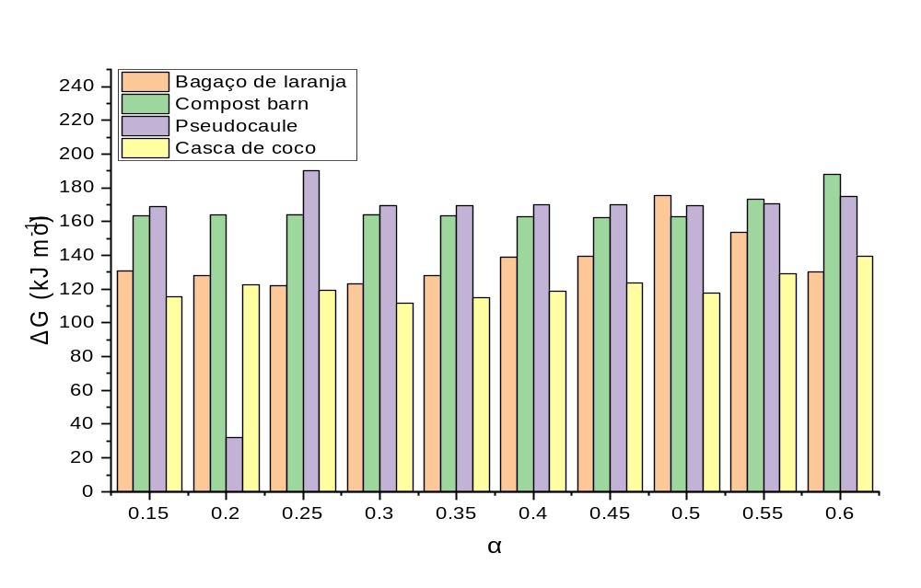

Fig. S3 – Variation in entropy (ΔS), as a function of conversion (α), obtained from Friedman's method data, for a heating rate of 20 °C.min⁻¹.

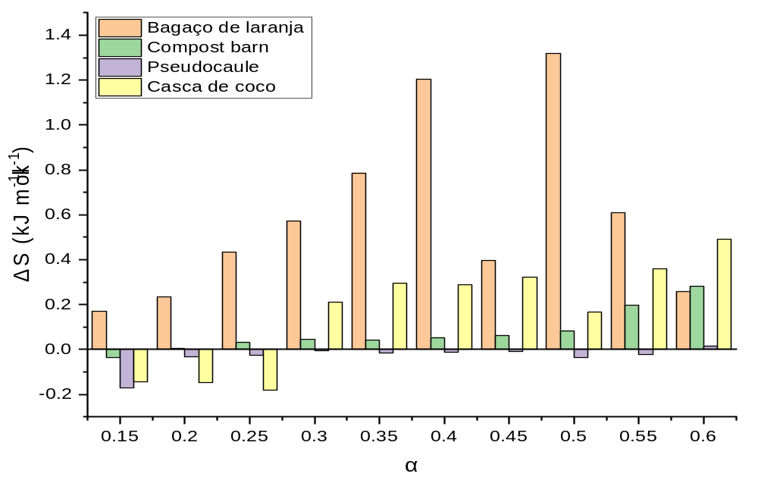

Fig. S4 - Variation of enthalpy (ΔH) as a function of conversion (α): (a) FWO and (b) KAS isoconversional methods at a heating rate of 20 °C min⁻¹.
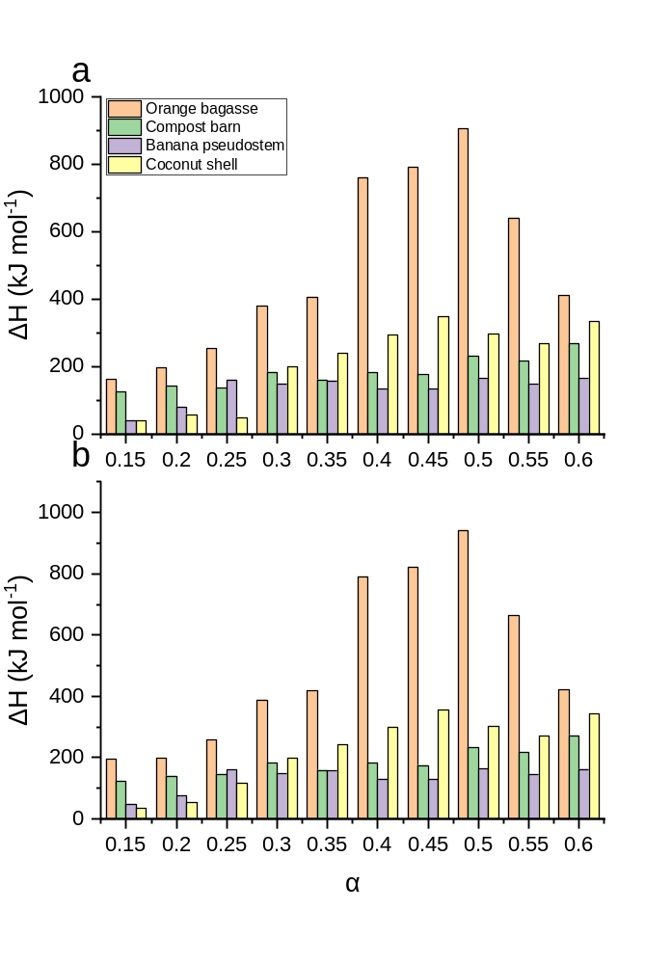

Fig. S5 – Variation in entropy (ΔS) as a function of conversion (α): (a) FWO and (b) KAS isoconversional methods at a heating rate of 20 °C min⁻¹.
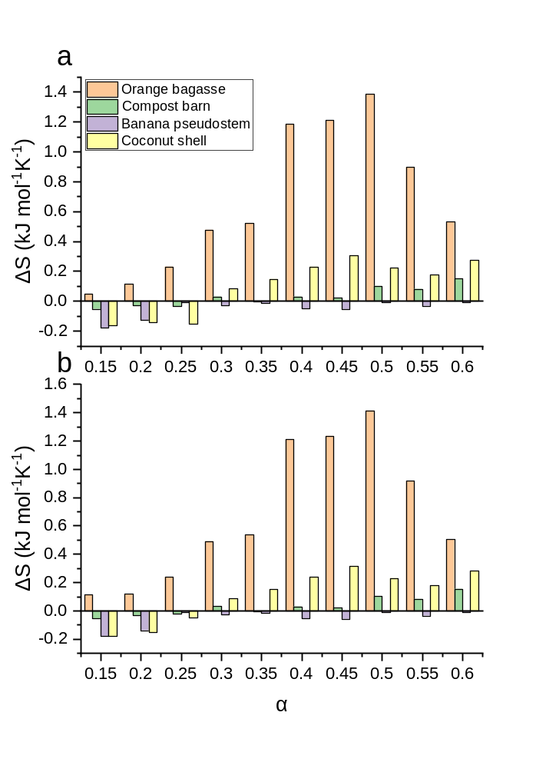

Fig. S6 – Gibbs free energy (ΔG) as a function of conversion (α): (a) FWO and (b) KAS
isoconversional methods at a heating rate of 20 °C min⁻¹.
