Appendix 1. Supplementary Material on PDA items to accompany:
“Stressors, appraisal of stressors, experienced stress and cardiac response: a real-time, real-life investigation of work stress in nurses.”

Mood PDA items

Items were scored from 0-100 and anchored No-Yes. Adjectives were selected from the UWIST Mood Adjective Checklist (Matthews, Jones & Chamberlain, 1990) to measure experienced stress (ES) affect (A), and fatigue (F))

Analogue scales (No-Yes, 0-100):
“How are you feeling?”
Alert (F)
Tired (F)
Happy (A)
Stressed (ES)
Angry (A)
Energetic (F)
Sad (A)
Nervous (ES)
Cheerful (A)
Calm (ES)
Relaxed (ES)
Sluggish (F)

Figure 1 shows a PDA screenshot of mood items as seen by the participants.

Figure 1.
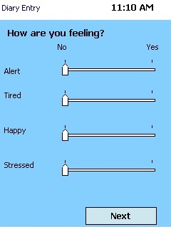

Work Stress determinants PDA items

All items refer to last 10 minutes. Analogue items were scored from 0-100. Binary item radio buttons were labelled ‘Yes’ and ‘No’. JCQ = items adapted from Job Content Questionnaire; ERI = items adapted from Effort-Reward Imbalance Questionnaire.

Analogue scales (summary measures of Demand, Control, Effort, Reward):
“Think about mental and physical activity in the past 10 minutes …”
• Work has been demanding
• I have put in a lot of effort
• Had control over work
• Work has been rewarding

Figure 2 shows a PDA screenshot of analogue work stress determinants scales, as seen by the participants.

Figure 2.
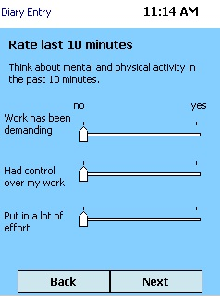

Binary items:
Demand
“In the past 10 minutes work has required that I…”
• Work Hard (JCQ)
• Work Fast (JCQ)
• Do too much (JCQ)

• Were you interrupted during your main activity in the last 10 mins?
• Enough resources available?
• Enough time available?

Effort
“In the past 10 minutes I have…”
• Been under constant pressure (ERI)
• Had a lot of responsibility (ERI)
• Been under a lot of physical demand (ERI)

• Were you interrupted during your main activity in the last 10 mins?

Control
“In the last 10 minutes work has…”
- Required a high level of skill (JCQ)
- Allowed me to make the main decisions about what I did (JCQ)
- Allowed me a lot of say in what I did (JCQ)

Reward
“In the last 10 minutes my work has been …”
• Appreciated
• Valued
• Respected (ERI)

Additional items
“In the last 10 minutes …”
- I would have liked more control of my work
- Work has been challenging

Figure 3 shows a PDA screenshot of binary work stress determinants scales, as seen by the participants.

Figure 3.
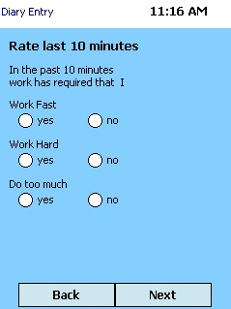
Nursing task PDA items

Items were taken from the Work Observation Method By Activity Timing (Westbrook & Ampt, 2009).

Main activity was identified using a mutually exclusive list of work tasks:
- Direct care
- Indirect care
- Medication
- Documentation
- Professional Communication
- Ward related
- In transit
- Supervision
- Social/Break
- Other

Figure 4 shows a PDA screenshot of nursing task items as seen by the participants. There are also items assessing “Who else was involved” and any “Tools/Equipment” used which do not relate to the issues examined in this paper.

Figure 4.
