SUPPLEMENTARY MATERIAL

Fit-for-purpose method development to determine co-occurring multiclass mycotoxins in apple and apple puree samples

Laura Carbonell-Rozas^{1*}, Linde Van der Cruyssen², Chiara Dall’Asta^{1*}, Marco Camardo Leggieri³, Paola Battilani³

¹Department of Food and Drug, University of Parma, Viale delle Scienze 27/A, 43124 Parma (Italy)
²Centre of Excellence in Mycotoxicology and Public Health, University of Gent (Belgium)
³Department of Sustainable Crop Production; Università Cattolica del Sacro Cuore, Piacenza (Italy)

Analyte  Table S1. Methodologies previously reported to determine mycotoxins in apples and apple-based products. | Sample | Sample treatment | Separation and detection technique | LOD | LOQ | R (%) | Rf.
PAT | Apple juice  (5 g) | LLE  - Extraction solvent: 5 mL ethyl acetate-hexane (94:4, v/v)  - Salt: 0.5g of NaHCO₃  - 3 mL of organic phase + 30µL of acetic acid  - Dry under N₂ stream  - Add injection solvent | LC-UV  Column: C₁₈ reversed-phase  (150 x 4.6 mm, 5 µm)  Mobile phases: water/MeCN  Gradient mode.  Flow: 1 mL min⁻¹ | 2.1 µg kg⁻¹ | 6.3 µg kg⁻¹ | 69.3-74.3
PAT | Fruits  (50 g) | LLE  - Add 100 mL of water  - Extraction solvent: 50 mL ethyl acetate (repeat twice with 20 mL)  - Salt: 2 mL of 1.5 % sodium carbonate  - Dry at 60 °C + injection solvent | HPLC-UV  Column: C₁₈  (250 mm x 4.6 mm, 5 µm)  Mobile phases: water/MeCN  Isocratic mode.  Flow: 1 mL min⁻¹ | 0.04 µg kg⁻¹ | 0.12 µg kg⁻¹ | 85.5-93.7
AOH, TEN, AME | Apples  (1 g) | Microscale extraction  - Extraction solvent: 1 mL ethyl acetate (1 % formic acid) in an ultrasonic bath (twice)  - Dry under N₂ stream  - Add injection solvent | HPLC-DAD  Column: C₁₈  (250 mm x 4.6 mm, 5 µm)  Mobile phases: water/MeCN  Gradient mode.  Flow: 1 mL min⁻¹ | 20 µg kg⁻¹ | 50 µg kg⁻¹ | 96-109
AOH, TEN, AME, TeA, altenuene (ALT)  altertoxin-I (ATX-I) | Fruit and vegetable juices (2 g) | QuEChERS  - Extraction solvent: 10 mL MeCN  - Salts: 2g of MgSO₄, 0.5 g of NaCl, 2.0 g Na₂SO₄  - Dry at 40 °C  - Add injection solvent | UPLC-MS/MS  Column: C₁₈  (100 mm x 2.1 mm, 1.8 µm)  Mobile phases: water + 1% acetic acid/ MeCN +1% acetic acid  Gradient mode.  Flow: 0.4 mL min⁻¹ | - | 1.1-5.7  µg kg⁻¹ | 87-109.8
PAT | Apple juice  (10 g) | MI-SPE  - SLE: 10 mL MeCN + salts (4 g MgSO₄ and 1 g NaCl)  - Vortex and centrifugation  - Preparation of the MI-SPE columns  - Elution with 1 mL water/MeCN | LC-MS/MS  Column: Waters XBridge C18 (4.6 × 250 mm, id: 5 μm)  Mobile phases: water/MeCN  Gradient mode.  Flow: 0.25 mL min⁻¹ | 0.06 ng g⁻¹ | 0.2 ng g⁻¹ | 81.3-106.3
PAT | Apple juice  (10 mL) | SD-LLLME  - Addition of 0.5 g NaCl  - 2. 1.5 mL of ethyl acetate added (extraction solvent)  - 5 μL microdrop in the organic phase for 20 min extraction | LC-MS/MS  Column: ACQUITY UPLC®BEHC18 (2.1 × 50 mm, 1.7 μm)  Mobile phases: water/MeCN  Gradient mode.  Flow: 0.3 mL min⁻¹ | 0.5 μg L⁻¹ | 2 μg L⁻¹ | 83.6-96.3
PAT | Apple concentrate, juice, puree, and jam  (5g) | SLE-SPE  - Extraction with 10 mL ethyl acetate (x2)  - Cleaning with 1.5 % sodium carbonate solution + 5 g sodium sulfate  - Dry and reconstitution step with 2.5 mL acetic acid/acetate buffer solution  - SPE in HLB cartridges  - Elution with 3 ml (ethyl acetate/ethyl ether, 10:90) | ID-LC-MS/MS  Column: Scherzo SM-C18 column (4.6 x 250 mm i.d., 3 μm)  Mobile phases: 80 % A (5 mmol L⁻¹ ammonium acetate and 3.5 mmol L⁻¹ acetic acid in water) and 20 % B (MeOH)  Isocratic mode.  Flow: 0.5 mL min⁻¹ | 0.2-0.7 μg kg⁻¹ | 0.8-2.4 μg kg⁻¹
AOH, TEN, AME, AFB1, AFB2, AFG1, AFG2 | Apples  (2 g) | QuECheRS  - 4 mL MeCN containing 1% formic acid  - 400 mg PSA, 1.2 g MgSO4, and 0.5 g NaCl | UHPLC-MS/MS  Column: BEH C18  (50 mm × 2.1 mm, 1.7 μm)  Mobile phases: water +0.1% formic acid/ MeOH + 0.1% formic acid  Gradient mode.  Flow: 0.3 mL min⁻¹ | 0.05-20 μg L⁻¹ | 0.10-30 μg L⁻¹ | 71.3- 119.4

Figure S1. Extracted ion chromatograms (EICs) of the target mycotoxins resulted from the analysis of a spiked apple puree sample at their corresponding LOQs.

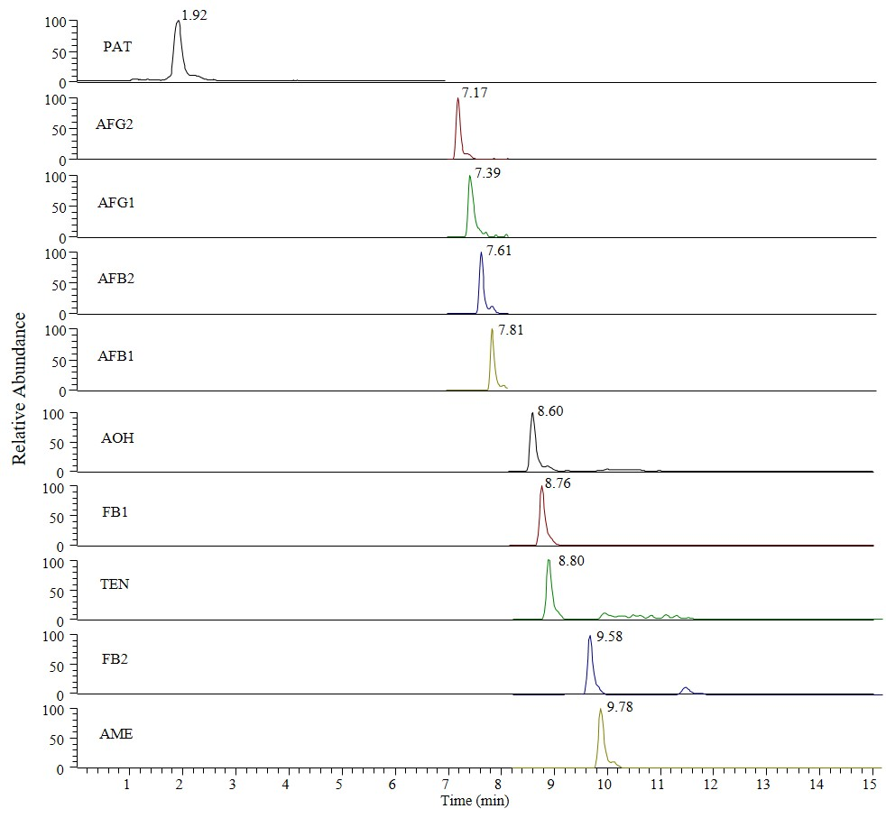

[] Valle-Algarra FM, Mateo EM, Gimeno-Adelantado J, Mateo-Castro R, Jiménez M (2009). Optimization of clean-up procedure for patulin determination in apple juice and apple purees by liquid chromatography. Talanta 80(2):636-642. https://doi.org/10.1016/j.talanta.2009.07.040
[] Iqbal SZ, Malik S, Asi MR, Selamat J, Malik N (2018).Natural occurrence of patulin in different fruits, juices and smoothies and evaluation of dietary intake in Punjab, Pakistan. Food Control 84:370-374. https://doi.org/10.1016/j.foodcont.2017.08.024
[] Ntasiou P, Myresiotis C, Konstantinou S, Papadopoulou-Mourkidou E, Karaoglanidis GS (2015) Identification, characterization and mycotoxigenic ability of Alternaria spp. causing core rot of apple fruit in Greece. Int J Food Microbiol 197:22-29. https://doi.org/10.1016/j.ijfoodmicro.2014.12.008
[] Walravens J, Mikula H, Rychlik M, Asam S, Devos T, Njumbe Ediage E, et al. (2016) Validated UPLC-MS/MS methods to quantitate free and conjugated Alternaria toxins in commercially available tomato products and fruit and vegetable juices in Belgium. J Agric Food Chem 64(24):5101-5109. https://doi.org/10.1021/acs.jafc.6b01029
[] Zhao M, Shao H, He Y, Li H, Yan M, Jiang Z, Jing Wang JAM, Abd El-Aty AM et al. (2019) The determination of patulin from food samples using dual-dummy molecularly imprinted solid-phase extraction coupled with LC-MS/MS. J Chromatogr B 1125:121714. https://doi.org/10.1016/j.jchromb.2019.121714
[] Li X, Li H, Ma W, Guo Z, Li X, Li X, Zhang Q (2018) Determination of patulin in apple juice by single-drop liquid-liquid-liquid microextraction coupled with liquid chromatography-mass spectrometry. Food Chem 257:1-6. https://doi.org/10.1016/j.foodchem.2018.02.077
[] Seo M, Kim B, Baek SY (2015) An optimized method for the accurate determination of patulin in apple products by isotope dilution-liquid chromatography/mass spectrometry. Anal Bioanal Chem 407:5433-5442. https://doi.org/10.1007/s00216-015-8705-3
[] Tang Y, Mu L, Cheng J, Zhenxia D, Yang Y (2020) Determination of multi-class mycotoxins in apples and tomatoes by combined use of QuEChERS method and ultra-high-performance liquid chromatography tandem mass spectrometry. Food Anal Methods 13:1381-1390. https://doi.org/10.1007/s12161-020-01753-z

