A novel stability-indicating RP-HPLC method for the simultaneous estimation and in vitro evaluation: Curcumin and Naringin co-amorphous system
Pooja Mallya¹, Dani Lakshman Yarlagadda², Shaila Lewis¹*
- Department of Pharmaceutics, Manipal College of Pharmaceutical Sciences, Manipal Academy of Higher Education (MAHE), Manipal- 576104, Karnataka, India.
- Department of Pharmaceutical Quality Assurance, Manipal College of Pharmaceutical Sciences, Manipal Academy of Higher Education (MAHE), Manipal- 576104, Karnataka, India.

*For Correspondence:
Shaila Lewis
Department of Pharmaceutics,
Manipal College of Pharmaceutical Sciences,
Manipal Academy of Higher Education (MAHE),
Manipal- 576104, Karnataka, India.
Mail ID: s.lewis@manipal.edu

Supplementary Material

Table S1. Calibration curve of Curcumin
Concentration (µg/ml) | Average area | SD | % CV
0.125 | 3394.67 | 81.27 | 2.39
0.5 | 25148.67 | 365.71 | 1.45
1 | 37110.33 | 759.29 | 2.05
2 | 62917.67 | 65.16 | 0.10
4 | 117690.33 | 794.11 | 0.67
8 | 202145.67 | 1551.71 | 0.77
16 | 406286.67 | 2450.50 | 0.60

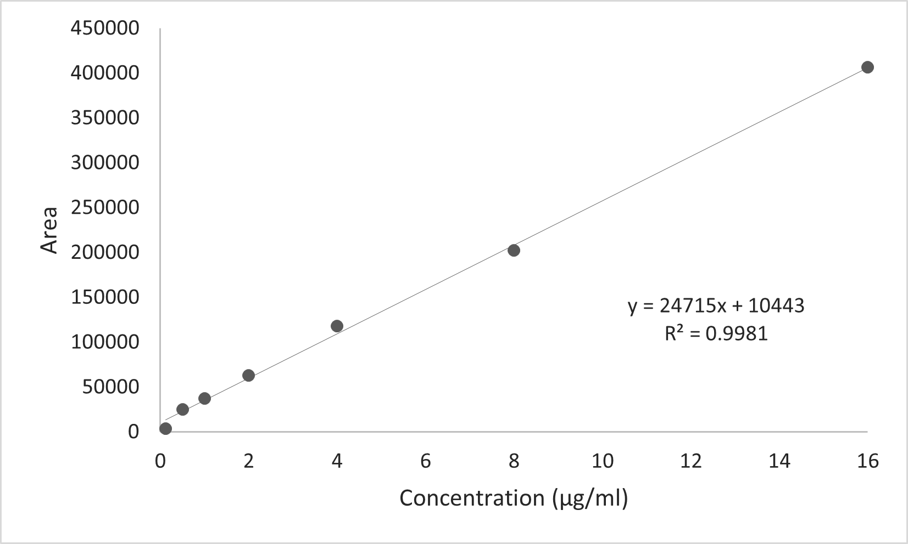
Figure S1. Calibration curve of Curcumin by HPLC

Table S2. Calibration curve of Naringin
Concentration (µg/ml) | Average area | SD | % CV
0.125 | 4042 | 129.46 | 3.20
0.5 | 31964 | 544.49 | 1.70
1 | 66106.67 | 434.75 | 0.66
2 | 128386.67 | 146.0 | 0.11
4 | 258734.67 | 573.37 | 0.22
8 | 481044.33 | 392.53 | 0.08
16 | 985866 | 347.49 | 0.03

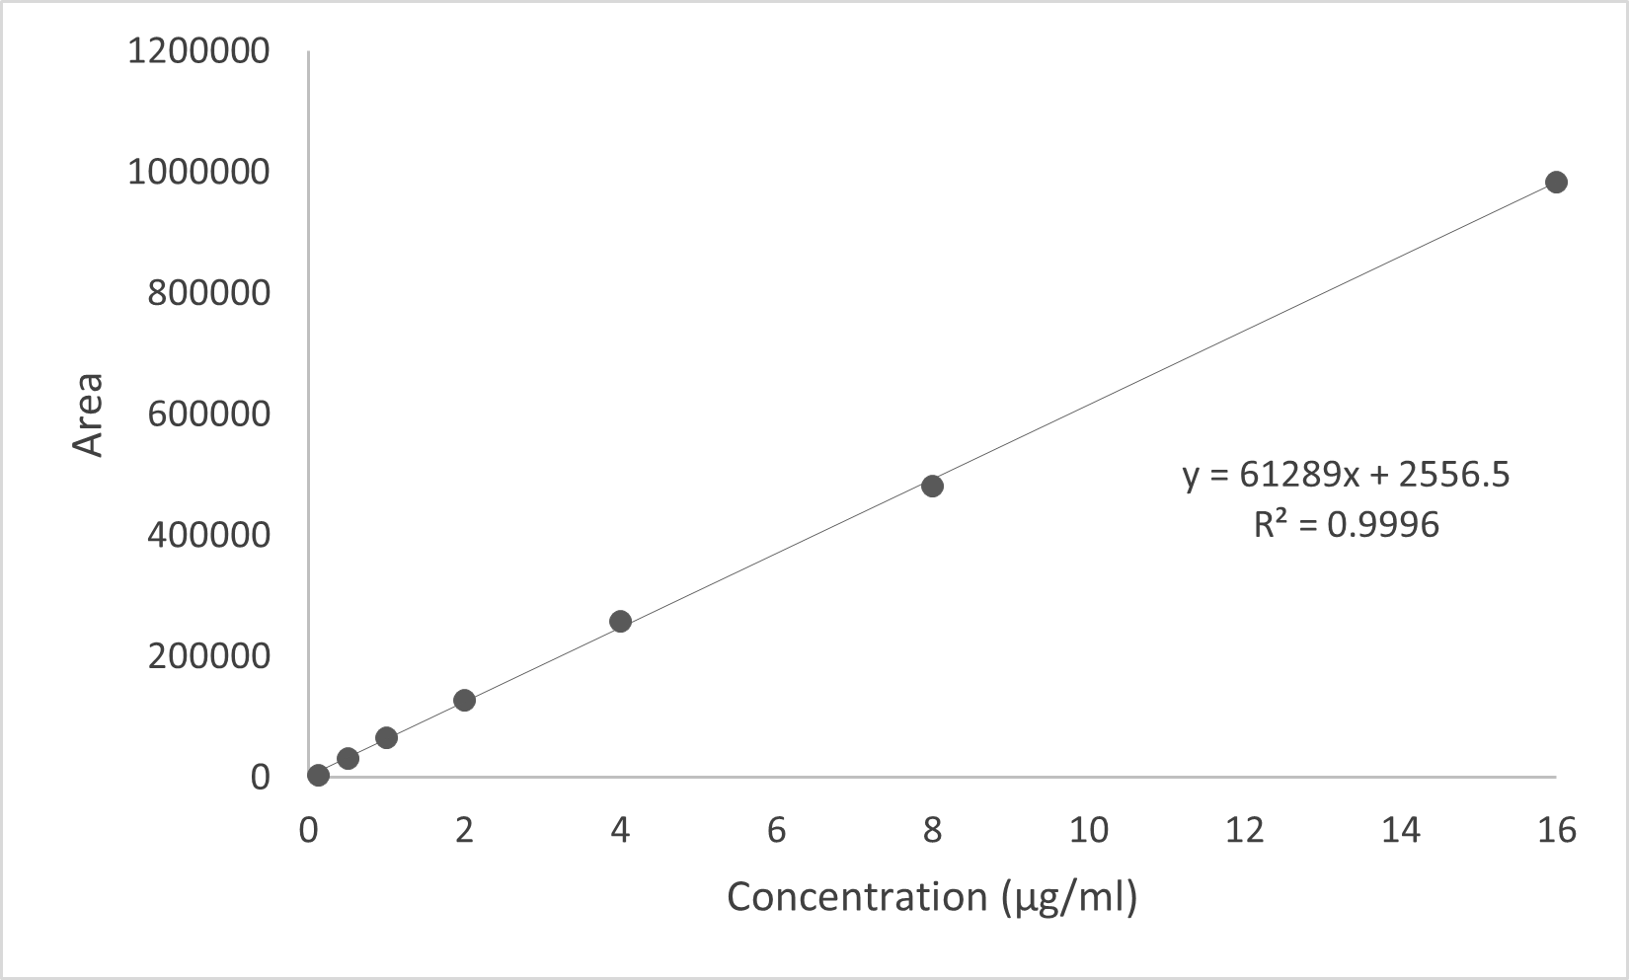
Figure S2. Calibration curve of Naringin by HPLC

Table S3. Robustness results of Curcumin
Parameters | Area(mV) |  |  | RT (Min)
Parameters | Mean | SD | %CV | Mean | SD | %CV
Column temperature (°C)
24 | 31879.33 | 162.30 | 0.51 | 11.21 | 0.016 | 0.15
26 | 30579.67 | 231.82 | 0.76 | 10.96 | 0.058 | 0.53
Flow rate
0.4 | 35171 | 27.78 | 0.08 | 13.39 | 0.015 | 0.115
0.6 | 26148.67 | 411.89 | 1.57 | 9.475 | 0.072 | 0.76
Wavelength (nm)
288 | 30230.33 | 266.75 | 0.88 | 11.123 | 0.012 | 0.109
290 | 28963 | 91.99 | 0.32 | 11.097 | 0.011 | 0.099
Injection volume (µl)
19 | 28199.33 | 717.58 | 2.54 | 11.03 | 0.039 | 0.35
21 | 30004.33 | 274.34 | 0.91 | 11.056 | 0.016 | 0.149

Table S4. Robustness results of Naringin
Parameters | Area(mV) |  |  | RT (Min)
Parameters | Mean | SD | %CV | Mean | SD | %CV
Column temperature (°C)
24 | 63726 | 95.69 | 0.15 | 5.19 | 0.008 | 0.16
26 | 63510.33 | 191.40 | 0.30 | 5.11 | 0.033 | 0.65
Flow rate
0.4 | 78601.33 | 158.92 | 0.20 | 6.15 | 0.001 | 0.018
0.6 | 52483.67 | 139.29 | 0.26 | 4.36 | 0.017 | 0.401
Wavelength (nm)
288 | 65665.33 | 18.50 | 0.03 | 5.17 | 0.003 | 0.062
290 | 62060.67 | 12.50 | 0.02 | 5.16 | 0.001 | 0.019
Injection volume (µl)
19 | 59886.67 | 48.09 | 0.08 | 5.14 | 0.017 | 0.325
21 | 62865 | 5162.36 | 8.21 | 5.15 | 0.006 | 0.119

Table S5. Results of accuracy and precision of NRG and CUR
NRG
Accuracy
Concentration level | Nominal concentration (µg/ml) | Area | % RSD | Calculated concentration (µg/ml) | Mean recovery (%) | Acceptance criteria
80 % | 8 | 506181 ± 397.81 | 0.079 | 8.209 | 102.624 | 90-110 %
100 % | 10 | 615740 ± 2582.59 | 0.419 | 10.003 | 100.029 | 90-110 %
120 % | 12 | 750215 ± 1670.12 | 0.223 | 12.204 | 101.70 | 90-110 %
Precision
Concentration level | Nominal concentration (µg/ml) | Inter-day |  | Intra-day |  | Acceptance criteria
Concentration level | Nominal concentration (µg/ml) | Calculated concentration (µg/ml) | % RSD | Calculated concentration (µg/ml) | % RSD | Acceptance criteria
80 % | 8 | 8.209 | 0.078 | 8.197 | 0.116 | <2.0 %
100 % | 10 | 10.003 | 0.419 | 9.986 | 0.299 | <2.0 %
120 % | 12 | 12.204 | 0.223 | 12.147 | 0.09 | <2.0 %
CUR
Accuracy
Concentration level | Nominal concentration (µg/ml) | Area | % RSD | Calculated concentration (µg/ml) | Mean recovery (%) | Acceptance criteria
80 % | 8 | 205839 ± 164.83 | 0.798 | 7.815 | 97.69 | 90-110 %
100 % | 10 | 259055 ± 3243.87 | 1.252 | 10.005 | 100.05
120 % | 12 | 307271 ± 2082.39 | 0.678 | 11.99 | 99.905
Precision
Concentration level | Nominal concentration (µg/ml) | Inter-day |  | Intra-day |  | Acceptance criteria
Concentration level | Nominal concentration (µg/ml) | Calculated concentration (µg/ml) | % RSD | Calculated concentration (µg/ml) | % RSD | Acceptance criteria
80 % | 8 | 7.799 | 0.321 | 7.678 | 0.415 | <2.0 %
100 % | 10 | 9.933 | 0.298 | 9.928 | 0.568 | <2.0 %
120 % | 12 | 12.039 | 0.214 | 12.033 | 0.644 | <2.0 %

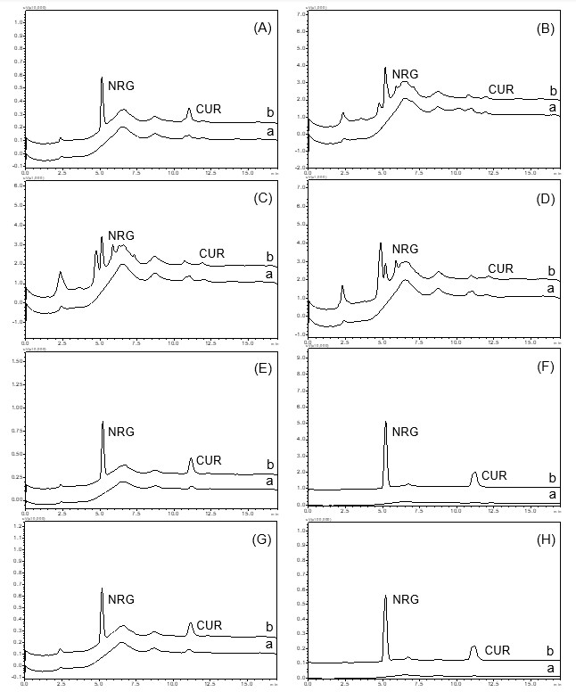
Figure S3. Chromatograms of forced degradation of CUR and NRG: (i) Acid-induced hydrolysis: (A) 0.1 N HCl—(a) blank and (b) sample; (B) 1 N HCl—(a) blank and (b) sample; (ii) base-induced hydrolysis: (C) 0.1 N NaOH—(a) blank and (b) sample; (D) 1 N NaOH—(a) blank and (b) sample; (E) oxidation-induced degradation—(a) blank and (b) sample; (F) photolytic—(a) blank and (b) sample; (G) thermal degradation at 80°C—(a) blank and (b) sample; (H) benchtop—(a) blank and (b) sample

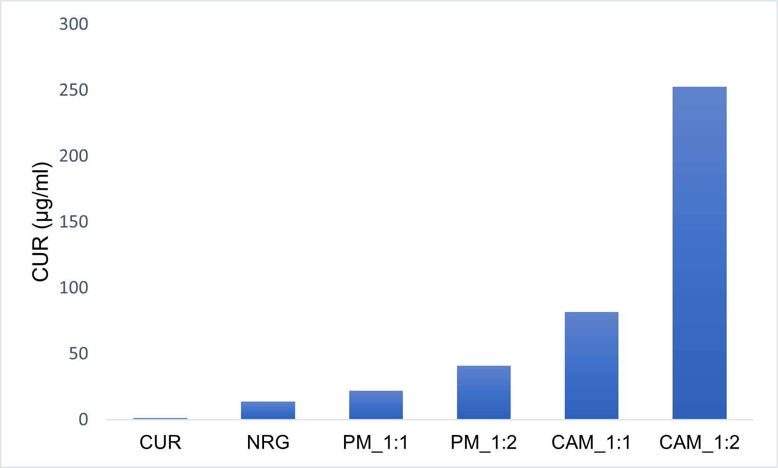
Figure S4. Solubility results of CUR, NRG, physical mixtures (PM), and CAM

Crystallinity index of co-amorphous formulation of curcumin and naringin
In addition to XRPD analysis, the crystallinity indices for CUR and CAMs were calculated by deconvolution method using following equation:
$$CI \left(\%\right)=100 × \frac{S_{c}}{S_{t}}$$
Where $S_{c}$ represents the area of the crystalline domain and $S_{t}$ represents the area of the total domain (Rotaru et al., 2018).
Crystallinity index
The crystallinity index of CUR and CAMs were calculated using Origin software (Fig. 7 and Table 3).
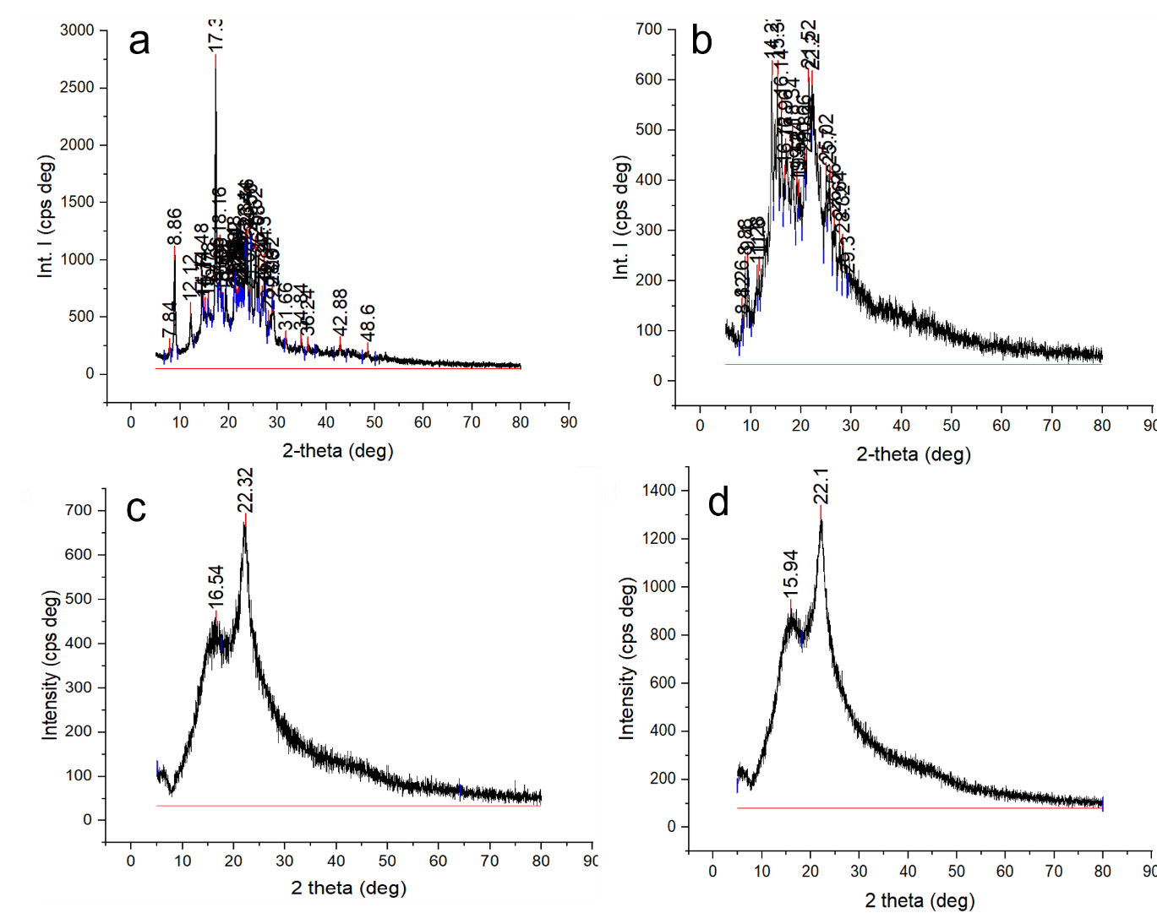
Figure S5. PXRD patterns of a. CUR b. NRG c. CAM 1:1 d. CAM 1:2 and their crystallinity index calculation using Origin software

Table S6. Crystallinity indices (CI) of pure drugs and co-amorphous formulations as calculated from the XRD patterns
Sample | Crystallinity index (CI) in %
CUR | 97.13
NRG | 65.85
CAM 1:1 | 25.06
CAM 1:2 | 19.48

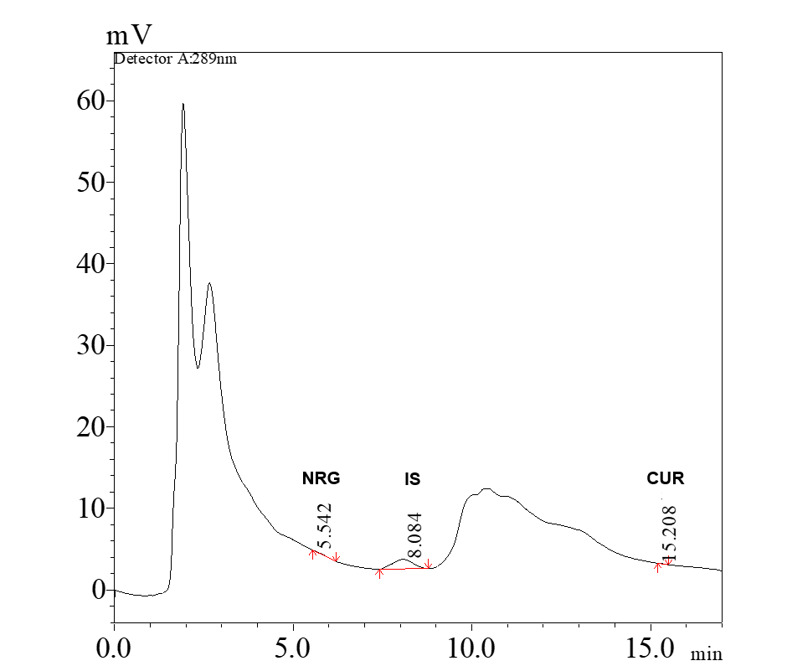
Figure S6. Chromatogram showing low limit of quantification (LLOQ) at a concentration of 100 ng/ml
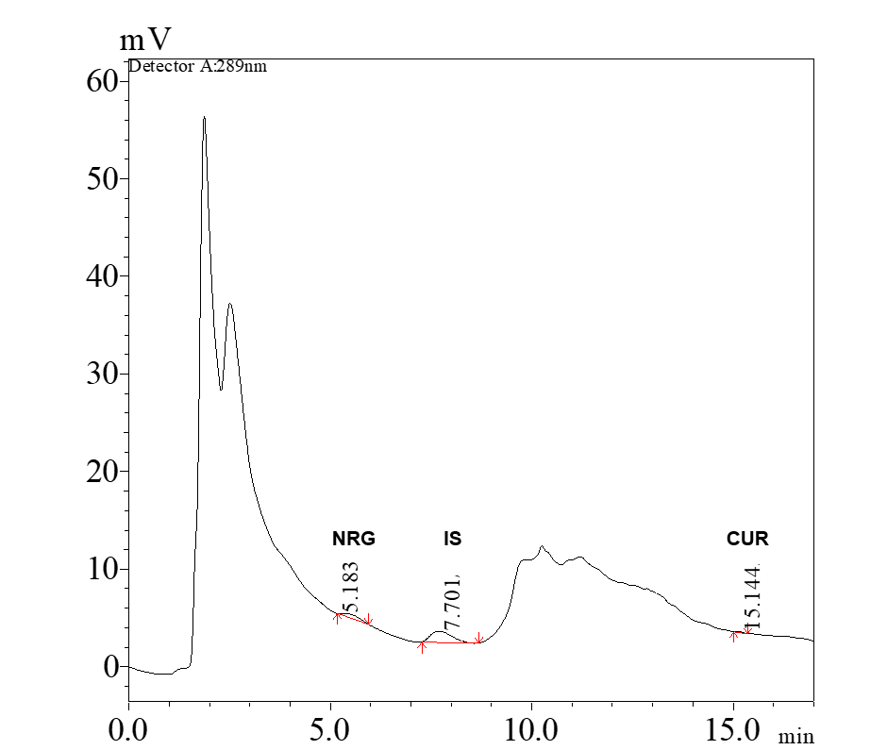
Figure S7. Chromatogram showing lower quality control (LQC) concentration of 300 ng/ml

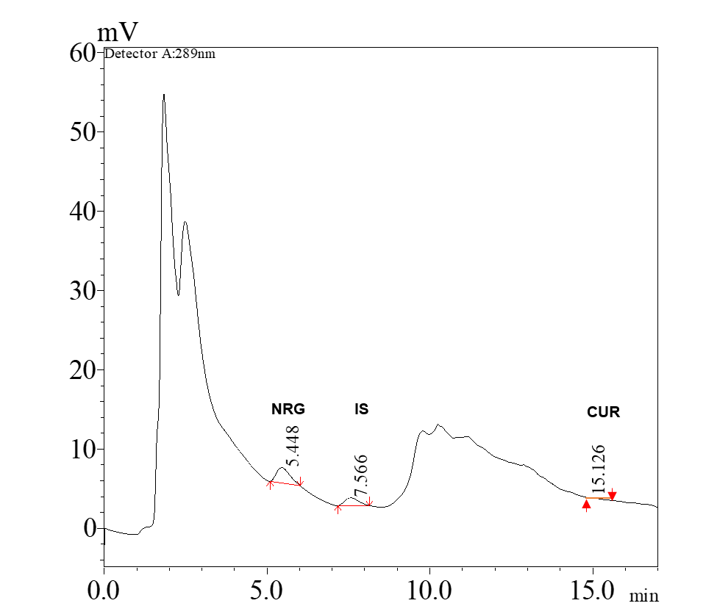
Figure S8. Chromatogram showing middle quality control (LQC) concentration of 1280 ng/ml
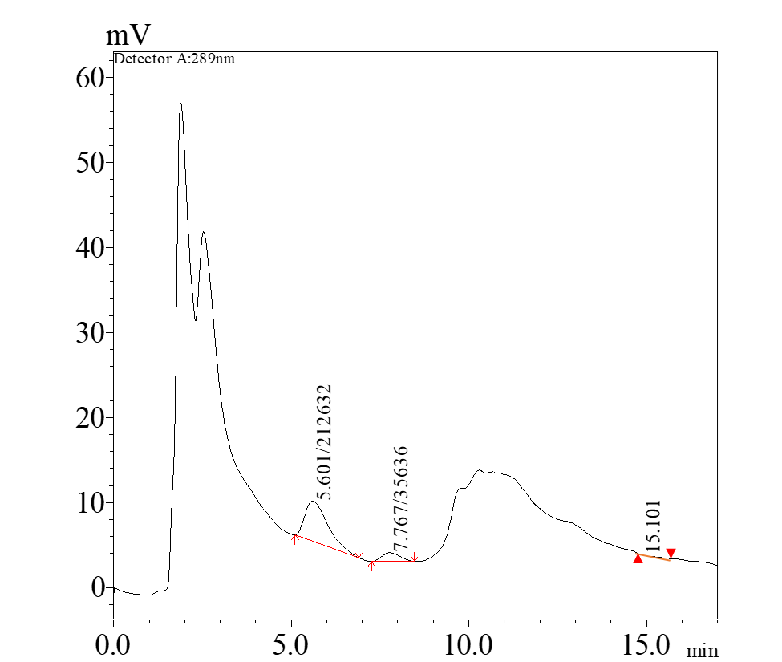
Figure S9. Chromatogram showing high quality control (HQC) concentration of 2400 ng/ml

