Supplements

A new ammonia determination assay based on the linear
activation of horseradish peroxidase for the determination of protein-glutamine glutaminase activities

Katrin Reichenberger, Gudrun Horstmann, Sabine Lutz-Wahl, Lutz Fischer*

University of Hohenheim, Institute of Food Science and Biotechnology,
Department of Biotechnology and Enzyme Science, Garbenstr. 25, 70599 Stuttgart, Germany

*Corresponding author: Lutz Fischer
E-mail address: lutz.fischer@uni-hohenheim.de
Tel.: +49 711 459-23018

Keywords: ammonia determination, horseradish peroxidase, protein glutaminase

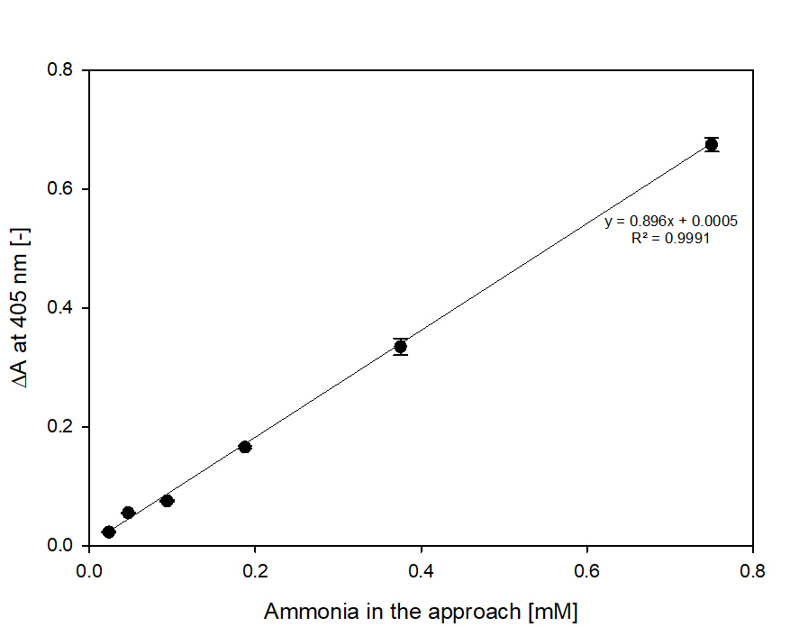
Figure S1: Calibration curve for ammonia detection in water samples (in 100 mM BR buffer with pH 10.0, 4.8 nkat mL⁻¹ horseradish peroxidase, 0.2 mM o-dianisidine and 400 µM hydrogen peroxide, concentrations given are the concentrations in the approach)

