Supplementary material
Hierarchical identification to quantification method to detect adulterants in honey using time domain nuclear magnetic resonance (TD-NMR)

Leonardo Francisco Rafael Lemes¹, Vitória Sofia da Paz¹, Jéssica Thaís de Lima¹, Leice Milla Ribeiro de Novais¹, Caroline Da Ros Montes D’Oca¹, Frederico Luis Felipe Soares^{1*}

¹Department of Chemistry, Federal University of Paraná, Avenida Coronel Francisco Heráclito dos Santos, 100, Curitiba, PR 81531-980, Brazil

*Corresponding author:
E-mail address: frederico.soares@ufpr.br ( Frederico Luis Felipe Soares)

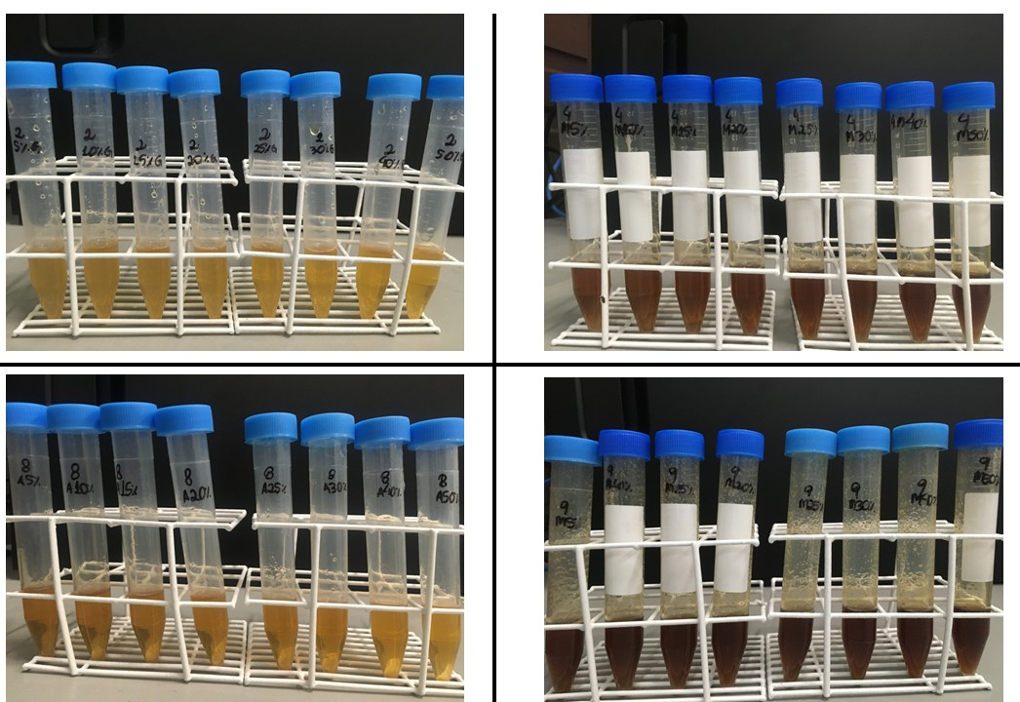

Figure S1. Different types of honey samples (Orange, Organic, Eucalyptus, and Silvestre) and different types of adulteration with cane molasses, inverted sugar, and corn syrup.

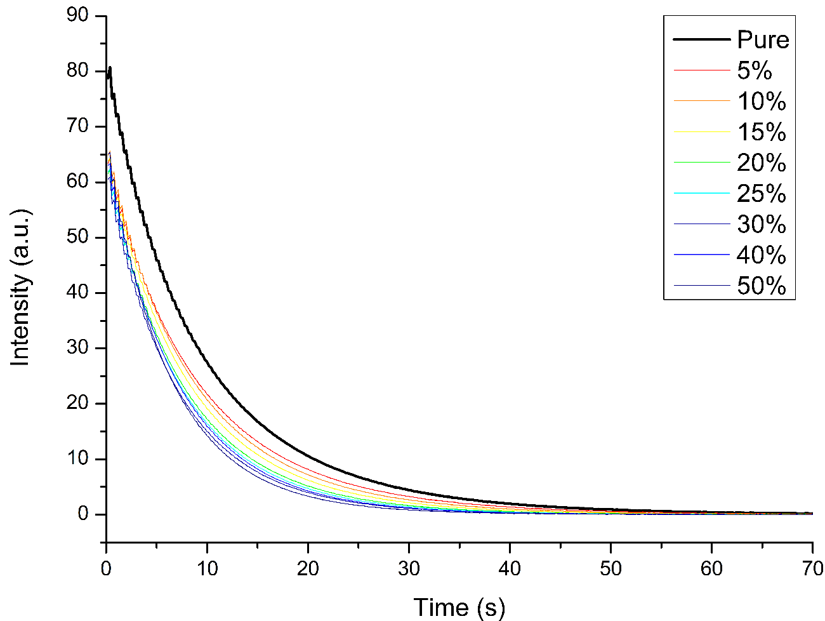
Figure S2. ¹H TD-NMR signal decays recorded for pure and adulterated honey samples.

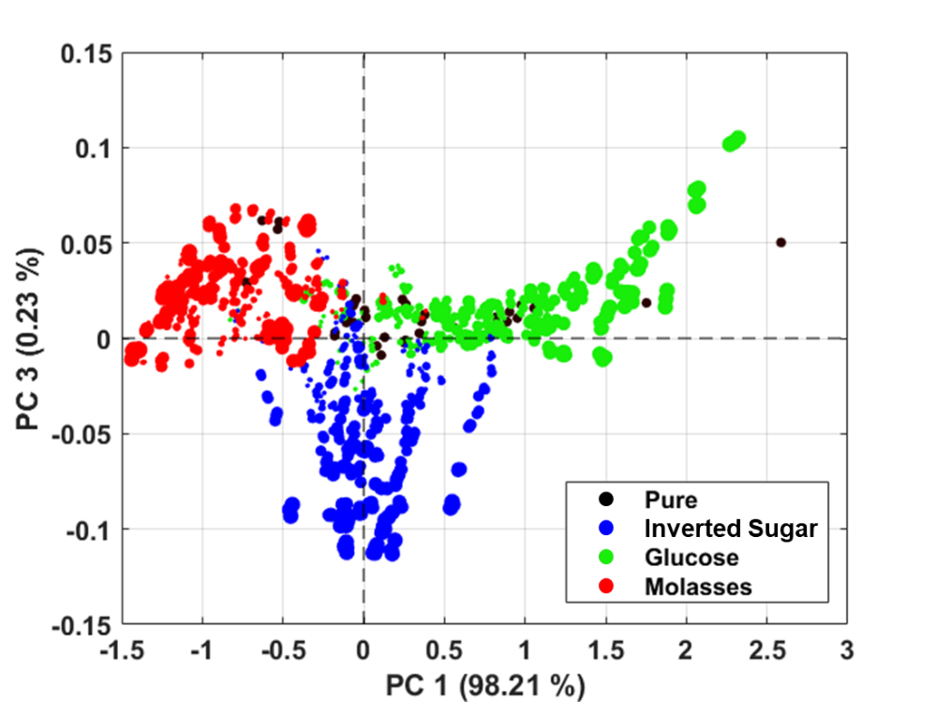
Figure S3. PCA score plot of the maximum normalized and mean-centered ¹H TD-NMR signal decays of pure and adulterated samples. The marker sizes represent the level of adulteration presented in the sample.

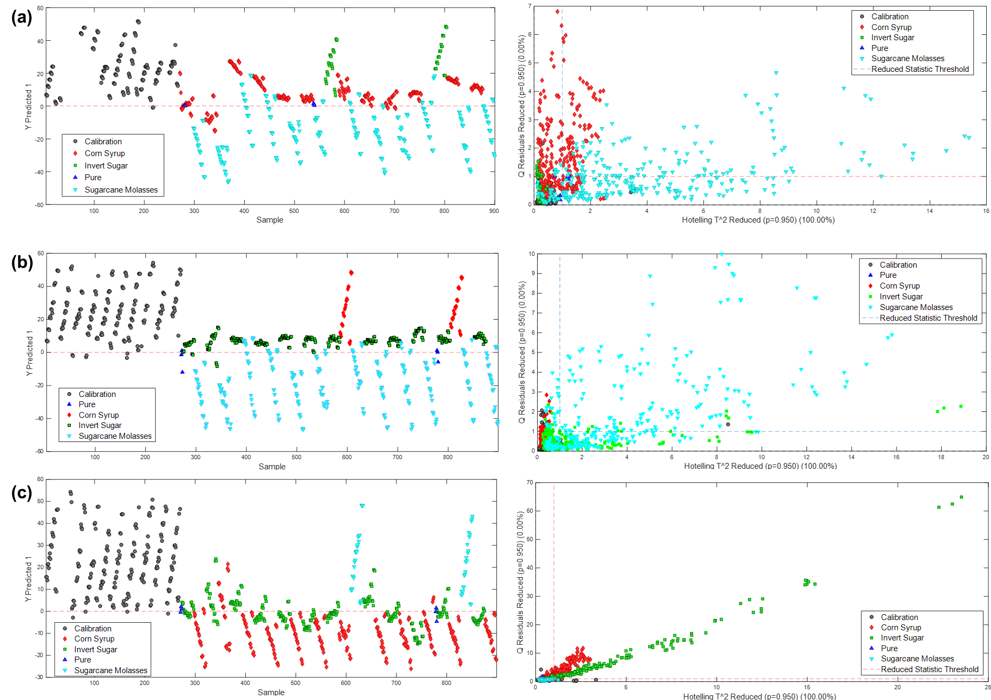
Figure S4. Set of calibration, prediction, and analysis of residues containing adulterants of the target class: (a) inverted sugar, (b) corn syrup, and (c) sugarcane molasses and other adulterated samples.

Figure S5. EJCR tests for the prediction models. The red marker is the theoretical ideal point.

Table S1
Figures of merit for DD-SIMCA models applied to pure and adulterated honey.
Sample | Data sets | TP | FN | TN | FP | Sensitivity (%) | Specificity (%) | Accuracy (%) | Number of PCs
Pure honey | Cal | 30 | 0 | - | - | 100.00 | - | 99.67 | 5
 | External | 11 | 1 | - | - | 92.00 | - | 99.67 | 5
Adulterated honey | Cal | - | - | - | - | - | - | 99.67 | 5
 | External | 0 | 0 | 862 | 2 | - | 99.76 | 99.67 | 5
Cal: calibration; Val: validation, External: External Validation; TP: true positive; FN: false negative; TN: true negative; FP; false positive; PCs: principal components.

Table S2
The confusion matrix for calibration and external validation samples in PLS-DA modeling.
Real/prediction | Method | Class 1 | Class 2 | Class 3
Class 1 | Calibration | 221 | 16 | 12
Class 2 | Calibration | 2 | 218 | 1
Class 3 | Calibration | 17 | 6 | 227
Class 1 | External Validation | 48 | 3 | 0
Class 2 | External Validation | 0 | 45 | 0
Class 3 | External Validation | 0 | 0 | 48
Class 1: Inverted sugar; Class 2: Corn syrup; Class 3: Sugarcane molasses.

