Electronic supplementary material
Supplemental Table 1. Key inclusion criteria.
Key inclusion criteria
- Patients for whom the current standard of treatment is difficult to apply:
- Younger patients for whom long-term treatment is anticipated.
- Patients categorized as low risk, but for whom cytoreduction is recommended due to disease-related signs and symptoms (headache, dizziness, pruritus, night sweats, fatigue, erythromelalgia, vision disorders, scintillating scotoma, early satiety, and abdominal distension).
- Patients with history of hydroxyurea treatment intolerance [modified European LeukemiaNet criteria]) [1].

- The following additional inclusion criteria were applied only to cytoreduction-naïve patients who were deemed to require cytoreductive treatment at baseline, defined as meeting one or more of the following criteria:
- Patients with ≥1 previous well documented major cardiovascular polycythemia vera-related event.
- Patients with poor tolerance of phlebotomy defined as a phlebotomy/procedure-related adverse event causing significant adverse impact on the patient and limiting ability to apply phlebotomy with the intention to keep hematocrit <45%.
- Patients with frequent need of phlebotomy defined as ≥2 phlebotomies within the last month prior to participating the study.
- Patients with platelet count >1,000 × 10⁹/L or WBC count > 10 × 10⁹/L at two measurements within the month prior to treatment start.
- Patients with manifestation of disease-related signs and symptoms (e.g., headache, dizziness, pruritus, night sweats, fatigue, erythromelalgia, vision disorders, scintillating scotoma, early satiety, or abdominal distension).
- Barosi G, Birgegard G, Finazzi G, Griesshammer M, Harrison C, Hasselbalch H, et al. A unified definition of clinical resistance and intolerance to hydroxycarbamide in polycythaemia vera and primary myelofibrosis: Results of a European LeukemiaNet (ELN) consensus process. Br J Haematol. 2010;148:961–3.

Supplemental Table 2. Treatment-emergent adverse events related to ropeginterferon alfa-2b occurring in ≥2 patients with low-risk polycythemia vera.
 | N = 20
Alopecia | 11 (55.0)
Influenza-like illness | 7 (35.0)
Alanine aminotransferase increased | 6 (30.0)
Fatigue | 6 (30.0)
Aspartate aminotransferase increased | 5 (25.0)
Diarrhea | 5 (25.0)
Beta-2 microglobulin urine increased | 4 (20.0)
Liver function test abnormal | 3 (15.0)
Myalgia | 3 (15.0)
Pyrexia | 3 (15.0)
Abdominal pain | 2 (10.0)
Anemia | 2 (10.0)
Anti-thyroid antibody-positive | 2 (10.0)
Arthralgia | 2 (10.0)
Hypothyroidism | 2 (10.0)
Injection site reaction | 2 (10.0)
Insomnia | 2 (10.0)
Malaise | 2 (10.0)
White blood cell count decreased | 2 (10.0)
Data are n (%) and classified according to the Medical Dictionary for Regulatory Activities, v23.0.

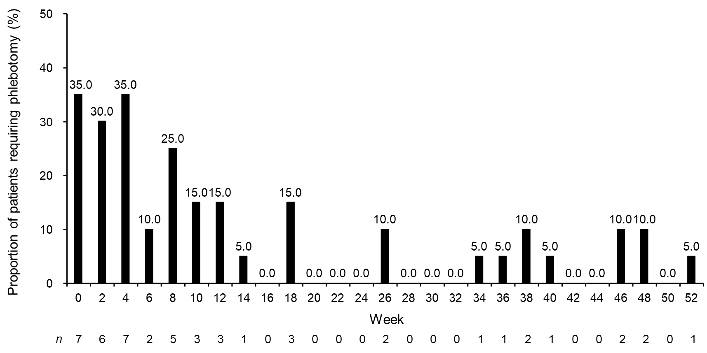Supplemental Fig. 1. Proportion of patients with low-risk polycythemia vera requiring phlebotomy over time.
N = 20

