Real-World Effectiveness and Safety of Ibrutinib in Patients with Chronic Lymphocytic Leukemia in Japan: the Orbit Study
Authors: Tsuyoshi Muta¹, Yosuke Masamoto², Go Yamamoto³, Shingo Kurahashi⁴, Yoshihiro Kameoka^{5,6}, Shuichi Ota⁷, Eri Matsuki⁸, Kazutaka Ozeki⁹, Takanori Toyama¹⁰, Naoki Takahashi¹¹, Takahiro Kumode¹², Nobuyuki Aotsuka¹³, Takuro Yoshimura¹⁴, Hideto Tamura^{15,16}, Ai Omi¹⁷, Kazuhiro Shibayama¹⁸, Aki Watanabe¹⁹, Yasushi Isobe²⁰, Kensuke Kojima²¹, Jun Takizawa²², Hirokazu Nagai²³, Junji Suzumiya²⁴, Sadao Aoki^{25,26}
Affiliations: ¹Department of Transfusion Medicine Clinical Laboratory, Hiroshima Red Cross Hospital and Atomic-bomb Survivors Hospital, Hiroshima, Japan; ²Department of Cell Therapy and Transplantation Medicine, The University of Tokyo Hospital, Tokyo, Japan; ³Department of Hematology, Toranomon Hospital, Tokyo, Japan; ⁴Department of Hematology and Oncology, Toyohashi Municipal Hospital, Aichi, Japan; ⁵Department of Hematology, Nephrology and Rheumatology, Akita University Graduate School of Medicine and Faculty of Medicine, Akita, Japan; ⁶Department of Hematology, Akita Red Cross Hospital, Akita, Japan; ⁷Department of Hematology, Sapporo Hokuyu Hospital, Sapporo, Japan; ⁸Division of Hematology, Department of Medicine Keio University School of Medicine, Tokyo, Japan; ⁹Department of Hematology and Oncology, JA Aichi Konan Kosei Hospital, Aichi, Japan; ¹⁰Department of Internal Medicine, Miyazaki Prefectural Nobeoka Hospital, Miyazaki, Japan; ¹¹Department of Hematology, International Medical Center, Saitama Medical University, Saitama, Japan; ¹²Department of Hematology and Rheumatology, Kindai University Hospital, Osaka, Japan; ¹³Department of Hematology and Oncology, Japanese Red Cross Narita Hospital, Chiba, Japan; ¹⁴Department of Hematology, Osaka City General Hospital, Osaka, Japan; ¹⁵Department of Diabetes, Endocrinology and Hematology, Dokkyo Medical University Saitama Medical Center, Saitama, Japan; ¹⁶Department of Hematology, Nippon Medical School, Tokyo, Japan; ¹⁷Department of Medical Affairs, Janssen Pharmaceutical K.K., Tokyo, Japan; ¹⁸Statistics & Decision Sciences Japan, Janssen Pharmaceutical K.K., Tokyo, Japan; ¹⁹Medical Affairs Delivery Unit, Global Development, Janssen Pharmaceutical K.K., Tokyo, Japan; ²⁰Department of Medical Oncology, Hematology and Infectious Diseases, Fukuoka University Hospital, Fukuoka, Japan; ²¹Department of Hematology, Kochi Medical School, Kochi University, Kochi, Japan; ²²Department of Hematology, Endocrinology and Metabolism, Niigata University Faculty of Medicine, Niigata, Japan; ²³Hematology Department, National Hospital Organization Nagoya Medical Center, Aichi, Japan; ²⁴Department of Hematology, Koga Community Hospital, Yaizu, Japan; ²⁵Department of Medical Technology, Faculty of Medical Technology, Niigata University of Pharmacy and Medical and Life Sciences, Niigata, Japan; ²⁶Department of Hematology, Niigata Minami Hospital, Niigata, Japan.

Supplementary Material

Supplementary Table S1.
Prior treatment for chronic lymphocytic leukemia in patients with relapsed or refractory disease (n=94).
 | N=94
No. of prior treatment lines
Median (range) | 2 (1–6)
Category, n (%)
1 | 44 (46.8)
2 | 22 (23.4)
≥3 | 23 (24.5)
Unknown | 5 (5.3)
Most recent CLL treatment, n (%)
Fludarabine | 22 (23.4)
Cyclophosphamide | 13 (13.8)
Bendamustine + rituximab | 10 (10.6)
Rituximab | 9 (9.6)
Fludarabine + cyclophosphamide + rituximab | 8 (8.5)
Bendamustine | 5 (5.3)
Fludarabine + rituximab | 5 (5.3)
Ofatumumab | 4 (4.3)
R-CHOP | 3 (3.2)
Fludarabine + cyclophosphamide | 2 (2.1)
Cyclophosphamide + corticosteroid | 2 (2.1)
Cyclophosphamide + corticosteroid + procarbazine | 2 (2.1)
Cyclophosphamide + corticosteroid + pirarubicin + vincristine | 1 (1.1)
Cyclophosphamide + corticosteroid + procarbazine + etoposide | 1 (1.1)
Cyclophosphamide + corticosteroid + vincristine | 1 (1.1)
Rituximab + cyclophosphamide + corticosteroid | 1 (1.1)
Rituximab + cyclophosphamide + corticosteroid + etoposide + procarbazine | 1 (1.1)
Rituximab + cyclophosphamide + vincristine + prednisone | 1 (1.1)
Venetoclax | 1 (1.1)
Yttrium ibritumomab tiuxetan | 1 (1.1)
Unknown | 1 (1.1)
CLL, chronic lymphocytic leukemia; R-CHOP, rituximab, cyclophosphamide, doxorubicin, vincristine, and prednisone.

Supplementary Table S2.
Baseline laboratory values in the safety analysis set.
Laboratory values, median (range) | Total population  n=237ª | 1L CLL  n=142 | RR CLL  n=94
IgA, mg/dL | 74.0  (7.0–3769.0) | 79.6  (11.0–3769.0) | 70.0  (7.0–998.0)
IgG, mg/dL | 830.5  (34.0–5,912.6) | 946.0  (265.0–5,912.6) | 626.0  (34.0–2,141.0)
IgM, mg/dL | 29.0  (2.0–2,279.2) | 39.0  (8.0–1,569.0) | 26.0  (2.0–2,279.2)
WBC count, /μL | 18,700  (1,239–384,800) | 20,200  (1,239–384,800) | 16,310  (1,870–286,000)
Neutrophil count, /μL | 2,918.7  (0.0–22,072.0) | 3,068.5  (0.0–22,072.0) | 2,573.0  (0.0–13,040.0)
ªIncludes one patient with unknown CLL/SLL status, who met exclusion criteria immediately after registration and had no data collected thereafter.
1L, first-line; CLL, chronic lymphocytic leukemia; IgA/G/M, immunoglobulin A/G/M; RR, relapsed or refractory; WBC, white blood cell.

Supplementary Table S3.
Summary of subsequent treatment after ibrutinib in the per-protocol set.
 | 1L CLL  n=141 | RR CLL  n=93
Post-ibrutinib treatment, n (%)
Yes | 31 (22.0) | 31 (33.3)
No | 109 (77.3) | 62 (66.7)
Unknown | 1 (0.7) | 0
Regimen, n (%) | n=31 | n=31
Venetoclax ± rituximab | 12 (38.7) | 14 (45.2)
Acalabrutinib | 10 (32.3) | 2 (6.5)
R-CHOP | 2 (6.5) | 3 (9.7)
Bendamustine + rituximab | 2 (6.5) | 1 (3.2)
Corticosteroid | 2 (6.5) | 1 (3.2)
Doxorubicin + bleomycin + vinblastine + dacarbazine | 1 (3.2) | 0
Etoposide | 1 (3.2) | 0
Rituximab | 1 (3.2) | 0
Cyclophosphamide | 0 | 4 (12.9)
Fludarabine | 0 | 2 (6.5)
Bendamustine | 0 | 1 (3.2)
Cyclophosphamide + corticosteroid | 0 | 1 (3.2)
Hydroxycarbamide | 0 | 1 (3.2)
Ofatumumab | 0 | 1 (3.2)
1L, first-line; CLL, chronic lymphocytic leukemia; R-CHOP, rituximab, cyclophosphamide, doxorubicin, vincristine, and prednisone; RR, relapsed or refractory.

Supplementary Figure S1.
Study design.
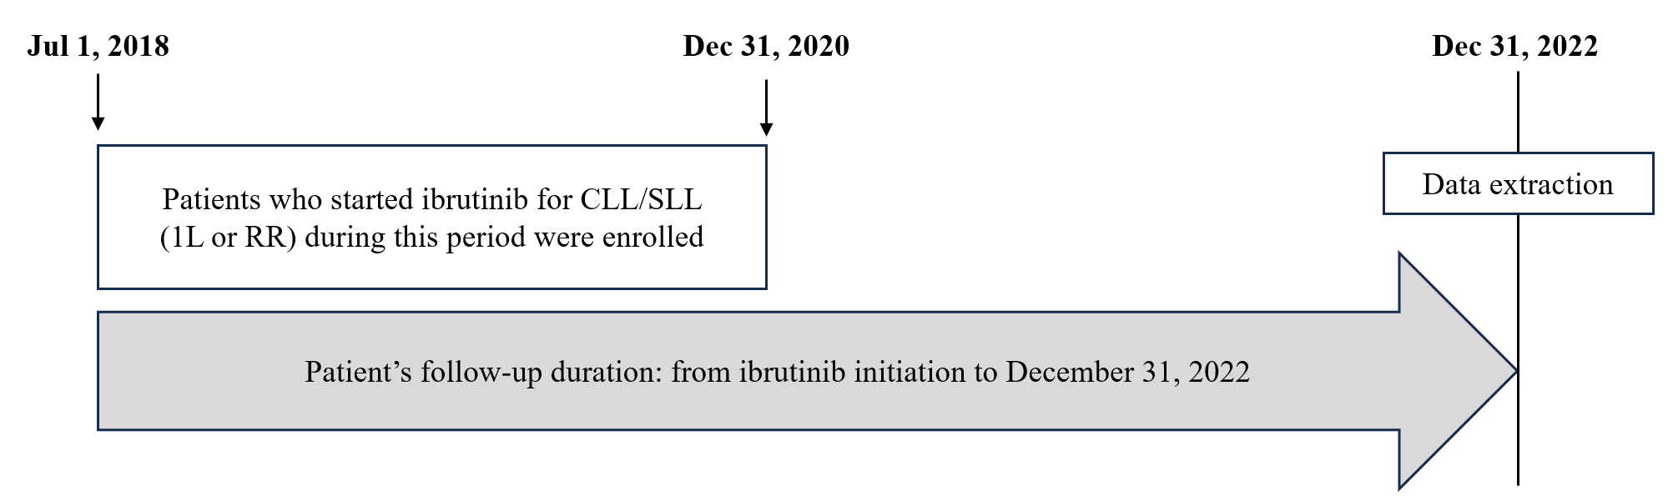
1L, first-line; CLL, chronic lymphocytic leukemia; RR, relapsed or refractory; SLL, small lymphocytic lymphoma.

Supplementary Figure S2.
Kaplan–Meier curves of time to next treatment in patients with chronic lymphocytic leukemia receiving ibrutinib as (a) first-line therapy and (b) for relapsed or refractory disease in the per-protocol set.
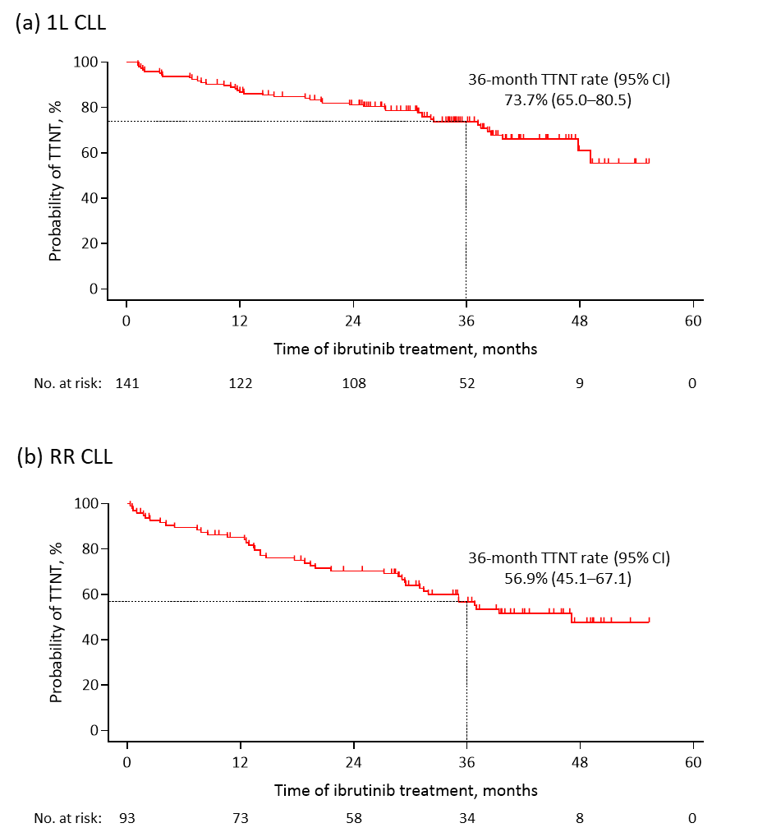
1L, first-line; CI, confidence interval; CLL, chronic lymphocytic leukemia; No., number; RR, relapsed or refractory; TTNT, time to next treatment.

