Supplementary Materials
Daratumumab plus VRd in Japanese transplant-ineligible/deferred NDMM patients: Japanese subgroup of the CEPHEUS trial

Author list:
Kenshi Suzuki¹, Morio Matsumoto², Hiroyuki Takamatsu³, Hiroshi Kosugi⁴, Tadakazu Kondo⁵, Tomoaki Fujisaki⁶, Thierry Facon⁷, Sonja Zweegman⁸, Miku Ito⁹, Chika Sakai⁹, Satoshi Kanai⁹, Tomohiko Nakatogawa⁹, Melissa Rowe¹⁰, Robin Carson¹¹, Saad Z. Usmani¹²

Affiliations:
¹Department of Hematology, Japanese Red Cross Medical Center, Tokyo, Japan
²Department of Hematology, NHO Shibukawa Medical Center, Gunma, Japan
³Department of Hematology, Kanazawa University Hospital, Ishikawa, Japan
⁴Department of Hematology, Ogaki Municipal Hospital, Gifu, Japan
⁵Department of Hematology, Kobe City Medical Center General Hospital, Hyogo, Japan.
⁶Department of Hematology, Matsuyama Red Cross Hospital, Ehime, Japan
⁷Service des Maladies du sang, Hôpital Claude Huriez, Centre Hospitalier Universitaire de Lille, Lille, France
⁸Department of Hematology, Cancer Center Amsterdam, Vrije Universiteit Medical Center, Amsterdam, The Netherlands
⁹Johnson & Johnson, Tokyo, Japan
¹⁰Johnson & Johnson, High Wycombe, UK
¹¹Johnson & Johnson, PA, USA
¹²Memorial Sloan Kettering Cancer Center, NY, USA

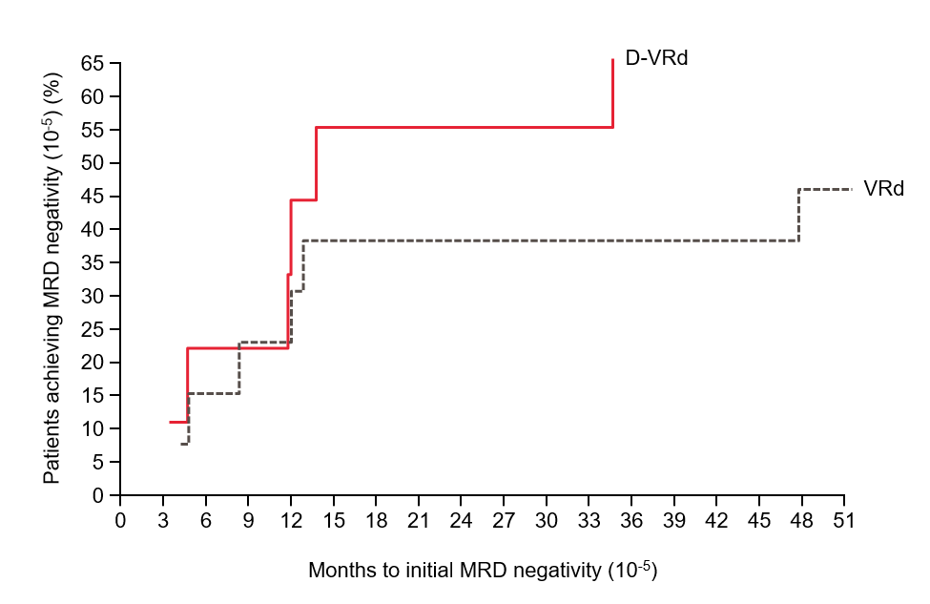
Supplementary Figure 1. Cumulative incidence of MRD negativity.
D-VRd, daratumumab plus bortezomib/lenalidomide/dexamethasone; MRD, minimal residual disease; VRd, bortezomib/lenalidomide/dexamethasone.
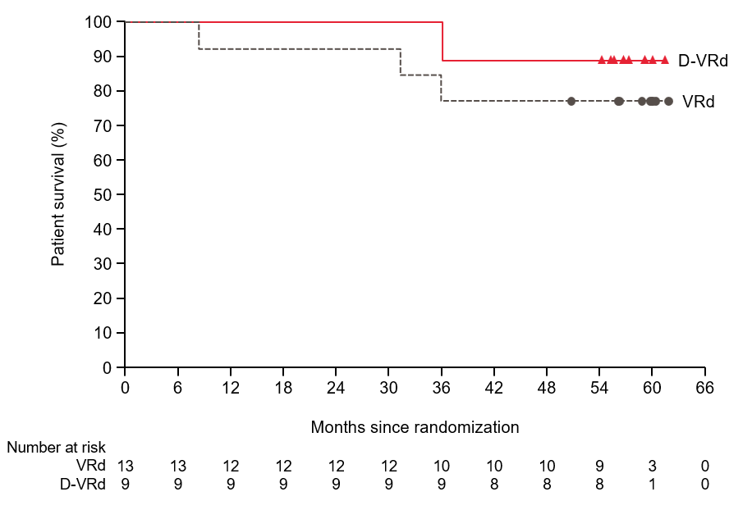Supplementary Figure 2. Overall survival.
D-VRd, daratumumab plus bortezomib/lenalidomide/dexamethasone; VRd, bortezomib/lenalidomide/dexamethasone.
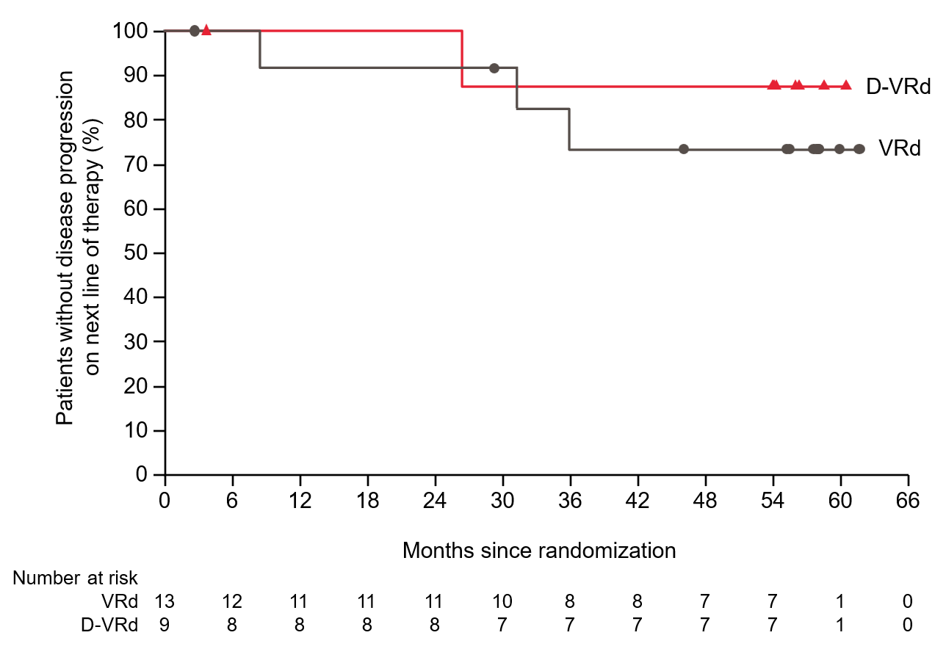Supplementary Figure 3. Progression-free survival on next line of therapy.
D-VRd, daratumumab plus bortezomib/lenalidomide/dexamethasone; VRd, bortezomib/lenalidomide/dexamethasone.

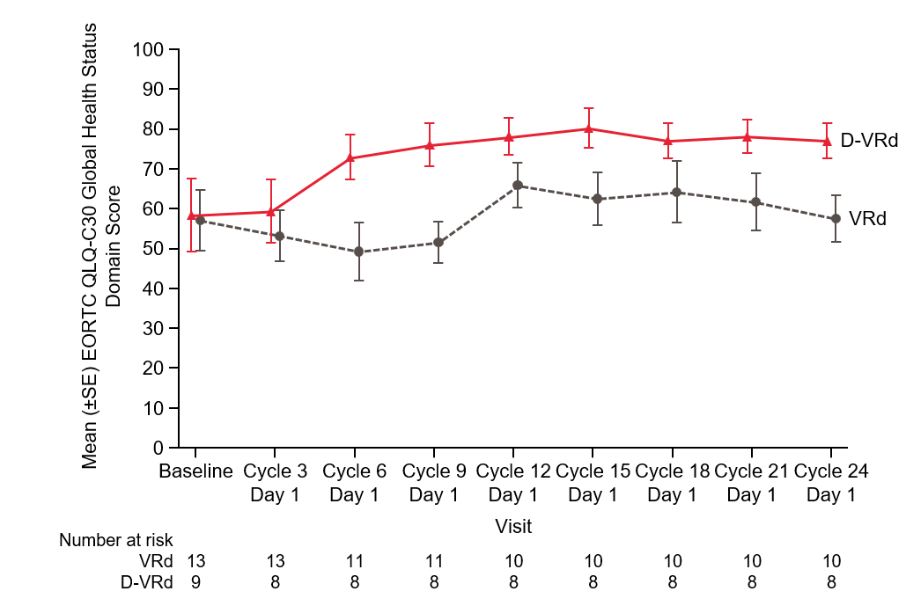
Supplementary Figure 4. The EORTC QLQ-C30 global health status domain scores over time.
D-VRd, daratumumab plus bortezomib/lenalidomide/dexamethasone; EORTC QLQ-C30, European Organisation for Research and Treatment of Cancer Quality of Life Questionnaire–Core 30; SE, standard error; VRd, bortezomib/lenalidomide/dexamethasone.

Supplementary Table 1. Best confirmed response.
 | D-VRd  (n = 9) |  | VRd  (n = 13)
 | n (%) | 95% CI for % | n (%) | 95% CI for % | Odds ratio (95% CI)
Stringent complete response | 8 (88.9) | (51.8, 99.7) | 7 (53.8) | (25.1, 80.8) | 6.86 (0.66, 71.72)
Complete response | 0 | (NE, NE) | 3 (23.1) | (5.0, 53.8)
Very good partial response | 1 (11.1) | (0.3, 48.2) | 2 (15.4) | (1.9, 45.4)
Partial response | 0 | (NE, NE) | 0 | (NE, NE)
Stable disease | 0 | (NE, NE) | 1 (7.7) | (0.2, 36.0)
Progressive disease | 0 | (NE, NE) | 0 | (NE, NE)
Not evaluable | 0 | (NE, NE) | 0 | (NE, NE)
Overall responseª | 9 (100.0) | (66.4, 100.0) | 12 (92.3) | (64.0, 99.8) | NE (NE, NE)
Very good partial response or better | 9 (100.0) | (66.4, 100.0) | 12 (92.3) | (64.0, 99.8) | NE (NE, NE)
Complete response or better | 8 (88.9) | (51.8, 99.7) | 10 (76.9) | (46.2, 95.0) | 2.40 (0.21, 27.72)
ªIncluding stringent complete response, complete response, very good partial response, and partial response categories.
CI, confidence interval; D-VRd, daratumumab plus bortezomib/lenalidomide/dexamethasone; NE, not estimable; VRd, bortezomib/lenalidomide/dexamethasone.

