Investigating the Influence of Agent Modality and Expression on Agent-Mediated Fairness Behaviours

Appendix A: Agent Examples

Figure A1
Cortana
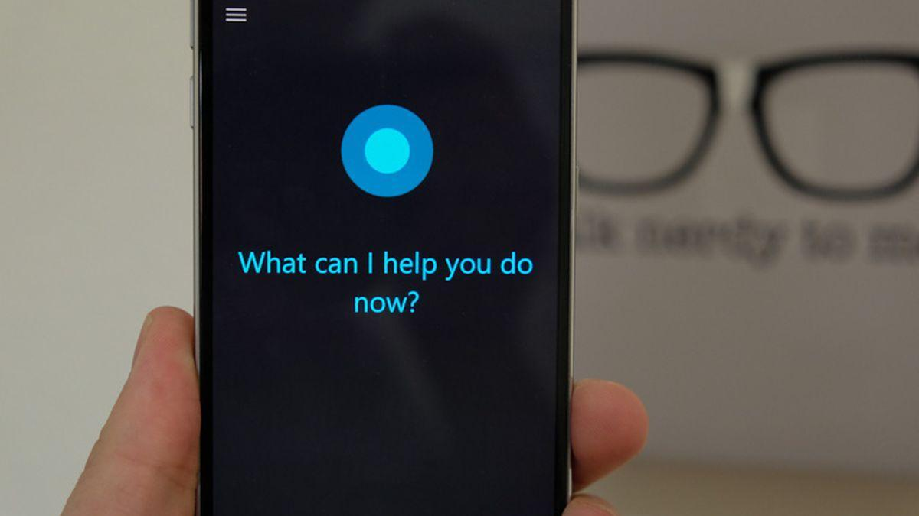
Note. Photo by Cipriani (2015)

Figure A2
Siri
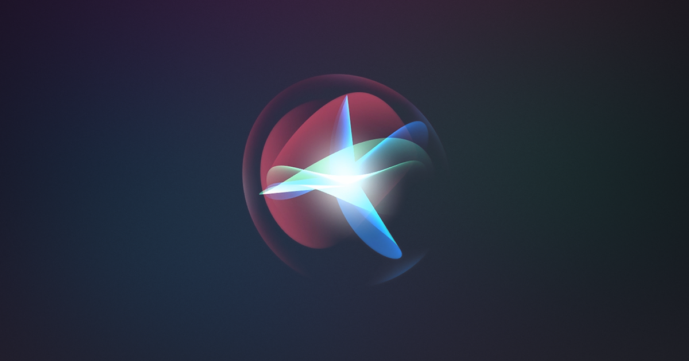
Note. Photo by Apple (n.d.)
Figure A3
Alexa
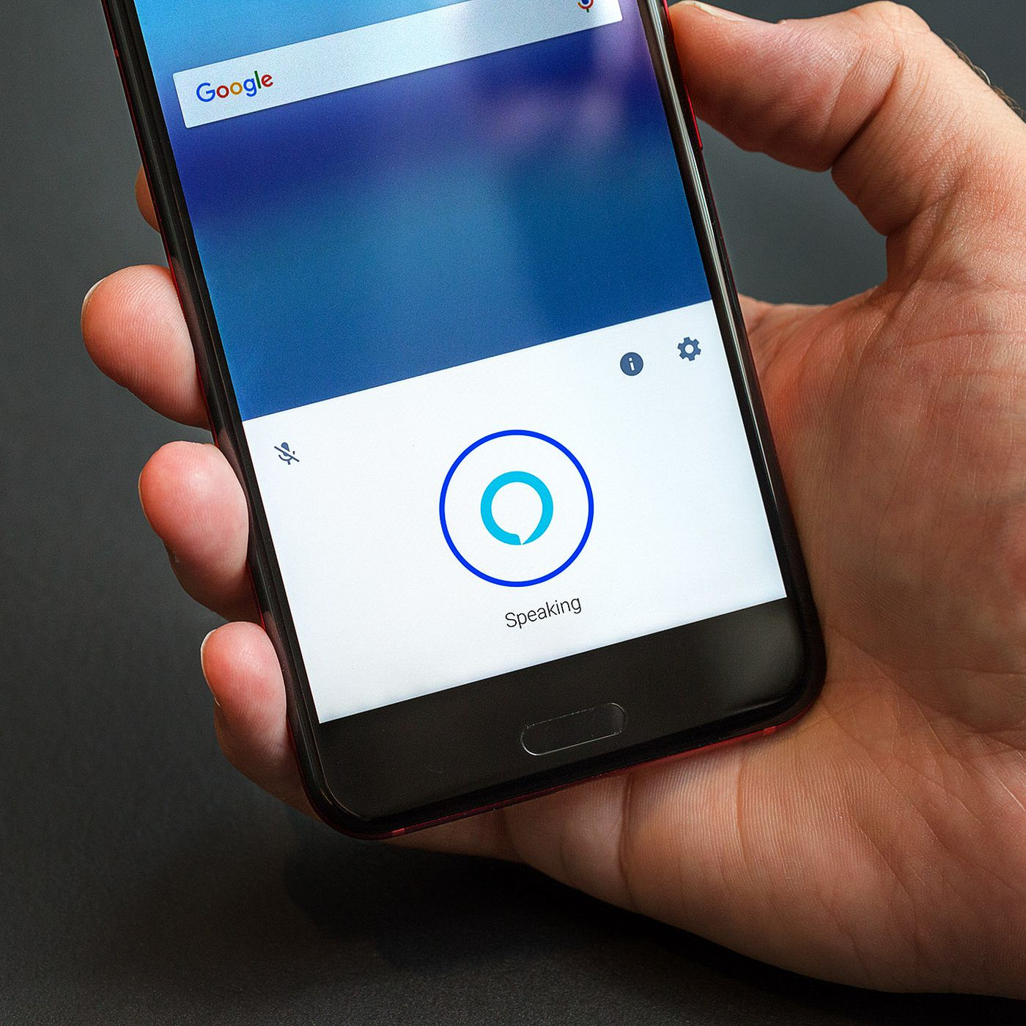
Note. Photo by Krales (2018)

Figure A4
ASIMO
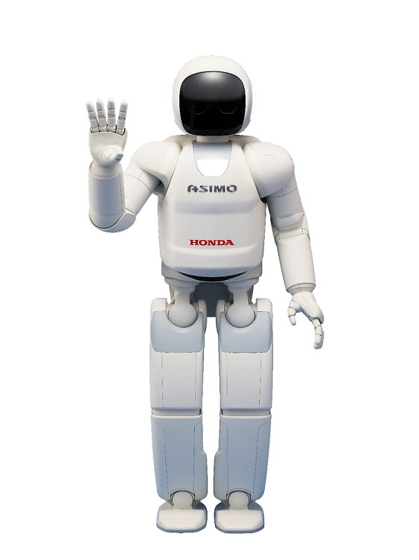
Note. Taken from Honda Motor Co. (n.d.)

Figure A5
REEM
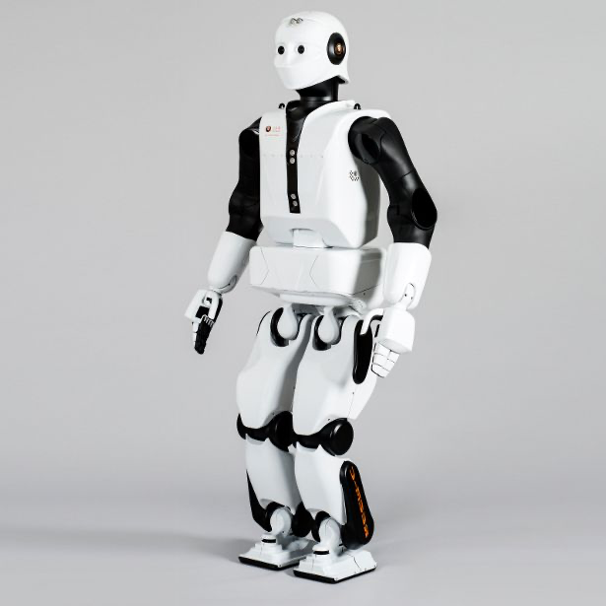
Note. Taken from Pal Robotics (n.d.)

Appendix B: Audio Analysis

In addition to analysing the fundamental frequency of the audio stimuli, we also analysed the Spectral Centroid and the average frequencies of the first three formants which are included here for reference.

Spectral Centroid:

A paired samples wil coxon test demonstrate that the spectral centroid for the smiling clips (Mdn = 822.36) and neutral clips (Mdn = 707.99) were not significantly different (T = 354, z = -1.22, p = .22).

F1 – 3:

Paired samples t-test show that the average formants for the smiling (M = 1690.21, SD = 121.51) and the neutral recordings (M = 1709.40, SD = 130.17) were not significantly different (t(41) = -1.44, p = .157, 95% CI [-46.09, 7.71, Cohen’s d = -.22).

