Supplementary Materials
Fluorine Doped Hard Carbon as the Advanced Performance Anode Material of Sodium Ion Batteries
Lingchen Kong¹ ·Yu Li¹ ·Wei Feng¹
¹School of Materials Science and Engineering, Tianjin University, Tianjin 300072, China
Correspondence to Wei Feng, E-mail address: weifeng@tju.edu.cn

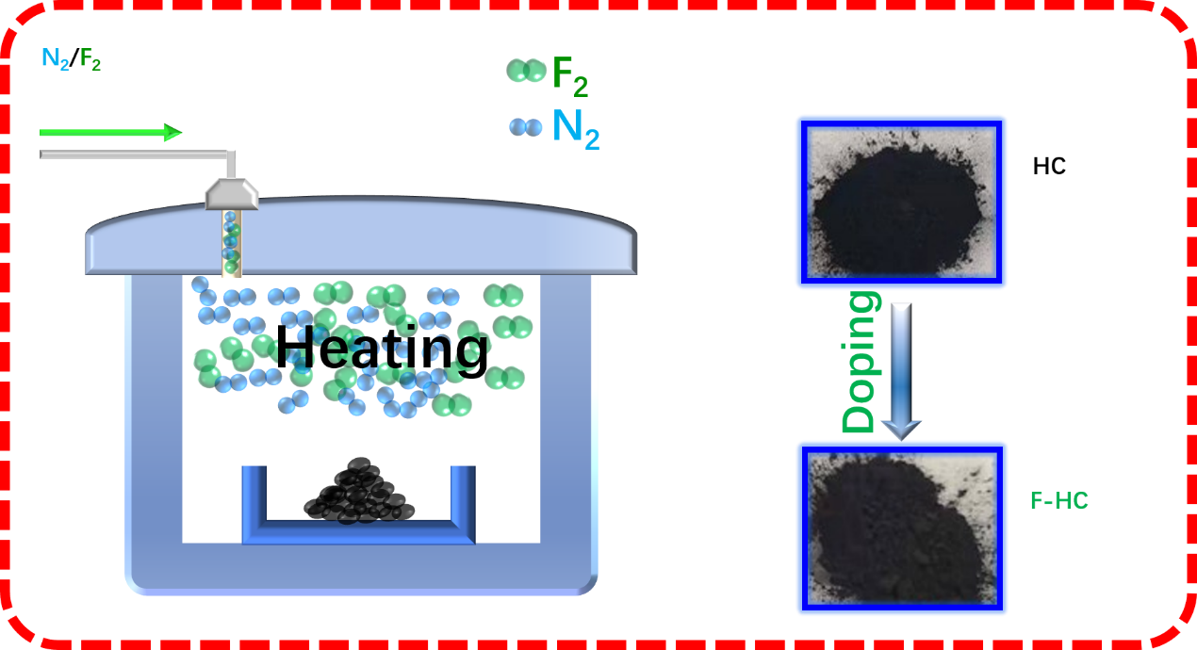
Fig. S1 Experimental process and digital photographs of pristine HC and synthesized F–HC
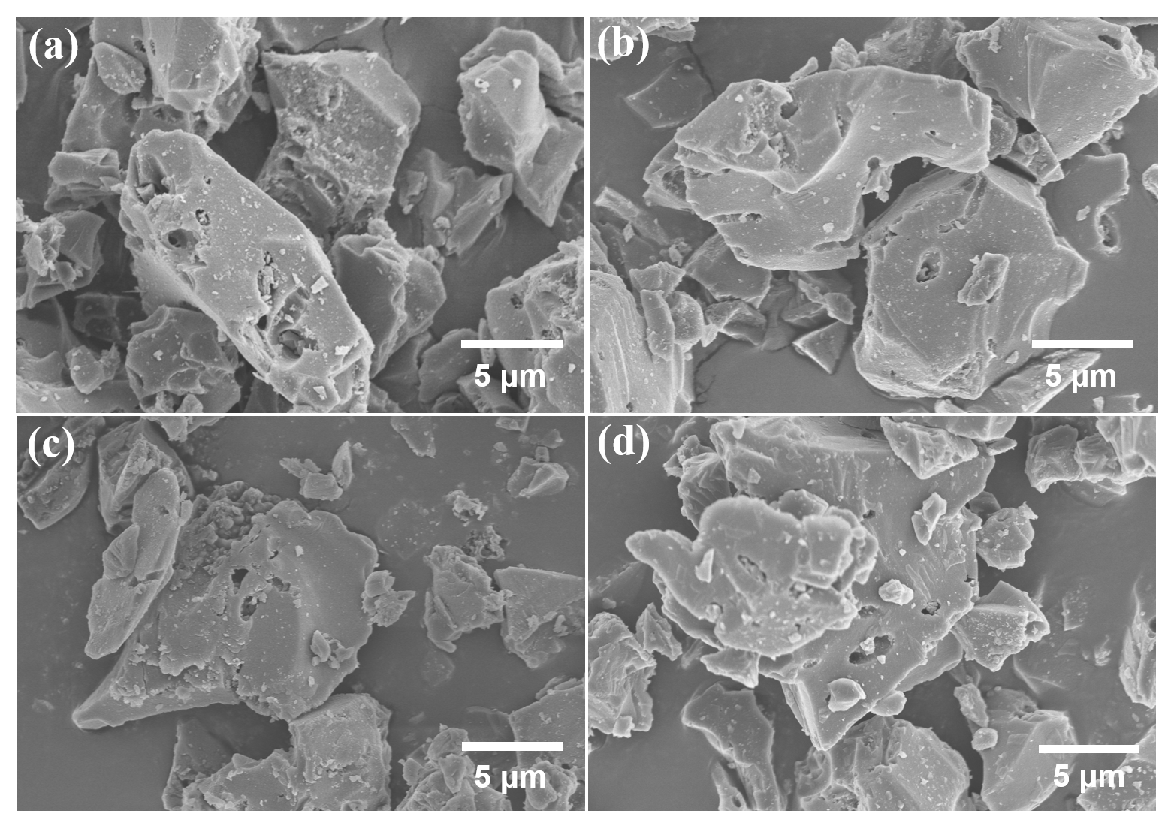
Fig. S2 SEM images of a HC, b F–HC50, c F–HC100, and d F–HC150
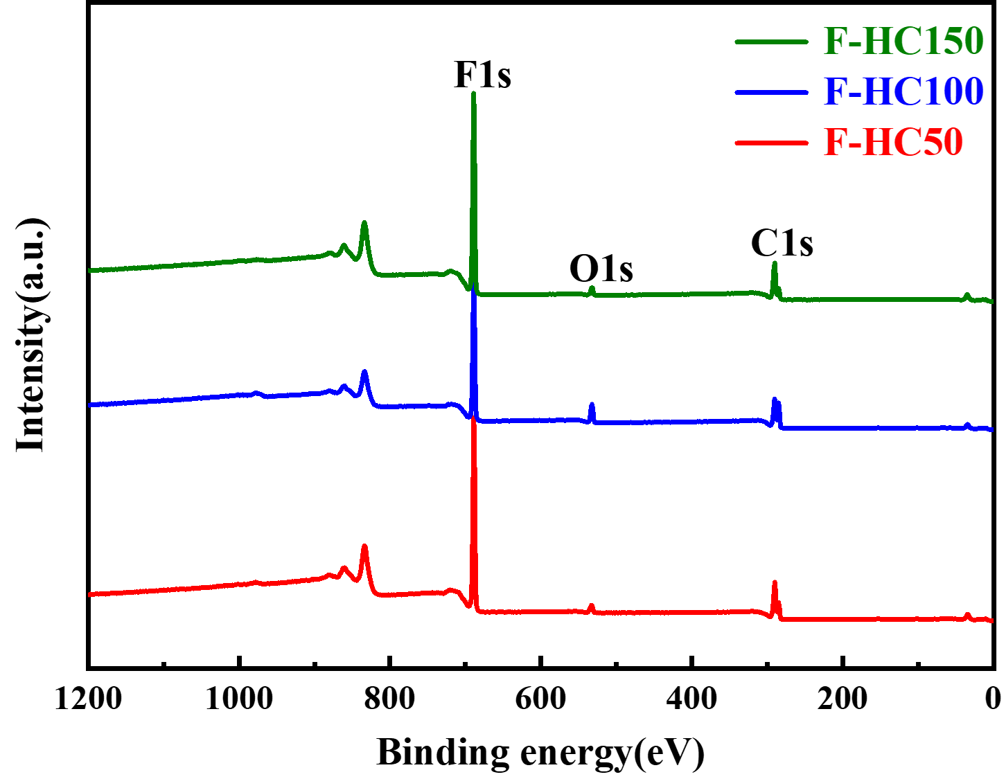
Fig. S3 XPS survey spectra of F–HC
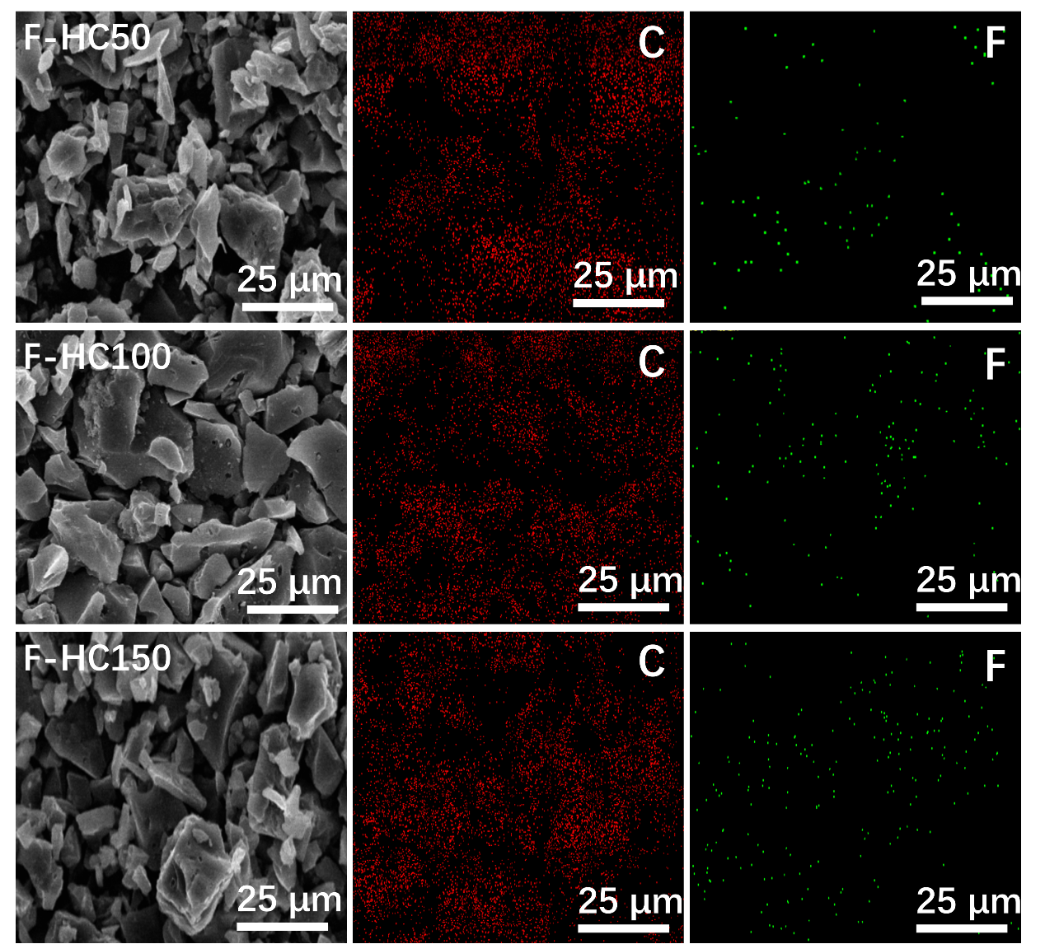
Fig. S4 Elemental mapping image of C and F components of F–HC

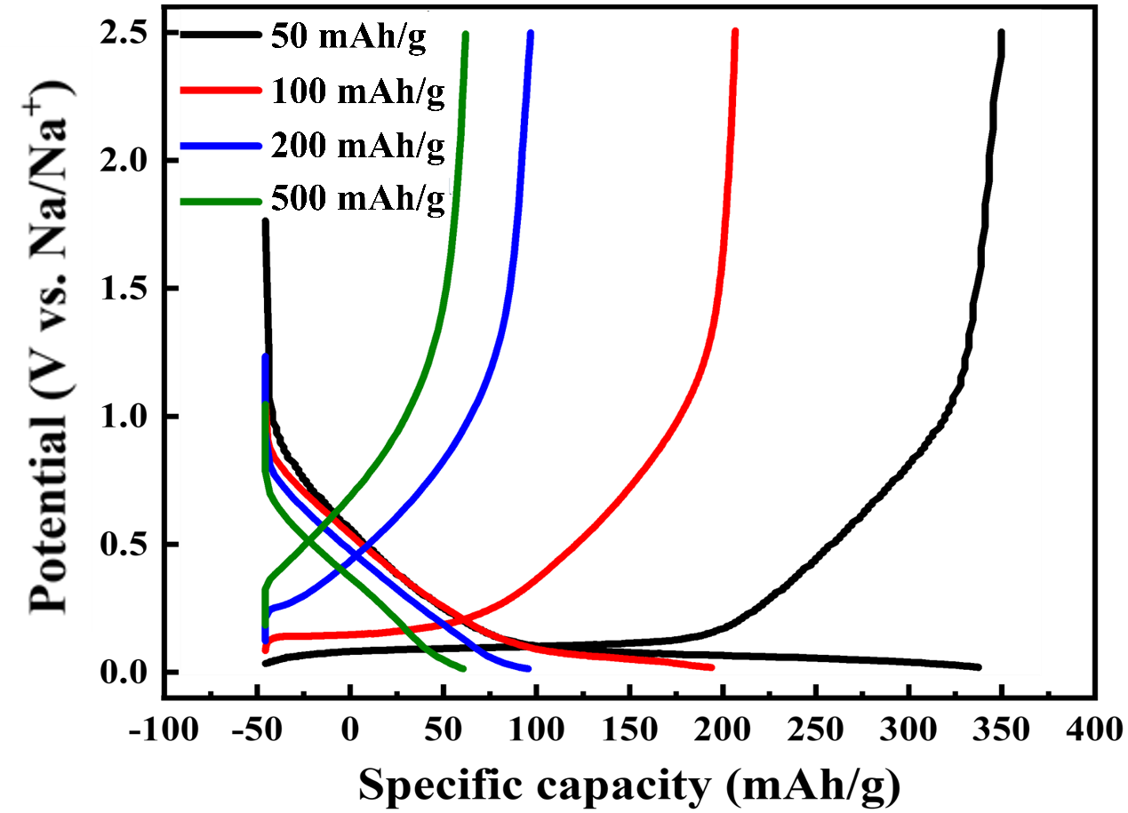
Fig. S5 Typical discharge/charge profiles of F–HC100 at different current densities
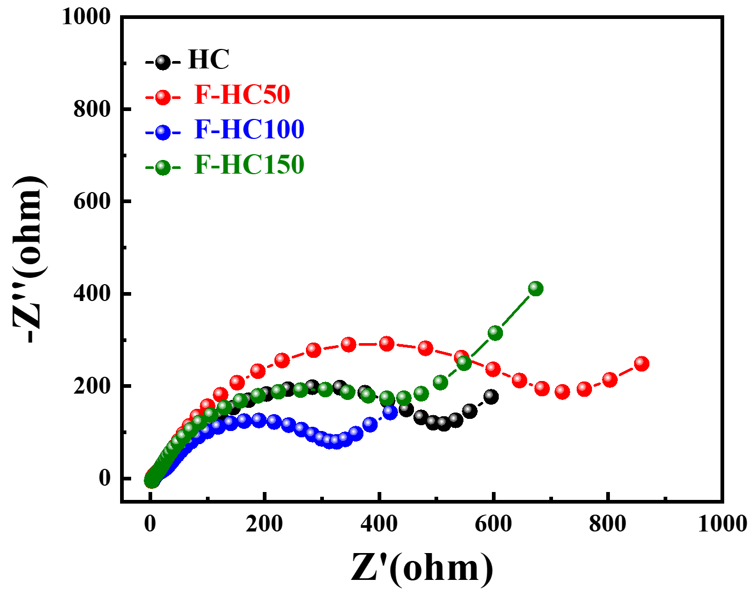
Fig. S6 Nyquist plots of HC and F–HC after 100 cycles at 50 mA/g
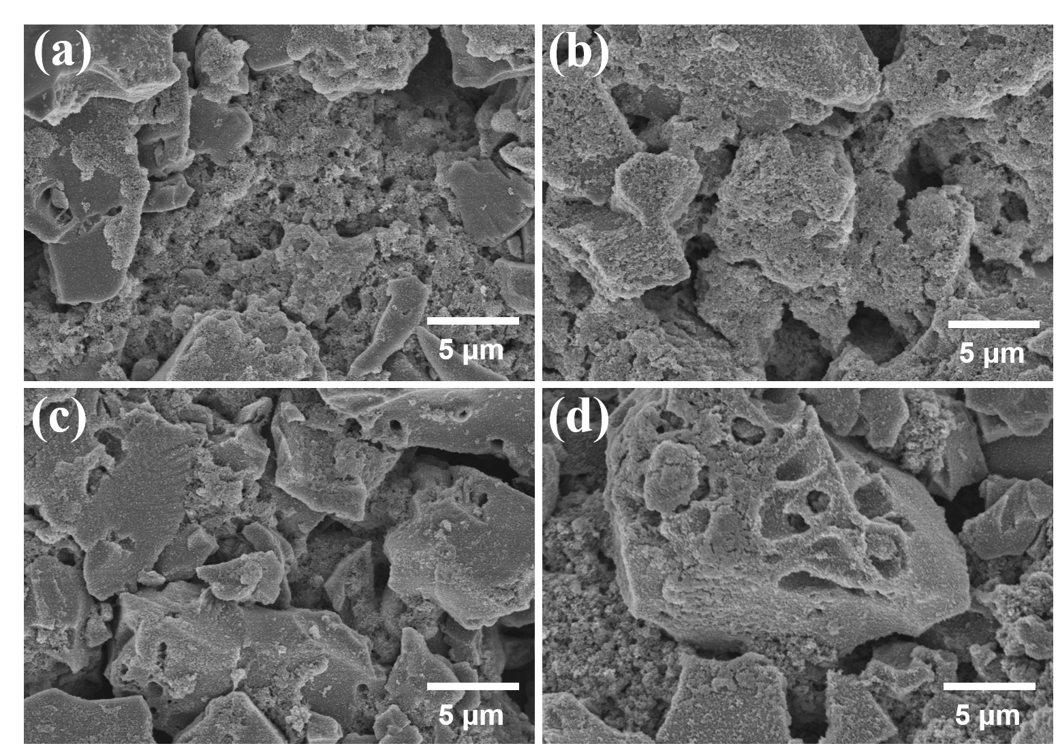
Fig. S7 SEM images of a HC, b F–HC50, c F–HC100, and d F–HC150 after 100 cycles at 50 mA/g

Table S1 Structural parameters of HC and F–HC
Sample | d-spacing  (Å) | I_{D}/I_{G} | Surface area  (m²/g) | Pore volume  (cm³/g)
HC | 3.86 | 1.01 | 2.60 | 0.006
F–HC50 | 4.02 | 1.02 | 3.31 | 0.010
F–HC100 | 4.12 | 104 | 4.44 | 0.011
F–HC150 | 4.05 | 1.07 | 4.56 | 0007

Table S2 C1s and F1s peak assignments and proportions obtained from the XPS spectra of F–HC
Sample | C1s assignments (eV) |  |  |  |  | F1s assignments (eV)
Sample | sp² C  (at.%) | sp³ C  (at.%) | C–O  (at.%) | Semi-ionic C–F bond  (at.%) | Covalent C–F bond  (at.%) | Absorbed F atom  (at.%) | Semi-ionic F atom  (at.%) | Covalent F atom  (at.%)
F–HC50 | 284.7 | 285.3 | 286.1 | 286.6 | 289.2 | 686.5 | 687.4 | 688.6
F–HC50 | 24.6 | 25.0 | 14.1 | 22.8 | 13.5 | 36.4 | 33.3 | 30.3
F–HC100 | 286.4 | 285.5 | 286.0 | 286.8 | 289.3 | 686.7 | 687.8 | 688.9
F–HC100 | 26.8 | 16.8 | 17.3 | 19.4 | 19.7 | 31.1 | 38.9 | 30.0
F–HC150 | 284.8 | 285.4 | 285.9 | 286.7 | 298.5 | 686.8 | 687.7 | 689.0
F–HC150 | 30.8 | 15.9 | 13.8 | 12.8 | 26.7 | 28.8 | 35.1 | 36.1

Table S3 Comparison of the energy density of F–HC products in this study and previously reported cathode of sodium-ion battery
Reference | Published year | Cathode type | Reversible capacity | Initial coulombic efficiency | Retained capacity
[21] | 2020 | Lignin-derived N-doped carbon | 320.5 mAh/g | 99.32% | 130.8 mAh/g  (after 1144 cycles)
[23] | 2015 | F-doped carbon derived from lotus petioles | 230 mAh/g | 52.3% | 228 mAh/g  (after 200 cycles)
[25] | 2019 | N, F co-doped porous carbon | 329.93 mAh/g | ~99% | 312.6 mAh/g  (after 300 cycles)
[26] | 2017 | N, F co-doped graphene | 220 mAh/g | 95% | 203 mAh/g  (after 100 cycles)
[27] | 2021 | N-enriched carbon nanofibers | 199 mAh/g | / | 150 mAh/g  (after 2000 cycles)
[53] | 2019 | Na₃V₂(PO₄)₃@C@  CNT porous network | 100 mAh/g | 99% | 83 mAh/g  (after 4500 cycles)
[54] | 2020 | Microspherical Sb@C composite | 721.6 mAh/g | 63.5% | 280 mAh/g  (after 500 cycles)
[55] | 2021 | Porous polyaniline-PEDOT | 81.9 mAh/g | ~92% | 80.91 mAh/g  (after 200 cycles)
This work |  | F–HC100 | 358 mAh/g | 78.13% | 343 mAh/g  (after 100 cycles)

