Research Article

Li₂TiO₃ Dopant and Phosphate Coating Improve the Electrochemical Performance of LiCoO₂ at 3.0–4.6 V
Baozhao Shi¹∙ Jiangli Feng¹ ∙ Jing Liu¹ ∙Yanan Zhou¹ ∙Jinli Zhang^{1, 2} ∙ Wei Li^{1, 2}
¹School of Chemical Engineering and Technology, Tianjin University, Tianjin 300350, China
²Haihe Laboratory of Sustainable Chemical Transformations, Tianjin 300192, China
Correspondence to Wei Li, Email: liwei@tju.edu.cn
Received: 5 July 2022 / Revised: 11 July 2022 / Accepted: 25 July 2022 / Published online:

Contents
- Fig. S1 Rietveld refinements for the a LCO-P and b LCO-Ti
- Fig. S2 SEM images of a LCO, b LCO-Ti/P, c LCO-P and d LCO-Ti
- Fig. S3 EDS elemental mapping of Co, O, P and Ti for LCO-Ti/P
- Fig. S4 XPS spectra of four kinds of samples
- Fig. S5 FT-IR spectra of LCO and LCO-Ti/P
- Fig. S6 Discharge mean voltage fading in the cycling process for all the samples at 1 C and room temperature
- Fig. S7 The full spectra of in-situ XRD characterization for a LCO and b LCO-Ti/P during the first charge-discharge process
- Fig. S8 EIS spectra of a LCO-P and b LCO-Ti based on the 1st, 5th, 10th, 50th and 100th cycles
- Fig. S9 Linear fit of the cell voltage as a function of the τ^{1/2}. b Single titration step of GITT curve for LCO-Ti/P. c D_{Li}⁺ calculated from GITT during 100th cycle of the discharging process of all samples
- Fig. S10 The interface structure models of matched crystal planes between Li₂TiO₃ and LiCoO₂: a Li₂TiO₃(002) and LiCoO₂(104), b Li₂TiO₃(202) and LiCoO₂(003)
- Table S1 Comparison of electrochemical performance with the results in the literature
- Table S2 Relative percentages and binding energies of O Species in O 1s XPS spectra
- Table S3 Relativepercentages and binding energy of Co³⁺/Co²⁺ in Co 2p XPS spectra
- Table S4 EIS fitting results of LCO-Ti and LCO-P

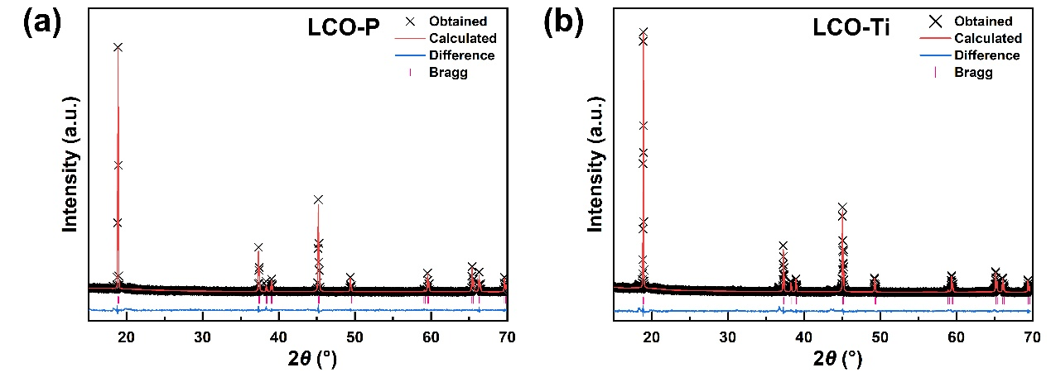
Fig. S1 Rietveld refinements for the a LCO-Pand b LCO-Ti
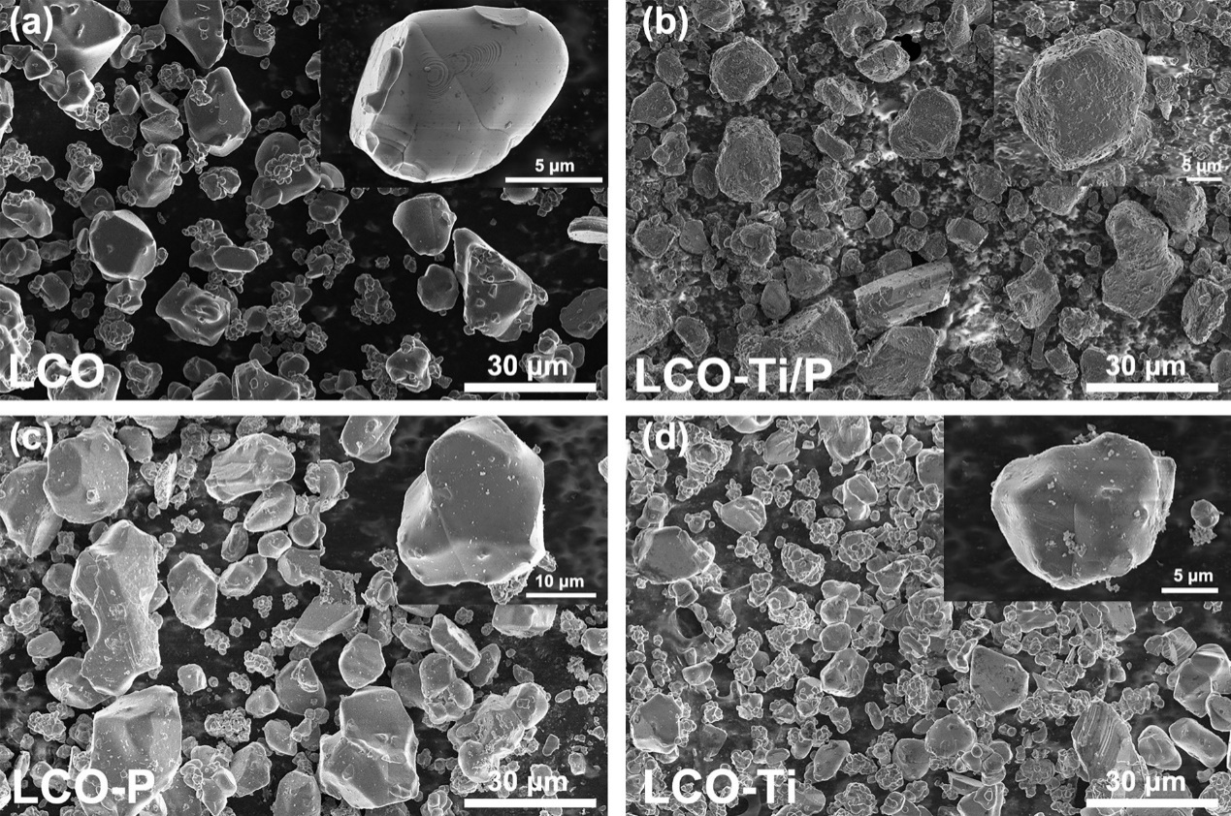
Fig. S2 SEM images of a LCO, b LCO-Ti/P, c LCO-P and d LCO-Ti

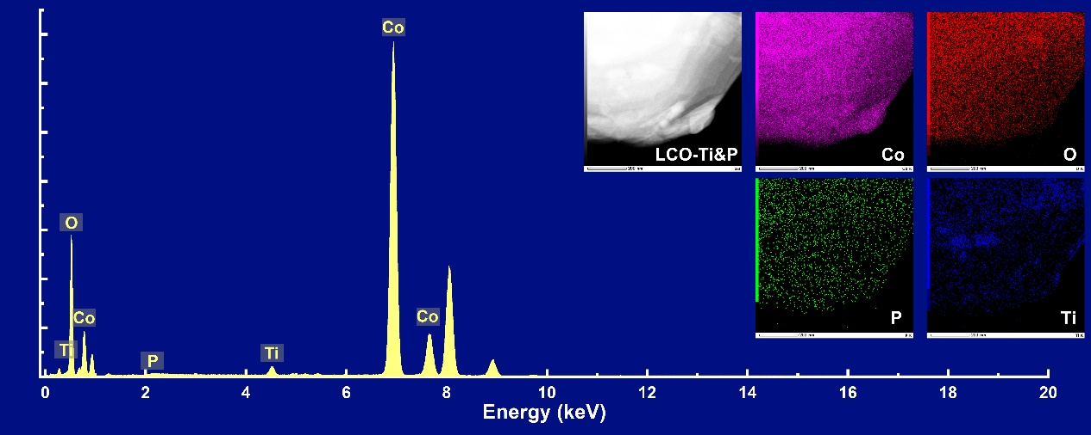
Fig. S3 EDS elemental mapping of Co, O, P and Ti for LCO-Ti/P
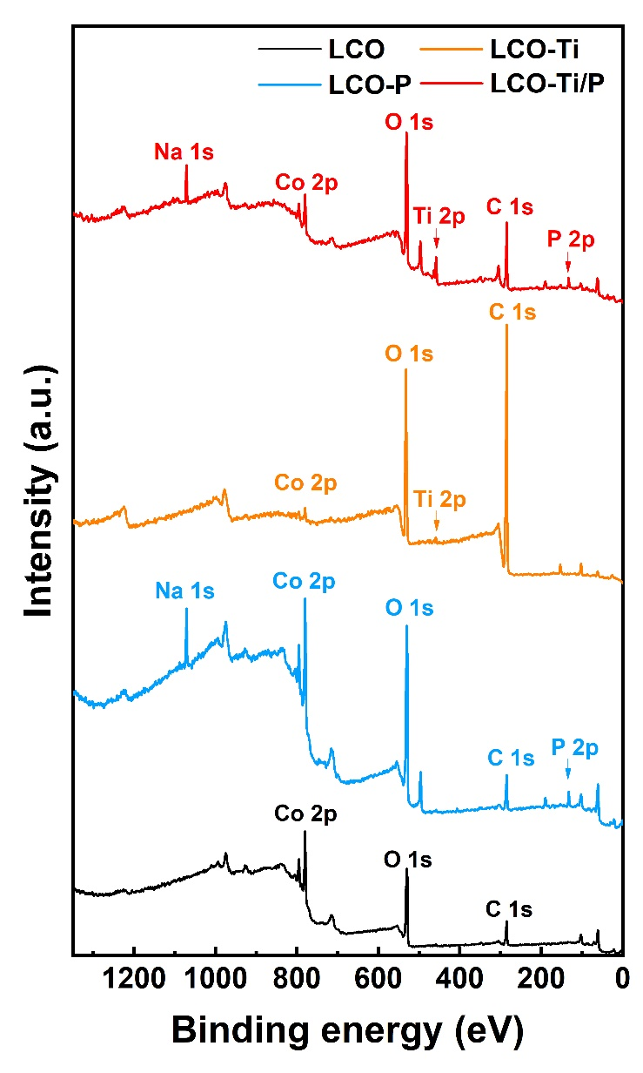
Fig. S4 XPS spectra of four kinds of samples
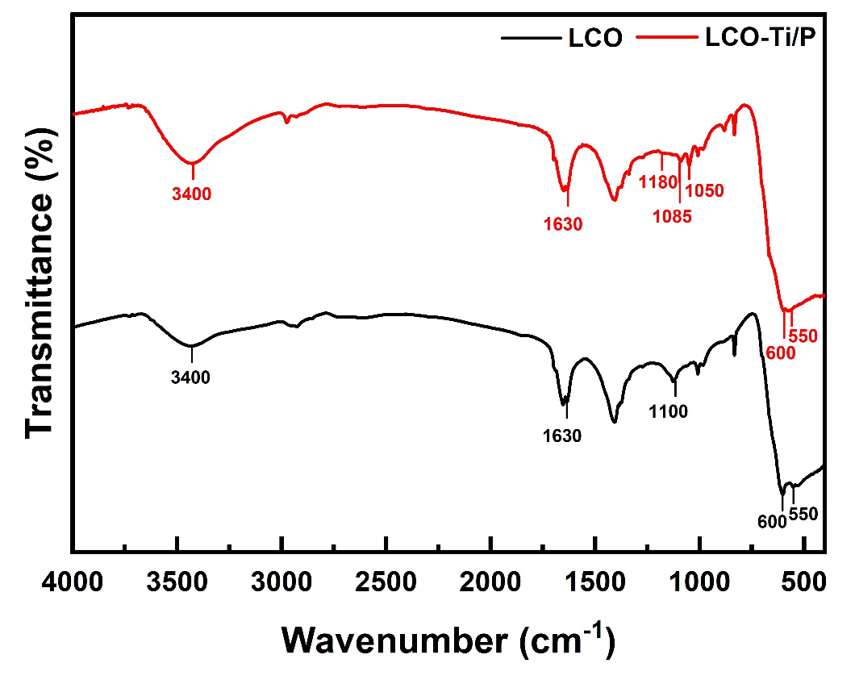
Fig. S5 FT-IR spectra of LCO and LCO-Ti/P
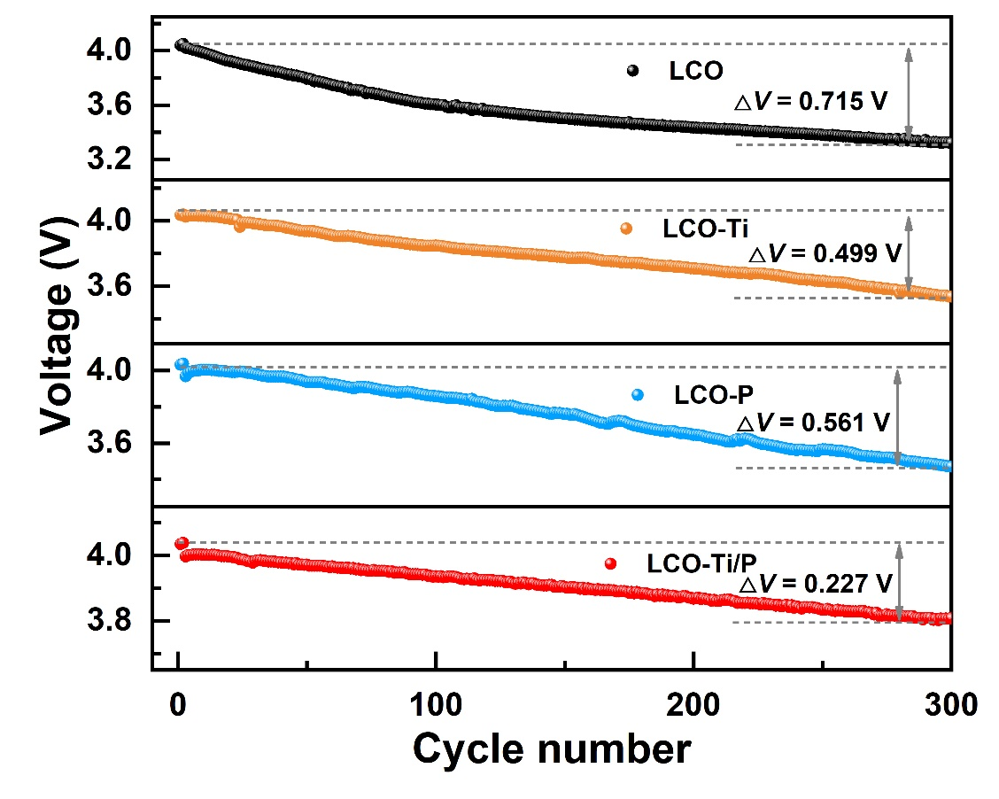
Fig. S6 Discharge mean voltage fading in the cycling process for all the samples at 1C and room temperature
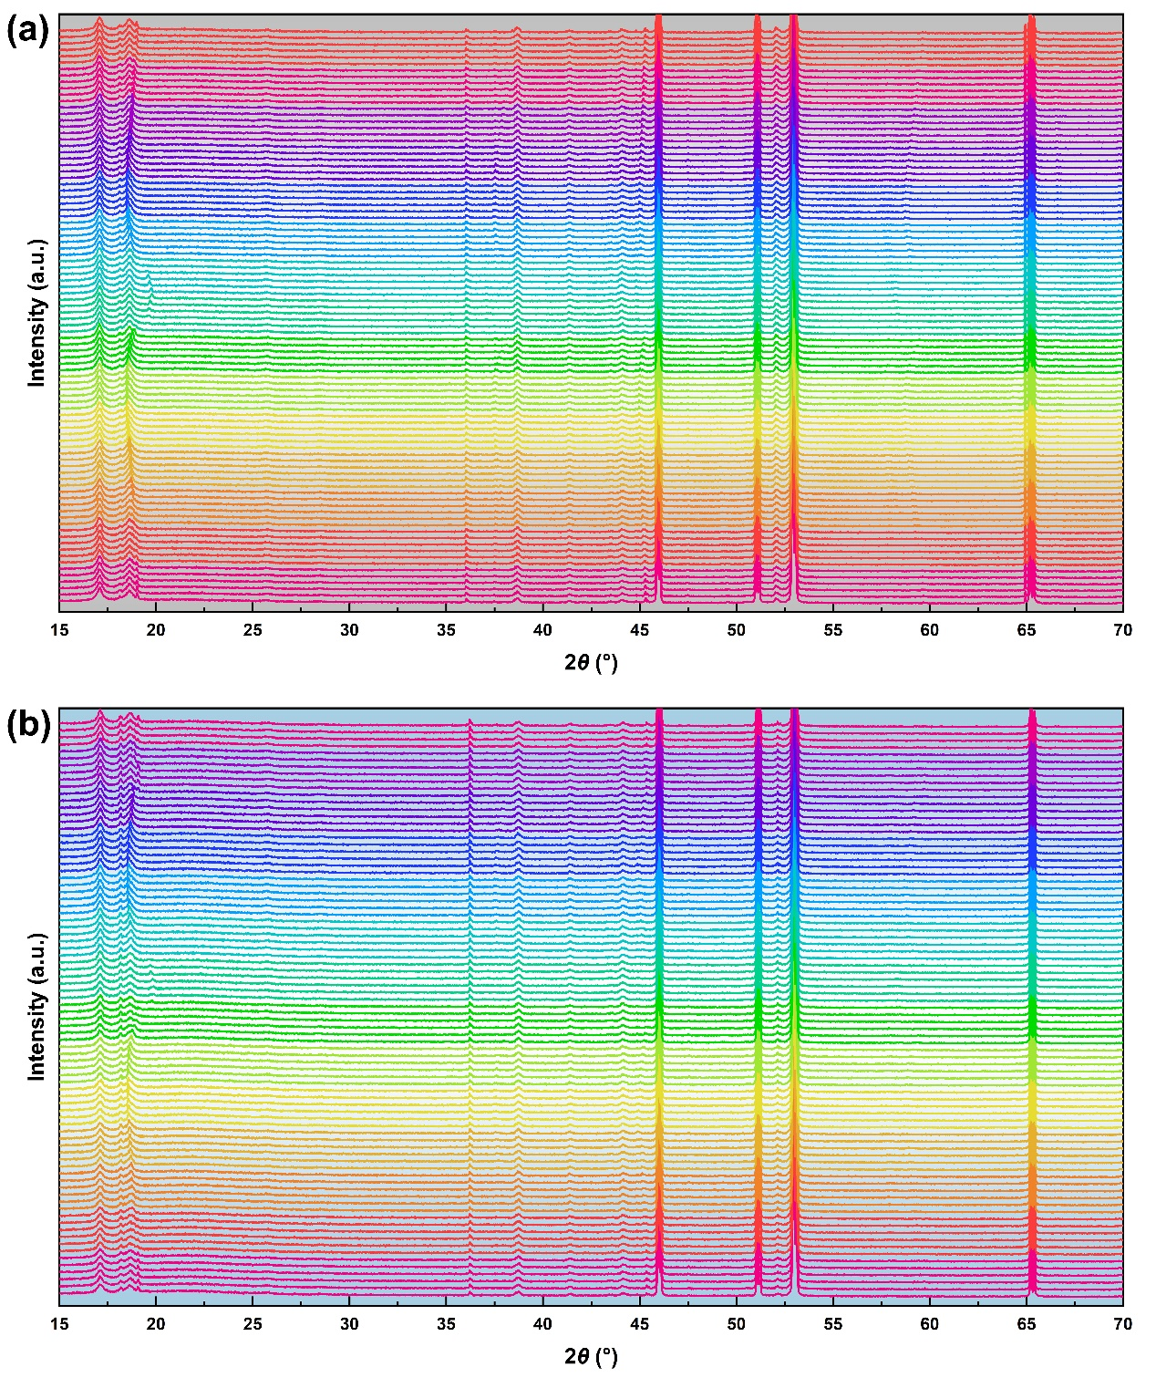
Fig. S7 The full spectra of in-situ XRD characterization for a LCO and b LCO-Ti/P during the first charge-discharge process

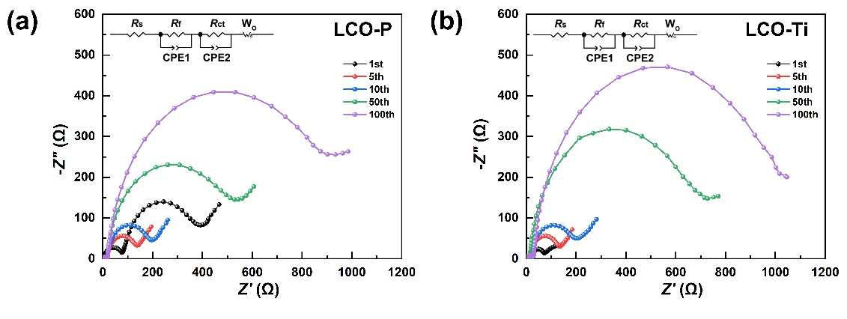
Fig. S8 EIS spectra of a LCO-Pand b LCO-Ti based on the 1st, 5th, 10th, 50th and 100th cycles

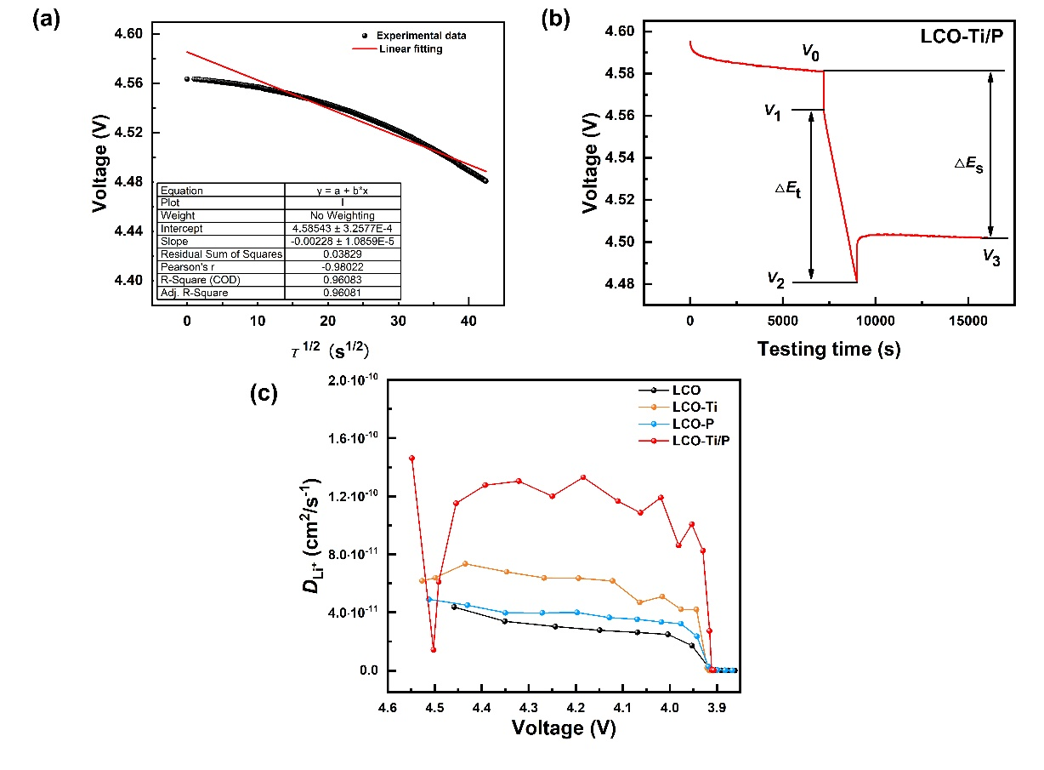
Fig. S9 a Linear fit of the cell voltage as a function of the τ^{1/2}. b Single titration step of GITT curve for LCO-Ti/P. c D_{Li}⁺ calculated from GITT during 100th cycle of the discharging process of all samples

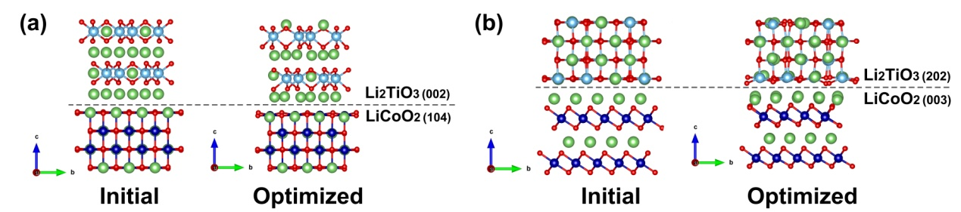
Fig. S10 The models of interface structure of different crystal planes between Li₂TiO₃ and LiCoO₂: a Li₂TiO₃(002) and LiCoO₂(104), b Li₂TiO₃(202) and LiCoO₂(003)
Table S1 Comparison of electrochemical performance with the results in the literature
Modified cathodes | Voltage range(V);  Temperature | Current density (mA/g) | Initial capacity (mAh/g) (current rate) | Capacity after n-cycles (mAh/g) | Capacity retention | Ref.
Li₃PO₄ and AlPO₄ -coated with Al and P -doped LiCoO₂ | 3.0-4.6  RT | 1 C = 274 | 214.1 (0.1 C) | 180.4 (200th, 0.5 C) | 88.6% | [1]
BaTiO₃ and TiO₂-coated with Mg and Ti -doped LiCoO₂ | 3.0-4.6  RT | 1 C = 200 | 208.8 (0.5 C) | 150.7 (300th, 1 C) | 75.0% | [2]
Li_{1.5}Al_{0.5}Ti_{1.5}(PO₄)₃ -coated LiCoO₂ | 3.0-4.6  RT | 1 C = 274 | 214.6 (0.2 C) | 180.3 (100th, 0.5 C) | 88.3% | [3]
Li_{1.5}Al_{0.5}Ti_{1.5}(PO₄)₃ -coated LiCoO₂ | 3.0-4.6  45℃ | 1 C = 274 | 214.6 (0.2 C) | 160.9 (100th, 0.5 C) | 72.9% | [3]
ZnO -coated and Al -doped LiCoO₂ | 3.0-4.6  RT | 1 C = 185 | 183.9 (1 C) | 120.8 (500th, 1 C) | 65.7% | [4]
Mg -doped LiCoO₂ | 3.0-4.6  RT | 1 C = 270 mA/g | 204 (0.2 C) | 158 (100th, 1C) | 84% | [5]
Spinel LiNi_{0.5}Mn_{1.5}O₄ -coated LiCoO₂ | 3.0-4.6  RT | 1 C = 220 | 219 (0.5 C) | 156.8 (55th, 0.5 C) | 71.6% | [6]
Ti and Mg and Al -doped LiCoO₂ | 3.0-4.6  RT | 1 C = 274 | 202.3 (0.5 C) | 174 (100th, 0.5 C) | 86% | [7]
Ti and Mg and Al -doped LiCoO₂ | 3.0-4.6  RT | 1 C = 140 | 224.9 (0.1 C) | 169.9 (200th, 0.5 C) | 78% | [8]
F-doped Al₂O₃ -coated LiCoO₂ | 3.0-4.6  RT | 27.4 | 208.6 (27.4mA/g) | 185.3  (100th, 27.4mA/g) | 89.1% | [9]
LiAlO₂ -coated LiCoO₂ | 3.0-4.6  RT | 20 | 198.7 (20mA/g) | 172.2 (50th, 20 mA/g) | 86.7% | [10]
Dual-element Ti and P modified LiCoO₂ | 3.0-4.6  RT | 1 C = 200 | 211.6 (0.1 C)  193.8 (1 C) | 166.1 (100th, 1 C)  130.4 (300th, 1 C) | 85.7%  67.3% | This work

Table S2 Relative percentages and binding energies of O species in O 1s XPS spectra
Sample | Relative content (%) |  |  |  | Binding energy (eV)
Sample | Co–O | Ti–O or P–O | C=O | C–O | Co–O | Ti–O or P–O | C=O | C–O
LCO-P | 44.07 | 39.68 | 8.16 | 8.09 | 529.08 | 530.80 | 532.00 | 533.18
LCO-Ti | 9.05 | 8.39 | 40.63 | 41.93 | 529.52 | 531.40 | 532.00 | 533.17
LCO-Ti/P | 39.19 | 37.31 | 13.62 | 9.88 | 529.51 | 531.04 | 532.00 | 533.17

Table S3 Relative percentages and binding energy of Co³⁺/Co²⁺ in Co 2p 3/2 XPS spectra
Sample | Relative content(%) |  | Binding energy(eV)
Sample | Co³⁺ | Co²⁺ | Co³⁺ | Co²⁺
LCO | 73.63 | 26.37 | 779.66 | 781.17
LCO-P | 73.99 | 26.01 | 779.52 | 781.06
LCO-Ti | 73.47 | 26.53 | 779.87 | 781.40
LCO-Ti/P | 82.50 | 17.50 | 779.95 | 781.59

Table S4 EIS fitting results of LCO-Ti and LCO-P
Samples | Cycle number | R_{s} (Ω) | R_{f} (Ω) | R_{ct} (Ω) | Samples | Cycle number | R_{s} (Ω) | R_{f} (Ω) | R_{ct} (Ω)
LCO-Ti | 1st | 1.48 | 12.27 | 25.53 | LCO-P | 1st | 2.83 | 80.71 | 347.90
LCO-Ti | 5th | 1.11 | 16.18 | 128.20 | LCO-P | 5th | 4.28 | 13.41 | 100.60
LCO-Ti | 10th | 1.59 | 18.98 | 193.10 | LCO-P | 10th | 4.82 | 13.68 | 156.80
LCO-Ti | 50th | 1.30 | 15.78 | 701.30 | LCO-P | 50th | 2.47 | 19.40 | 539.70
LCO-Ti | 100th | 1.96 | 26.75 | 1048.00 | LCO-P | 100th | 1.17 | 18.63 | 952.60

The Analysis Details of Galvanostatic Intermittent Titration Technique (GITT)
The GITT experiments were performed with coin-type cells at charge/discharge at 0.1 C for 0.5 h with 2 h relaxation time between each pulse (voltage range of 3.0–4.6 V). The diffusion co-efficient of Li⁺ can be calculated according to the following formula:
$${\text{D}}_{{\text{Li}}^{\text{+}}} \text{=} \frac{\text{4}}{\text{π}\text{τ}}{\left(\frac{{\text{m}}_{\text{B}}{\text{V}}_{\text{M}}}{{\text{M}}_{\text{B}}\text{S}}\right)}^{\text{2}}{\left(\frac{{\text{Δ}\text{E}}_{\text{S}}}{{\text{Δ}\text{E}}_{\text{t}}}\right)}^{\text{2}} \left(\text{τ} \text{≪ }\frac{{\text{L}}^{\text{2}}}{{\text{D}}_{{\text{Li}}^{\text{+}}}}\right)$$
Where τ is the time of the constant current pulse; S represents the contact area between the cathode active material and the electrolyte; ΔE_{t} is the voltage change before and after the constant current pulse, and ΔE_{s} is the steady-state voltage change. V_{M}, M_{B} and m_{B} are the molar volume, molar mass and mass of the electrode material, respectively. The value of V_{M} is obtained from the Rietveld refinement results of GSAS. L is the diffusion length.

References
1. Wang X, Wu Q, Li SY et al (2021) Lithium-Aluminum-Phosphate coating enables stable 4.6 V cycling performance of LiCoO₂ at room temperature and beyond. Energy Storage Materials 37:67–76
2. Hu B, Geng FS, Shen M et al (2021) A multifunctional manipulation to stabilize oxygen redox and phase transition in 4.6 V high-voltage LiCoO₂ with sXAS and EPR studies. J Power Sources 516: 230661
3. Wang Y, Zhang QH, Xue ZC et al (2020) An in situ formed surface coating layer enabling LiCoO₂ with stable 4.6 V high‐voltage cycle performances. Adv Energy Mater 10(28):2001413
4. Cheng T, Ma ZT, Qian RC et al (2021) Achieving stable cycling of LiCoO₂ at 4.6 V by multilayer surface modification. Adv Funct Mater 31(2):2001974
5. Huang YY, Zhu YC, Fu HY et al (2021) Mg-Pillared LiCoO₂ : towards stable cycling at 4.6 V. Angew Chem Int Ed Engl 60(9):4682–4688
6. Pang PP, Wang Z, Deng YM et al (2020) Delayed phase transition and improved cycling/thermal stability by spinel LiNi_{0.5}Mn_{1.5}O₄ modification for LiCoO₂ cathode at high voltages. ACS Appl Mater Interfaces 12(24):27339–27349
7. Zhang JN, Li QH, Ouyang CY et al (2019) Trace doping of multiple elements enables stable battery cycling of LiCoO₂ at 4.6 V. Nat Energy 4(7):594–603
8. Wang LL, Ma J, Wang C et al (2019) A novel bifunctional self-stabilized strategy enabling 4.6 V LiCoO₂ with excellent long-term cyclability and high-rate capability. Adv Sci 6(12):1900355
9. Qian JW, Liu L, Yang JX et al (2018) Electrochemical surface passivation of LiCoO₂ particles at ultrahigh voltage and its applications in lithium-based batteries. Nat Commun 9(1):4918
10. Xie J, Zhao J, Liu YY et al (2017) Engineering the surface of LiCoO₂ electrodes using atomic layer deposition for stable high-voltage lithium ion batteries. Nano Res 10(11):3754–3764

