Supporting Information

Ultrafast Carbonized Wood of Electrode-Scaled Aligned-Porous Structure for High-Performance Lithium Batteries

Shaojie Chen¹ · Lu Nie¹ · Hongsheng Shi¹ · Xiangchen Hu¹ · Zeyu Wang¹ · Xinshui Zhang¹ · Yuyao Zhang¹ · Qilin Hu¹ · Tianyi Gao¹ · Yi Yu^{1,2} · Wei Liu^{1,2,3}

¹School of Physical Science and Technology, ShanghaiTech University, Shanghai 201210, China
²Shanghai Key Laboratory of High-resolution Electron Microscopy, ShanghaiTech University, Shanghai 201210, China
³Key Laboratory of Advanced Energy Materials Chemistry (Ministry of Education), Nankai University, Tianjin 300071, China

Received: 19 April 2023/ Revised: 7 June 2023/ Accepted: 13 July 2023/ Published online:

Corresponding to Wei Liu, E-mail: liuwei1@shanghaitech.edu.cn

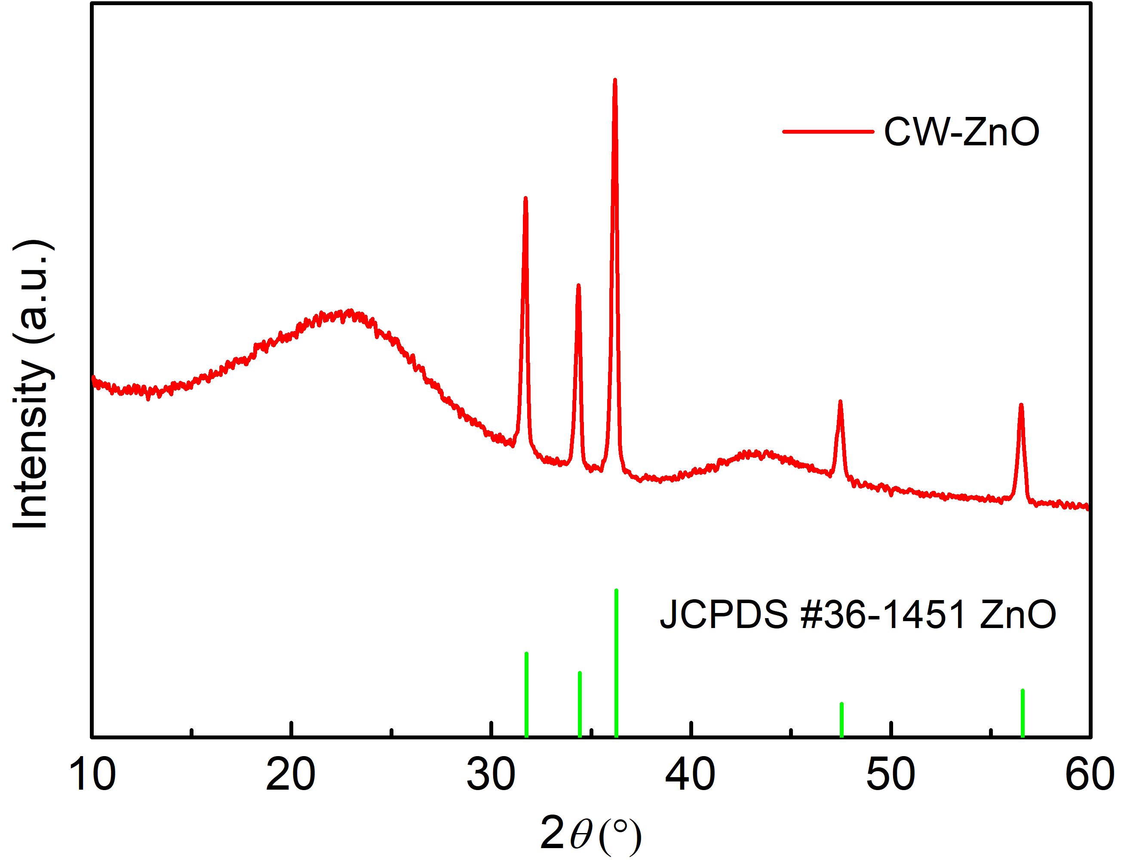
Fig. S1 XRD of CW-ZnO

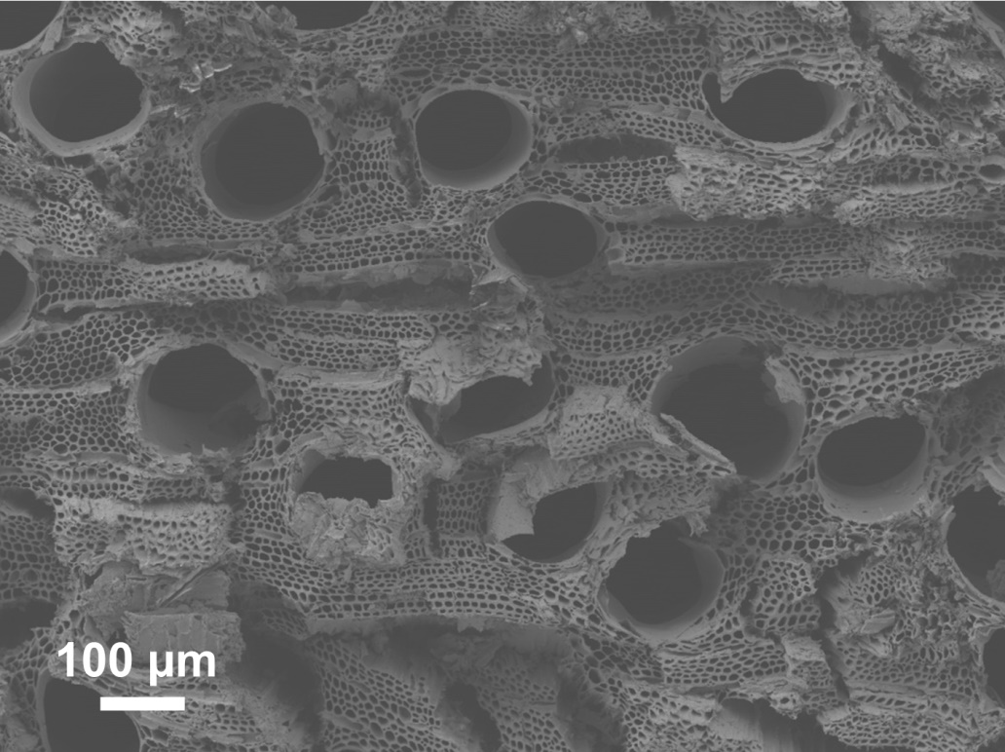
Fig. S2 SEM image of the CW anode after cycling

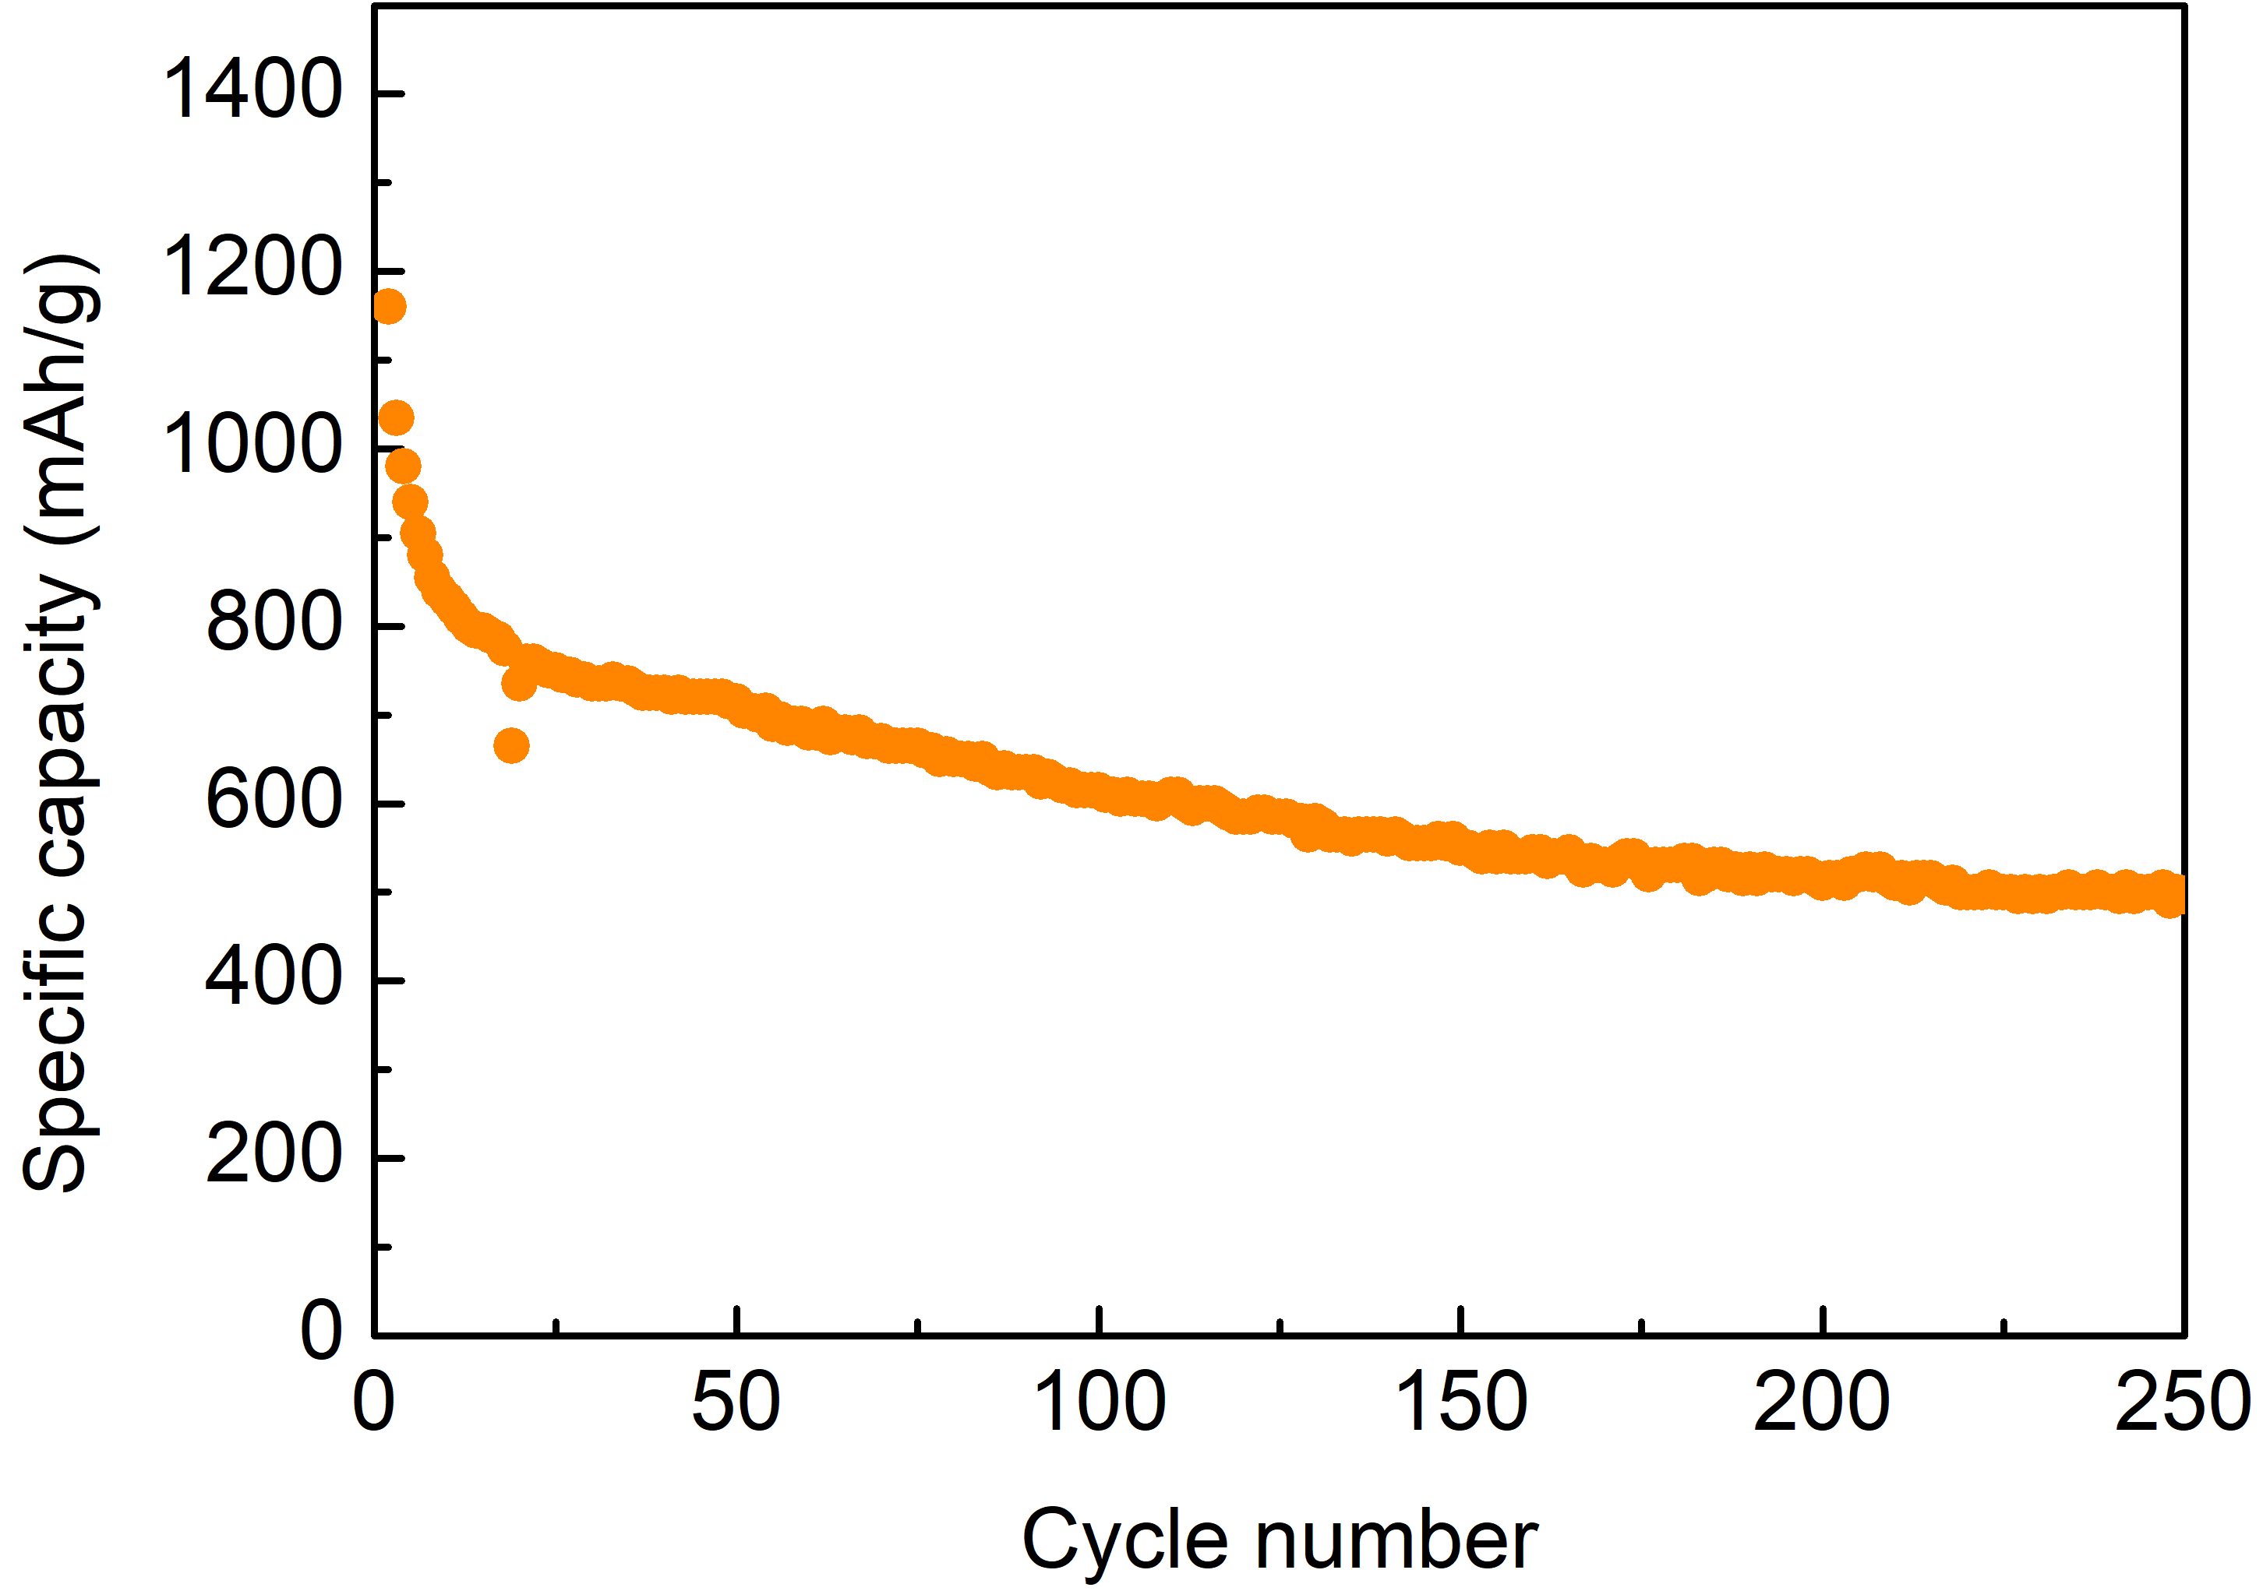
Fig. S3 Cycling performance of S@CW cathode at 0.1 C

Table S1 Carbon, hydrogen, oxygen and nitrogen contents of carbonized wood samples
Sample | Carbon/% | Hydrogen/% | Nitrogen/% | Oxygen/% | H/C | O/C
Pyrolysis | 94.01 | 0.82 | 0.71 | 4.46 | 0.009 | 0.047
MAUCT | 96.15 | 0.88 | 1.21 | 1.76 | 0.009 | 0.018

