Supporting Information
Pd⁰–O_{v}–Ce³⁺ Interfacial Sites with Charge Redistribution for Enhanced Hydrogenation of Methyl Oleate to Methyl Stearate
Zhaohui Meng¹ · Ying Liao²· Ling Liu¹· Yaqian Li²·Hao Yan²· Xiang Feng²· Xiaobo Chen²· Yibin Liu²· Chaohe Yang²

¹SINOPEC Dalian Research Institute of Petroleum and Petrochemicals Co., Ltd.
²State Key Laboratory of Heavy Oil Processing, China University of Petroleum, Qingdao 266580, China

Correspondence to Hao Yan, Email:haoyan@upc.edu.cn; Yibin Liu, Email:liuyibin@upc.edu.cn

Catalytic Performance of the Pd/CeO₂-x Catalysts
Table S1 Catalytic performance of Cis-C18:1 hydrogenation over Pd/CeO₂-x catalysts
Catalysts | Cis-C18:1 conversion (%) | Selectivity (%) |  |  |  | Pd dispersion (FE)ª
Catalysts | Cis-C18:1 conversion (%) | MS | Trans-C18:1 |  |  | Pd dispersion (FE)ª
Pd/CeO₂-300 | 89.1 | 86.9 |  | 12.6 | 0.52
Pd/CeO₂-500 | 99.8 | 93.2 |  | 5.4 | 0.56
Pd/CeO₂-700 | 80.6 | 85.4 |  | 14.0 | 0.52
Pd/CeO₂-900 | 74.7 | 81.7 |  | 18.0 | 0.50
Reaction condition: [25 mL Cis-C18:1 in n-hexane solution (0.14 mol/L), 0.03 g Pd/CeO₂-x catalyst, 0.3 MPa H₂, 1 h, 30 °C]. ªThe formula for the Pd dispersion (FE) is calculated as: ${\text{d}}_{\text{rel(}\text{VS)}}\text{= }\frac{\text{3.32}}{{\text{FE}}^{\text{1.23}}}$, in which ${\text{d}}_{\text{rel(VS)}}\text{= }\frac{{\text{d}}_{\text{VS}}}{{\text{d}}_{\text{at}}}$, d_{vs} refers to the particle size of the metal measured by TEM, while d_{at} represents the atomic diameter of the metal (Langmuir 1997, 13, 5613–5620)

2. Physical Property of Pd/CeO₂-x Catalysts
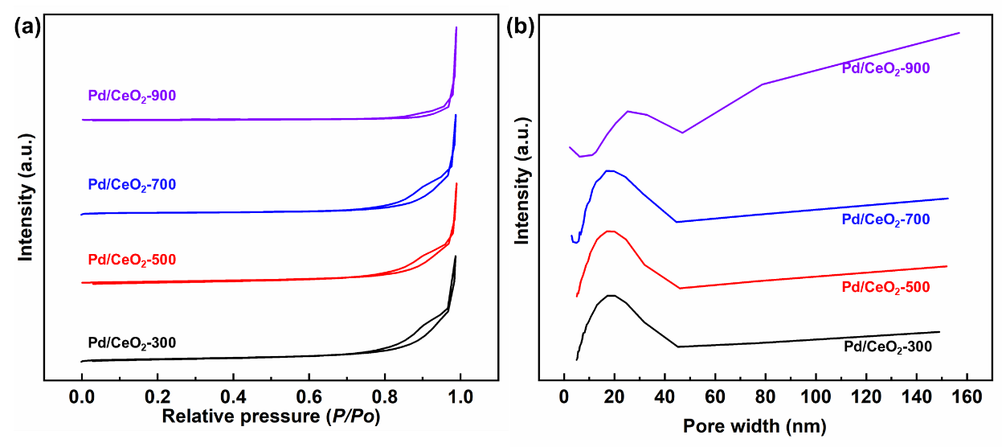
Fig. S1 a N₂ absorption-desorption isotherms and b pore size distribution of Pd/CeO₂-x catalysts

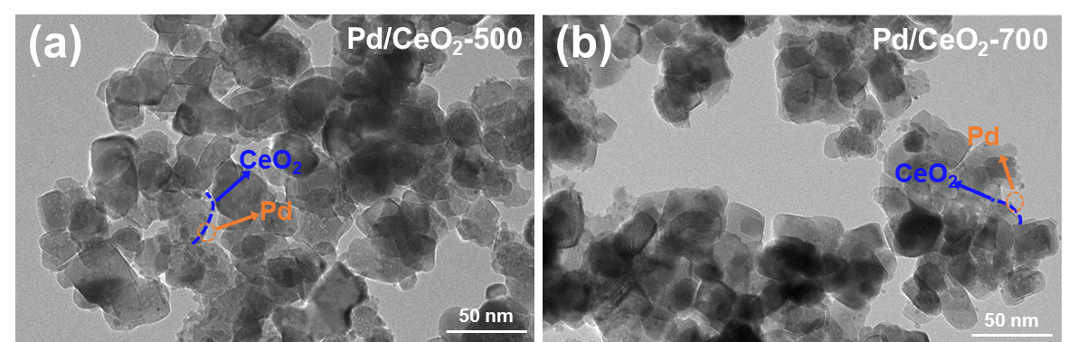
Fig. S2 TEM images of a Pd/CeO₂-500 and b Pd/CeO₂-700
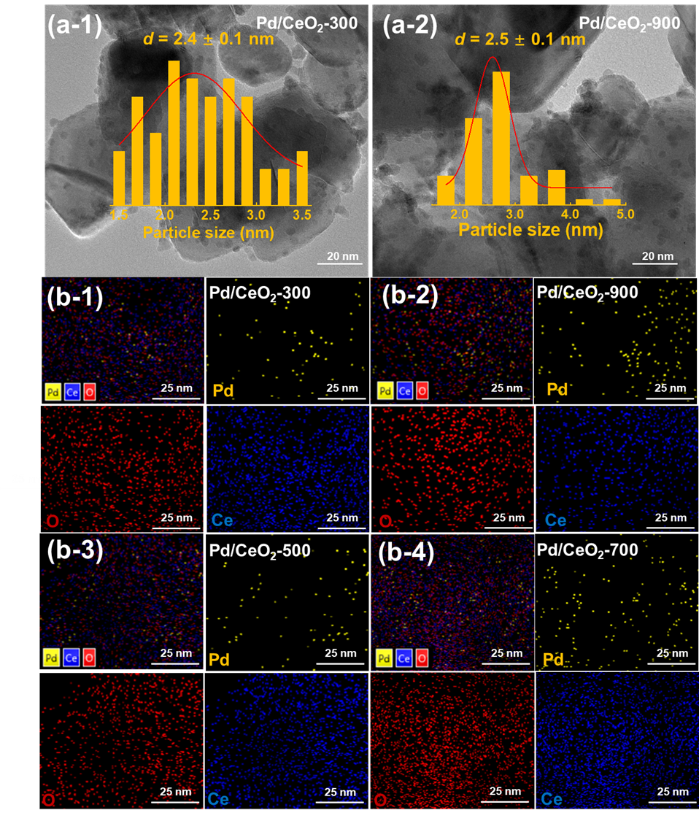
Fig. S3. TEM images of a-1 Pd/CeO₂-300, and a-2 Pd/CeO₂-900 with particle-size distribution. EDX mapping of b-1 Pd/CeO₂-300, b-2 Pd/CeO₂-900, b-3 Pd/CeO₂-500, and b-2 Pd/CeO₂-700
Table S2 Composition, structure and structural data of Pd/CeO₂-x samples
Catalysts | Pd (wt%)ª | S_{BET} (m²/g)^{b} | V_{p} (cm³/g)^{b} | D_{p} (nm)^{b} | d_{CeO2} (nm)^{c}
Pd/CeO₂-300 | 0.98 | 33.15 | 0.33 | 28.13 | 23.60
Pd/CeO₂-500 | 1.01 | 23.12 | 0.29 | 33.29 | 23.80
Pd/CeO₂-700 | 0.97 | 18.17 | 0.27 | 33.33 | 26.50
Pd/CeO₂-900 | 1.00 | 5.49 | 0.32 | 67.06 | 89.50
ªPd loading of catalyst samples, determined by ICP-AES. ^{b}S_{BET} and V_{p} represented the BET surface area, pore volume, respectively, which were measured by N₂ adsorption-desorption. ^{c}Average diameter of CeO₂ crystal particles, calculated by the Debye-Scherrer equation based on XRD patterns.

3. Chemical States of Catalyst Surface Elements
Table S3 Raman data of the Pd/CeO₂-x catalysts
Catalysts | F_{2g} peakª (℃) | O_{V} defects peakª (℃) | I(584)/I(467)^{b}
Pd/CeO₂-300 | 467 | 586 | 0.14
Pd/CeO₂-500 | 468 | 583 | 0.27
Pd/CeO₂-700 | 466 | 584 | 0.08
Pd/CeO₂-900 | 464 | 580 | 0.07
ª The temperature of the corresponding peak.
^{b} Determined from relative peak area of Raman results.
Table S4 O 1s data of the Pd/CeO₂-x catalysts
Catalysts | O_{Ⅰ} |  | O_{Ⅱ} |  | O_{Ⅲ}
Catalysts | B.E. (eV)ª | Content (%)^{b} | B.E. (eV) | Content (%) | B.E. (eV) | Content (%)
Pd/CeO₂-300 | 529.2 | 67.8 | 531.1 | 23.2 | 532.6 | 9.0
Pd/CeO₂-500 | 529.2 | 64.7 | 531.2 | 28.0 | 532.5 | 7.3
Pd/CeO₂-700 | 529.2 | 65.7 | 531.1 | 25.4 | 532.7 | 8.9
Pd/CeO₂-900 | 529.2 | 50.8 | 531.4 | 22.4 | 533.3 | 26.8
ª Binding energy for O 1s.
^{b} Determined from relative peak area of fitted XPS results.
Table S5 Ce 3d data of the Pd/CeO₂-x catalysts
Catalysts | Ce³⁺ |  |  |  | Ce⁴⁺
Catalysts | B.E. (eV)ª |  | Content (%)^{b} |  | B.E. (eV) |  | Content (%)
Pd/CeO₂-300 | 903.0, 900.0 | 30.9 |  | 916.4, 906.9, 900.8 |  | 69.1
Pd/CeO₂-500 | 902.8, 900.1 | 33.0 |  | 916.4, 906.9, 900.8 |  | 67.0
Pd/CeO₂-700 | 902.9, 900.0 | 29.6 |  | 916.2, 906.6, 900.6 |  | 70.4
Pd/CeO₂-900 | 902.7, 900.0 | 28.6 |  | 916.3, 907.1, 900.6 |  | 71.1
ª Binding energy for Ce 3d_{3/2}.
^{b} Determined from relative peak area of fitted XPS results.
Table S6 Pd 3d data of the Pd/CeO₂-x catalysts
Catalysts | Pd⁰ |  | Pd²⁺
Catalysts | B.E. (eV)ª | Content (%)^{b} | B.E. (eV) |  | Content (%)
Pd/CeO₂-300 | 335.7 | 41.8 | 337.7 | 58.2
Pd/CeO₂-500 | 335.4 | 64.0 | 337.3 | 36.0
Pd/CeO₂-700 | 335.6 | 60.3 | 337.6 | 39.7
Pd/CeO₂-900 | 335.8 | 56.6 | 337.7 | 43.4
ª Binding energy for Pd 3d_{5/2}.
^{b} Determined from relative peak area of fitted XPS results.

4. Structure-Dependent Kinetics over Pd/CeO₂-x Catalysts
Table S7 Catalytic performance of Cis-C18:1 hydrogenation over Pd/CeO₂-x catalysts
Reaction time (h) | Cis-C18:1 conversion (%) | Selectivity (%) |  |  | Carbon balance (%)
Reaction time (h) | Cis-C18:1 conversion (%) | MS | Trans-C18:1MS |  | Carbon balance (%)
0.5 | 75.6 | 80.2 |  | 18.9 | 99.1
1.0 | 99.8 | 93.2 |  | 5.4 | 98.6
1.5 | 99.6 | 96.3 |  | 2.4 | 98.7
2.0 | 100.0 | 99.8 |  | 0.0 | 99.8
Reaction condition: [25 mL Cis-C18:1 in n-hexane solution (0.14 mol/L), 0.03 g Pd/CeO₂-x catalyst, 0.3 MPa H₂, 30 °C].
Table S8 Catalytic performance of Cis-C18:1 hydrogenation over Pd/CeO₂-x catalysts
Reaction temperature (°C) | Cis-C18:1 Conversion (%) | Selectivity (%) |  |  |  | Carbon balance (%)
Reaction temperature (°C) | Cis-C18:1 Conversion (%) | Trans-C18:1 |  | MS |  | Carbon balance (%)
30 | 75.6 | 80.2 | 18.9 |  | 99.1
40 | 86.4 | 85.9 | 13.3 |  | 99.2
50 | 91.3 | 86.2 | 12.6 |  | 98.8
60 | 94.7 | 86.3 | 11.1 |  | 97.4
Reaction condition: [25 mL Cis-C18:1 in n-hexane solution (0.14 mol/L), 0.03 g Pd/CeO₂-x catalyst, 0.3 MPa H₂, 0.5h].

